|  |
| --- |
| DEVELOPMENT OPPORTUNITYLAND AT THE GRANGE, MIDHURSTWEST SUSSEX |

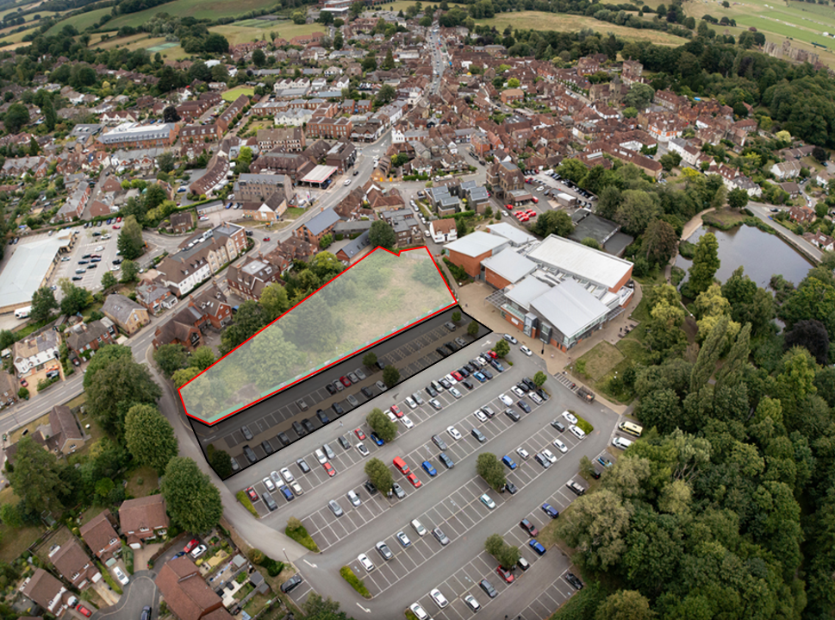Images used with permission – Christopher Ison Photography

**FREEHOLD FOR SALE**

**Chichester District Council are bringing forward a mixed-use development opportunity for the freehold acquisition of the former Grange Leisure Centre site off Bepton Road in Midhurst. The site extends to approximately 0.33 hectares (0.815 acres) with the option for the successful bidder to include an additional area within the Council car park extending to further 0.168 ha/0.416 acres (subject to internal consents) for a combined area of 0.498 ha/ 1.23 acres.**

Header Banner - Development Opportinity : Land at The Grange, Midhurst, West Sussex

**Location**

Situated in the heart of the South Downs National Park, Midhurst is a picturesque market town with a thriving local economy. Just to the South of the main high street this site is easily accessible by public transport and is an ideal location for a small to medium sized mixed-use development.

**Site Description**

The site benefits from a good level of footfall and is within comfortable walking distance of the town centre.

To the west of the site, it is predominantly residential, with commercial and retail to the north, whilst immediately to the south is the largest public car park in Midhurst.

The site formerly housed the old Grange leisure centre which has since been demolished. The site location can be viewed on foot from the adjacent car park.

There is the option for bidders to include an additional area within their offer (shaded black on the above aerial image) and immediately south of the subject site, with any such proposals subject to a review by the Council.

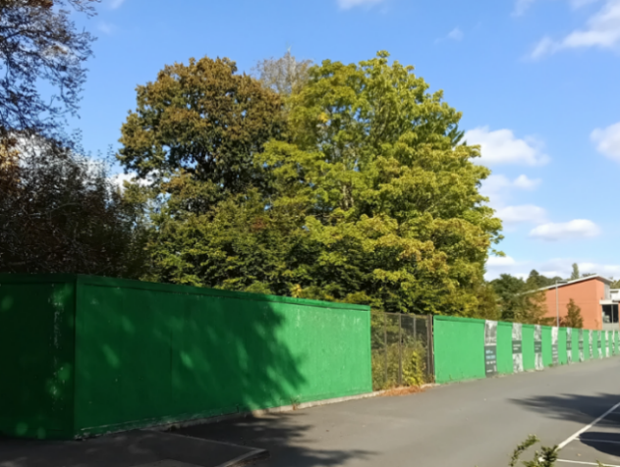

**Disclaimer:** Under the Property Misrepresentation Act 1967 and Property Misdescriptions Act 1991, these particulars do not from part of a contract. Chichester District Council give notice that (1) the particulars are set out as a general outline for guidance for intending purchasers and do not constitute, nor constitute part of, an offer or contract (2) all descriptions, dimensions, references to condition and necessary permission for use and occupation and other details are believed to be correct, but intending purchasers should not rely on them as statements or representations of fact, but must satisfy themselves by inspection or otherwise as to the correctness of each of them (3) no person in the employ of Chichester District Council has any authority to make or give any representation or warranty whatever in relation to this property.

**Planning and Development**

The site previously benefited from planning permission (now lapsed) for 16 dwellings (Ref: 11/01180).

**Bids are now invited for a mixed-use development that includes a 100% affordable housing element, comprising one and two bed accommodation. Bids will be assessed based on proposed delivery of affordable housing units to meet identified need in the Midhurst area. Consideration should be given to Strategic Policy SD28, which states that the overriding housing need in the National Park is for low-cost rented accommodation. Alternative tenures may be considered if supported by a local housing needs assessment.**

Potential purchasers are advised to make their own enquiries with South Downs National Park Authority (SDNPA) the Local Planning Authority.

The site is in a sensitive location within the Midhurst Conservation Area and the impact of any development will need to be carefully considered ensuring that it preserves or enhances its character.

The scale and design of any new development will need to take account of its setting in relation to the adjacent Community and Leisure Centre and the existing character and appearance of the area.

Development proposals will require detailed consideration by the Local Planning Authority and developers will need to demonstrate that the proposed scheme provides adequate car parking.

Header Banner - Development Opportinity : Land at The Grange, Midhurst, West Sussex

**Highways/Access**

The site is located off Bepton Road (A286) in Midhurst, which is an adopted highway. The access road to the site is within the Council’s ownership. Rights of access to the site will be granted by the Council.

**Services**

Potential purchasers should carry out their own investigations of any cables or pipes at the site and make their own enquiries as to the availability of utility services.

**Wayleaves**

The land is to be sold subject to all existing Wayleaves and Wayleave Agreements in respect of electricity, water, drainage, telephone cables, pylons, poles, stays, wire, pipes etc, if any.

**Rights/Easements/Covenants**

The land is to be sold and will be conveyed subject to the burden of all easements, public and private rights of way and other rights and privileges and liabilities affecting the land or any part thereof.

**Site History**

Interested parties are advised to undertake their own research on the environmental, land quality and archaeology of the site.

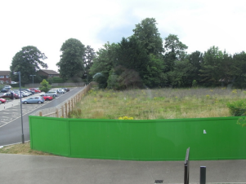

**Disclaimer:** Under the Property Misrepresentation Act 1967 and Property Misdescriptions Act 1991, these particulars do not from part of a contract. Chichester District Council give notice that (1) the particulars are set out as a general outline for guidance for intending purchasers and do not constitute, nor constitute part of, an offer or contract (2) all descriptions, dimensions, references to condition and necessary permission for use and occupation and other details are believed to be correct, but intending purchasers should not rely on them as statements or representations of fact, but must satisfy themselves by inspection or otherwise as to the correctness of each of them (3) no person in the employ of Chichester District Council has any authority to make or give any representation or warranty whatever in relation to this property.

**Method of Sale**

This is an informal tender process. Offers received for the site will be assessed against the strength of the financial bid (50%), the number of affordable homes provided (40%) and the evidenced ability of the bidder to deliver a complimentary mixed-use scheme (10%).

Any offer received is subject to the consideration and approval of the Councils Cabinet. The Council also reserves the right to withdraw the site from the market at any time.

Details of offers made will not be disclosed, nor will the District Council be under any obligation to discuss the reason for the acceptance or rejection of any offer until it becomes publicly available information.

**Submission of Offers**

Offers are to be made using the Grange Site Offer Form, which is available on request from the Estates Service, contact details as below. Bidders may submit a single offer, either for the site alone or to include the additional area, which would be subject to the caveats detailed above.

**Further Information**

For further information please contact:

Estates Team, Chichester District Council

Telephone: 01243 534632

Email: [property@chichester.gov.uk](mailto:property@chichester.gov.uk)

**Closing Date/Time**

Offers to be submitted no later than 12 noon on **Monday 8th December 2025**.

Header Banner - Development Opportinity : Land at The Grange, Midhurst, West Sussex

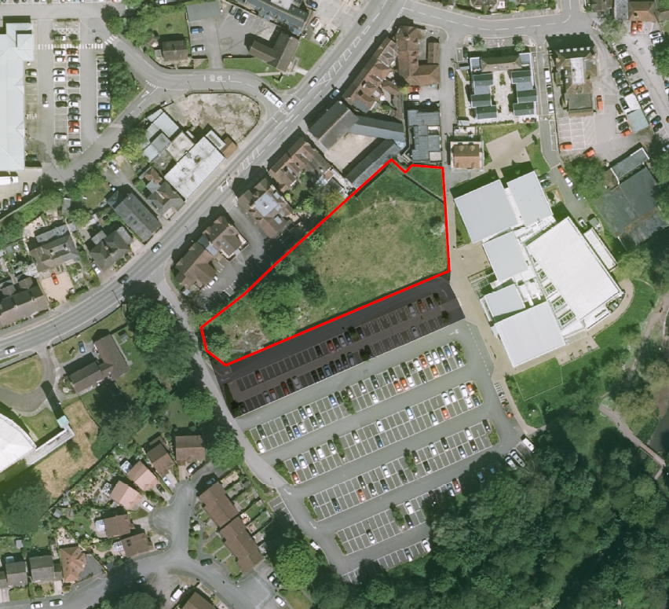

Images used with permission – Crown copyright and database rights 2025. Ordnance survey (AC0000822437)

& Christopher Ison Photography

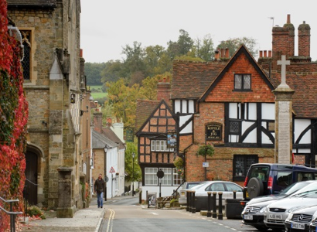 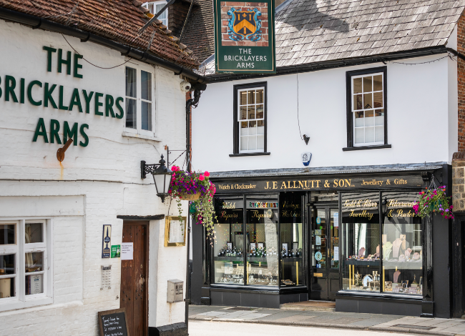

**Disclaimer:** Under the Property Misrepresentation Act 1967 and Property Misdescriptions Act 1991, these particulars do not from part of a contract. Chichester District Council give notice that (1) the particulars are set out as a general outline for guidance for intending purchasers and do not constitute, nor constitute part of, an offer or contract (2) all descriptions, dimensions, references to condition and necessary permission for use and occupation and other details are believed to be correct, but intending purchasers should not rely on them as statements or representations of fact, but must satisfy themselves by inspection or otherwise as to the correctness of each of them (3) no person in the employ of Chichester District Council has any authority to make or give any representation or warranty whatever in relation to this property.