|  |  |  |
| --- | --- | --- |
|  |  |  |

##### Local Development Scheme 2025-2028



###### 

###### [www.chichester.gov.uk](http://www.chichester.gov.uk/) Revised April 2025

###### Contents

|  |  |  |
| --- | --- | --- |
| 1 | Introduction | 2 |
| 2 | Geographical Coverage of the Chichester Local Plan | 3 |
| 3 | The Planning System | 4 |
| 4 | The Current Development Plan | 5 |
| 5 | Interim Statements | 7 |
| 6 | Development Plan Documents – Timetable | 8 |
| 7 | Other Documents | 13 |

1. **Introduction**
   1. The Local Development Scheme (LDS) identifies and timetables the planning documents that the council will prepare to plan for development in its area. Section 15 of The Planning and Compulsory Purchase Act 2004 (as amended by Section 111 of the Localism Act 2011) requires local planning authorities to prepare, maintain and publish an LDS. This enables local communities and stakeholders to find out which planning documents are to be prepared for the area within a rolling three-year timeframe. This LDS covers the period from 2025–2028 and updates the previous LDS published in July 2024.
   2. This LDS reflects the progress made in preparing the Local Plan. It provides information on the future Development Plan Documents (DPDs) that the council intends to produce, as well as a timetable for their production. However, it should be noted that the timetable for the review of the Local Plan required following the adoption of the emerging Local Plan 2021 – 2039 will be set out in an update to the LDS following adoption of the Local Plan. This is due to the uncertainty over the timetable to adoption of the Local Plan combined with the lack of detail on the timing of and details of the new plan-making procedures that the council will be required to use.

1.3 The LDS has two purposes:

* It enables the local community and stakeholders to find out about existing planning policies for their area; and
* It sets out the timetable for the update of and preparation of new local plan policies including key production and public consultation stages for development plan documents.
  1. The LDS will be published and kept up to date on the council's website:  
     [www.chichester.gov.uk/planningpolicy](http://www.chichester.gov.uk/planningpolicy).

1. **Geographical Coverage of the Chichester Local Plan**

2.1 The Local Plan covers Chichester District excluding the area within the South Downs National Park (SDNP) (see map 2.1). The South Downs National Park Authority is the Local Planning Authority for the SDNP area.

**Map 2.1 Local Plan Area**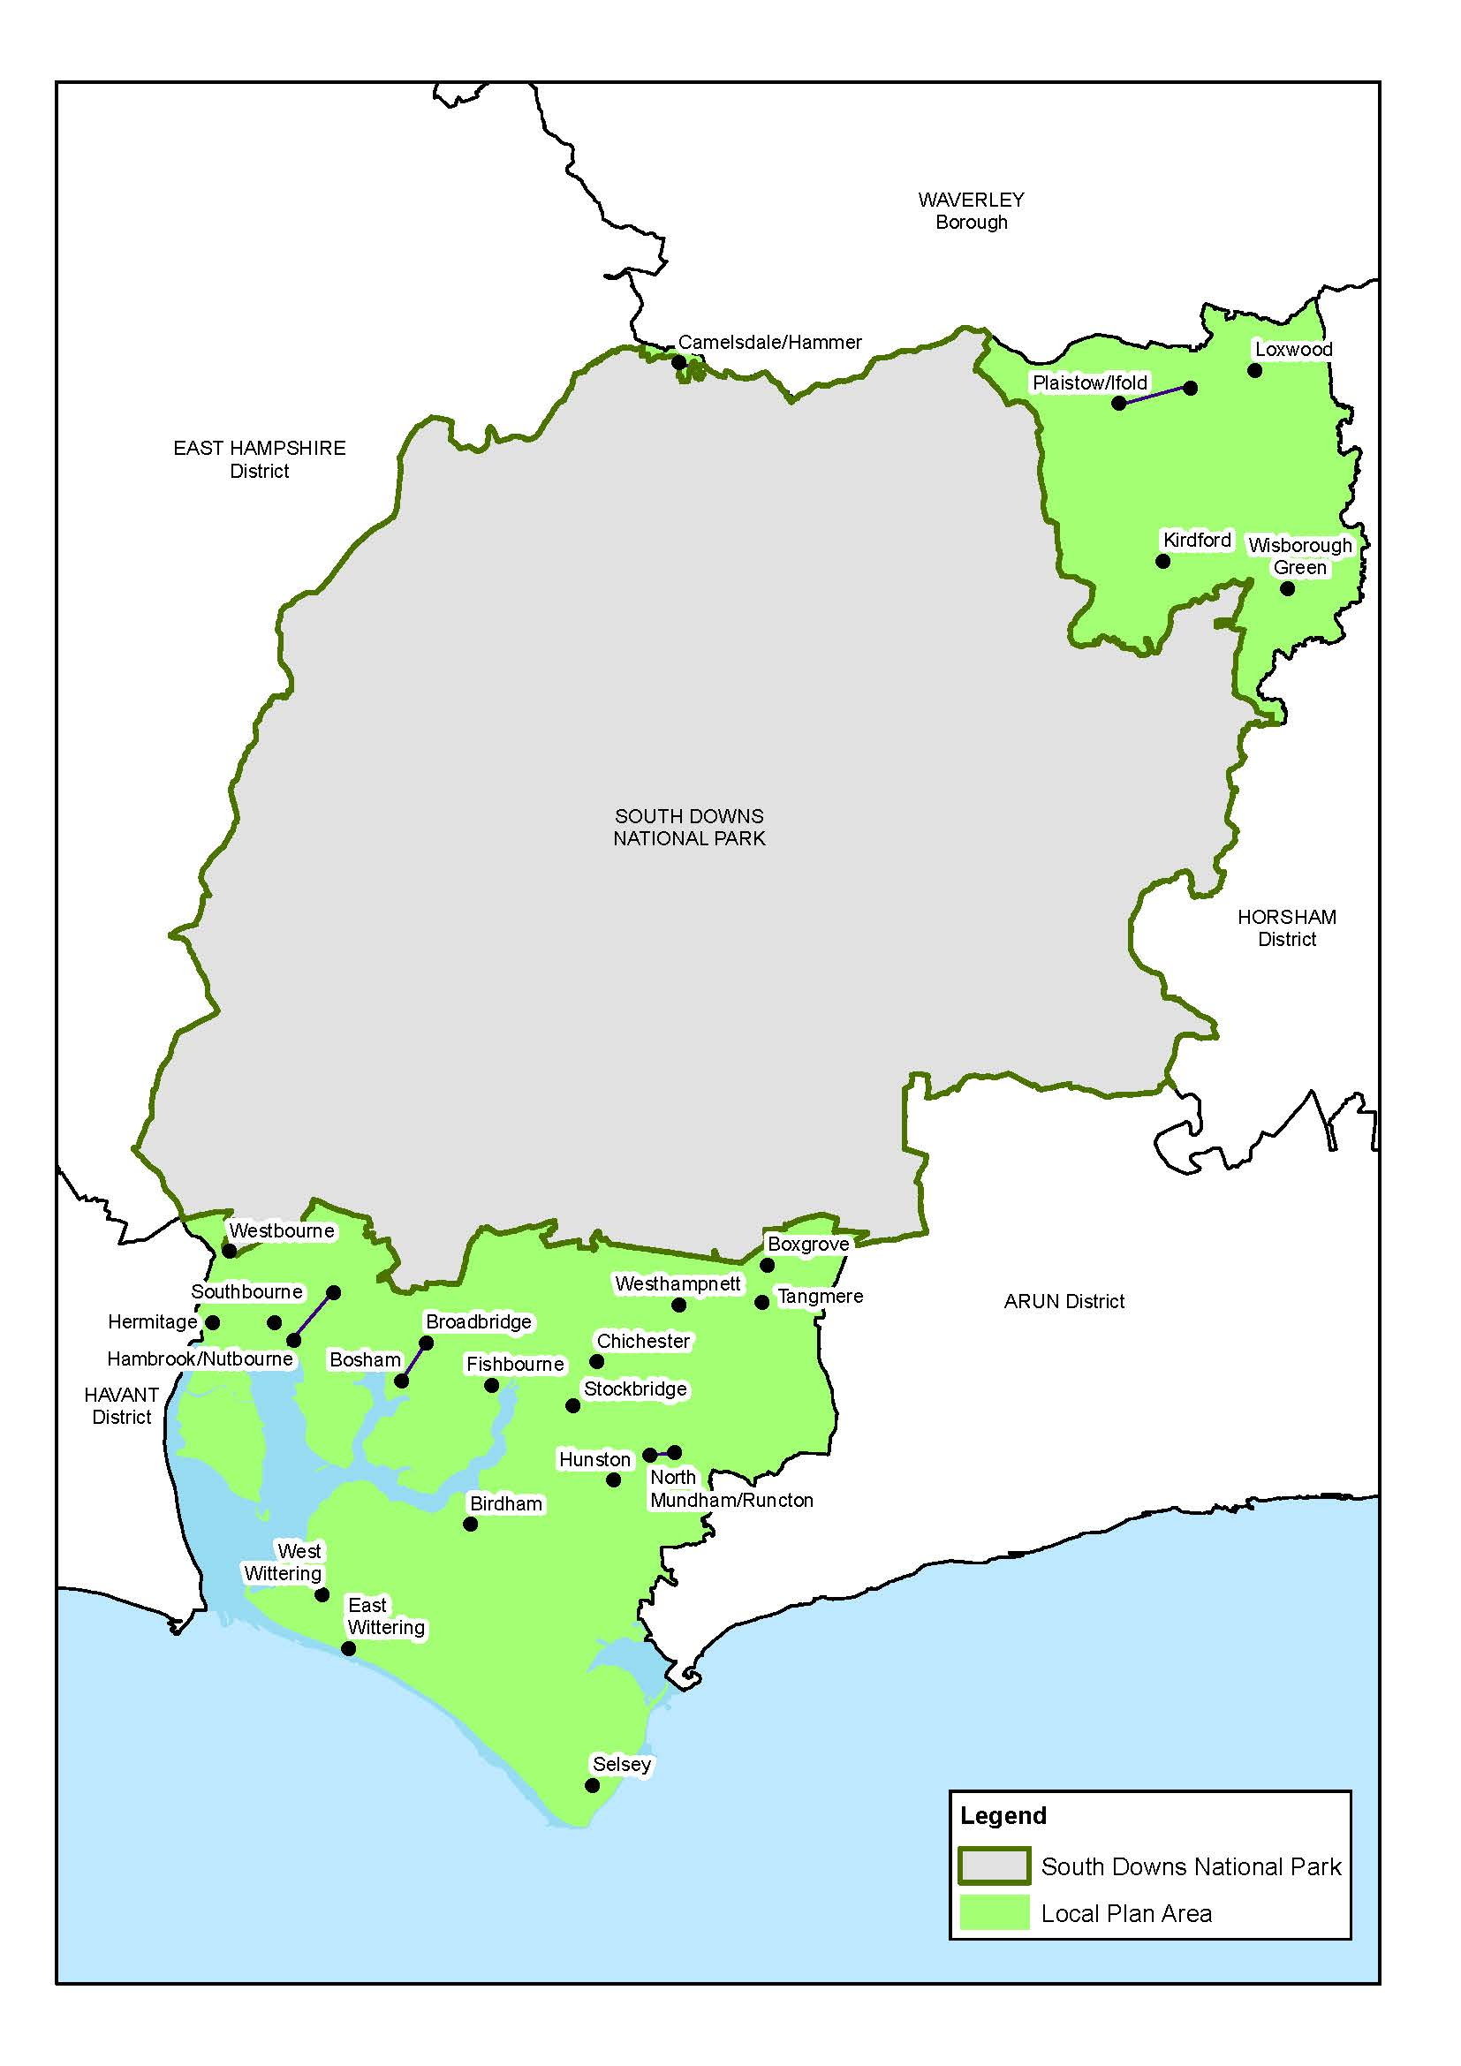

1. **The Planning System**

3.1 The National Planning Policy Framework (NPPF) was last updated on 19 December 2024. The revisions in the December 2024 NPPF included a new standard method for calculating the housing need for an area and also included transitional arrangements for local plans currently at examination and ‘part 2’ plans that sit underneath them. Under these transitional arrangements the emerging Local Plan 2021 – 2039 will continue progression through examination under the September 2023 NPPF and the council can also continue to produce the Southbourne DPD and a Site Allocation DPD (which are ‘daughter’ or ‘part 2’ documents to the emerging Local Plan).

3.2 Whilst the NPPF is a material consideration in decision making, the weight given to it relative to the development plan is left to the decision taker. The NPPF confirms that the planning system is “plan-led” which means that planning applications must be determined in accordance with the development plan unless material considerations indicate otherwise.

3.3 The NPPF also confirms that the policies in emerging plans will gather more weight as development plans progress towards adoption.

3.4 The Planning Practice Guidance web-based resource provides more detailed guidance to the NPPF. It is an indication of the Secretary of State's views and is intended to assist practitioners. Planning practice guidance is currently, where necessary, being updated to reflect changes to the National Planning Policy Framework.

1. **The Current Development Plan**

4.1 On publication of this LDS in March 2025, the development plan will comprise:

* Chichester Local Plan: Key Policies 2014-2029
* Site Allocation Development Plan Document 2014-2029
* West Sussex Waste Local Plan April 2014
* West Sussex Joint Minerals Local Plan July 2018 (Partial Review March 2021)
* Kirdford Parish Neighbourhood Development Plan 2014 *(joint with South Downs National Park Authority)* July 2014
* Loxwood Parish Neighbourhood Plan 2013-2029 March 2015
* Fishbourne Neighbourhood Plan 2014-2029 Post Examination Version February 2016
* Birdham Parish Neighbourhood Plan Post Examination Version March 2016
* Tangmere Parish Neighbourhood Plan 2014-2029 Post Examination Version March 2016
* Wisborough Green Post Examination Version Neighbourhood Plan 2014-2029 March 2016 *(joint with South Downs National Park Authority)*
* Chidham and Hambrook Parish Council Neighbourhood Plan 2015 Post Examination Version June 2016
* Bosham Parish Neighbourhood Plan 2014-2029 Post Examination Version September 2016
* Lavant Neighbourhood Development Plan 2016-2031 *(joint with South Downs National Park Authority) July 2017*
* Petworth Neighbourhood Plan 2015-2033 *(joint with South Downs National Park Authority)* July 2018
* Selsey Neighbourhood Plan 2014-2029 Referendum Issue May 2021
* Boxgrove Submission Neighbourhood Development Plan 2017-2029 Referendum Version *(joint with South Downs National Park Authority)*
* Westbourne Neighbourhood Plan 2017-2029 Post Examination Version June 2021 *(joint with South Downs National Park Authority)*
* West Wittering Neighbourhood Plan 2019-2029 Post Examination Version October 2023
* Southbourne Modified Neighbourhood Plan 2014-2029 Referendum Modified Plan November 2023

4.2 The preparation of neighbourhood development plans (NDPs) are not compulsory, however, when 'made', they are a statutory document which forms part of the development plan. NDPs put in place policies to guide the future development of the neighbourhood plan area. They can be produced by town and parish councils in consultation with their communities. It should be noted that a number of parishes are currently progressing new neighbourhood plans or neighbourhood plan reviews, and when the neighbourhood plans are ‘made’, they will also form part of the development plan – more information is available on individual parish websites and the neighbourhood planning page on the council’s website listed below. The council has a legal duty to support the preparation of any NDP, which must generally conform with the NPPF and ‘strategic policies’ in the Local Plan. Prior to its adoption, it must be subject to a referendum. If over 50% of the votes are in favour, the local planning authority has a duty to ‘make’ the NDP.

##### 4.3 There are 25 Neighbourhood Plan Designated Areas in the local planning authority area. Further information on neighbourhood planning can be found via [www.chichester.gov.uk/neighbourhoodplan](http://www.chichester.gov.uk/neighbourhoodplan).

1. **Interim Statements**

5.1 The council has produced an Interim Position Statement for Housing which will help guide development in the Local Plan area until the new Local Plan is adopted. The Statement does not include areas within the South Downs National Park as these areas are subject to a separate plan undertaken by the South Downs National Park Authority (SDNPA). The Interim Position Statement draws together the adopted and emerging Local Plan polices to outline the types of new residential development that the council would support within the Local Plan area. The Statement is designed to assist potential applicants in understanding the sorts of proposals that would be considered appropriate.

1. **Development Plan Documents (DPDs) – Timetable**

6.1 The following tables set out the DPDs that the council will prepare over the next three years to 2028.

6.2 A profile for each document is provided below, setting out the scope of the document and the proposed timetable for preparation. The timetable will be kept under review and will be regularly updated, including an update once the emerging Local Plan 2021 – 2039 is adopted. The timetable uses meteorological seasons as follows: Winter (Dec, Jan, Feb), Spring (Mar, Apr, May), Summer (Jun, Jul, Aug) and Autumn (Sept, Oct, Nov).

**Chichester Local Plan 2021 - 2039**

|  |  |
| --- | --- |
| **Overview** | |
| Role and Subject | The new Chichester Local Plan document will provide the overall planning framework for the Local Plan area for the period to 2039. It will set out the overall strategy for the whole plan area and strategic and development management policies. It will provide the policy context for neighbourhood and other community-led planning documents. Revisions to the Policies Map have been submitted with the Chichester Local Plan document. |
| Geographical Area | Chichester District, outside of the South Downs National Park. |
| Status | Development Plan Document. |

|  |  |
| --- | --- |
| **Key milestones:** | **Dates** |
| Approval of consultation on strategy options | Cabinet - June 2017 Council - June 2017 |
| Consultation on strategy options | June - August 2017 |
| Approval of Preferred Approach DPD for consultation | Cabinet - November 2018 Council - November 2018 |
| Consultation on Preferred Approach (Reg 18) | December 2018 –  February 2019 |
| Approval of Statutory Public Consultation DPD for consultation (Publication) | Cabinet – 23 January 2023  Council – 24 January 2023 |
| Statutory Public Consultation document (Reg 19) (Publication) | 3 February – 17 March 2023 |
| Submission to Secretary of State | 3 May 2024 |
| Examination Hearings | Autumn 2024 |
| Adoption | Summer 2025 (as the plan is currently at examination, this timetable is dependant on the outcomes of the examination) |

6.3 Strategic development at Southbourne, proposed within the Local Plan 2021 - 2039, will be progressed by delivery of a Development Plan Document to allocate site/s at this location.

**Southbourne Allocation Development Plan Document**

|  |  |
| --- | --- |
| **Overview** | |
| Role and Subject | The Southbourne Allocation DPD will allocate land to deliver the policy requirements set out in Policy A13 of the Local Plan 2021 - 2039, namely mixed-use development comprising a net of approximately 800 dwellings (the gross BLD number of 1,050 dwellings minus extant permissions from 1 April 2021 – 31 January 2025), local employment opportunities and supporting community uses and facilities within the identified Broad Location for Development (BLD). The DPD will also address accommodation for gypsy and travellers, self and custom build housing and other specialised housing needs. Reviews of the BLD and landscape gap boundaries will be undertaken. |
| Geographical Area | BLD within Southbourne Parish. |
| Status | Development Plan Document. |

|  |  |
| --- | --- |
| **Key milestones:** | **Dates** |
| Approval of draft Southbourne Allocation DPD for consultation | Autumn 2024 |
| Consultation on draft DPD (Reg 18) | Autumn 2024 |
| Approval for Statutory Public Consultation on Southbourne Allocation DPD (Publication) | Autumn 2025 |
| Statutory Public Consultation on Southbourne Allocation DPD (Reg 19) (Publication) | Autumn 2025 |
| Submission to Secretary of State | Winter 2025/26 |
| Examination Hearings | Spring 2026 |
| Adoption (anticipated) | Summer 2026 |

6.4 A further Development Plan Document will accompany the new Local Plan. This will allocate land for any residual development needs identified, but not allocated, within the new Local Plan or neighbourhood plans, such as for housing, gypsy and traveller sites, and other matters.

**Local Plan Site Allocation Development Plan Document**

|  |  |
| --- | --- |
| **Overview** | |
| Role and Subject | The Local Plan Site Allocation DPD will allocate land for any residual development needs identified in the Local Plan 2021 - 2039 but not allocated within the Local Plan. Allocations may be necessary for housing, accommodation for gypsy and travelling showpeople, self and custom build housing, specialist accommodation, landscape gaps and local green space designations. It covers the Plan area. The Site Allocation DPD will also review Settlement Boundaries, where appropriate, in line with the Chichester Local Plan. |
| Geographical Area | Chichester District, outside of the South Downs National Park. |
| Status | Development Plan Document. |

|  |  |
| --- | --- |
| **Key milestones:** | **Dates** |
| Approval of Site Allocation DPD for consultation | Spring 2026 |
| Consultation on Site Allocation DPD (Reg 18) | Summer 2026 |
| Approval for Statutory Public Consultation on Site Allocation DPD (Publication) | Autumn 2026 |
| Statutory Public Consultation on Site Allocation DPD (Reg 19) (Publication) | Autumn/Winter 2026 |
| Submission to Secretary of State | Winter 2026/27 |
| Examination Hearings | Spring 2027 |
| Adoption (anticipated) | Summer/Autumn 2027 |

**Local Plan review (new)**

6.5 In line with the transitional arrangements set out in the NPPF (December 2024) the council are required to begin work on a new plan under the revised plan-making system as soon as the provisions are brought into force in 2025, which will require new or amended secondary legislation.

|  |  |
| --- | --- |
| **Overview** | |
| Role and Subject | The new Chichester Local Plan will provide the overall planning framework for the Local Plan area for a period of at least 15 years, following adoption of the Local Plan 2021 - 2039. It will set out the overall strategy for the whole plan area and strategic and development management policies (excluding those to be replaced by national development management policies). It will include site allocations. It will provide the policy context for neighbourhood and other community-led planning documents. Revisions to the Policies Map will also be required. |
| Geographical Area | Chichester District, outside of the South Downs National Park. |
| Status | Development Plan Document. |

|  |  |
| --- | --- |
| **Key milestones:** | **Dates** |
| To be confirmed once new plan making system is in place and following adoption of Local Plan 2021 - 2039 | TBC |

6.6 In addition to the above, Supplementary Planning Documents or Supplementary Plans (under the new plan making system) will be brought forward as and when appropriate. Supplementary Planning Documents (SPD) are not required to be formally identified in the Local Development Scheme – but details of forthcoming consultations will be advertised in the usual way. Any Supplementary Plans to be produced under the new system will be set out in a future update to the LDS, as they are required to be included.

1. **Other Documents**

**Policies Map**

7.1 The Policies Map, which is available online, identifies policy designations, proposals, and sites allocated for particular land uses in the Chichester Local Plan. It is updated as the following documents are adopted or made:

* Chichester Local Plan;
* Southbourne Allocation DPD
* Site Allocation DPD;
* Neighbourhood Development Plans.

**Community Infrastructure Levy**

7.2 The CIL Charging Schedule sets out standard charge(s) that the Council levies on specified types of development to contribute towards required infrastructure. It applies to Chichester District with the exception of the area covered by the SDNP. It is supported by the Infrastructure Delivery Plan, which shows what infrastructure is needed within the Plan area over the lifetime of the Plan, when it is needed and how much it will cost.

7.3 The CIL Charging Schedule and Planning Obligations and Affordable Housing SPD were adopted by the Council in January 2016 and came into force on 1 February 2016.

7.4 Both the CIL Charging Schedule and the Planning Obligations and Affordable Housing SPD will require review and possible amendment in the light of the development proposed in the Local Plan, the contents of the Infrastructure Delivery Plan and the Whole Plan Viability Assessment (evidence base documents to support the Local Plan). At the current time the precise timescales for these reviews are uncertain. The LDS will be updated when they have been determined.

**Statement of Community Involvement**

7.5 The Statement of Community Involvement (SCI) was adopted by the Council on 23 January 2024. It sets out the methods of consultation to be used for the various public consultation stages in the preparation of local plan documents and for development management consultations.

**Brownfield Land Register**

7.6 The Council is legally required to prepare, maintain and publish a register of brownfield (previously developed) land within the District. The brownfield land register aims to provide publicly available information on all brownfield sites which the council considers are appropriate for residential development. The register will be used to monitor the government’s commitment to the delivery of brownfield sites. The current version is published on the council’s website at the following link: [Brownfield Land Register](http://www.chichester.gov.uk/article/29787/Brownfield-land-register).

**Sustainability Appraisal incorporating Strategic Environmental Assessment**

7.7 A Sustainability Appraisal (incorporating Strategic Environmental Assessment) will be undertaken for all DPDs, and where required for SPDs. This will ensure that the social, economic and environmental effects of policies are understood and fully taken into consideration. This is particularly important in the appraisal of reasonable options. A Sustainability Appraisal report will accompany each published stage of a DPD, including the final submission version.

**Appropriate Assessment**

7.8 A Habitats Regulations Assessment (HRA) is undertaken during the production of a DPD to assess whether the policies and proposals will have a significant effect on the integrity of sites of European importance. The HRA is updated to assess any fundamental changes or amendments to the DPD and will be published at each stage of the production of a DPD.

**Monitoring and Review – The Authority’s Monitoring Report**

7.9 Local planning authorities are required to publish a report that monitors the  
implementation of the LDS and whether adopted planning policies are delivering their objectives. The current version is published on the council’s website at the following link: [Local Plan Monitoring](http://www.chichester.gov.uk/article/29753/Local-plan-monitoring).

**Evidence Base**

7.10 A number of studies are prepared to support the evidence base for the new Chichester Local Plan. Other evidence is being or will be prepared to support DPDs as relevant. These will either be published on the council’s website or, where too large to be published this way, will be made available in an alternative format.

**Duty to Cooperate**

7.11 Procedures/protocols are being put in place under the ‘duty to cooperate’, which show how local authorities and other public bodies have cooperated with each other in the production of DPDs, particularly where the issues span across district council boundaries. The council will continue to work with the other members of the West Sussex and Greater Brighton Strategic Planning Board on strategic planning issues, particularly those focusing on housing, economic growth and infrastructure. In addition, the council will collaborate with other authorities on specific issues as necessary.

**Council Procedures and Reporting Protocols**

7.12 The preparation of DPDs will be informed and monitored by the council through:

* The council’s Strategic Leadership Team headed by the Chief Executive;
* The council’s Development Plan and Infrastructure Panel which comprises

the Leader of the Council, the Planning Portfolio holder, and other councillors;

* The council’s Cabinet; and
* The full Council

to include formal consideration of the submission version of the Local Plan and other DPDs, to agree submission to the Secretary of State and to adopt following receipt of the Inspector’s report.

**Resources**

7.13 The council currently has a well-resourced Planning Policy team including the Planning Policy Divisional Manager supported by a Planning Policy Team Manager and a range of Principal Planning Officers and Planning Policy Officers. In addition, the team includes dedicated staff resources to collect, monitor and manage the Community Infrastructure Levy and funds secured through S106 planning obligations.

**Risk Assessment**

7.14 Contingency arrangements will be put in place in the event that insufficient resources are available to progress the DPDs in line with this LDS. For example, staff shortages may occur through sickness, or through job turnover. Contingency actions are as required:

* Additional legal resources may be required to be procured in periods of heavy workload;
* Consultants may be appointed on short-term contracts to undertake specialised technical studies;
* Joint working will take place with neighbouring authorities where deemed appropriate, which will help spread the workload;
* Staff from elsewhere in the council may be required to help out with matters, for example, publicity and consultation, and inputting responses to public consultations;
* Advice on procedural matters may be sought from the Planning Advisory Service and the Planning Inspectorate; and
* Implementation of the council’s Business Continuity Plans.