# Let's talk climate change logo New Climate Emergency Action Plan consultation process and feedback

## Introduction to the Consultation Process

A survey and consultation web hub were created to capture people’s views on a range of potential climate change proposals to help individuals and organisations in the district to reduce their carbon emissions. The consultation was live between 1 July and 30 September 2024.

The survey was available online, in a hard-copy format on request, and was included as a five-page article within the Summer issue of the council’s residents magazine, initiatives. The magazine was delivered direct to the doorstep of every home and business in the district.

The survey enabled respondents to comment specifically on the proposals, as well as give their views on the council’s target to reduce its own emissions. To help people get involved in the consultation, Frequently Asked Questions were included on a dedicated consultation web page to provide background, context and definitions of key terms used in the survey. Here, respondents could easily find links to the survey in which they could share their views.

The council’s new consultation platform, Collaborate, in which we were involved in the design to ensure it met the council’s needs, was used to create the survey. The platform enabled us to use videos - created in-house - to simplify the complex proposals being consulted on. Using this platform made the consultation more accessible, easier to use, and engaging, and we feel this helped increase the response rate significantly.

Branding for the consultation was updated, building on existing and recognised branding, to promote the consultation in a variety of ways. In-person and online consultation events were organised and heavily promoted to provide residents, businesses and organisations the opportunity to find out more and ask questions. These included events targeting younger people. A full list of promotions and details about the events is available in Section 12.

## Consultation headlines

**1,382 people visited our survey** during the consultation period, almost seven times the number of the previous consultation in 2020. 78% of survey responses (1,075) were marked as complete. This was one of the best responses that the council has ever seen. A comparable survey, conducted recently by a neighbouring council about their Climate Change Strategy, received 757 responses.

10 respondents said their response represented more than one person. These 10 responses represented 444 individuals.

## Section 1: Our council emissions target

Firstly, we asked respondents whether they agreed with the council’s approach to reduce council emissions to net zero by 2050.

Of those that responded to this question, the majority felt that the **target should be earlier** than 2050 (**41%** or 436 responses). **38%** (407) agreed with the council’s approach, and **6%** (61) thought the target should be later than 2050.   
  
**10%** (104) didn’t agree with the council setting a target at all, whereas **5%** (52) felt that the council should set a different type of target.

### Graph 1 Question 1.2: We’re aiming to reduce council emissions to net zero by 2050. This is in line with the Government’s national target. Do you agree with this approach?

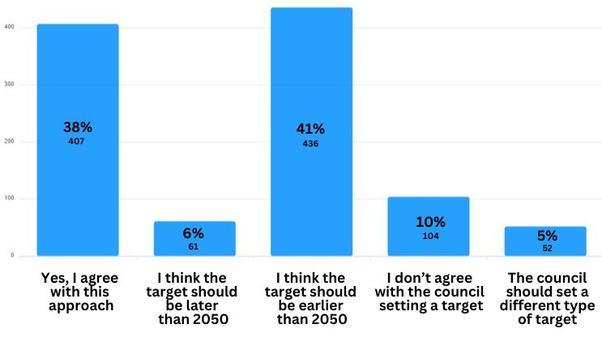

Respondents were then asked for comments. These are categorised below. As a respondent’s comments may fall into more than one category, percentages are not shown. This applies to other tables in the report where respondents’ comments are analysed.

### Table 1: Analysis of responses to Question 1.2 asking for comments on setting a 2050 net zero target

|  |  |
| --- | --- |
| **Themes** | **Count** |
| Supportive of the whole approach | 263 |
| Concerns about the high cost that will be incurred | 56 |
| Does not agree with the target setting approach | 23 |
| Net Zero or climate change is a hoax/ con | 23 |
| As a wealthy area, the Council should set example | 21 |
| Other countries emit more than UK. They need to be more responsible | 20 |
| Need to also involve businesses | 15 |
| Target setting is not the Council's job | 13 |
| No Comment or Don't Know | 9 |
| Need to work with other countries in meeting the targets | 3 |
| Setting the targets will negatively affect the poorest | 3 |
| Need to ensure pollution not shifted to another country | 2 |

## Section 2: High-cost proposals

Respondents were asked whether they would like to rank a series of high-cost proposals (estimated to cost more than £50,000 per proposal). **73%** of people who answered this question said they would like to prioritise the proposals (575). **14%** (109) said they didn’t want to prioritise the proposals and **13%** (106) said that they didn’t agree with the proposals.

Respondents that said they would like to prioritise the proposals were then presented with a list of 5 options that they could put into order before confirming their rankings. A video was created to explain the proposals. **575** respondents ranked these proposals.

Points were awarded in the following way: 5 for a first place ranking, 4 for a second place, 3 for a third, 2 for a fourth and 1 for a fifth. The number of points each proposal got was then added. The number of first place rankings is shown for comparison.

### Table 2: Ranking of High-Cost Proposals

|  |  |  |
| --- | --- | --- |
|  | **Total points** | **No. of first place rankings** |
| Home decarbonisation - increased focus on able-to-pay households | 2322 | 233 |
| Local Area Energy Plan | 2242 | 217 |
| Land-based offset scheme | 1615 | 42 |
| Marine-based carbon offset scheme | 1462 | 56 |
| Expanded pay-as-you-go community car hire | 984 | 27 |

Respondents had the opportunity to comment on each proposal. These comments are categorised in Tables 3-7. Some people made comments that fell into more than one category.

### Table 3: Question 9.2.a Comments on “Local Area Energy Plan”

|  |  |
| --- | --- |
| **Themes** | **Count** |
| Use renewable energy sources | 7 |
| Comments on other topics | 7 |
| Do concrete actions. No more reports. | 4 |
| Not working fast enough | 2 |
| Greenwashing | 2 |
| Waste of money | 2 |
| Integrate with Regional Energy Strategic Plans | 1 |
| Concern about local energy distribution and lack of supplier choice | 1 |

### Table 4: Question 9.2.b Comments on “Strategy to help reduce the environmental impact from housing”

|  |  |
| --- | --- |
| **Themes** | **Count** |
| Solar panels and better insulation should be mandatory | 9 |
| No comment | 3 |
| Need innovative funding or crowdsourcing | 1 |
| Need to fit with central government initiatives | 1 |
| Need to clean rivers | 1 |
| Convert lamp posts to electric car charging post | 1 |
| Would love to collaborate on this | 1 |
| Need to care more for biodiversity | 1 |
| Suggest to work with existing initiatives like Eliq and Snugg | 1 |

### Table 5: Question 9.2.c Comments on “Land-based carbon offset schemes”

|  |  |
| --- | --- |
| **Themes** | **Count** |
| Disagree with offsetting | 7 |
| Supportive of this initiative | 3 |
| Does not believe the existence of climate change | 2 |
| Change farming practices | 1 |

### Table 6: Question 9.2.d Comments on “Marine-based carbon offset schemes”

|  |  |
| --- | --- |
| **Themes** | **Count** |
| Offsetting scheme is faulty | 6 |
| Supportive of this initiative | 2 |
| Unclear about the intended audience of the video | 1 |

### Table 7: Question 9.2.e Comments on “Pay-as-you-go community car hire scheme (car club)”

|  |  |
| --- | --- |
| **Themes** | **Count** |
| Waste of money | 4 |
| Scheme needs more publicity | 2 |
| Too Chichester city-focused | 2 |
| Need more focus on bike safety | 1 |

## Section 3: Medium-cost proposals

We then asked respondents to rank medium-cost proposals (estimated to cost between £5,000 and £50,000 per proposal). **73%** of peoplethat answered this question agreed to rank the proposals(588), **15%** (120) said they didn’t want to prioritise the proposals, and **13%** (102) said that they didn’t agree with the proposals.

Respondents that said they would like to help prioritise the proposals were then presented with a list of four options that they could put into order before confirming their rankings. A video was provided explaining the options.

Points were awarded in the following way: 4 for a first place ranking, 3 for a second place, 2 for a third, 1 for a fourth. The number of points each proposal got was then added. The number of first place rankings is shown for comparison.

**588** respondents ranked these proposals.

### Table 8: Ranking of Medium-Cost Proposals

|  |  |  |
| --- | --- | --- |
|  | **Total points** | **No. of first place rankings** |
| Tree Strategy Officer | 1825 | 247 |
| Greater focus on adaptation | 1636 | 235 |
| Cycle route feasibility study | 1257 | 64 |
| Secure cycle storage | 1162 | 42 |

Respondents could comment on individual proposals. The comments are categorised below.

### Table 9: Question 9.2.f Comments on “Fund a tree officer that helps increase tree planting across the district”.

|  |  |
| --- | --- |
| **Themes** | **Count** |
| Supportive of tree planting | 11 |
| Waste of money | 2 |
| Need tree policy | 2 |
| Need water management | 2 |
| Supportive but not for offsetting purposes | 2 |
| Need farmers and large landowners’ engagement plan on climate change | 1 |

### Table 10: Question 9.2.g Comments on “Fund a study to identify part of a new cycling wheeling and walking route through Oaklands Park in Chichester”

|  |  |
| --- | --- |
| **Themes** | **Count** |
| Focus on places outside of Chichester | 10 |
| Oaklands Park is not appropriate for this scheme | 6 |
| More action and less research | 4 |
| Waste of money | 3 |
| Instead invest in better public transport | 3 |

### Table 11: Question 9.2.h Comments on “Fund secure cycle storage units”

|  |  |
| --- | --- |
| **Themes** | **Count** |
| Needed because expensive bikes get stolen | 7 |
| The amount planned is not ambitious enough | 3 |
| Waste of money | 3 |
| No need, just need good locks | 2 |
| The city itself is not bike-friendly | 2 |
| Improve motorbike parking as well | 1 |

### Table 12: Question 9.2.i Comments on “To place a greater focus on projects that help the district to better cope with changing weather patterns”

|  |  |
| --- | --- |
| **Themes** | **Count** |
| Avoid unnecessary reports, plans, and consultants | 1 |
| Explore diverse solutions: tree planting, meadow rewilding, rain gardens, wetland/marsh creation | 1 |
| Climate change impacts West Sussex; increased support for residents required | 1 |
| Developers should include Sustainable Urban Drainage Schemes | 1 |
| Insufficient context; cannot determine impact or staffing needs | 1 |
| Excessive rainfall since Oct 2023 caused road issues | 1 |
| Importance of district-wide strategy to prepare for climate change impacts | 1 |
| Need to adapt to weather/climate change | 1 |
| Prioritise habitat restoration over development | 1 |
| Coastal villages face rapid climate change impacts | 1 |

## Section 4: Low-cost proposals

In this section, we explained that the council had identified a series of low-cost proposals (estimated to cost less than £5,000 per proposal) that could potentially be used in our new Climate Emergency Action Plan. A video was created to explain the proposals.

We **asked whether people would like to help us prioritise these proposals**, and **74%** of peoplethat answered this question said **‘yes’** (639). **14%** (123) said they didn’t want to prioritise the proposals and **11%** (97) said that they didn’t agree with the proposals. Respondents that said they would like to help prioritise the proposals were then presented with a list of eight options that they could drag and drop into the right order before confirming their rankings. **638** respondents ranked these proposals.

Points were awarded in the following way: 8 for a first place ranking, 7 for a second place, 6 for a third, 5 for a fourth, etc. The number of points each proposal got was then added. The number of first place rankings is shown for comparison.

### Table 13: Ranking of Low-Cost Proposals

|  |  |  |
| --- | --- | --- |
| **Proposal** | **Total points** | **No. of first place rankings** |
| Home decarbonisation | 4288 | 303 |
| Green travel plans | 3110 | 84 |
| Street tree planting policy | 2824 | 49 |
| Climate Champion community engagement | 2961 | 96 |
| Taxi and private hire licensing policy | 2712 | 29 |
| School climate change project | 2612 | 43 |
| Networking for public sector and community groups | 2502 | 22 |
| Template climate policies for community groups | 1959 | 12 |

Respondents were then given the opportunity to comment on the proposals. These comments are shown below.

### Table 14: Question 9.2.j Comments on “To create a network of community Climate Champions”

|  |  |
| --- | --- |
| **Themes** | **Count** |
| Does not support this initiative | 6 |
| Could be useful to increase awareness | 3 |

### Table 15: Question 9.2.k Comments on “To work with a school on a climate change project”

|  |  |
| --- | --- |
| **Themes** | **Count** |
| One school is not enough | 9 |
| Does not support this initiative | 2 |
| Good to educate children about climate change | 1 |
| Suggestion to look up a local writer on  climate change for children | 1 |
| Create event to clean the council area instead | 1 |
| Climate change is nonsense | 1 |

### Table 16: Question 9.2.l Comments on “To promote energy efficiency measures to reduce the environmental impact from housing making them warmer healthier and cheaper to run”

|  |  |
| --- | --- |
| **Themes** | **Count** |
| This scheme is essential | 6 |
| Grants need to be easily available | 4 |
| Reduce bureaucracy imposed by energy suppliers | 1 |
| Cost would be the principal concern for this scheme | 1 |
| Would like to collaborate on this. | 2 |
| Mandate developers to include energy efficient | 1 |

### Table 17: Question 9.2.m Project: To organise climate action networking events for public sector organisations and community groups

|  |  |
| --- | --- |
| **Themes** | **Count** |
| Waste of money | 5 |
| Good to spread information | 3 |
| Create event to clean the council area instead | 1 |

### Table 18: Question 9.2.n To introduce further steps to reduce emissions from taxis and private hire vehicles

|  |  |
| --- | --- |
| **Themes** | **Count** |
| Unnecessary and may be counter productive | 4 |
| Should also include buses | 3 |
| Need to transition to electric vehicles | 2 |
| Taxis/private hire vital for disabled, unsustainable journeys. Penalizing them counterproductive | 2 |
| No comment or don't know | 1 |
| Many taxis are not registered in CDC area | 1 |
| Focus on anti-idling is needed at bottle neck places | 1 |
| Taxi electrification will increase prices, harming ordinary people | 1 |

### Table 19: Question 9.2.o To provide template climate policies for community

### groups

|  |  |
| --- | --- |
| **Themes** | **Count** |
| Could be useful. Saves time and money | 3 |
| Critical of CDC – most proposals should have been in place years ago | 1 |
| Don't know or no comment | 1 |
| More parking encourages car use; need climate policy templates for parish councils | 1 |
| Community organisations do not have much impact | 1 |

### Table 20: Question 9.2.p To produce guidance on street tree planting schemes for new development

|  |  |
| --- | --- |
| **Themes** | **Count** |
| Need to put pressure on builders, developers and companies | 4 |
| Supportive but need constant management after planting | 2 |
| No comment or don't know | 1 |
| How to quantify CO2 impact and capture benefits over time for projects | 1 |

### Table 21: Question 9.2.q To explore options for green travel plans for new developments

|  |  |
| --- | --- |
| **Themes** | **Count** |
| Supportive of this scheme | 8 |
| Better cycling and walking infrastructure | 6 |
| Important but options should not be restricted to new developments | 3 |
| More fundamental questions need to be asked about new developments than green travel plans. | 2 |
| Electric car sharing schemes should be compulsory (or at least strongly advised) on larger housing estates | 2 |
| Supports ride sharing schemes | 2 |
| Need incentives for people to change to electric cars if they need a car at all | 1 |
| This needs to be 'carrot' not 'stick'. Restricting parking penalises possession, not use of a vehicle. | 1 |
| Cheaper transport using mini buses into town rather than a huge bus. | 1 |
| Facilities within walking distances | 1 |
| Building in established towns and villages would reduce the need for two car families | 1 |
| Reduce emissions by improving traffic flow | 1 |
| Fixed taxi fares | 1 |
| Monitor for developers for compliance | 1 |
| Developments accessible to public transport. | 1 |
| Park and ride | 1 |
| Shouldn’t just be for Chichester. | 1 |

## Section 5: Your home

This section asked questions relating to home retrofitting. To help respondents who may not be familiar with the term, we created a short video that was available to view at the top of the web page.

The first question in this section asked respondents to let us know of any organisations that they feel the council should be working with to help improve the energy efficiency of people’s homes. Organisations that were given are listed in Table 22.

### Table 22: Question 5.1 “Are there any organisations that you feel the council should be working with to help improve the energy efficiency of people's homes?”

|  |  |
| --- | --- |
| Act on Energy | Guildford Zero |
| Age UK | Harvest UK |
| Bristol Wind Generation Group | Hyde Housing Association |
| British Gas | Insulate Britain |
| CAB | Loop |
| Centre for Sustainable Energy | Meadow Blue solar farm |
| Chichester College | National Energy Action |
| Citizens Advice Arun & Chichester | National Energy Foundation (SuperHomes) |
| Clarion Housing Association | Octopus Energy |
| Community Energy South | Portsmouth Water |
| EDF Energy | Ripple Energy |
| Eliq | Snugg |
| Energise South Downs | Solar Energy Services Ltd |
| Energy Saving Trust | Transition Chichester |
| Great British Insulation Scheme | Trussell Trust |
| Greening Westbourne | West Sussex County Council |

We then asked whether there were **any factors that put respondents off installing measures to make their homes more energy efficient or from using renewable energy**. Respondents could select one or more factors from several options and/or tell us about a different factor by selecting ‘other’.

**698 respondents** answered this question, and the **most common factor was ‘it is too expensive’ (388),** followed by ‘I don’t know how to find a trusted installer’ (203) and then ‘I don’t know enough about retrofitting, but I want to know more’ (199). The graph below breaks down the full results — as respondents could select more than one choice, percentages have not been included.

### Graph 2: Question 5.2 “Do any of the following factors put you off installing new measures to make your home energy efficient/use renewable energy?”

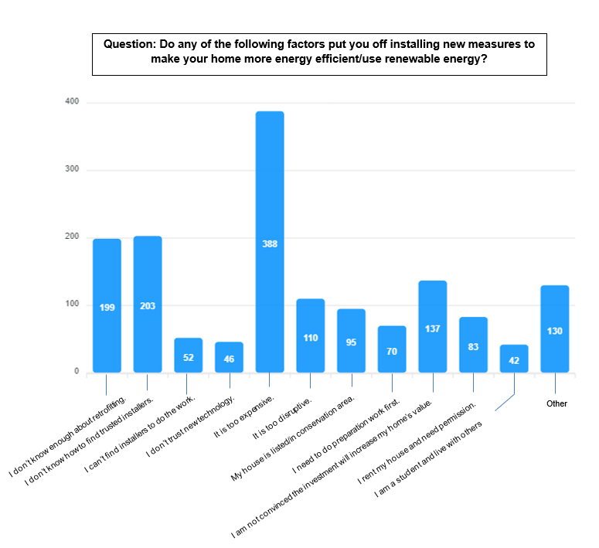

### Table 23: Question 5.2.a “Factors putting off retrofitting – other - please state”

|  |  |
| --- | --- |
| **Themes** | **Count** |
| Already retrofitted or energy-efficient | 29 |
| Too expensive | 19 |
| Building cannot be retrofitted | 16 |
| Retrofitting technology or evidence of effectiveness is still lacking | 6 |
| Too old to do anything | 6 |
| Wind turbine as alternative to heat pump | 6 |
| Plan to move out soon | 4 |
| Not eligible for grant | 4 |

## Section 6: Your local environment

This section included questions relating to some of the proposals discussed in previous sections of the survey. Respondents were given the opportunity to watch a video that recapped the relevant proposals.

We asked respondents for their views on our approach to tree planting should the decision be made to employ a Tree Strategy Officer.   
  
Two options were given and most respondents who answered this question **(60% or 417 respondents) felt that we should prioritise farmers and larger landowners to maximise the number of trees planted**, as opposed to 40% (281 respondents) who felt we should fund a larger number of smaller grants for all property owners.

### Graph 3: Question 6.1 “If we employ a Tree Strategy Officer to increase tree planting in the district, should we….?”

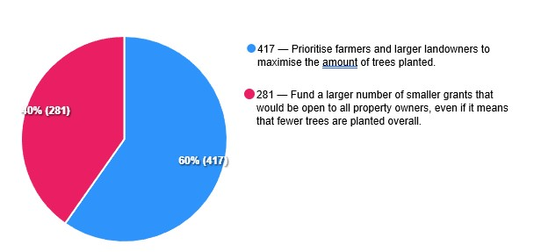

We then asked whether respondents had any suggestions about how the council could support partners in setting up marine-based schemes.   
  
Table 24: Question 6.2 “Do you have any suggestions about how the council can support partners in setting up marine-based schemes?”

|  |  |
| --- | --- |
| **Themes** | **Count** |
| Don't know or no comment | 47 |
| Waste of money | 27 |
| Does not support this initiative generally | 24 |
| Unsure about carbon offsetting mechanisms | 21 |
| Work with academia | 20 |
| Work with Chichester Harbour generally and Chichester Harbour Conservancy specifically | 18 |
| Do kelp restoration | 14 |
| Get company involvement | 10 |
| Explore offsetting mechanisms some more | 8 |
| Should be a government initiative | 5 |
| Speak or benchmark with other seaside councils | 5 |
| Finance studies about this | 5 |
| Work with wildlife trust | 5 |
| There should be no large-scale fishing | 4 |
| Work with yacht or sailing communities | 3 |
| Reduce sewage and pollution first | 2 |

Finally, we asked respondents to advise what they would like us to prioritise if a decision is made to place a greater focus on proposals that help the district to better cope with changing weather patterns.   
  
Most people that answered this question **(56%) said they would like us to prioritise ‘flood and coastal erosion risks’** (403 respondents), whereas **33%** said they would like us to focus on **resourcing a wider ranging action plan** (242). 11% said they weren’t sure (81).

### Graph 4: Question 6.3: “If a decision is made to place a greater focus on proposals that help the district better cope with changing weather patterns, should we prioritise…?”

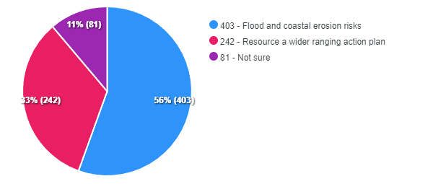

## Section 7: Planning for the future

Respondents were asked whether they had any suggestions that they felt would help the council encourage developers and management companies to introduce and maintain high quality tree planting schemes for new roads.

### Table 25: Question 7.1 “How can we encourage developers and management companies to introduce and maintain high quality tree planting schemes on new roads?”

|  |  |
| --- | --- |
| **Themes** | **Count** |
| Should be part of planning process | 158 |
| Make the scheme mandatory | 137 |
| Give incentive or reward or grant | 35 |
| Maintenance is equally important | 32 |
| Impose penalty | 24 |
| Lobby for new legislation | 18 |
| Stop development altogether | 12 |
| Enforce the S106 agreement | 8 |
| Plant native trees | 6 |

We then asked what measures would encourage respondents to use their cars less if they were to move to a new development. The **majority quoted ‘good public transport connections’ (571)**, closely followed by ‘good walking a cycling routes’ (546).

The graph below breaks down the full results — as respondents could select more than one choice, percentages have not been included.

### Graph 5: Question 7.2: “If you were moving to a new development, what would encourage you to use your car less?”

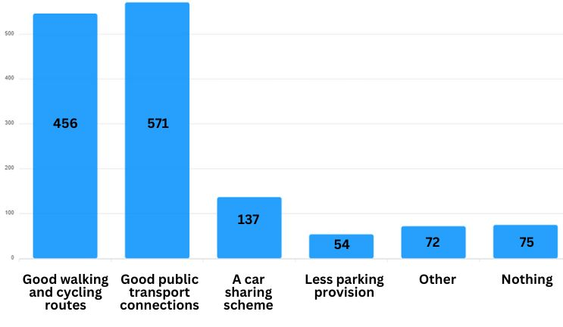

### Table 26: Question 7.2a “If you were moving to a new development what would encourage you to use your car less?” Reasons given by respondents selecting “Other”.

|  |  |  |
| --- | --- | --- |
| **Themes** | **Count** | **Percentage (within the question)** |
| Need to be close to shops, doctors, school, amenities and walkable | 27 | 40 |
| Ensuring safety while walking or cycling | 9 | 13 |
| Ensure better cycling infrastructures | 7 | 10 |
| Supportive of the scheme | 6 | 9 |
| Will still use cars as it is more practical | 5 | 7 |
| More parking provision | 5 | 7 |
| Need public chargers and electric buses | 4 | 6 |
| Need better public transport | 3 | 4 |
| No comment | 3 | 4 |
| Park and Ride scheme | 2 | 3 |
| Need to protect wildlife | 2 | 3 |
| Make parking more expensive | 2 | 3 |

## Section 8: Community involvement

We started this section by explaining that the council is due to receive funding from the developers of Graylingwell in Chichester to develop a Low Carbon Chichester Fund.

Respondents were given two options on how we should spend this money. Of the 709 respondents that answered this question, most said that the **funding should be distributed across the district (54% or 382)** as opposed to spending it in Chichester as the development is in the city (46% or 327).

### Graph 6: Question 8.1 “We are due to receive funding from the developers of Graylingwell in Chichester to develop a Low Carbon Chichester fund. Do you think we should...?”

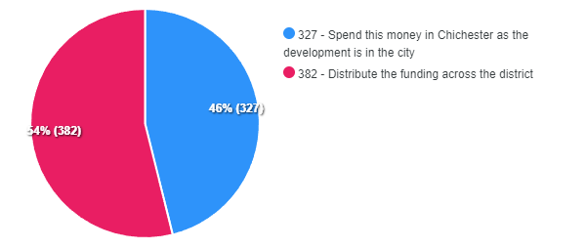

We also asked respondents whether they would be **interested in finding out more about becoming a Climate Champion?** **133 respondents** were and submitted their contact details.

Finally, we asked for any suggestions of public sector or not-for-profit organisations that we should be working with on climate change. Almost 170 organisations of all types (including for profit) were named and are listed below.

### Table 27: Question 8.3 “Do you have any suggestions of public sector or not-for-profit organisations that we should be working with on climate change?

|  |  |
| --- | --- |
| 38 Degrees | Lush (Chichester branch) |
| Act on Energy | Manhood Peninsula  Action Group |
| Aldingbourne Trust | Manhood Peninsula Project |
| Allotment holders | Manhood Wildlife and Heritage Group |
| Arun and Chichester Food Partnership | Marine Conservation Society UK |
| BedZed | Mayday Action Group |
| Bosham Association | Men's Shed |
| BREEAM (Building Research Establishment standard) | Mental health organisations |
| British Plastics Federation | Midhurst Climate Action Network |
| CAGNE (Campaign Against Gatwick Noise and Emissions) | National Lottery Community Fund |
| Campaign for the Protection of Rural England | National Trust |
| Canal Trust | Natural England |
| Carbon Literacy Project | Net Zero All-Party Parliamentary Group (Chair Alex Sobel MP) |
| Cavity Insulation Guarantee Agency | NHS including NHS Forests |
| Centre for Sustainable Energy | OBE Limited |
| Charities | Octopus Energy |
| Chichester & District Cycle Forum | Ofgem |
| Chichester and Arun Green Party | Olio |
| Chichester Bike Project | One Planet |
| Chichester Business Improvement District | Parish and Town Councils |
| Chichester Chamber of Commerce | Petersfield Climate Action Network |
| Chichester Community Development Trust | Places of worship |
| Chichester Earth Café | Planet Wild |
| Chichester Festival Theatre | Protect the wild |
| Chichester future group | Rabbit and Cat Rescue |
| Chichester Harbour Conservancy | Recoup UK - plastic recycling charity |
| Chichester Harbour Trust | Re-generation Earth |
| Chichester Society | Resident Associations |
| Chichester Trishaw (BrightRide CIC) | Rewilding Britain |
| ChiCycle | Rolls Royce |
| Clean Air Fund | RSPB |
| Climate Coalition | Save Our South Coast Alliance |
| Climate hubs in Worthing, Lewes, SDNP etc | SCATE (South Coast Alliance Transport and Environment) |
| Co-housing initiatives | Schools |
| Committee on Climate Change | Scope |
| Community gardens and orchards | Scouts |
| Council for the Protection of Rural England | Sea Cadets |
| Cowdray Estate | SECA (South East Climate Alliance) |
| Cycling UK | Sees.ai |
| David Bellamy | Selsey Community Forum |
| Department for the Environment, Food and Rural Affairs | Singleton Forest Watch |
| Doughnut Economics | Snugg |
| Earth Café | Solent Seascape Project |
| Earthwatch | South Downs National Park Authority |
| Eco churches | South Harting Climate Network |
| Eco Rother Action | Southbourne Environment Group |
| Eco-chi | Southern Water |
| Eliq | Sports clubs |
| Ellen Macarthur Foundation | Stagecoach |
| Energise South Downs | Stop Arundel Bypass |
| Environment Agency | Surfers against Sewage |
| Equality Trust | Sussex Kelp |
| Esmee Fairbairn Trust | Sussex Past |
| Extinction Rebellion | Sussex Wildlife Trust |
| Final Straw Foundation | Sustainable Food Trust |
| Fire and Rescue Service | Sustrans |
| Forestry Commission | Switch Off The Lights campaign |
| Friends of Centurion Way | The Regulator Guy (Richard Winstone) |
| Friends of Chichester Harbour | The Schools' Energy Co-operative |
| Friends of the Earth | Transition Town Chichester |
| Friends of the Ham Brook | Tree planting charities and organisations |
| Future Build exhibitors | Trees and Design Action Group |
| Global Warming Policy Foundation | Tuppenny Barn Organic Farm in Southbourne near Emsworth |
| Good Law Project | Universities including Open University, CES and the Institute for Sustainability, University of Surrey |
| Goodwood Estate | University of the Third Age |
| Great British Nuclear | Vitality Hemp - hemp grows very rapidly and can capture 5 times more carbon than trees. They offer a carbon credits scheme |
| Green energy companies | Voluntary Action Arun and Chichester |
| Green New Deal Group | Weald Action Group |
| Greening Westbourne | Weald to Waves |
| Greenpeace | West Dean Estate |
| Guides | West Sussex County Council |
| Harting Climate Action Network | West Sussex Cycle Forum |
| Hidden Garden Selsey | West Sussex Federation of Women's Institutes |
| Highways Agency | West Sussex Rivers Trust |
| Horticultural societies | Wild Trout Trust - great at implementation of flood management solutions that benefit river habitat |
| Housing Associations | Wildfowl and Wetland Trust |
| Identify the public sector / Not For Profit organisations that have risk assessed the environmental issues/carbon emissions to their operation as 'high', and allocate funding, support, direction, advice accordingly. | Women's Aid |
| Just Stop Oil | Wood recycling project in Southampton |
| Knepp rewilding project | Woodlands Trust |
| Law courts and Police. To encourage people to be more aware of the importance of climate change and issue fines for inconsiderate and damaging behaviour | World Cetacean Alliance |
| LEED | Young Farmers |
| Local Authorities in the more enlightened and environmentally advanced areas of Europe, such as the Scandinavian Countries, Austria, Switzerland, Germany etc. | Youth groups |
| Loop Homes | Zero Hour |

## Section 9: Further comments

Respondents were then given the opportunity to comment on the proposals discussed within the survey as they wished. **144 respondents** said they wanted to provide comments in this section (20% of those that answered this question). These comments are shown under the relevant ranking tables in sections 2-4.

## Section 10: About you

The last section of the survey asked questions about the respondent. Respondents were asked to select which answer best represented them from a list of options. Most respondents (**549**) told us they are district residents. The graph below breaks down the full results. As respondents could select more than one choice, percentages have not been included.

### Table 28: Question 10.1 “Please select the answer that best represents you.”

|  |  |
| --- | --- |
| **Response** | **Count** |
| Resident | 549 |
| I work in the Chichester District | 167 |
| I regularly visit the Chichester District | 64 |
| I am studying in the Chichester District | 41 |
| Community Group | 34 |
| Other | 33 |
| Charitable organisation | 23 |
| Parish council | 17 |
| Public sector organisation | 16 |
| Business | 8 |

### Table 29: Question 10.1a “If ‘Other’, please specify.”

|  |  |
| --- | --- |
| **Response** | **Count** |
| Council Tax payer | 1 |
| Master of the Sea | 1 |
| Disabled | 1 |
| ignored - no pavements, no lights, potholes everywhere | 1 |
| sometimes visit Chichester and the surrounding area. | 1 |
| Retired | 1 |
| Member of Chichester and Arun Green Party. | 1 |
| Weekend resident | 1 |
| No answer given under “Other” | 25 |

Of those who live in the district, 171 respondents said they live in Chichester City. The table below shows the number and percentage of respondents from different areas across the district, from the most responses to the least. It is worth noting that only 37% of people going on the website completed this question and so the results can only provide an indication.

### Table 30: Question 10.1c “Which area of the Chichester District do you live in?”

|  |  |  |
| --- | --- | --- |
| **Area** | **Count** | **Percentage of people responding to this question** |
| Chichester City | 171 | 34% |
| Selsey | 32 | 6% |
| Midhurst | 31 | 6% |
| The Witterings | 28 | 6% |
| Fishbourne | 18 | 4% |
| Bosham | 16 | 3% |
| Donnington | 16 | 3% |
| Southbourne | 15 | 3% |
| Lavant | 13 | 3% |
| Fernhurst | 10 | 2% |
| Tangmere | 10 | 2% |
| Westbourne | 10 | 2% |
| Harting | 9 | 2% |
| Petworth | 9 | 2% |
| Ifold | 9 | 2% |
| Easebourne | 8 | 2% |
| Rogate | 8 | 2% |
| Chidham and Hambrook | 7 | 1% |
| North Mundham | 7 | 1% |
| Birdham | 6 | 1% |
| Boxgrove | 6 | 1% |
| Bury | 6 | 1% |
| Sidlesham | 6 | 1% |
| Funtington | 5 | 1% |
| Wisborough Green | 5 | 1% |
| Westhampnett | 4 | 1% |
| Nutbourne | 3 | 1% |
| Oving | 2 | 0% |
| Plaistow | 2 | 0% |
| Other | 35 | 7% |

We asked respondents to say which age range they fitted into with 36% of those who went on the consultation website replying. Based on that data, the age profile of respondents was found to be closely aligned to the age profile of residents based on census data except for the under 15 age group. The match is closer than the previous climate consultation, which was skewed towards the over 55s (see Graph ).

Graph 7: Question 10.3 “Please select your age group”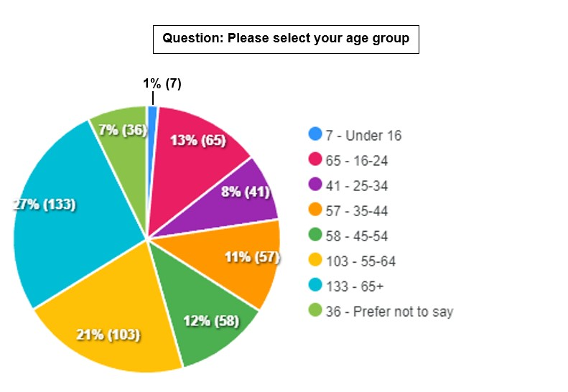

### Graph 8: The age of consultation respondents compared to census data and previous climate consultation

There were more female respondents (**56%** or 287) than male (**35%** or 180) in this consultation. 29 respondents did not wish to disclose their gender, 12 selected non-binary and another selected ‘Other’. It is worth noting that only 37% of people going on the website opted to answer this. So, while it is a useful indicator, this information may not be an accurate reflection of the number of survey responses received from different gender groups.

Eighteen respondents said they were responding on behalf of an organisation (Question 10.2). Question 10.2b asked: “How many people are you representing?” Two said the question was not applicable with other answers ranging from 2-300. In total, 444 people were represented across all organisations that responded. In the previous consultation, 18 organisations responded representing more than 9,000 individuals.

Question 10.1b asked respondents to select where their business or organisation was based. The following locations were selected once: Boxgrove, Bury, Chichester City, Funtington, Sidlesham and Other. Bosham was selected twice.

## Section 11: How did you find out about the consultation?

At the end of the consultation, we asked respondents how they heard about the consultation. The most popular channel by far was the council’s resident magazine, **initiatives (174 respondents)**. In the summer edition, we included a five-page article with a copy of the survey for people to fill in and return to us.

The second biggest referrer was social media with 102 respondents selecting this option, followed by the council’s initiatives+ email newsletter (58).

The table below breaks down the full results — as respondents could select more than one choice, percentages have not been included — and more details of all the marketing activity undertaken as part of the consultation can be found in Section 12.

### Table 31: Question 10.5: “How did you hear about this consultation? You can choose as many answers as are appropriate.”

|  |  |
| --- | --- |
| **Response** | **Count** |
| Initiatives (council magazine) | 174 |
| Social media | 102 |
| Other | 66 |
| Initiatives+ email newsletter | 58 |
| Council website | 49 |
| At an event | 49 |
| Word of mouth | 44 |
| Local media article | 13 |
| Drawing competition | 11 |
| Greatest Hits Radio advert | 10 |
| Poster | 8 |
| Advert in Chichester or Midhurst & Petworth Observer | 6 |
| V2 Radio advert | 2 |
| Car park advertising | 1 |

**205 respondents joined the Let’s Talk Panel** at the end of the survey, and **170 subscribed to the council’s email newsletter**, initiatives+.

## **Section 12: Consultation methods**

Social media reachTo create awareness about the consultation and to encourage as many individuals, groups and organisations as possible to take part, a comprehensive social media plan was created.

As part of this, a variety of copy, videos, imagery and graphics were created and tailored for the council’s different social media channels: Facebook, X (formerly Twitter), Instagram, NextDoor and LinkedIn.   
  
A total of **42** posts were published, resulting in:

* a reach of over **36,000**
* almost **60,000** impressions
* nearly **900** clicks, and
* an engagement rate of **2.7%**, which is higher than the 2% average rate seen across the council’s channels.

Event-specific and wider consultation promotional posts were published in relevant **community group Facebook pages** across the district.

In addition, **Facebook and NextDoor ‘Events’** were created and some paid-for boosted posts were placed on Facebook.

**20%** of households in the Chichester District are on Nextdoor. This is a very high engagement figure– most authorities can only reach around 5% of their population.

The video content was also placed on the council’s YouTube channel.

Consultation logo   
  
Building on the council’s existing and recognised Climate Change branding, the logo was refreshed and used to promote the consultation in a variety of ways.

### In-person Events Organised by Chichester District Council

Four in-person eventsin Chichester (Assembly Rooms), Midhurst (Grange Leisure Centre), Selsey (The Selsey Centre) and Petworth (Leconfield Hall) were organised by the council. These ran from 3pm-7pm to make them accesible to:

* Parents/carers collecting children from school
* Teenagers
* People who do not like going out after dark
* People finishing work

Display materials and a pull up banner was used at the events. Attendees could discuss proposals with council officers from different teams and also the Cabinet Member for the Environment.

The events were opened to other organisations in the area working on climate change-related topics so they could have stands about their work. UK Harvest, Arun and Chichester Citizens Advice (home energy advice), Manhood Wildlife and Heritage Group, Sussex Bay, Chichester Harbour Conservancy attended one or more of the events. One member of the public spoke to attendees about his home retrofit experience and another spoke about his experiencing of DIY retrofitting to passivhaus standard. Members of the public who had participated in the council’s Trees Outside Woodland project also attended to share their experience of the scheme. This step underscored that achieving net zero in the district involves us all.

an aim was to make the events less formal and more interactive. Locally sourced brownies, strawberries and raspberries were served along with drinks – to tide people over until they could get home for their tea. Attendees could complete the consultation survey online or on paper while at the event and children could take part in a colouring competition.

The Chichester event was the best attended, with about 40-50 people coming along. On co-benefit was that the events strengthened links between the council and participating organisations/individuals and this is already leading to enhanced collaboration.

### Attendance at Other In-Person Events

Environmental Strategy Unit officers attended:

* Three freshers’ fayres at Chichester College and Chichester University.
* UK Harvest food distribution events (Parklands, Chichester, The Grange, Midhurst, Oving, Graylingwell, Chichester)
* Libraries (Chichester, Southbourne, Petworth)
* Leisure centres (Bourne)
* Markets (Chichester Farmers Market twice Cross Market & More, Chichester)

The freshers’ fayres were particularly successful in generating responses to the survey with an estimated 100 students going online.

Officers presented on the consultation to Manhood Peninsula Partnership and at Chichester District Association of Local Councils AGM.

### Online consultation events

Three events were organised and heavily promoted to provide residents, businesses and organisations the opportunity to find out more and ask questions. Unfortunately, we did experience some issues with the technology at these particular events and some respondents were unable to join us because of this. This issue has since been resolved.

### Media relations

* **Media releases** were issued to promote the launch of the consultation and to remind people of the deadline. These were issued to key media contacts, as well as parish councils (which also received advance notice of the consultation and consultation events), and members.
* Information about the consultation was also included in **other relevant media releases** issued by the council.
* The consultation was also promoted several times during the consultation period in the council’s weekly **District Dispatch column** for the Chichester Observer and the Midhurst and Petworth Observer.

### Print

* A five-page article was included within the Summer issue of the council’s resident magazine, **initiatives**, which was delivered direct to the doorstep of every home and business in the district. In total 69,000 copies were printed.
* **Promotional posters were created and given to council partners**, including parish, town and the city councils, the district’s leisure centres, district libraries, and local attractions such as Chichester Cathedral and Pallant House gallery.
* A4 posters were also delivered to **GP surgeries** through the council’s Social Prescribers.
* **A3 posters** were displayed in areas such as the entrances to East Pallant House, in district leisure centres and Little London public conveniences.
* An **A1 poster** was also displayed in the reception of **East Pallant House.**
* **Members** (councillors)were provided with posters and link to the consultation page and **encouraged to promote in their areas.**

### Outside advertising

* **30 A1 posters** were created and provided to **Stagecoach** to display in their buses on local routes.
* A **large format (6ftx4ft) advert** in the council’s busy city centre **Avenue de Chartres car park.**

### Radio and newspaper advertising

* Advertising campaigns were developed for the **Observer Series,** consisting of one full page and two half page adverts in Chichester Observer and the Midhurst and Petworth Observer, plus a **digital campaign** on the National World website.
* Advertising campaigns were also developed for **Greatest Hits Radio** and **V2 Radio**.

### Digital advertising

* To complement attendance at the University of Chichester’s Freshers’ Fair, we booked a **web advert to appear for a month on the Student Union website**, which linked through to the survey. We also ‘took over’ the **University’s Instagram Story** for 24 hours, with a specially recorded video targeted to the audience.
* The **council’s social media platforms,** such as Facebook, Twitter, Nextdoor, LinkedIn and Instagram, were used to promote the consultation and invite people to take part — see Section 12 for a breakdown.

The consultation was promoted in a range of **email newsletters**: the council’s general email newsletter, initiatives+, Ebiz business email newsletter, Sussex Police’s Neighbourhood Watch bulletins, and in West Sussex County Council’s ‘Your Voice’ consultation newsletter on several occasions.

* West Sussex County Council also featured the consultation on their **Consultations Hub** web page.
* An **email signature banner** promoting the campaign and linking through to the survey, was featured on every email sent from a council email address during the consultation period.
* A **digital TV screen advert** was displayed in the reception at East Pallant House, The Novium Museum and at Chichester College.
* **1,100 Let’s Talk Panel members**, who have all signed up for consultation updates, were notified of the consultation by email and given details on how to participate.
* A **campaign banner** promoting the consultation was displayed on the **homepage of the council website**, which linked through to the consultation web hub.
* **Digital assets** were **supplied to parish councils** to use to promote the consultation in their areas, as well as to partners and attractions.

### Competitions

* A prize draw with a prize worth up to £500 was offered to people going on our survey site. The prize could be a train, bus or coach season ticket, a local/organic weekly veg box, a push bike or a contribution to an e-bike. 451 of respondents chose to enter the draw. It was not open to council employees.
* A **Paint for the Planet competition** was created to engage children up to the age of 12 about climate change. 10,000 **postcards** were printed with vegetable-based inks on chlorine-free FSC recycled paper **and distributed through primary school book bags and at events.** The 70 designs received through the competition were so good that they are on rolling display on the monitors in East Pallant House reception. There was a £25 book voucher prize for two winners.

### Other

* A **recorded ‘hold’ message** was created and played on the council’s switchboard telephone line during the consultation period.
* The survey was sent to **all CDC staff** and placed on the **intranet and Viva Engage**. A **desktop advert** was also created and displayed as background on staff laptops, and information was included in the council’s **Staff News newsletter**.
* Updates were included in **Member’s Bulletin**, informing members (councillors) and encouraging them to promote the consultation.