COMMUNITY INFRASTRUCTURE LEVY APPLICATION FOR A REVIEW OF THE CHARGEABLE AMOUNT  UNDER REGULATION 113 | 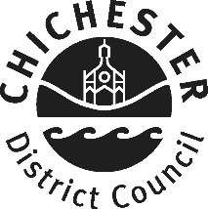

Application Details:

Applicants Name:

Applicants Address:

Applicants Telephone:

Applicants Email:

Planning Application Number:

Site Address:

Site Description:

Request for Review Details:

Liability Notice Date:
Reason for Request and Details of Request:

Schedule of Evidence Submitted in Support of Claim:
List of documents annexed to the application form (if relevant)

Declarations:

I/We declare that development on this site has not commenced

I/We declare that the development has commenced because it was for a retrospective planning permission

I/We declare that I/We understand that should development commence prior to the Council reaching its decision the claim shall lapse and
the charge will become payable in accordance with the current liability notice

I/We confirm that the details above and the supporting information provided (where relevant) are correct
Name:
Date:

It is an offence for a person to knowingly or recklessly supply information which is false or misleading in a material respect to a collecting or charging authority in response to a requirement under the Community Infrastructure Levy Regulations 2010 (as amended) (regulation 110, SI 2010/948). A person guilty of an offence under this regulation may face unlimited fines, two years imprisonment, or both.

On receipt of this application the Council will make a decision on your request for a review of the chargeable amount with 14 days and inform you of the decision, with reason, in writing.

