Council logo


2022 Air Quality Annual Status Report (ASR)

In fulfilment of Part IV of the Environment Act 1995 Local Air Quality Management

Date: 28 July 2022

|  |  |
| --- | --- |
| Information | Chichester District Council |
| **Local Authority Officer** | Kate Simons  Simon Ballard |
| **Department** | Environmental Protection |
| **Address** | East Pallant House  1 East Pallant  Chichester  West Sussex  PO19 1TY |
| **Telephone** | 01243 521160 |
| **E-mail** | [ksimons@chichester.gov.uk](mailto:ksimons@chichester.gov.uk)  [sballard@chichester.gov.uk](mailto:sballard@chichester.gov.uk) |
| **Report Reference Number** | ASR 22 |
| **Date** | July 2022 |

# Executive Summary: Air Quality in Our Area

## Air Quality in Chichester District

Air pollution is associated with a number of adverse health impacts. It is recognised as a contributing factor in the onset of heart disease and cancer. Additionally, air pollution particularly affects the most vulnerable in society: children, the elderly, and those with existing heart and lung conditions. There is also often a strong correlation with equalities issues because areas with poor air quality are also often less affluent areas[1],[2].

The mortality burden of air pollution within the UK is equivalent to 28,000 to 36,000 deaths at typical ages[3], with a total estimated healthcare cost to the NHS and social care of £157 million in 2017[4].

Air quality across most of Chichester district is good however along roads in and adjacent to Chichester city and within Midhurst there are areas of elevated concentrations of pollutants. The main pollutant of concern under the Local Air Quality Management regime is nitrogen dioxide (NO2), the key source being road traffic. The latest monitoring data indicates that levels have generally decreased over the last five years. (However, it should be noted that there was a slight increase in NO2 concentrations in 2021 compared to 2020 which is considered to be due to the effect of the Covid 19 pandemic on 2020 traffic volumes.)

The Air Quality Monitoring Areas (AQMAs) within the district are located at:

* St Pancras, Chichester
* Rumbolds Hill, Midhurst
* Orchard Street, Chichester
* Stockbridge roundabout at the junction of the A27 and A286.

Note that the latter two AQMAs have been revoked in 2022 see link to webpage as below

[Air quality: Chichester District Council](https://www.chichester.gov.uk/pollutioncontrolairquality)

The Council has revised and published its Air Quality Action Plan (AQAP) during 2021/22 and this is available at the following link

[Air quality: Chichester District Council](https://www.chichester.gov.uk/pollutioncontrolairquality)

The AQAP recognises the health effects of PM2.5 (although currently this pollutant is not included in the statutory Local Air Quality Management regime which defines our air quality activities). The AQAP includes actions designed to tackle both PM2.5 and NO2. The government is committed to adopting a binding standard for PM2.5 as part of the requirements of the Environment Bill and we will consider the new standard once adopted (expected to be later in 2022).

Air quality is recognized by the Council as an important public health issue which we are working with our partners to address. Our partners include other services at the Council (including Development Management, Parking Services and Estates), West Sussex County Council (WSCC) departments (Public Health, Transport and Planning and Highways) and CDC is also a member of the Sussex-Air Quality Partnership (SAQP) known as Sussex-air.

Our Local Cycling and Walking Infrastructure Plan (LCWIP) for Chichester City was adopted in January 2021 and the Council is working with WSCC and other neighbouring district and borough councils to develop feasibility designs for some of the priority LCWIP schemes across the County. One of the LCWIP routes within Chichester City is being considered as part of this work. This work should enable WSCC to bid to the Active Travel Fund (ATF) in due course for funding to develop these schemes.

We continue to work with our planning policy team in the development of the review of the Chichester Local Plan. We are developing a GIS layer of proposed cycling infrastructure identified in the Chichester City LCWIP, the WSCC LCWIP and routes identified in WSCC STIP[5] and LTIP[6] work streams. The GIS layer will provide background evidence to assist in prioritising routes in the Council’s Infrastructure Business Plan thus enabling funding to be allocated in the future.

The Council has agreed to deliver a two-car pool fleet of electric/low emission cars and two additional pool cycles (e-bikes) during 2022. We are also funded to expand the car club by one further vehicle when usage rates indicate the need for another vehicle.

## Actions to Improve Air Quality

Whilst air quality has improved significantly in recent decades and will continue to improve due to national policy decisions, there are some areas where local action is needed to improve air quality further.

The 2019 Clean Air Strategy[7] sets out the case for action, with goals to reduce exposure to harmful pollutants. The Road to Zero[8] sets out the approach to reduce exhaust emissions from road transport through a number of mechanisms; this is extremely important given that Chichester District’s Air Quality Management Areas (AQMAs) are designated due to elevated concentrations of pollutants heavily influenced by transport emissions.

Key completed actions during 2021 are as follows:

* Adoption of the revised Air Quality Action Plan 2021 by Cabinet in January 2022 and making the document available on the website.
* Adoption of the Chichester City Local Cycling and Walking Infrastructure Plan (LCWIP) in April 2021 and making the document available on the website.
* We have launched a low emission salary sacrifice car scheme for staff to access.
* We continue our partnership working with WSCC, Sussex-Air and Chichester & District Cycle Forum.
* We continued to run and maintain four air quality monitoring stations during 2021 and published the monitoring information at <http://sussex-air.net> – this work is used within the air Alert forecasting service (see Measure 16 in Table 2.2). (Note that two of the air quality monitoring stations were decommissioned at the beginning of 2022).
* We continue to monitor 20 sites using NO2 diffusion tubes.

## Conclusions and Priorities

The 2021 monitoring of NO2 and PM10 shows no exceedances of Air Quality Standards at any of the four real-time monitoring stations. At all the twenty diffusion tube locations the UK’s NO2 air quality annual mean Objective of 40 µg/m3 was met (both within and outside AQMAs). The AQMAs at Orchard Street and Stockbridge roundabout (both in Chichester) have been revoked as discussed in last year’s ASR based on the air quality monitoring data over the last five years and air quality modelling data to 2025.

We are not aware of any new developments within the district that will have a significant impact on air quality moving forward. Nevertheless, we are aware that there is residential development on going in the district and that future traffic from such developments could have an impact on air quality.

The AQAP was updated during 2021 and the Council’s priorities for the next five years are detailed in the document and summarised in Section 2.2 of this report.

## Local Engagement and How to get Involved

The public can get involved by supporting behavioural change initiatives such as car sharing, walking, cycling, using public transport, joining the Car Club, buying zero emissions vehicles for personal and commercial travel and turning petrol/diesel engines off when stationary. Other initiatives such as minimising wood burning, only burning dry, well-seasoned wood and composting instead of having bonfires can also reduce air pollution.

The Chichester and District Cycle Forum provides information on local cycling opportunities and campaigns on behalf of cyclists. The Forum is open to the public and further information can be obtained by emailing: [environmentalprotect@chichester.gov.uk](mailto:environmentalprotect@chichester.gov.uk)

The Environmental Protection team regularly provides updates to Members of the Council regarding progress on implementing the AQAP and provides details on the staff intranet/website regarding air quality issues and campaigns.

## Local Responsibilities and Commitment

This ASR was prepared by the Environmental Protection Team at Chichester District Council with the support and agreement of the following officers and departments:

Andy Mouland – Senior Local Transport Improvements Officer, Highways, Transport and Planning, WSCC

This ASR has been approved by:

Andrew Frost – Director Planning and Environment, CDC

Cllr Penny Plant – Cabinet Portfolio holder for the Environment and for Contract Services, CDC

This ASR has not been signed off by a Director of Public Health.

If you have any comments on this ASR please send them to Kate Simons at:

Chichester District Council

East Pallant House

East Pallant

Chichester

West Sussex

PO19 1TY

Telephone: 01243 521160

Email: ksimons@chichester.gov.uk

Table of Contents

Executive Summary: Air Quality in Our Area i

Air Quality in Chichester District i

Actions to Improve Air Quality ii

Conclusions and Priorities iii

Local Engagement and How to get Involved iv

Local Responsibilities and Commitment iv

1 Local Air Quality Management 1

2 Actions to Improve Air Quality 2

2.1 Air Quality Management Areas 2

2.2 Progress and Impact of Measures to address Air Quality in Chichester District 5

2.3 PM2.5 – Local Authority Approach to Reducing Emissions and/or Concentrations 14

3 Air Quality Monitoring Data and Comparison with Air Quality Objectives and National Compliance 15

3.1 Summary of Monitoring Undertaken 15

3.1.1 Automatic Monitoring Sites 15

3.1.2 Non-Automatic Monitoring Sites 15

3.2 Individual Pollutants 15

3.2.1 Nitrogen Dioxide (NO2) 16

3.2.2 Particulate Matter (PM10) 17

3.2.3 Particulate Matter (PM2.5) 18

3.2.4 Ozone (O3) 18

Appendix A: Monitoring Results 20

Appendix B: Full Monthly Diffusion Tube Results for 2021 34

Appendix C: Supporting Technical Information / Air Quality Monitoring Data QA/QC 36

New or Changed Sources Identified Within Chichester District During 2021 36

Additional Air Quality Works Undertaken by Chichester District Council During 2021 36

QA/QC of Diffusion Tube Monitoring 36

Diffusion Tube Annualisation 36

Diffusion Tube Bias Adjustment Factors 37

NO2 Fall-off with Distance from the Road 37

QA/QC of Automatic Monitoring 37

PM10 and PM2.5 Monitoring Adjustment 38

Automatic Monitoring Annualisation 38

NO2 Fall-off with Distance from the Road 38

Appendix D: Maps of Monitoring Locations and AQMAs 42

Appendix E: Summary of Air Quality Objectives in England 46

Glossary of Terms 47

References 49

Figures

Figure A.1 – Trends in Annual Mean NO2 Concentrations 26

Figure A.2 – Trends in Number of NO2 1-Hour Means > 200µg/m3 29

Figure A.3 – Trends in Annual Mean PM10 Concentrations 31

Figure A.4 – Trends in Number of 24-Hour Mean PM10 Results > 50µg/m3 33

Figure A.5 – Trends in Annual Mean PM2.5 Concentrations **Error! Bookmark not defined.**

Figure D.1 – Map of Non-Automatic Monitoring Site 42

Tables

Table 2.1 – Declared Air Quality Management Areas 3

Table 2.2 – Progress on Measures to Improve Air Quality 8

Table A.1 – Details of Automatic Monitoring Sites 20

Table A.2 – Details of Non-Automatic Monitoring Sites 21

Table A.3 – Annual Mean NO2 Monitoring Results: Automatic Monitoring (µg/m3) 23

Table A.4 – Annual Mean NO2 Monitoring Results: Non-Automatic Monitoring (µg/m3) 24

Table A.5 – 1-Hour Mean NO2 Monitoring Results, Number of 1-Hour Means > 200µg/m3 28

Table A.6 – Annual Mean PM10 Monitoring Results (µg/m3) 30

Table A.7 – 24-Hour Mean PM10 Monitoring Results, Number of PM10 24-Hour Means > 50µg/m3 32

Table A.8 – Annual Mean PM2.5 Monitoring Results (µg/m3) **Error! Bookmark not defined.**

Table A.9 – SO2 2021 Monitoring Results, Number of Relevant Instances **Error! Bookmark not defined.**

Table B.1 – NO2 2021 Diffusion Tube Results (µg/m3) 34

Table C.1 – Bias Adjustment Factor 37

Table C.2 – Annualisation Summary (concentrations presented in µg/m3) 39

Table C.3 – Local Bias Adjustment Calculation 40

Table C.4 – NO2 Fall off With Distance Calculations (concentrations presented in µg/m3) 41

Table E.1 – Air Quality Objectives in England 46

# Local Air Quality Management

This report provides an overview of air quality in Chichester District during 2021. It fulfils the requirements of Local Air Quality Management (LAQM) as set out in Part IV of the Environment Act (1995) and the relevant Policy and Technical Guidance documents.

The LAQM process places an obligation on all local authorities to regularly review and assess air quality in their areas, and to determine whether or not the air quality objectives are likely to be achieved. Where an exceedance is considered likely the local authority must declare an Air Quality Management Area (AQMA) and prepare an Air Quality Action Plan (AQAP) setting out the measures it intends to put in place in pursuit of the objectives. This Annual Status Report (ASR) is an annual requirement showing the strategies employed by Chichester District Council to improve air quality and any progress that has been made.

The statutory air quality objectives applicable to LAQM in England are presented in Table E.1.

# Actions to Improve Air Quality

## Air Quality Management Areas

Air Quality Management Areas (AQMAs) are declared when there is an exceedance or likely exceedance of an air quality objective. After declaration, the authority should prepare an Air Quality Action Plan (AQAP) within 12 months setting out measures it intends to put in place in pursuit of compliance with the objectives.

A summary of AQMAs declared by Chichester District Council can be found in Table 2.1. The table presents a description of the four AQMAs that were designated within Chichester District during 2021. It should be noted that two of the AQMAs were revoked in May 2022 (Orchard Street and Stockbridge roundabout AQMAs). Appendix D: Maps of Monitoring Locations and AQMAs provides maps of AQMAs and the air quality monitoring locations in relation to the AQMAs. The air quality objectives pertinent to the current AQMA designations are as follows:

* NO2 annual mean

Based on the monitoring over the last five years and modelling to 2025 we revoked Orchard Street and Stockbridge roundabout AQMAs in May 2022 (see section 3.2).

Table 2.1 – Declared Air Quality Management Areas

| AQMA Name | Date of Declaration | Pollutants and Air Quality Objectives | One Line Description | Is air quality in the AQMA influenced by roads controlled by National Highways? | Level of Exceedance: Declaration | Level of Exceedance: Current Year | Name and Date of AQAP Publication | Web Link to AQAP |
| --- | --- | --- | --- | --- | --- | --- | --- | --- |
| Stockbridge Roundabout AQMA | 24-Aug-06 | NO2 Annual Mean | An area encompassing the Stockbridge Roundabout at the junction of the Chichester bypass (A27) and Stockbridge Road (A286) | YES | 44.9 | 29.2 | CDC AQAP 2022 | https://www.chichester.gov.uk/pollutioncontrolairquality |
| Orchard Street AQMA | 17-May-07 | NO2 Annual Mean | An area along Orchard Street, Chichester at the eastern end of the street where it meets Northgate | NO | 40.7 | 25.1 | CDC AQAP 2022 | as above |
| St Pancras AQMA | 17-May-07 | NO2 Annual Mean | An area along St Pancras, Chichester between Eastgate Square and New Park Road. Note St Pancras forms a street canyon in this section. | NO | 48.3 | 37.5 | CDC AQAP 2022 | as above |
| Rumbolds Hill AQMA | 17-Jan-20 | NO2 Annual Mean | An area along Rumbolds Hill, Midhurst between the A272 at its southern end and the junction of North Street (A286) and Knockhundred Row at its northern end. | NO | 42 | 36 | CDC AQAP 2022 | as above |

**CDC confirms the information on UK-Air regarding their AQMA(s) is up to date**

**CDC confirms that all current AQAPs have been submitted to Defra**

## Progress and Impact of Measures to address Air Quality in Chichester District

Defra’s appraisal of last year’s ASR and our response is shown in the bullet points below:

* Defra’s comment: The Council’s AQAP is out of date; the AQAP was published in 2015. However, the Council have provided an update stating a new AQAP is expected to be adopted in Autumn 2021. The Council have also mentioned suggested new measures in the 2021 AQAP to target PM2.5 specifically. This is encouraging to see, and the Council is urged to finalise their updated AQAP, reporting on new measures in their 2022 ASR.
* *CDC’s response: The Council’s revised AQAP was finalised at the end of 2021 and adopted 11 January 2022.*
* Defra’s comment: The Council have stated they are considering revocation of the Stockbridge Roundabout and Orchard Street AQMAs due to continual compliance with the annual mean NO2 objective. This decision is supported.
* *CDC’s response: The two AQMAs as above were revoked in May 2022.*
* Defra’s comment: Suggestions have been made regarding a couple of improvements to the presentation of graphs within the report.
* *CDC’s response: The suggestions made by Defra have been taken on board in the ASR 2022.*

Chichester District Council has taken forward a number of direct measures during the current reporting year of 2021 in pursuit of improving local air quality. Details of all measures completed, in progress or planned are set out in Table 2.2. Twenty-three measures are included within Table 2.2, with the type of measure and the progress Chichester District Council has made during the reporting year of 2021 presented. Where there have been, or continue to be, barriers restricting the implementation of the measure, these are also presented within Table 2.2.

More detail on these measures can be found in our Air Quality Action Plan (AQAP) and Chichester City Local Cycling and Walking Infrastructure Plan (LCWIP). Key completed measures are:

* Adoption of the revised Air Quality Action Plan 2021 by Cabinet in January 2022 and making the document available on the website.
* Adoption of the Chichester City Local Cycling and Walking Infrastructure Plan (LCWIP) in April 2021 and making the document available on the website.
* We have launched a low emission salary sacrifice car scheme for staff to access.
* We continue our partnership working with WSCC, Sussex-Air and Chichester & District Cycle Forum.
* We continued to run and maintain four air quality monitoring stations during 2021 and published the monitoring information at <http://sussex-air.net> – this work is used within the air Alert forecasting service (see measure 16 in Table 2.2). (Note that two of the air quality monitoring stations were decommissioned at the beginning of 2022).
* We continue to monitor 20 sites using NO2 diffusion tubes.

Chichester District Council (CDC) expects the following measures to be completed over the course of the next reporting year:

* To continue to support our partners, particularly WSCC, with respect to developing an initial design/feasibility study for one of the cycle routes in the Chichester City LCWIP (Route K) to enable bidding for Active Travel Funding during 2022/2023.
* To deliver a fleet of two electric bikes equipped such that staff can make work related journeys on them (due for delivery in July 2022).
* To deliver a two-car pilot pool car fleet for CDC staff to include ULEV and ZEV vehicles (due for delivery in July 2022).
* To complete a GIS layer of cycle routes (aspirational and existing) for inclusion in the revised Local Plan (due for public consultation by the end of 2022).
* To associate the Sussex-air Air Quality and Emissions Guidance for Sussex within the Council’s planning process.
* To expand the Car Club in Chichester city by tendering for an additional car to be in place by April 2023.

CDC’s priorities for the coming year are to:

* To work with WSCC on a feasibility study/options appraisal of one of the higher priority routes within the Chichester City LCWIP to enable future bidding for funding to develop the route.
* To complete the development of a GIS layer to link to the revised Local Plan showing routes within CDC’s LCWIP report, the emerging WSCC LCWIP, WSCC STIP and LTIP routes in order to inform developers and other potential funders of infrastructure requirements within the district to enable increased active travel.
* To continue to work to implement our policy that ‘all new council cars and vans shall be electric unless there is a business case as to why not’.
* To bid for grant monies that facilitate the implementation of actions within the revised AQAP.

Chichester District Council worked to implement these measures in partnership with the following stakeholders during 2021:

* WSCC Highways/Transport teams
* Neighbouring District and Borough Councils
* National Highways
* Public Health Team at WSCC
* Sussex-air members.

The principal challenges and barriers to implementation that CDC anticipates facing are:

* Availability of funding for LCWIP and AQAP projects.
* Availability of WSCC highways staff resources to deliver multiple LCWIP schemes.

Progress on the following measures has been slower than expected due to:

* The launch of an additional Car Club car continues to be delayed due to changes in travel patterns following the pandemic.

Whilst the measures stated above and in Table 2.2 will help to contribute towards compliance, CDC anticipates that further additional measures not yet prescribed will be required in subsequent years to achieve compliance and enable the revocation of St Pancras and Rumbolds Hill AQMAs.

Table 2.2 – Progress on Measures to Improve Air Quality

| Measure No. | Measure | Category | Classification | Year Measure Introduced | Estimated / Actual Completion Year | Organisations Involved | Funding Source | Defra AQ Grant Funding | Funding Status | Estimated Cost of Measure | Measure Status | Reduction in Pollutant / Emission from Measure | Key Performance Indicator | Progress to Date | Comments / Barriers to Implementation |
| --- | --- | --- | --- | --- | --- | --- | --- | --- | --- | --- | --- | --- | --- | --- | --- |
| 1 | Set up Air Quality Working Group | Promoting Travel Alternatives | Other | 2008 | 2030 | CDC | CDC | NO | Not Funded |  | Implementation | n/a | 2 meetings per year | 14 meetings held to date | Reported to West Sussex Air Quality group led by Public Health since 2018 and group now reports to Environment Panel at CDC |
| 2 | Cleaner vehicles | Promoting Low Emission Transport | Procuring alternative Refuelling infrastructure to promote Low Emission Vehicles, EV recharging, Gas fuel recharging | 2012 | 2025 | WSCC/CDC | WSCC/CDC | NO | Partially Funded | £50k - £100k | Implementation |  | No. of electric vehicle recharging points | installed a total of 18 recharging points in Chichester district having secured funding in 2019 from OLEV. Part of regional network of rapid charging points through Sussex-air project. | WSCC is leading a partnership of 6 of the 7 district and borough councils across the county seeking to procure a market based supplier to deliver a charge point network across the County under a Concession Contract. Given the nature of the procurement there is no requirement for any County Council investment. However, local authorities can bid for funds from The Office for Zero Emission Vehicles (OZEV) On-Street Residential Charging Scheme. The purpose of which is to increase the availability of on-street charging points in residential streets where off-street parking is not available. If sites identified by the delivery authorities are deemed uneconomical by the preferred supplier, the County Council will consider making a bid for this funding to support provision. CDC is watching the progress of this project and will get involved if a supplier is identified. |
| 3 | Planning policy | Policy Guidance and Development Control | Air Quality Planning and Policy Guidance | 2012 | 2022 | CDC | CDC | NO | Not Funded |  | Implementation |  | No. of planning conditions imposed on planning consultations | Sussex-air produced Planning Guidance and Low Emissions Strategy and in discussion with CDC Policy Planners regarding adopting LES approach. Sussex-air has reviewed its guidance in 2020 and document has been submitted to CDC Environment Panel. Document to be adopted by 2022/23 | WSCC revised parking standards (2019) are also applied as necessary (relating to EV charging points and cycle parking facilities) |
| 4 | Cycling and walking initiatives | Promoting Travel Alternatives | Promotion of cycling | 2012 | 2021 | CDC/WSCC | CDC/WSCC | NO | Partially Funded | £50k - £100k | Completed |  | % increase in cycling | Stable levels of cycling from 2020- 2021 on most routes. LCWIP for Chichester City completed 2020, consulted on and revised Jan 2021 and adopted April 2021. WSCC has produced strategic LCWIP which will be adopted in 2022. Successful bid by CDC for pooled business rates funding to fund this work (£70k). | Prioritisation of LCWIP routes across West Sussex delivered as part of partnership between WSCC and districts and boroughs in 2021 and Capability Funding received to develop concept designs for one of CDC's active travel schemes. WSCC Planning to bid for ATF funding in 2022/23 for schemes that have a completed concept design. WSCC received funding for 2022/23 for new Toucan crossing on A259 between Chichester and Bognor Regis to improve crossing for cyclists and pedestrians, to be implemented by end of 2022/23. |
| 5 | Car Clubs | Alternatives to private vehicle use | Car Clubs | 2012 | 2023 | CDC/WSCC | CDC/car club operator | NO | Partially Funded | £10k - 50k | Planning |  | Utilisation rate of cars to be 20% | 5 cars now available to book (1 car removed during Covid pandemic), development worker employed 2014-16 to promote Club, utilisation rate increasing throughout 2019 and ranged from 11 - 20% depending on car location. £13k monies available to fund new vehicle. | Proposing to introduce new car to fleet in 2022/23 depending on utilisation rates increasing again. |
| 6 | School travel plans | Promoting Travel Alternatives | School Travel Plans | 2012 | 2030 | WSCC/CDC | WSCC | NO | Not Funded |  | Planning |  | % children travelling to school by sustainable means | Living Streets project engaged with 5 primary schools in the District and staff and students at Chichester University between 2018 - 2021. | WSCC has received Capability Fund monies to enable future work in this area. |
| 7 | WSCC and CDC travel plans | Promoting Travel Alternatives | Workplace Travel Planning | 2012 | 2030 | WSCC/CDC | WSCC/CDC | NO | Not Funded |  | Implementation |  | % WSCC and CDC staff travelling by sustainable means | WSCC grey fleet business mileage was 4.13 million km below 6.0 million km target. Easit scheme at WSCC and CDC to encourage rail use. Cycle to work scheme at CDC | WSCC Pool fleet mileage: Petrol pool – 170,968 km, Hybrid pool – 234,625 km. EV pool – 57,400 km, Total 462,993 miles. Train travel 612,676 km at WSCC. Significant increase from 2020 in pool fleet mileage and train mileage. |
| 8 | Business travel plans | Promoting Travel Alternatives | Workplace Travel Planning | 2012 | 2030 | WSCC | WSCC | NO | Not Funded |  | Implementation |  | Travel Plans implemented within target time period | Over 45 Travel Plans submitted since 2009 and Travel Plan group set up attended by large organisations to work on joint measures. | 2 business plans submitted in 2021 |
| 9 | Residential travel plans | Promoting Travel Alternatives | Personalised Travel Planning | 2012 | 2030 | WSCC | WSCC | NO | Not Funded |  | Implementation |  | Travel Plans implemented within target time period | Over 44 Travel Plans have been submitted since 2009 | Additional 6 plans during 2021 |
| 10 | TravelWise/smarter choices | Public Information | Via the Internet | 2012 | 2030 | WSCC/CDC | WSCC | NO | Not Funded |  | Implementation |  | No. of users of WSCC car share database for PO19 area | Covid 19 has altered travel patterns in 2021 with employees working from home for part of year and many staff not attending workplaces on full time basis. |  |
| 11 | Cycle route information | Promoting Travel Alternatives | Promotion of cycling | 2012 | 2030 | CDC | CDC | NO | Not Funded |  | Implementation |  | No. of maps sold through Tourist Information or other outlets. | 5 route leaflets have been produced so far and over 1460 copies have been sold to date. | 29 maps sold in 2021 but museum was closed for part of the year. |
| 12 | Cycle journey planning | Public Information | Via the Internet | 2012 | 2030 | WSCC | WSCC | NO | Not Funded |  | Implementation |  | No. of journeys planned on website (note this covers whole of West Sussex area) | Web link available on WSCC and CDC websites | 4510 journeys planned 2021-22 (decrease from 2020/21 however still higher than 2019/20) |
| 13 | Public transport infrastructure | Transport Planning and Infrastructure | Public transport improvements-interchanges stations and services | 2012 | 2030 | WSCC | WSCC | NO | Funded | £50k - £100k | Implementation |  | Increase in use of public transport | RTPI displays installed at key locations across City | 7 RTPI displays installed in 2020/21 and 4 more installed 2021 funded by CIL payments (1 planned for 2022). 3 new bus shelters in 2020/21 provided by City Council. |
| 14 | Cleaner buses | Promoting Low Emission Transport | Public Vehicle Procurement -Prioritising uptake of low emission vehicles | 2012 | 2030 | WSCC | WSCC | NO |  |  | Planning |  | % of Euro 5 buses | Two Euro 6 double deckers added to fleet in 2019. Emissions retrofitting project ongoing for 2020 for five Euro 4 and three Euro 3 buses | WSCC has committed along with bus operators to enter into an Enhanced Partnership from April 2022. The Partnership will be responsible for the delivery of annual Bus Service Improvement Plans (BSIPs) with the 2022/23 BSIP being drafted by the end of October. The BSIP will form part of a bid that the Partnership will make to central government for continued recovery funding as well as improvements from £3bn of new money. The BSIP will include the approach to achieving zero emission bus services. |
| 15 | Licensing requirement for taxis | Promoting Low Emission Transport | Taxi Licensing conditions | 2012 | 2030 | CDC | CDC | NO | Not Funded |  | Implementation |  | No. of Euro 4 vehicles | For vehicles 5 years and over, MOT and fitness test required every 6 months | Action within revised AQAP to work to provide infrastructure to allow the introduction of EV taxis to fleet |
| 16 | Forecasting, monitoring and public information | Public Information | Via other mechanisms | 2012 | 2030 | SAQP | SAQP | NO | Partially Funded |  | Implementation |  | No. of people registered to receive alerts | Over 1182 subscribers registered across Sussex |  |
| 17 | AQ monitoring and traffic monitoring | Traffic Management | UTC, Congestion management, traffic reduction | 2012 | 2030 | CDC/WSCC | CDC/WSCC | NO | Not Funded |  | Implementation |  | Reduction in traffic volumes | Traffic flows between 2018 - 2019 have reduced by 3% in the Orchard St AQMA however the data was incomplete in the other two AQMAs so the flows could not be compared. | Traffic flows in 2021 sllightly reduced due to Covid 19 but vehicle numbers almost back to pre-Covid levels. |
| 18 | A27 by-pass improvements | Traffic Management | Strategic highway improvements, re-prioritising road space away from cars, including Access management, Selective vehicle priority, bus priority, high vehicle occupancy lane | 2017 | 2030 | National Highways | National Highways | NO | Not Funded |  | Planning |  | Reduction in congestion | NH consulted during 2017 on options for improving A27 around Chichester however no option chosen | No funds allocated for A27 improvements at the present time. |
| 19 | Variable message signing (VMS) on A27 | Traffic Management | UTC, Congestion management, traffic reduction |  |  | National Highways | National Highways | NO | Not Funded |  |  |  | No. of warnings made per year | NH decision awaited | Awaiting outcome of A27 improvements decision |
| 20 | Park and ride schemes in and around City | Alternatives to private vehicle use | Bus based Park & Ride |  |  | CDC/WSCC | CDC/WSCC | NO | Not Funded |  |  |  | Reduce traffic in City centre by 3% | Linked to A27 improvements that have not yet been brought forward | Awaiting outcome of A27 improvements decision |
| 21 | Speed limit changes - 20 mph as part of school safety zone | Traffic Management | Reduction of speed limits, 20mph zones | 2012 | 2015 | WSCC | WSCC | NO | Funded |  | Completed |  | Reduction in traffic queues within Orchard St AQMA area | Signs installed around schools and on nearby residential streets | Reductions in NO2 within AQMA should be achieved through smoothing of traffic flow |
| 22 | Blanket 20mph scheme on residential streets | Traffic Management | Reduction of speed limits, 20mph zones | 2014 | 2016 | WSCC | WSCC | NO | Funded |  | Completed |  | Reduced speed on residential streets | WSCC contracted officer to promote 20mph and work with schools and community and CDC hosted officer and provided support | Roads monitored before and after implementation and speed reductions achieved on some roads |
| 23 | MOVA traffic signal optimisation | Traffic Management | UTC, Congestion management, traffic reduction | 2012 | 2015 | WSCC | WSCC | NO | Not Funded |  | Completed |  | Reduction in traffic queues within AQMAs | 2 new Puffins to replace existing crossings implemented | Improves emissions by eliminating ghost users and reducing red time |

## PM2.5 – Local Authority Approach to Reducing Emissions and/or Concentrations

As detailed in Policy Guidance LAQM.PG16 (Chapter 7), local authorities are expected to work towards reducing emissions and/or concentrations of PM2.5 (particulate matter with an aerodynamic diameter of 2.5µm or less). There is clear evidence that PM2.5 has a significant impact on human health, including premature mortality, allergic reactions, and cardiovascular diseases.

Data from the Public Health Outcomes Framework indicates that Chichester has a lower fraction of mortality (5.4% in 2020) attributable to particulate pollution (PM2.5) than the England average of 5.6%. The percentage is the same as for other authorities in the south-east such as Lewes, Rother, Wealden and lower than some of the larger conurbations such as Crawley (6.2%).

Chichester District Council and partners are taking the following measures to address PM2.5:

* Measure 2- cleaner vehicles – we have installed electric vehicle charging points across the district and have a procurement policy to encourage the use of electric vehicles where the business case is favourable. We are implementing a pilot pool car fleet for CDC employees to include ULEV and ZEV vehicles in 2022. We are considering how to roll out further EV charge points in 2022-23.
* Measure 4 and 5 – we are implementing two electric pool bikes for staff in 2022 to enhance the current pool bike fleet. We continue to promote cycling opportunities and the use of the Car Club in responses to planning applications for large scale developments (as cyclists and car club members are demonstrably more likely to have a reduced vehicle milage and use alternative modes of transport).
* Measure 14 – cleaner buses – WSCC has committed to enter into an Enhanced Partnership with bus operators from April 2022. The partnership aims to assist operators to increase their fleets of zero emission vehicles.
* Measure 15 – taxi licensing conditions – air quality considerations have been included within the recent review of taxi licensing policy.

Within the revised AQAP 2021, we have included the following measures:

* Consider declaring Smoke Control Areas which would allow for regulatory oversight of firewood and stoves being sold.
* Include in the Communications Plan for Air Quality a specific thread on domestic burning, bonfires, fire-pits, open fires and wood burners.

Where considered appropriate we have recommended that construction environmental management plans (CEMP) are put in place during the construction of new developments which include dust control strategies.

# Air Quality Monitoring Data and Comparison with Air Quality Objectives and National Compliance

This section sets out the monitoring undertaken within 2021 by Chichester District Council and how it compares with the relevant air quality objectives. In addition, monitoring results are presented for a five-year period between 2017 and 2021 to allow monitoring trends to be identified and discussed.

## Summary of Monitoring Undertaken

### Automatic Monitoring Sites

Chichester District Council (CDC) undertook automatic (continuous) monitoring at four sites during 2021. Table A.1 in Appendix A shows the details of the automatic monitoring sites. NB. Local authorities do not have to report annually on the following pollutants: 1,3 butadiene, benzene, carbon monoxide and lead, unless local circumstances indicate there is an issue and so this ASR includes no data or analysis of those pollutants. The <http://www.sussex-air.net> page presents automatic monitoring results for Chichester District Council, with automatic monitoring results also available through the [UK-Air website](https://uk-air.defra.gov.uk/interactive-map).

Maps showing the location of the monitoring sites are provided in [Appendix D](#_Appendix_E:_Map(s)). Further details on how the monitors are calibrated and how the data has been adjusted are included in Appendix C.

### Non-Automatic Monitoring Sites

CDC undertook non- automatic (ie passive) monitoring of NO2 at 20 sites during 2021 (note at some locations there are co-located tubes). Table A.2 in Appendix A presents the details of the non-automatic sites.

Maps showing the location of the monitoring sites are provided in Appendix D. Further details on Quality Assurance/Quality Control (QA/QC) for the diffusion tubes, including bias adjustments and any other adjustments applied (e.g. annualisation and/or distance correction), are included in Appendix C.

## Individual Pollutants

The air quality monitoring results presented in this section are, where relevant, adjusted for bias, annualisation (where the annual mean data capture is below 75% and greater than 25%), and distance correction. Further details on adjustments are provided in Appendix C.

### Nitrogen Dioxide (NO2)

Table A.3 and Table A.4 in Appendix A compare the ratified and adjusted monitored NO2 annual mean concentrations for the past five years with the air quality objective of 40µg/m3. Note that the pollutant concentration data presented represents the concentration at the location of the monitoring site, following the application of bias adjustment and annualisation, as required (i.e. the values do not include any adjustment of pollutant concentration for fall-off with distance).

For diffusion tubes, the full 2021 dataset of monthly mean values is provided in Appendix B. Note that the concentration data presented in Table B.1 includes distance corrected values, only where relevant.

Table A.5 in Appendix A compares the ratified continuous monitored NO2 hourly mean concentrations for the past five years with the air quality objective of 200µg/m3, not to be exceeded more than 18 times per year.

Continuing decreased economic activity during 2021 due to Covid 19 and the effect of lockdown restrictions during the year resulted in slightly reduced vehicle trips during the year. Depending on how the UK emerges from the pandemic and the economic downturn, data more indicative of the long-term trend may not be available until 2023/2024.

Data in Table A.3 indicates that there has been a slight increase in the NO2 annual mean concentration at the Stockbridge monitoring station (from 23 to 24 µg/m3) and the air quality objective was not exceeded. The results at this location have been decreasing for the past five years (from 33 to 24 µg/m3). The monitoring station is not within the AQMA and does not represent a location of relevant exposure however it is the only location near the Stockbridge AQMA. There are three co-located diffusion tubes at the monitoring station and the 2021 annual mean for these tubes was 24 µg/m3. As noted for the air quality monitoring station the air quality objective was not exceeded. Results for the Claremont Court diffusion tube location (which is in the Stockbridge AQMA) have slightly increased in the last year from 27 to 29 µg/m3 (however during the past 5 years the results have decreased from 39 to 29 µg/m3). The decision was therefore made to revoke the Stockbridge Roundabout AQMA based on this long term trend and the results of air quality modelling (presented within the AQAP) and the AQMA was formally revoked on 9 May 2022.

At the Orchard Street monitoring station the NO2 annual mean concentration was 18 µg/m3. Results at this monitoring station have been decreasing over the last five years (from 23 to 18 µg/m3) and the air quality objective has never been exceeded since it was installed. A diffusion tube has been co-located at the monitoring station for four years and the annual mean for this tube was 17 µg/m3 (previous years’ annual means have been 22, 20 and 16 µg/m3). At another nearby diffusion tube location the annual mean was 25 µg/m3 (average of the two co-located tubes). The results at this nearby diffusion tube location have been decreasing over the last five years (from 33 to 25 µg/m3). Both the monitoring station and the diffusion tubes are located within the AQMA and represent relevant exposure. The Council has taken the decision to revoke the AQMA based on this long term trend and the results of AQ modelling data (see details in the AQAP) and the AQMA was formally revoked on 9 May 2022. The air conditioning plant within the monitoring station failed at the end of 2021 so the monitoring station has also been decommissioned. The diffusion tube co-located at the station and the tubes nearby remain in place.

At the Westhampnett Road monitoring station the NO2 annual mean concentration was 23 µg/m3. This monitoring station was commissioned in February 2019 so we do not have a five year trend at this location. There is a diffusion tube located to the east of the monitoring station. The annual mean for the diffusion tube has been decreasing over the last five years (from 30 to 23 µg/m3). Neither the monitoring station nor the diffusion tube are located within an AQMA.

At the diffusion tube locations within the St Pancras AQMA, there were no exceedances of the air quality objective of 40 µg/m3 (however one of the St Pancras co-located tubes was within 10% of the objective) and the concentrations monitored were:

* St Pancras co-located diffusion tube annual mean 38 µg/m3
* Nag’s Head diffusion tube annual mean 33 µg/m3

At the diffusion tube locations within the Rumbolds Hill AQMA in Midhurst, there were no exceedances of the air quality objective of 40 µg/m3 (however one of the co-located tubes at Rumbolds Hill was within 10% of the objective) and the concentrations were:

* Rumbolds Hill co-located diffusion tube annual mean 36 µg/m3
* Midhurst Stationery diffusion tube annual mean 24 µg/m3
* Nat West Bank diffusion tube annual mean 33 µg/m3
* Nationwide diffusion tube annual mean 28 µg/m3.

At all other diffusion tube monitoring sites within Chichester and Midhurst, the NO2 concentration has increased slightly from 2020 to 2021 however this is to be expected following the large decrease in 2020 due to the pandemic. All sites were compliant with the air quality objective. It is not intended that the locations of any of the diffusion tubes will be changed in the coming year.

From Table A.5 there have been no exceedances of the NO2 1-hour mean concentration at the Stockbridge, Orchard Street or Westhampnett Road monitoring stations for the last five years. The DEFRA guidance suggests the 1-hour mean objective is unlikely to be breached unless the annual mean concentration is 60 µg/m3 or above.

### Particulate Matter (PM10)

Table A.6 in Appendix A: Monitoring Results compares the ratified and adjusted monitored PM10 annual mean concentrations for the past five years with the air quality objective of 40µg/m3.

Table A.7 in Appendix A compares the ratified continuous monitored PM10 daily mean concentrations for the past five years with the air quality objective of 50µg/m3, not to be exceeded more than 35 times per year.

From Table A.6, the annual mean concentration (20 µg/m3 in 2021) has fluctuated over the last five years between 19 µg/m3 in 2017 and 2019 and 18 µg/m3 in 2018 and 2020 and is fully compliant with the air quality objective of 40 µg/m3. In addition, the number of PM10 daily mean concentrations exceeding the Objective has ranged over the last five years from a maximum of one occasion in 2017 to zero occasions in the last four years. The air quality objective (50µg/m3 not to be exceeded more than 35 times per year) has therefore been met for the last five years. The TEOM used for monitoring PM10 has been in place for many years so the Council is intending to replace the equipment and undertake monitoring for both PM10 and PM2.5 in 2022 - 2023.

### Particulate Matter (PM2.5)

An estimate of PM2.5 has been derived using the methodology in Technical Guidance LAQM TG16 (box 7.7)

Step 1: multiply the annual mean PM10 concentration by the nationally derived correction factor : 20 x 0.7 = 14

Step 2: Estimated annual mean PM2.5 = 14µg/m3

### Ozone (O3)

CDC has been monitoring ozone in the rural village of Lodsworth for over 16 years although the pollutant is not included in the statutory Local Air Quality Management regime. Ozone concentrations can become elevated when nitrogen dioxide and volatile compounds react in the presence of strong sunlight.

The table below compares the ratified and adjusted monitored O3 concentrations and indicates that the number of exceedances of the running 8 hour mean (of 100µg/m3 or 50ppb) was eleven for 2021. This has fluctuated over the last five years from fifteen in 2017, forty-four in 2020, to eleven in 2021.

Table showing number of exceedances of running 8 hour mean ozone concentrations at Lodsworth monitoring station between 2017 and 2021

| **Site ID** | **Site Type** | **Valid Data Capture for Monitoring Period (%) (1)** | **Valid Data Capture 2021 (%) (2)** | **O3 - No more than 10 days where maximum rolling 8 hr mean >= 100 µg/m3** | | | | |
| --- | --- | --- | --- | --- | --- | --- | --- | --- |
| **2017** | **2018** | **2019** | **2020** | **2021** |
| AR1 | Rural  (Lodsworth) |  | 97 | 15 | 36 | 10 | 44 | 11 |

(1) Data capture for the monitoring period, in cases where monitoring was only carried out for part of the year.

(2) Data capture for the full calendar year (e.g. if monitoring was carried out for 6 months, the maximum data capture for the full calendar year is 50%).

The latest data shows that the objective was not achieved in 2021, this is presented in the graph below:

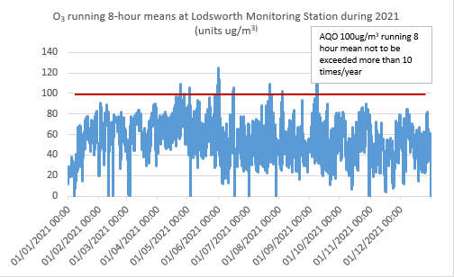

The air quality monitoring station at Lodsworth has had to be decommissioned as the air conditioning unit failed in early 2022.

# Appendix A: Monitoring Results

Table A.1 – Details of Automatic Monitoring Sites

| Site ID | Site Name | Site Type | X OS Grid Ref (Easting) | Y OS Grid Ref (Northing) | Pollutants Monitored | In AQMA?  Which AQMA? | Monitoring Technique | Distance to Relevant Exposure (m) (1) | Distance to kerb of nearest road (m) (2) | Inlet Height (m) |
| --- | --- | --- | --- | --- | --- | --- | --- | --- | --- | --- |
| CI1 | Stockbridge | Suburban | 485881 | 103791 | NO2, PM10 | NO | Chemiluminescent; TEOM | 25 | 26 | 3 |
| CI4 | Orchard Street | Roadside | 485982 | 105221 | NO2 | YES Orchard Street AQMA | Chemiluminescent | 9.8 | 3.75 | 2 |
| AR1 | Lodsworth | Rural | 492396 | 123248 | O3 | NO | UV | n/a | n/a | 2.1 |
| CI5 | Westhampnett Road | Roadside | 487212 | 105372 | NO2 | NO | Chemiluminescent | 11.8 | 4.2 | 1.9 |

**Notes:**

(1) 0m if the monitoring site is at a location of exposure (e.g. installed on the façade of a residential property).

(2) N/A if not applicable

Table A.2 – Details of Non-Automatic Monitoring Sites

| Diffusion Tube ID | Site Name | Site Type | X OS Grid Ref (Easting) | Y OS Grid Ref (Northing) | Pollutants Monitored | In AQMA? Which AQMA? | Distance to Relevant Exposure (m) (1) | Distance to kerb of nearest road (m) (2) | Tube Co-located with a Continuous Analyser? | Tube Height (m) |
| --- | --- | --- | --- | --- | --- | --- | --- | --- | --- | --- |
| 1 | Kings Ave/SouthbankJct | Roadside | 485776 | 103961 | NO2 | No | 11.0 | 2.3 | No | 3.0 |
| 2a, 2b | Claremont Court | Roadside | 485772 | 103847 | NO2 | Yes, Stockbridge roundabout AQMA | 0.0 | 7.5 | No | 3.0 |
| 3, 4, 5 | Cabin | Suburban | 485880 | 103791 | NO2 | No | 25.0 | 26.0 | Yes | 2.7 |
| 6 | Stockbridge Road South | Urban Background | 485696 | 103731 | NO2 | No | 14.0 | 2.0 | No | 2.9 |
| 7 | Cleveland Rd | Roadside | 486953 | 104414 | NO2 | No | 18.0 | 1.8 | No | 2.8 |
| 8 | Westhampnett Road | Roadside | 487341 | 105474 | NO2 | No | 3.0 | 1.7 | No | 2.9 |
| 9a, 9b | Hornet | Roadside | 486502 | 104795 | NO2 | No | 0.0 | 1.8 | No | 3.1 |
| 10a, 10b | St Pancras | Roadside | 486533 | 104860 | NO2 | Yes, St Pancras AQMA | 0.0 | 2.0 | No | 3.0 |
| 11 | Arthur Purchase | Urban Background | 486082 | 105026 | NO2 | No | 0.0 | 6.0 | No | 2.7 |
| 12a, 12b | 174 Orchard St | Roadside | 485914 | 105185 | NO2 | Yes, Orchard St AQMA | 0.0 | 2.0 | No | 2.7 |
| 13a, 13b | Rumbolds Hill | Roadside | 488561 | 121479 | NO2 | Yes, Rumbolds Hill AQMA | 0.5 | 1.5 | No | 3.4 |
| 14 | Sussex Cleaners | Roadside | 486575 | 104799 | NO2 | No | 0.0 | 1.8 | No | 3.0 |
| 15 | Nag's Head | Roadside | 486495 | 104845 | NO2 | Yes, St Pancras AQMA | 0.0 | 2.4 | No | 3.2 |
| 16 | Orchard St Cabin | Roadside | 485982 | 105221 | NO2 | Yes, Orchard St AQMA | 9.8 | 3.8 | Yes | 2.0 |
| 17 | Midhurst Stationery | Roadside | 488545 | 121434 | NO2 | Yes, Rumbolds Hill AQMA | 1.8 | 0.6 | No | 2.8 |
| 18 | Nat West Bank | Roadside | 488583 | 121512 | NO2 | Yes, Rumbolds Hill AQMA | 9.9 | 1.1 | No | 3.0 |
| 19 | Nationwide | Roadside | 488605 | 121538 | NO2 | Yes, Rumbolds Hill AQMA | 0.5 | 2.2 | No | 2.7 |
| 20 | British Heart Foundation | Roadside | 488636 | 121613 | NO2 | No | 0.0 | 3.8 | No | 2.8 |
| 21 | Whyke Road | Roadside | 486899 | 103720 | NO2 | No | 20.0 | 1.7 | No | 2.4 |
| 22 | St Pauls Road | Roadside | 485957 | 105334 | NO2 | No | 0.0 | 2.1 | No | 2.1 |

**Notes:**

(1) 0m if the monitoring site is at a location of exposure (e.g. installed on the façade of a residential property).

(2) N/A if not applicable.

Table A.3 – Annual Mean NO2 Monitoring Results: Automatic Monitoring (µg/m3)

| Site ID | X OS Grid Ref (Easting) | Y OS Grid Ref (Northing) | Site Type | Valid Data Capture for Monitoring Period (%) (1) | Valid Data Capture 2021 (%) (2) | 2017 | 2018 | 2019 | 2020 | 2021 |
| --- | --- | --- | --- | --- | --- | --- | --- | --- | --- | --- |
| CI1 | 485881 | 103791 | Suburban |  | 99 | 33 | 29 | 28 | 23 | 24 |
| CI4 | 485982 | 105221 | Roadside |  | 93 | 23 | 22 | 21 | 16 | 18 |
| CI5 | 487212 | 105372 | Roadside |  | 91 |  |  | 27 | 19 | 23 |

**Reported concentrations are those at the location of the monitoring site (annualised, as required), i.e. prior to any fall-off with distance correction.**

**Notes:**

The annual mean concentrations are presented as µg/m3.

Exceedances of the NO2 annual mean objective of 40µg/m3 are shown in **bold**.

All means have been “annualised” as per LAQM.TG16 if valid data capture for the full calendar year is less than 75%. See Appendix C for details.

Concentrations are those at the location of monitoring and not those following any fall-off with distance adjustment.

(1) Data capture for the monitoring period, in cases where monitoring was only carried out for part of the year.

(2) Data capture for the full calendar year (e.g. if monitoring was carried out for 6 months, the maximum data capture for the full calendar year is 50%).

Table A.4 – Annual Mean NO2 Monitoring Results: Non-Automatic Monitoring (µg/m3)

| Diffusion Tube ID | X OS Grid Ref (Easting) | Y OS Grid Ref (Northing) | Site Type | Valid Data Capture for Monitoring Period (%) (1) | Valid Data Capture 2021 (%) (2) | 2017 | 2018 | 2019 | 2020 | 2021 |
| --- | --- | --- | --- | --- | --- | --- | --- | --- | --- | --- |
| 1 | 485776 | 103961 | Roadside | 100 | 100.0 | 29.0 | 27.0 | 25.0 | 20.8 | 22.9 |
| 2a, 2b | 485772 | 103847 | Roadside | 100 | 100.0 | 39.0 | 33.0 | 33.0 | 27.2 | 29.2 |
| 3, 4, 5 | 485880 | 103791 | Suburban | 100 | 100.0 | 33.0 | 29.0 | 28.0 | 24.4 | 24.1 |
| 6 | 485696 | 103731 | Urban Background | 100 | 100.0 | 36.0 | 34.0 | 33.0 | 27.9 | 31.6 |
| 7 | 486953 | 104414 | Roadside | 100 | 100.0 | 16.0 | 15.0 | 14.0 | 11.7 | 12.8 |
| 8 | 487341 | 105474 | Roadside | 100 | 100.0 | 30.0 | 29.0 | 27.0 | 21.6 | 23.4 |
| 9a, 9b | 486502 | 104795 | Roadside | 100 | 100.0 | 38.0 | 36.0 | 34.0 | 26.9 | 30.4 |
| 10a, 10b | 486533 | 104860 | Roadside | 100 | 100.0 | **44.0** | **45.0** | **42.0** | 33.3 | 37.5 |
| 11 | 486082 | 105026 | Urban Background | 100 | 100.0 | 18.0 | 17.0 | 17.0 | 13.1 | 14.5 |
| 12a, 12b | 485914 | 105185 | Roadside | 100 | 100.0 | 33.0 | 33.0 | 30.0 | 21.5 | 25.1 |
| 13a, 13b | 488561 | 121479 | Roadside | 100 | 100.0 | **49.0** | **42.0** | **40.0** | 33.5 | 36.0 |
| 14 | 486575 | 104799 | Roadside | 100 | 100.0 |  | 32.0 | 31.0 | 25.6 | 25.1 |
| 15 | 486495 | 104845 | Roadside | 100 | 100.0 |  | 38.0 | 37.0 | 28.3 | 33.0 |
| 16 | 485982 | 105221 | Roadside | 100 | 100.0 |  | 22.0 | 20.0 | 15.5 | 17.2 |
| 17 | 488545 | 121434 | Roadside | 100 | 100.0 |  | 28.0 | 26.0 | 22.0 | 24.2 |
| 18 | 488583 | 121512 | Roadside | 100 | 100.0 |  | 37.0 | 37.0 | 30.2 | 33.3 |
| 19 | 488605 | 121538 | Roadside | 90.7 | 90.7 |  | 38.0 | 33.0 | 29.0 | 29.8 |
| 20 | 488636 | 121613 | Roadside | 100 | 100.0 |  | 27.0 | 24.0 | 18.7 | 20.3 |
| 21 | 486899 | 103720 | Roadside | 100 | 100.0 |  |  |  | 25.1 | 28.0 |
| 22 | 485957 | 105334 | Roadside | 100 | 100.0 |  |  |  | 17.0 | 20.8 |

**Diffusion tube data has been bias adjusted.**

**Reported concentrations are those at the location of the monitoring site (bias adjusted and annualised, as required), i.e. prior to any fall-off with distance correction.**

**Notes:**

The annual mean concentrations are presented as µg/m3.

Exceedances of the NO2 annual mean objective of 40µg/m3 are shown in **bold**.

NO2 annual means exceeding 60µg/m3, indicating a potential exceedance of the NO2 1-hour mean objective are shown in **bold and underlined**.

Means for diffusion tubes have been corrected for bias. All means have been “annualised” as per LAQM.TG16 if valid data capture for the full calendar year is less than 75%. See Appendix C for details.

Concentrations are those at the location of monitoring and not those following any fall-off with distance adjustment.

(1) Data capture for the monitoring period, in cases where monitoring was only carried out for part of the year.

(2) Data capture for the full calendar year (e.g. if monitoring was carried out for 6 months, the maximum data capture for the full calendar year is 50%).

Figure A.1 – Trends in Annual Mean NO2 Concentrations (monitoring stations and diffusion tube sites)

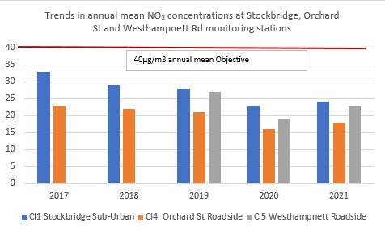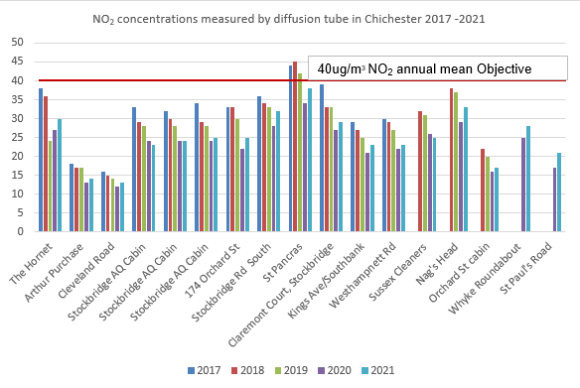

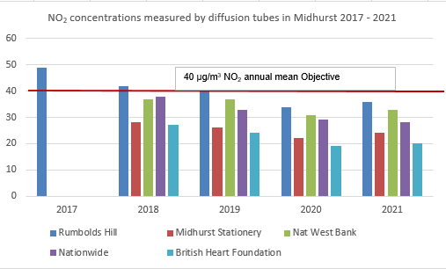

Table A.5 – 1-Hour Mean NO2 Monitoring Results, Number of 1-Hour Means > 200µg/m3

| Site ID | X OS Grid Ref (Easting) | Y OS Grid Ref (Northing) | Site Type | Valid Data Capture for Monitoring Period (%) (1) | Valid Data Capture 2021 (%) (2) | 2017 | 2018 | 2019 | 2020 | 2021 |
| --- | --- | --- | --- | --- | --- | --- | --- | --- | --- | --- |
| CI1 | 485881 | 103791 | Suburban |  | 99 | 0 | 0 | 0 | 0 | 0 |
| CI4 | 485982 | 105221 | Roadside |  | 93 | 0 | 0 | 0 | 0 | 0 |
| CI5 | 487212 | 105372 | Roadside |  | 91 |  |  | 0 | 0 | 0 |

**Notes:**

Results are presented as the number of 1-hour periods where concentrations greater than 200µg/m3 have been recorded.

Exceedances of the NO2 1-hour mean objective (200µg/m3 not to be exceeded more than 18 times/year) are shown in **bold**.

If the period of valid data is less than 85%, the 99.8th percentile of 1-hour means is provided in brackets.

(1) Data capture for the monitoring period, in cases where monitoring was only carried out for part of the year.

(2) Data capture for the full calendar year (e.g. if monitoring was carried out for 6 months, the maximum data capture for the full calendar year is 50%).

Figure A.2 – Trends in Number of NO2 1-Hour Means > 200µg/m3(no exceedance of 200µg/m3)

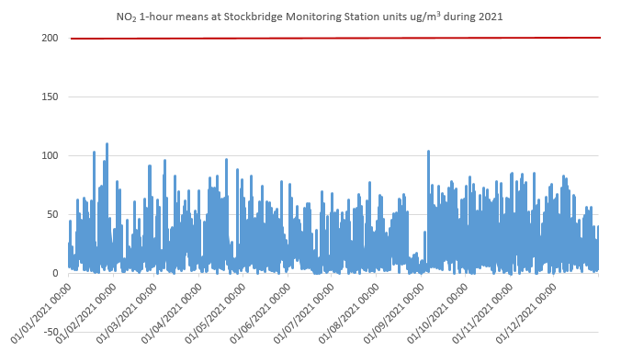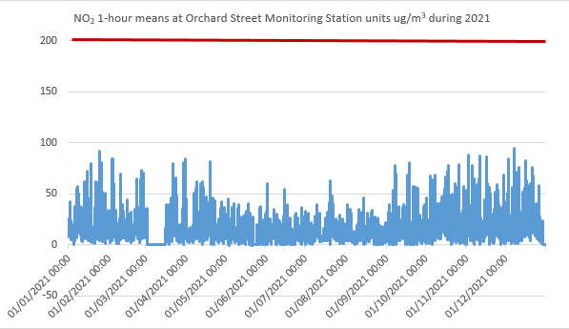

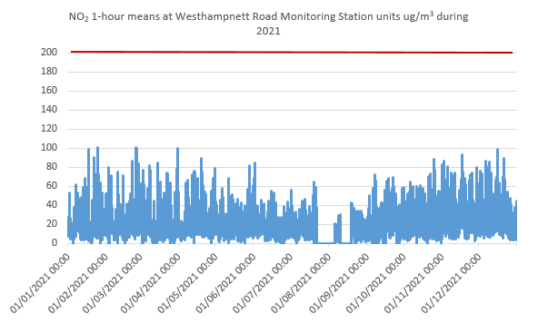

Table A.6 – Annual Mean PM10 Monitoring Results (µg/m3)

| Site ID | X OS Grid Ref (Easting) | Y OS Grid Ref (Northing) | Site Type | Valid Data Capture for Monitoring Period (%) (1) | Valid Data Capture 2021 (%) (2) | 2017 | 2018 | 2019 | 2020 | 2021 |
| --- | --- | --- | --- | --- | --- | --- | --- | --- | --- | --- |
| CI1 | 485881 | 103791 | Suburban |  | 99 | 19 | 18 | 19 | 18 | 20 |

**Notes:**

The annual mean concentrations are presented as µg/m3.

Exceedances of the PM10 annual mean objective of 40µg/m3 are shown in **bold**.

All means have been “annualised” as per LAQM.TG16 if valid data capture for the full calendar year is less than 75%. See Appendix C for details.

(1) Data capture for the monitoring period, in cases where monitoring was only carried out for part of the year.

(2) Data capture for the full calendar year (e.g. if monitoring was carried out for 6 months, the maximum data capture for the full calendar year is 50%).

Figure A.3 – Trends in Annual Mean PM10 Concentrations

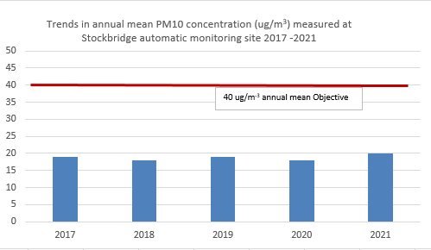

Table A.7 – 24-Hour Mean PM10 Monitoring Results, Number of PM10 24-Hour Means > 50µg/m3

| Site ID | X OS Grid Ref (Easting) | Y OS Grid Ref (Northing) | Site Type | Valid Data Capture for Monitoring Period (%) (1) | Valid Data Capture 2021 (%) (2) | 2017 | 2018 | 2019 | 2020 | 2021 |
| --- | --- | --- | --- | --- | --- | --- | --- | --- | --- | --- |
| CI1 | 485881 | 103791 | Suburban |  | 99 | 1 | 0 | 0 | 0 | 0 |

**Notes:**

Results are presented as the number of 24-hour periods where daily mean concentrations greater than 50µg/m3 have been recorded.

Exceedances of the PM10 24-hour mean objective (50µg/m3 not to be exceeded more than 35 times/year) are shown in **bold**.

If the period of valid data is less than 85%, the 90.4th percentile of 24-hour means is provided in brackets.

(1) Data capture for the monitoring period, in cases where monitoring was only carried out for part of the year.

(2) Data capture for the full calendar year (e.g. if monitoring was carried out for 6 months, the maximum data capture for the full calendar year is 50%).

Figure A.4 – Trends in Number of 24-Hour Mean PM10 Results > 50µg/m3

No exceedances of Objective 50µg/m3 during 2021

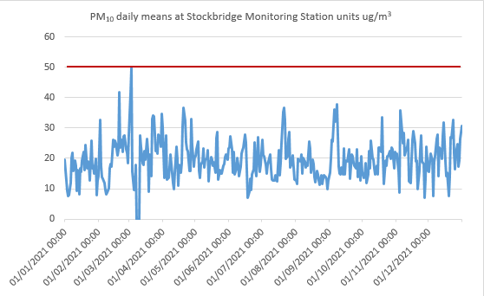

# Appendix B: Full Monthly Diffusion Tube Results for 2021

Table B.1 – NO2 2021 Diffusion Tube Results (µg/m3)

| DT ID | X OS Grid Ref (Easting) | Y OS Grid Ref (Northing) | Jan | Feb | Mar | Apr | May | Jun | Jul | Aug | Sep | Oct | Nov | Dec | Annual Mean: Raw Data | Annual Mean: Annualised and Bias Adjusted (0.83) | Annual Mean: Distance Corrected to Nearest Exposure | Comment |
| --- | --- | --- | --- | --- | --- | --- | --- | --- | --- | --- | --- | --- | --- | --- | --- | --- | --- | --- |
| 1 | 485776 | 103961 | 29.2 | 24.9 | 28.0 | 23.1 | 28.1 | 27.0 | 26.7 | 24.6 | 30.5 | 32.6 | 30.3 | 26.9 | 27.6 | 22.9 |  |  |
| 2a | 485772 | 103847 | 35.7 | 32.2 | 35.4 | 32.8 | 37.8 | 34.2 | 35.5 | 29.8 | 39.7 | 39.3 | 40.4 | 34.2 | - | **-** |  | Duplicate Site with 2a and 2b - Annual data provided for 2b only |
| 2b | 485772 | 103847 | 35.9 | 33.4 | 35.0 | 33.5 | 37.7 | 35.7 | 36.0 | 29.0 | 39.0 | 35.9 | 39.2 | 30.0 | 35.2 | 29.2 |  | Duplicate Site with 2a and 2b - Annual data provided for 2b only |
| 3 | 485880 | 103791 | 22.3 | 27.8 | 27.3 | 23.6 | 28.0 | 28.1 | 29.5 | 27.1 | 30.5 | 31.5 | 35.7 | 28.6 | - | **-** |  | Triplicate Site with 3, 4 and 5 - Annual data provided for 5 only |
| 4 | 485880 | 103791 | 31.6 | 27.0 | 27.1 | 24.5 | 29.6 | 27.1 | 30.6 | 26.8 | 30.3 | 33.8 | 32.0 | 27.8 | - | **-** |  | Triplicate Site with 3, 4 and 5 - Annual data provided for 5 only |
| 5 | 485880 | 103791 | 31.4 | 26.6 | 31.9 | 24.1 | 29.9 | 27.0 | 30.6 | 27.1 | 35.6 | 33.6 | 31.8 | 27.0 | 29.0 | 24.1 |  | Triplicate Site with 3, 4 and 5 - Annual data provided for 5 only |
| 6 | 485696 | 103731 | 42.1 | 40.0 | 38.9 | 43.9 | 35.6 | 35.6 | 35.9 | 36.5 | 36.0 | 32.9 | 46.6 | 37.3 | 38.1 | 31.6 |  |  |
| 7 | 486953 | 104414 | 21.0 | 20.5 | 18.5 | 13.1 | 10.4 | 13.7 | 11.9 | 9.1 | 16.0 | 14.4 | 20.7 | 18.0 | 15.4 | 12.8 |  |  |
| 8 | 487341 | 105474 | 27.1 | 28.9 | 30.7 | 24.9 | 25.5 | 27.4 | 24.9 | 24.2 | 32.6 | 29.4 | 34.1 | 30.7 | 28.2 | 23.4 |  |  |
| 9a | 486502 | 104795 | 36.2 | 30.2 | 37.3 | 36.8 | 33.1 | 33.7 | 32.2 | 34.3 | 42.1 | 37.1 | 51.9 | 39.0 | - | **-** |  | Duplicate Site with 9a and 9b - Annual data provided for 9b only |
| 9b | 486502 | 104795 | 36.4 | 33.4 | 35.9 | 37.3 | 29.9 | 32.5 | 32.3 | 35.5 | 41.4 | 36.8 | 53.9 | 37.0 | 36.6 | 30.4 |  | Duplicate Site with 9a and 9b - Annual data provided for 9b only |
| 10a | 486533 | 104860 | 37.0 | 46.2 | 42.0 | 39.2 | 45.1 | 47.9 | 50.4 | 42.2 | 54.8 | 41.7 | 50.8 | 42.9 | - | **-** |  | Duplicate Site with 10a and 10b - Annual data provided for 10b only |
| 10b | 486533 | 104860 | 34.4 | 41.1 | 44.0 | 42.7 | 49.7 | 48.0 | 49.7 | 44.6 | 57.2 | 44.6 | 47.2 | 45.5 | 45.2 | 37.5 |  | Duplicate Site with 10a and 10b - Annual data provided for 10b only |
| 11 | 486082 | 105026 | 23.3 | 20.7 | 19.2 | 15.7 | 14.1 | 15.8 | 15.5 | 13.2 | 16.5 | 14.4 | 24.5 | 19.9 | 17.5 | 14.5 |  |  |
| 12a | 485914 | 105185 | 28.5 | 32.4 | 27.1 | 28.1 | 25.2 | 28.2 | 28.2 | 21.5 | 37.4 | 31.9 | 35.1 | 32.0 | - | **-** |  | Duplicate Site with 12a and 12b - Annual data provided for 12b only |
| 12b | 485914 | 105185 | 29.0 | 32.8 | 28.9 | 27.8 | 27.8 | 28.7 | 29.6 | 23.9 | 37.6 | 33.3 | 37.1 | 33.5 | 30.2 | 25.1 |  | Duplicate Site with 12a and 12b - Annual data provided for 12b only |
| 13a | 488561 | 121479 | 45.3 | 39.2 | 45.0 | 42.8 | 43.2 | 44.6 | 37.4 | 42.9 | 44.6 | 44.8 | 55.8 | 43.2 | - | **-** |  | Duplicate Site with 13a and 13b - Annual data provided for 13b only |
| 13b | 488561 | 121479 | 38.9 | 39.8 | 44.6 | 42.4 | 40.1 | 46.2 | 42.2 | 41.9 | 46.7 | 41.8 | 59.1 | 38.6 | 43.4 | 36.0 | 34.6 | Duplicate Site with 13a and 13b - Annual data provided for 13b only |
| 14 | 486575 | 104799 | 29.2 | 25.1 | 27.4 | 24.6 | 32.2 | 30.5 | 32.0 | 26.6 | 35.7 | 33.5 | 30.2 | 33.9 | 30.2 | 25.1 |  |  |
| 15 | 486495 | 104845 | 38.4 | 34.2 | 40.4 | 39.6 | 36.8 | 40.8 | 37.5 | 38.4 | 45.4 | 39.9 | 51.8 | 37.9 | 39.8 | 33.0 |  |  |
| 16 | 485982 | 105221 | 25.1 | 22.8 | 24.6 | 20.8 | 16.4 | 17.8 | 16.7 | 15.1 | 21.1 | 20.8 | 25.1 | 23.2 | 20.7 | 17.2 |  |  |
| 17 | 488545 | 121434 | 28.9 | 27.9 | 34.0 | 32.8 | 26.4 | 29.5 | 26.6 | 26.6 | 30.5 | 27.4 | 33.9 | 27.2 | 29.1 | 24.2 |  |  |
| 18 | 488583 | 121512 | 39.7 | 36.2 | 43.2 | 37.8 | 39.5 | 41.6 | 41.7 | 38.2 | 43.0 | 39.6 | 44.5 | 38.7 | 40.1 | 33.3 |  |  |
| 19 | 488605 | 121538 | 36.5 | 34.0 | 36.8 |  | 32.1 | 36.8 | 35.2 | 32.7 | 42.6 | 36.1 | 38.5 | 35.0 | 35.9 | 29.8 |  |  |
| 20 | 488636 | 121613 | 23.2 | 29.3 | 22.6 | 27.7 | 23.8 | 24.9 | 21.6 | 22.7 | 28.7 | 21.7 | 25.1 | 23.3 | 24.4 | 20.3 |  |  |
| 21 | 486899 | 103720 | 31.0 | 33.9 | 31.6 | 29.5 | 31.2 | 35.3 | 37.5 | 32.2 | 42.6 | 33.5 | 34.9 | 32.9 | 33.8 | 28.0 |  |  |
| 22 | 485957 | 105334 | 27.4 | 28.9 | 28.5 | 25.7 | 19.7 | 23.0 | 22.8 | 17.9 | 26.6 | 25.1 | 30.8 | 26.0 | 25.1 | 20.8 |  |  |

**All erroneous data has been removed from the NO2 diffusion tube dataset presented in Table B.1.**

**Local bias adjustment factor used**

**Where applicable, data has been distance corrected for relevant exposure in the final column**

**CDC confirms that all 2021 diffusion tube data has been uploaded to the Diffusion Tube Data Entry System**

**Notes:**

Exceedances of the NO2 annual mean objective of 40µg/m3 are shown in **bold**.

NO2 annual means exceeding 60µg/m3, indicating a potential exceedance of the NO2 1-hour mean objective are shown in **bold and underlined**.

See Appendix C for details on bias adjustment and annualisation.

# Appendix C: Supporting Technical Information / Air Quality Monitoring Data QA/QC

## New or Changed Sources Identified Within Chichester District During 2021

CDC has not identified any new sources relating to air quality within the reporting year of 2021.

## Additional Air Quality Works Undertaken by Chichester District Council During 2021

CDC has revoked the AQMAs at Orchard Street and Stockbridge Roundabout during 2022.

CDC revised its AQAP in 2021 and the document is available on the website see link below:

## QA/QC of Diffusion Tube Monitoring

Chichester District Council uses Gradko Environmental for supplying and analysing the diffusion tubes. The tube preparation method is 50% TEA/Acetone and ANA UKAS Method GLM7 and GLM9. CDC uses a local bias adjustment factor. The monitoring was completed in adherence with the 2021 Diffusion Tube Monitoring Calendar except for the months of October and November when the exposure varied from the recommended period due to the CDC operator contracting Covid 19.

Gradko Environmental uses the AIR NO2 Proficiency Testing scheme for quality control. The result for 2021 was Satisfactory (Z score +/- 2) for 75% of results submitted (note not all testing was achieved in 2021 due to the Covid 19 pandemic).

### Diffusion Tube Annualisation

All diffusion tube monitoring locations within Chichester District recorded data capture of 75% therefore it was not required to annualise any monitoring data. In addition, any sites with a data capture below 25% do not require annualisation.

### Diffusion Tube Bias Adjustment Factors

The diffusion tube data presented within the 2021 ASR have been corrected for bias using an adjustment factor. Bias represents the overall tendency of the diffusion tubes to under or over-read relative to the reference chemiluminescence analyser. LAQM.TG16 provides guidance with regard to the application of a bias adjustment factor to correct diffusion tube monitoring. Triplicate co-location studies can be used to determine a local bias factor based on the comparison of diffusion tube results with data taken from NOx/NO2 continuous analysers. Alternatively, the national database of diffusion tube co-location surveys provides bias factors for the relevant laboratory and preparation method.

Chichester District Council has applied a local bias adjustment factor of 0.83 to the 2021 monitoring data. A summary of bias adjustment factors used by CDC over the past five years is presented in Table C.1.

There are three diffusion tubes co-located with the Stockbridge (CI1) continuous analyser which are used to derive the local bias adjustment factor.

Table C.1 – Bias Adjustment Factor

|  |  |  |  |
| --- | --- | --- | --- |
| Monitoring Year | Local or National | If National, Version of National Spreadsheet | Adjustment Factor |
| **2021** | Local |  | 0.83 |
| **2020** | Local |  | 0.79 |
| **2019** | Local |  | 0.84 |
| **2018** | Local |  | 0.85 |
| **2017** | Local |  | 0.93 |

### NO2 Fall-off with Distance from the Road

Wherever possible, monitoring locations are representative of exposure. However, where this is not possible, the NO2 concentration at the nearest location relevant for exposure has been estimated using the Diffusion Tube Data Processing Tool/NO2 fall-off with distance calculator available on the LAQM Support website. Where appropriate, non-automatic annual mean NO2 concentrations corrected for distance are presented in Table B.1.

At one site, Rumbolds Hill (in Midhurst) site 13a/13b, a fall off with distance calculation was required see Table C.4

## QA/QC of Automatic Monitoring

All sites are visited by a CDC officer for calibration and filter changes on a bi-monthly basis. CDC has a service agreement with a third party who provides site maintenance, auditing, regular inspections and 48 call-out response if problems are encountered. Data is downloaded from all sites twice daily by ERG[9] and is available to download online[10]. CDC has a contract with ERG to calibrate and ratify all real time data collected. Data presented in the report has been ratified.

### PM10 and PM2.5 Monitoring Adjustment

ERG applies an approved Volatile Correction Model (VCM) correction to the PM10 data (further details are available from ERG).

### Automatic Monitoring Annualisation

All automatic monitoring locations within Chichester District recorded data capture of greater than 75% therefore it was not required to annualise any monitoring data. In addition, any sites with a data capture below 25% do not require annualisation.

### NO2 Fall-off with Distance from the Road

Wherever possible, monitoring locations are representative of exposure. However, where this is not possible, the NO2 concentration at the nearest location relevant for exposure has been estimated using the NO2 fall-off with distance calculator available on the LAQM Support website. Where appropriate, non-automatic annual mean NO2 concentrations corrected for distance are presented in Table B.1.

No automatic NO2 monitoring locations within Chichester District required distance correction during 2021.

Table C.2 – Annualisation Summary (concentrations presented in µg/m3)

No annualisation required.

Table C.3 – Local Bias Adjustment Calculation

|  | Local Bias Adjustment Input 1 | Local Bias Adjustment Input 2 | Local Bias Adjustment Input 3 | Local Bias Adjustment Input 4 | Local Bias Adjustment Input 5 |
| --- | --- | --- | --- | --- | --- |
| **Periods used to calculate bias** | 12 |
| **Bias Adjustment Factor A** | 0.83 (0.79 - 0.88) |
| **Diffusion Tube Bias B** | 20% (13% - 27%) |
|  |  |
| **Diffusion Tube Mean (µg/m3)** | 29.0 |
| **Mean CV (Precision)** | 5.3% |
|  |  |
| **Automatic Mean (µg/m3)** | 24.2 |
| **Data Capture** | 98% |
|  |  |
| **Adjusted Tube Mean (µg/m3)** | 24 (23 - 26) |
|  |  |
| **Overall Diffusion Tube Precision** | **Good Overall Precision** |
| **Overall Continuous Monitor Data Capture** | **Good Overall Data Capture** |
|  |  |
| **Local Bias Adjustment Factor** | **0.83** |

**Notes:**

A single local bias adjustment factor has been used to bias adjust the 2021 diffusion tube results.

Table C.4 – NO2 Fall off With Distance Calculations (concentrations presented in µg/m3)

| Site ID | Distance (m): Monitoring Site to Kerb | Distance (m): Receptor to Kerb | Monitored Concentration (Annualised and Bias Adjusted | Background Concentration | Concentration Predicted at Receptor | Comments |
| --- | --- | --- | --- | --- | --- | --- |
| 13a, 13b | 1.5 | 2.0 | 36.0 | 12.8 | 34.6 |  |

# Appendix D: Maps of Monitoring Locations and AQMAs

Figure D.1 – Map of Non-Automatic Monitoring Sites in Chichester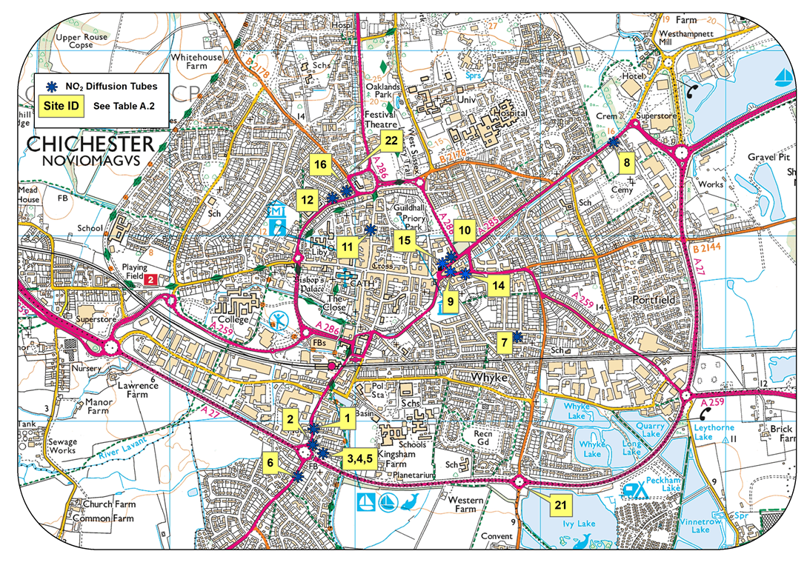

© Crown Copyright and database right 2020. Ordnance Survey 100018803

Figure D.2 – Map of Automatic and Non-Automatic Monitoring Sites at Stockbridge Roundabout AQMA, Chichester

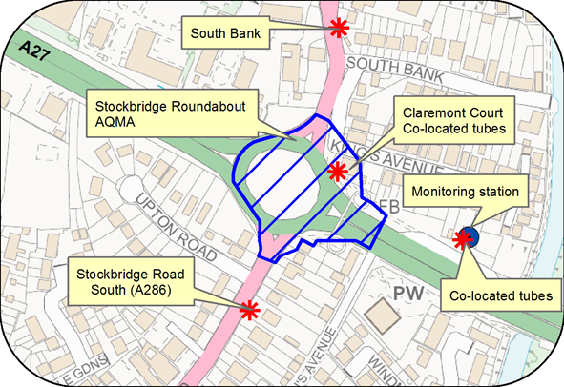

© Crown Copyright and database right 2021. Ordnance Survey 100018803

Figure D.3 – Map of Non-Automatic Monitoring Sites at St Pancras AQMA, Chichester

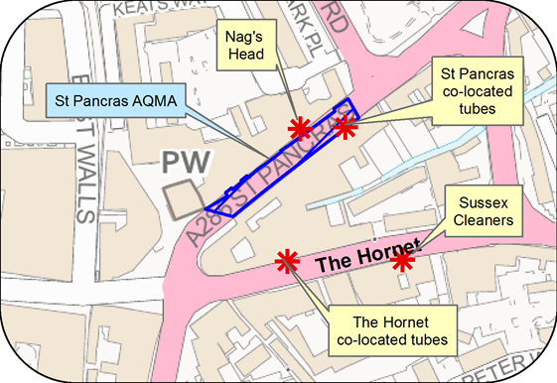

© Crown Copyright and database right 2021. Ordnance Survey 100018803

Figure D.4 – Map of Automatic and Non-Automatic Monitoring Sites at Orchard Street AQMA, Chichester

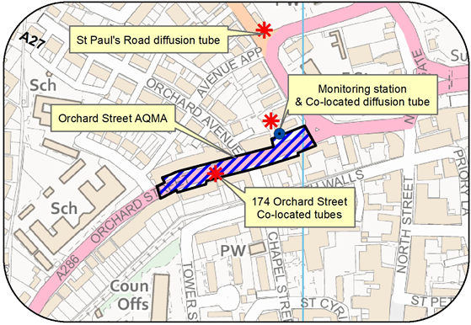

© Crown Copyright and database right 2021. Ordnance Survey 100018803

Figure D.5 – Map of Automatic and Non-Automatic Monitoring Sites at Westhampnett Road, Chichester

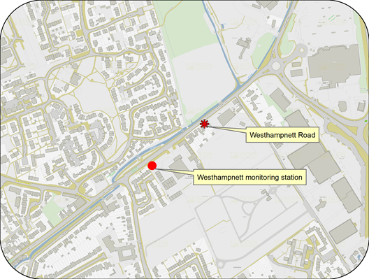

© Crown Copyright and database right 2021. Ordnance Survey 100018803

Figure D.6 – Map of Ozone Automatic Monitoring Site at Lodsworth

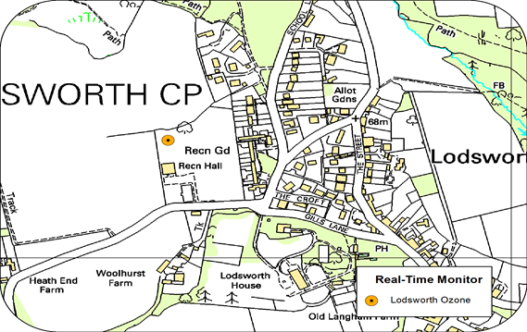

© Crown Copyright and database right 2021. Ordnance Survey 100018803

Figure D.7 – Map of Non Automatic Monitoring Sites at Rumbolds Hill AQMA, Midhurst

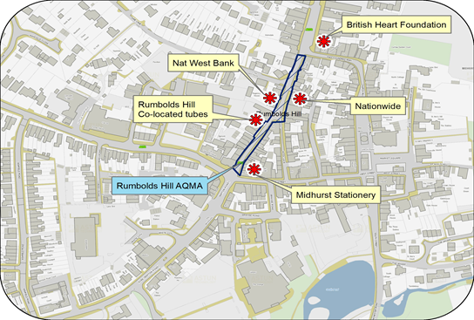

© Crown Copyright and database right 2021. Ordnance Survey 100018803

# Appendix E: Summary of Air Quality Objectives in England

Table E.1 – Air Quality Objectives in England[11]

| Pollutant | Air Quality Objective: Concentration | Air Quality Objective: Measured as |
| --- | --- | --- |
| Nitrogen Dioxide (NO2) | 200µg/m3 not to be exceeded more than 18 times a year | 1-hour mean |
| Nitrogen Dioxide (NO2) | 40µg/m3 | Annual mean |
| Particulate Matter (PM10) | 50µg/m3, not to be exceeded more than 35 times a year | 24-hour mean |
| Particulate Matter (PM10) | 40µg/m3 | Annual mean |
| Sulphur Dioxide (SO2) | 350µg/m3, not to be exceeded more than 24 times a year | 1-hour mean |
| Sulphur Dioxide (SO2) | 125µg/m3, not to be exceeded more than 3 times a year | 24-hour mean |
| Sulphur Dioxide (SO2) | 266µg/m3, not to be exceeded more than 35 times a year | 15-minute mean |

# Glossary of Terms

| Abbreviation | Description |
| --- | --- |
| AQAP | Air Quality Action Plan - A detailed description of measures, outcomes, achievement dates and implementation methods, showing how the local authority intends to achieve air quality limit values’ |
| AQMA | Air Quality Management Area – An area where air pollutant concentrations exceed / are likely to exceed the relevant air quality objectives. AQMAs are declared for specific pollutants and objectives |
| ASR | Annual Status Report |
| CCTV | Closed circuit television |
| CDC | Chichester District Council |
| Defra | Department for Environment, Food and Rural Affairs |
| DMRB | Design Manual for Roads and Bridges – Air quality screening tool produced by National Highways |
| EU | European Union |
| EV | Electric vehicle |
| FDMS | Filter Dynamics Measurement System |
| HE | Highways England |
| IAAQG | Inter Authority Air Quality Group |
| LAQM | Local Air Quality Management |
| LES | Low Emissions Strategy |
| MOVA | Microprocessor Optimised Vehicle Actuation |
| NHS | National Health Service |
| NO2 | Nitrogen Dioxide |
| NOx | Nitrogen Oxides |
| OLEV | Office of Low Emission Vehicles |
| O3 | Ozone |
| PM10 | Airborne particulate matter with an aerodynamic diameter of 10µm or less |
| PM2.5 | Airborne particulate matter with an aerodynamic diameter of 2.5µm or less |
| QA/QC | Quality Assurance and Quality Control |
| RTPI | Real Time Passenger Information |
| SAQP | Sussex Air Quality Partnership |
| SO2 | Sulphur Dioxide |
| UTC | Urban Transport Controls |
| VCM | Volatile correction measurement |
| VMS | Variable message signing |
| WSCC | West Sussex County Council |

# References

* Local Air Quality Management Technical Guidance LAQM.TG16. April 2021. Published by Defra in partnership with the Scottish Government, Welsh Assembly Government and Department of the Environment Northern Ireland.
* Local Air Quality Management Policy Guidance LAQM.PG16. May 2016. Published by Defra in partnership with the Scottish Government, Welsh Assembly Government and Department of the Environment Northern Ireland.
* West Sussex Walking and Cycling Strategy 2016 – 2026 produced by WSCC.
* Chichester City Local Cycling and Walking Infrastructure Plan 2021 produced by Transport Initiatives and PJA.
* Revised CDC Air Quality Action Plan 2021 – 2026 produced by CDC February 2021.

1. Public Health England. Air Quality: A Briefing for Directors of Public Health, 2017
2. Defra. Air quality and social deprivation in the UK: an environmental inequalities analysis, 2006
3. Defra. Air quality appraisal: damage cost guidance, July 2021
4. Public Health England. Estimation of costs to the NHS and social care due to the health impacts of air pollution: summary report, May 2018
5. Strategic Transport Investment Programme
6. Local Transport Improvement Programme
7. Defra. Clean Air Strategy, 2019
8. DfT. The Road to Zero: Next steps towards cleaner road transport and delivering our Industrial Strategy, July 2018
9. The Environmental Research Group (ERG) part of the School of Biomedical and Health Sciences at Imperial College London, a leading provider of air quality information and research in the UK
10. www.sussex-air.net
11. The units are in microgrammes of pollutant per cubic metre of air (µg/m3).