
Chichester Air Quality Action Plan Review - 2020
Report 2: Scenario modelling
February 2022

Chichester District Council
East Pallant
Chichester
West Sussex PO19 1TY
Document Control:
Project no. | Project
8276 | Chichester Air Quality Action Plan Review - 2019/2020

Ver/rev | Written By: | Checked by: | Authorised by: | Date
R2v01 (draft) | N. Jenkins/ H. Parfitt | R. Boakes | N. Jenkins | 17/08/2020
R2V02 (update) | N. Jenkins | R. Boakes | N. Jenkins | 27/08/2020
R2V03 (update) | N. Jenkins | R. Boakes | N. Jenkins | 04/09/2020
This report has been prepared for the exclusive use of the commissioning party and may not be reproduced without prior written permission from Phlorum Limited.
All work has been carried out within the terms of the brief using all reasonable skill, care
and diligence. No liability is accepted by Phlorum for the accuracy of data or opinions provided by others in the preparation of this report, or for any use of this report other than for the purpose for which it was produced.

Phlorum Limited
Southern Office: Unit 12, Hunns Mere Way, Woodingdean, Brighton, East Sussex, BN2 6AH
T: 01273 307 167 E: info@phlorum.com W: www.phlorum.com
Contents
1. Introduction 4
2. Baseline Modelling (2020 – 2025) 7
3. Scenario Modelling (2021 – 2024) 9
4. Cost Benefit Analysis 16
5. Summary 19

Glossary
Figures
Figure 1: Chichester modelled links and receptors.
Figure 2: St Pancras AQMA and Hornet modelled links and receptors.
Figure 3: Orchard Street AQMA modelled links and receptors
Figure 4: Oving Rd/A27 Intersection modelled links and receptors.
Figure 5: Stockbridge AQMA modelled links and receptors.
Figure 6: Whyke /A27 Roundabout modelled links and receptors.
Figure 7: Midhurst modelled links and receptors
Figure 9: St Pancras and Hornet – Bus LEZ annual mean NO2 concentration contours
Figure 10: St Pancras and Hornet – 5% Modal Shift annual mean NO2 concentration contours.
Figure 11: Oving Rd/A27 Intersection – Bus LEZ annual mean NO2 concentration contours.
Figure 12: Oving Rd/A27 Intersection – 5% Modal Shift annual mean NO2 concentration contours.
Figure 13: Stockbridge AQMA – Bus LEZ annual mean NO2 concentration contours.
Figure 14: Stockbridge AQMA – 5% Modal Shift annual mean NO2 concentration contours.
Figure 15: Whyke Roundabout – Bus LEZ annual mean NO2 concentration contours.
Figure 16: Whyke Roundabout – 5% Modal Shift annual mean NO2 concentration contours
Figure 17: Midhurst – 5% Modal Shift annual mean NO2 concentration contours.
Appendices
Appendix A: Receptor locations
Appendix B: Baseline and scenario modelling results (2018 – 2025) for PM₁₀ and PM_{2.5}

- Introduction
  - Chichester District Council (CDC) commissioned Phlorum Ltd to undertake a review of air quality across their district and to assess key areas of concern for air quality. The review will contribute towards the development of a new Air Quality Action Plan (AQAP) for CDC.
  - The key priority of an AQAP is to deliver compliance with the Air Quality Standards (AQS) within all Air Quality Management Areas (AQMAs), but also to improve air quality across the district.
Baseline modelling update (2020)
  - The previous report (Report 1 v7) provided an update to the baseline air quality modelling and source apportionment study following the provision of updated bus data as provided by Stagecoach Ltd (June 2020).
  - The updated Stagecoach data identified significant differences in the ratio of Euro class buses operating in the district from those identified in the Department for Environment, Food and Rural Affairs (Defra) Emissions Factor Toolkit (EFT). This data is significant as the Euro class determines the type of emissions control system that a vehicle has fitted and the higher the Euro class number (i.e. VI/6), the cleaner the vehicle and the lower the emissions.
Summary of previous report (Report 1)
  - The baseline modelling assessment reviewed key locations across Chichester district including the existing AQMAs and locations of concern. The air quality modelling was undertaken for the years 2018 (base and model verification year), 2020 and 2025.
  - The objective of the modelling assessment is to determine if and where there are predicted exceedances of national Air Quality Objectives of the key pollutants; nitrogen dioxide (NO₂) and particulate matter (PM₁₀ and PM_{2.5}).
  - The air quality assessment identified exceedances of the NO₂ 40µg.m⁻³ annual mean AQS in 2018; this included locations within the St Pancras AQMA (receptor 10), the Hornet (9 and 15), Whyke/A27 roundabout (W1), Oving Rd/A27 intersection (O2) and Rumbold’s Hill (Midhurst) (14). The Stockbridge Roundabout AQMA (2) was predicted to be marginally below the AQS by 0.8 µg/m⁻³.
  - Predicted exceedances of the NO₂ 40µg.m⁻³ AQS in 2020, occurred in three locations in Chichester District at; St Pancras AQMA, the Hornet and at Whyke roundabout.
  - In 2025, it is predicted that all locations within Chichester District will be compliant with the NO₂ 40µg.m⁻³ annual mean AQS.
  - No exceedances of the NO₂ 40µg.m⁻³ AQS were predicted within the Orchard Street AQMA, the Stockbridge Roundabout AQMA, or on Westhampnett Road in any assessment years. Although the Stockbridge Roundabout AQMA was only marginally below the AQS in 2018.
  - No exceedances of PM₁₀ and PM_{2.5} AQS were identified at any of the modelled locations in 2018, 2020 and 2025.
  - The source apportionment study identified sources of emissions at the three key locations of concern (St Pancras AQMA, Stockbridge AQMA/A27 and Midhurst) for emissions of oxides of nitrogen (NOx) and particulates.
  - The diesel sector emissions were the dominant source for both NOx and particulate emissions in all locations assessed. Petrol and diesel fuelled cars were also identified as a major contributing source of PM₁₀ and PM_{2.5} as tyre and brake wear particulate emissions make up a more significant source of total PM emissions than exhaust emissions. As such, as there are significantly more cars than other vehicles travelling through these locations, their proportion of emissions is subsequently higher.
Report 2: AQMA scenario testing
  - The scenario testing will involve using ADMS Roads (v5.0) and introducing a percentage of non-car mode scenarios at locations identified in exceedance from 2020, as reported in Report 1, namely:
- St Pancras AQMA;
- the Hornet;
- Whyke/A27 roundabout;
- Oving Rd/A27 intersection; and
- Rumbold’s Hill (Midhurst).
  - The air quality modelling assessment for the scenarios at the above locations will follow this process:
- Undertake further baseline (do nothing/business as usual) modelling for the intermediate years, 2021 – 2024, to determine likely year of compliance with “no intervention”;
- Run model scenarios for non-compliant locations with the following intervention options:
    - Early transition of bus fleet to Euro VI (from 2021), such as could be implemented through a “Bus Low Emission Zone” (Bus LEZ) intervention in Chichester; and
    - Modal shift options;
      - 2% modal shift equivalent to 2% reduction in car journeys; and
      - 5% modal shift equivalent to 5% reduction in car journeys.
- Provide draft AQAP scenario report for discussion (R2 – Report 2)
  - Finalise Report 2 after feed-back and discussion.
Report 3
  - Finalise assessment and provide final AQAP scenario report to include:
- Simple cost and benefit assessment to prioritise measures; and
- R3 – Report 3 (including Modelling Technical Report)

- Baseline Modelling (2020 – 2025)
Predicted baseline results
NO₂ results
  - The predicted concentrations of NO₂ in a baseline (‘do nothing’) scenario are included in Table 2.1 below. Baseline year (2018) and future year results for 2020 to 2025 are presented to identify where there are predicted exceedances of the AQS and locations of concern for air quality going forward.
  - Receptor descriptions and locations are provided in Appendix A.
Table 2.1: NO₂ concentration results
Receptor | NO₂ Concentration – annual mean (µg.m⁻³)
 | 2018 | 2020 | 2021 | 2022 | 2023 | 2024 | 2025
Chichester
1 | 34.5 | 31.5 | 29.4 | 27.9 | 26.4 | 25.1 | 23.8
2 | 39.9 | 36.4 | 33.8 | 31.9 | 30.1 | 28.5 | 27.0
(3,4,5) | 31.8 | 29.1 | 27.2 | 25.8 | 24.5 | 23.3 | 22.1
6 | 34.6 | 31.5 | 29.5 | 27.9 | 26.4 | 25.1 | 23.8
8 | 32.3 | 30.4 | 29.0 | 27.9 | 26.8 | 25.8 | 24.5
9 | 41.5 | 39.0 | 37.2 | 35.8 | 34.4 | 33.1 | 31.3
10 | 50.2 | 47.0 | 44.7 | 42.6 | 40.7 | 38.8 | 36.6
12 | 36.6 | 34.4 | 32.8 | 31.6 | 30.3 | 29.2 | 27.6
CI1 | 31.8 | 29.1 | 27.2 | 25.8 | 24.5 | 23.3 | 22.1
CI4 | 24.7 | 23.4 | 22.5 | 21.8 | 21.1 | 20.5 | 19.7
15 | 40.0 | 37.6 | 35.9 | 34.6 | 33.3 | 32.0 | 30.3
W1 | 43.5 | 39.5 | 36.8 | 34.8 | 32.9 | 31.2 | 29.5
W2 | 31.3 | 28.6 | 26.8 | 25.5 | 24.3 | 23.1 | 22.0
O1 | 30.7 | 28.4 | 26.8 | 25.7 | 24.7 | 23.7 | 22.7
O2 | 42.4 | 39.0 | 36.6 | 35.0 | 33.4 | 31.9 | 30.3
Midhurst
14 | 39.9 | 36.9 | 35.4 | 33.8 | 32.6 | 31.8 | 29.1
18 | 36.2 | 33.6 | 32.2 | 30.8 | 29.6 | 28.9 | 26.6
19 | 37.7 | 34.9 | 33.4 | 32.0 | 30.9 | 30.1 | 27.6
20 | 34.7 | 32.2 | 30.9 | 29.6 | 28.5 | 27.8 | 25.6
21 | 32.6 | 30.3 | 29.1 | 27.9 | 26.9 | 26.3 | 24.2
Note:
The NO₂ annual mean AQS = 40µg.m⁻³
Receptors in bold (> AQS), receptors underlined (within 10% of AQS)

  - Table 2.1 shows that five locations are predicted to exceed the 40µg.m⁻³ long-term AQS in 2018, with five other locations within 10% of the AQS. The locations in exceedance include:
- St Pancras AQMA (receptor 10);
- locations in the Hornet (9 and 15);
- Nursing Home, Whyke Rd (W1) ; and
- 187/188 Oving Rd (O2).
  - Two locations were also predicted to be marginally under the AQS at Stockbridge Roundabout AQMA (2) and Rumbold’s Hill, Midhurst (14) plus a further three locations within 10% of the AQS in 2018.
  - Only one location was predicted to be in exceedance of the 40µg.m⁻³ AQS in 2020:
- St Pancras AQMA (receptor 10)
  - Three locations were also predicted to be marginally under the AQS, namely; the Hornet (9), Nursing Home on Whyke Rd (W1) and 187/188 Oving Rd (O2).
  - St Pancras AQMA (receptor 10) is predicted to be non-compliant until 2024, however will remain with 10% of the AQS up to and including 2025.
  - As no location is likely to exceed the annual mean of 60µg.m⁻³, no location is likely to exceed the short-term NO₂ AQS.
AQMA results
  - No exceedances of the NO₂ AQS were predicted in any assessment years at:
- Orchard Street AQMA;
- Stockbridge Roundabout AQMA; and
- Midhurst AQMA.
Particulate results
  - PM₁₀ and PM_{2.5} modelling was undertaken, and results showed no exceedance of the long or short-term AQSs in any baseline scenarios from 2018 to 2025. These results are provided in Appendix A.
- Scenario Modelling (2021 – 2024)
  - Scenario modelling was undertaken to demonstrate the potential impact of individual interventions on local air quality. Each scenario is modelled independently and presented for the following scenarios.
Chichester Bus Low Emission Zone Scenario
  - The Bus LEZ scenario modelling is based on upgrading the local Chichester bus fleet from current baseline bus Euro ratios to becoming Euro VI compliant from 2021. This scenario reflects the change in concentrations if non-compliant buses were converted to Euro VI buses. No electric or hybrid buses were modelled.
  - The Bus LEZ scenario focused on Chichester only, i.e. excludes Midhurst, as the location was predicted to be compliant by 2021.
Chichester Bus LEZ
  - The predicted concentrations of NO₂ in the Bus LEZ scenario intervention is presented for future years 2021 to 2024 in Table 3.1 below.
Table 3.1: NO₂ concentration results – Bus LEZ
Receptor | Concentration NO₂ – annual mean (µg.m⁻³)
 | 2021 | 2022 | 2023 | 2024
Chichester
1 | 29.4 | 27.6 | 26.2 | 26.1
2 | 33.7 | 31.6 | 29.8 | 29.7
(3,4,5) | 27.1 | 25.6 | 24.2 | 24.2
6 | 29.4 | 27.6 | 26.2 | 26.1
8 | 27.2 | 26.0 | 24.9 | 24.8
9 | 33.9 | 32.2 | 30.8 | 30.7
10 | 41.9 | 39.7 | 37.7 | 37.6
12 | 30.5 | 29.0 | 27.7 | 27.7
CI1 | 27.1 | 25.6 | 24.2 | 24.2
CI4 | 21.2 | 20.4 | 19.7 | 19.7
15 | 32.7 | 31.1 | 29.8 | 29.7
W1 | 36.7 | 34.4 | 32.5 | 32.4
W2 | 26.8 | 25.3 | 24.0 | 24.0
O1 | 26.5 | 25.2 | 24.1 | 24.0
O2 | 35.7 | 33.7 | 32.1 | 32.0
Note:
The NO₂ annual mean AQS = 40µg.m⁻³
Receptors in bold (> AQS), receptors underlined (within 10% of AQS)
  - Table 3.1 shows that the Chichester Bus LEZ scenario predicts only one exceedance of the AQS at St Pancras AQMA (receptor 10) in 2021.
  - The predicted change in NO₂ concentrations are presented in Table 3.2. The concentration changes presented below are the difference between the predicted baseline concentrations (Table 2.1) and the predicted scenario concentration values.
Table 3.2: NO₂ concentration change – Chichester Bus LEZ
Receptor | Concentration change NO₂ – annual mean(µg.m⁻³)
 | 2021 | 2022 | 2023 | 2024
Chichester
1 | -0.2 | -0.2 | -0.2 | -0.2
2 | -0.3 | -0.3 | -0.3 | -0.3
(3,4,5) | -0.2 | -0.2 | -0.2 | -0.2
6 | -0.2 | -0.2 | -0.2 | -0.3
8 | -1.9 | -1.9 | -1.9 | -2.0
9 | -3.5 | -3.6 | -3.7 | -3.7
10 | -2.9 | -2.9 | -3.0 | -3.0
12 | -2.5 | -2.6 | -2.6 | -2.7
CI1 | -0.2 | -0.2 | -0.2 | -0.2
CI4 | -1.4 | -1.4 | -1.4 | -1.4
15 | -3.4 | -3.4 | -3.5 | -3.5
W1 | -0.4 | -0.4 | -0.4 | -0.4
W2 | -0.3 | -0.3 | -0.3 | -0.3
O1 | -0.5 | -0.6 | -0.6 | -0.6
O2 | -1.2 | -1.3 | -1.3 | -1.3
Note: Negative values = reductions in concentration.
  - Table 3.2 shows significant reductions in predicted concentrations within Chichester at receptors 8, 9, 10, 12, 15 and O2. Concentration changes were lower at the A27 receptor locations due to the relative lower number of buses using these routes.
  - The range of concentration reductions in Chichester ware predicted to be between -0.2 µg.m⁻³ to -3.7 µg.m⁻³ (equivalent to a 0.5% - 9.25% change in concentrations in relation to the AQS).

Particulates
  - PM₁₀ and PM_{2.5} scenario modelling was undertaken, and results showed no exceedance of the long or short-term AQSs in this scenario from 2021 to 2024. These results are provided in Appendix B.
  - There was no significant change in PM₁₀ or PM_{2.5} concentrations in the Chichester Bus LEZ scenario.
Modal Shift Scenario
  - The modal shift scenarios are provided to demonstrate the impact of influencing the shift in modes of transport i.e. moving people from car journeys to more sustainable or active journeys. The scenarios proposed demonstrate a 2% and 5% modal shift which has been modelled by reducing car journeys across the district by 2% and 5%.
2% Modal Shift Scenario
  - The predicted concentrations of NO₂ in the 2% modal shift scenario are presented for future years 2021 to 2024 in Table 3.3 below.
Table 3.3: NO₂ concentration results – 2% Modal Shift Scenario.
Receptor | Concentration NO₂ – annual mean (µg.m⁻³)
 | 2021 | 2022 | 2023 | 2024
Chichester
1 | 29.4 | 27.7 | 26.3 | 24.9
2 | 33.7 | 31.7 | 29.9 | 28.3
(3,4,5) | 27.2 | 25.6 | 24.3 | 23.1
6 | 29.4 | 27.7 | 26.3 | 24.9
8 | 28.9 | 27.7 | 26.6 | 25.6
9 | 37.2 | 35.6 | 34.2 | 32.9
10 | 44.4 | 42.3 | 40.4 | 38.6
12 | 32.8 | 31.4 | 30.1 | 29.0
CI1 | 27.2 | 25.6 | 24.3 | 23.1
CI4 | 22.5 | 21.7 | 21.0 | 20.4
15 | 35.8 | 34.3 | 33.0 | 31.8
W1 | 36.8 | 34.6 | 32.7 | 31.0
W2 | 26.9 | 25.4 | 24.1 | 23.0
O1 | 26.9 | 25.6 | 24.5 | 23.6
O2 | 36.7 | 34.8 | 33.2 | 31.7
Midhurst
14 | 35.2 | 33.7 | 32.4 | 31.3
18 | 32.1 | 30.7 | 29.5 | 28.5
19 | 33.3 | 31.9 | 30.7 | 29.7
20 | 30.7 | 29.4 | 28.4 | 27.5
21 | 28.9 | 27.8 | 26.8 | 25.9
Note:
The NO₂ annual mean AQS = 40µg.m⁻³
Receptors in bold (> AQS), receptors underlined (within 10% of AQS)
  - Table 3.3 shows that the 2% modal shift scenario predicted a continuance of the exceedance of the AQS at St Pancras AQMA (receptor 10) until 2024.
  - Other receptor locations, such as locations in the Hornet (9), Nursing Home on Whyke Rd (W1) and 187/188 Oving Rd (O2), are predicted to continue to be within 10% of the AQS until 2022 under this scenario.
  - The predicted change in NO₂ concentrations are presented in Table 3.4. The concentration changes presented below are the difference between the predicted baseline concentrations (Table 2.1) and the predicted scenario concentration values.
Table 3.4: NO₂ concentration change – 2% Modal Shift Scenario.
Receptor | Concentration change NO₂ – annual mean (µg.m⁻³)
 | 2021 | 2022 | 2023 | 2024
Chichester
1 | -0.2 | -0.2 | -0.2 | -0.1
2 | -0.2 | -0.2 | -0.2 | -0.2
(3,4,5) | -0.2 | -0.1 | -0.1 | -0.1
6 | -0.2 | -0.2 | -0.2 | -0.2
8 | -0.2 | -0.2 | -0.2 | -0.2
9 | -0.2 | -0.2 | -0.2 | -0.2
10 | -0.3 | -0.3 | -0.3 | -0.3
12 | -0.2 | -0.2 | -0.2 | -0.2
CI1 | -0.2 | -0.1 | -0.1 | -0.1
CI4 | -0.1 | -0.1 | -0.1 | -0.1
15 | -0.2 | -0.2 | -0.2 | -0.2
W1 | -0.2 | -0.2 | -0.2 | -0.2
W2 | -0.1 | -0.1 | -0.1 | -0.1
O1 | -0.1 | -0.1 | -0.1 | -0.1
O2 | -0.2 | -0.2 | -0.2 | -0.2
Midhurst
14 | -0.2 | -0.2 | -0.1 | -0.4
18 | -0.1 | -0.1 | -0.1 | -0.3
19 | -0.1 | -0.2 | -0.1 | -0.4
20 | -0.1 | -0.1 | -0.1 | -0.4
21 | -0.1 | -0.1 | -0.1 | -0.3
Note: Negative values = reductions in concentration.
  - Table 3.4 shows consistent reductions in predicted concentrations across all receptors.
  - The modelled receptors in Chichester showed minor reductions in concentrations between 0.1µg.m⁻³ to 0.2µg.m⁻³ (equivalent to 0.25% - 0.5% of the AQS) over the period. Midhurst receptors are predicted to have slightly higher reductions in concentrations ranging from 0.1µg.m⁻³ to 0.4 µg.m⁻³ (equivalent to 0.25% - 1% of the AQS) between 2021 and 2024.

Particulates
  - PM₁₀ and PM_{2.5} scenario modelling was undertaken, and results showed no exceedance of the long or short-term AQSs in this scenario from 2021 to 2024. These results are provided in Appendix B.
  - There was no significant change in PM₁₀ or PM_{2.5} concentrations in the 2% modal shift scenario. The maximum annual mean concentration reduction for both PM₁₀ and PM_{2.5} was 0.1µg.m⁻³ (equivalent to 0.25% of the PM₁₀ AQS).
5% Modal Shift Scenario
  - The predicted concentrations of NO₂ in the 5% modal shift scenario is presented for future years 2021 to 2025 in Table 3.5 below.
Table 3.5: NO₂ concentration results – 5% Modal Shift Scenario.
Receptor | Concentration NO₂ – annual mean (µg.m⁻³)
 | 2021 | 2022 | 2023 | 2024
Chichester
1 | 29.1 | 27.4 | 26.0 | 24.7
2 | 33.4 | 31.4 | 29.6 | 28.0
(3,4,5) | 27.0 | 25.4 | 24.1 | 23.0
6 | 29.2 | 27.4 | 26.0 | 24.7
8 | 28.6 | 27.4 | 26.4 | 25.4
9 | 36.8 | 35.2 | 33.9 | 32.6
10 | 43.9 | 41.8 | 39.9 | 38.1
12 | 32.4 | 31.0 | 29.8 | 28.7
CI1 | 27.0 | 25.4 | 24.1 | 23.0
CI4 | 22.3 | 21.5 | 20.9 | 20.2
15 | 35.5 | 34.0 | 32.7 | 31.5
W1 | 36.5 | 34.2 | 32.4 | 30.7
W2 | 26.6 | 25.1 | 23.9 | 22.8
O1 | 26.6 | 25.4 | 24.3 | 23.4
O2 | 36.4 | 34.5 | 32.9 | 31.4
Midhurst
14 | 34.9 | 33.4 | 32.2 | 31.1
18 | 31.8 | 30.4 | 29.3 | 28.3
19 | 33.0 | 31.6 | 30.5 | 29.5
20 | 30.5 | 29.2 | 28.2 | 27.3
21 | 28.7 | 27.6 | 26.6 | 25.8
Note:
The NO₂ annual mean AQS = 40µg.m⁻³
Receptors in bold (> AQS), receptors underlined (within 10% of AQS)
  - Table 3.5 shows that the 5% modal shift scenario predicted a continuance of the exceedance of the AQS at St Pancras AQMA (receptor 10) until 2023. This receptor is predicted to continue to be within 10% of the AQS until 2025, under this scenario.
  - Other receptor locations, such as locations in the Hornet (9), Nursing Home, Whyke Rd (W1) and 187/188 Oving Rd (O2), are predicted to continue to be within 10% of the AQS until 2022 under this scenario.
  - The predicted change in NO₂ concentrations are presented in Table 3.6. The concentration changes presented below are the difference between the predicted baseline concentrations (Table 2.1) and the predicted scenario concentration values.
Table 3.6: NO₂ concentration change – 5% Modal Shift Scenario.
Receptor | Concentration change NO₂ – annual mean (µg.m⁻³)
 | 2021 | 2022 | 2023 | 2024
Chichester
1 | -0.5 | -0.4 | -0.4 | -0.4
2 | -0.5 | -0.5 | -0.5 | -0.5
(3,4,5) | -0.4 | -0.4 | -0.3 | -0.3
6 | -0.5 | -0.4 | -0.4 | -0.4
8 | -0.5 | -0.5 | -0.4 | -0.4
9 | -0.6 | -0.6 | -0.5 | -0.5
10 | -0.9 | -0.8 | -0.8 | -0.7
12 | -0.6 | -0.5 | -0.5 | -0.5
CI1 | -0.4 | -0.4 | -0.3 | -0.3
CI4 | -0.3 | -0.3 | -0.3 | -0.3
15 | -0.6 | -0.6 | -0.5 | -0.5
W1 | -0.6 | -0.6 | -0.5 | -0.5
W2 | -0.4 | -0.4 | -0.3 | -0.3
O1 | -0.3 | -0.3 | -0.3 | -0.3
O2 | -0.5 | -0.5 | -0.5 | -0.5
Midhurst
14 | -0.4 | -0.4 | -0.4 | -0.7
18 | -0.4 | -0.3 | -0.3 | -0.6
19 | -0.4 | -0.4 | -0.4 | -0.6
20 | -0.4 | -0.4 | -0.3 | -0.6
21 | -0.3 | -0.3 | -0.3 | -0.5
Note: Negative values = reductions in concentration.
  - Table 3.6 shows consistent reductions in predicted concentrations across all receptors.
  - The modelled receptors in Chichester showed more significant reductions in concentrations between 0.3µg.m⁻³ to 0.9µg.m⁻³ (equivalent to 0.8% - 2.3% of the AQS) over the period. Midhurst receptors are predicted to have slightly lower reductions in concentrations ranging from 0.3µg.m⁻³ to 0.7 µg.m⁻³ (equivalent to 0.8% - 1.7% of the AQS) between 2021 to 2024.

Particulates
  - PM₁₀ and PM_{2.5} scenario modelling was undertaken, and results showed no exceedance of the long or short-term AQSs in this scenario from 2021 to 2024. These results are provided in Appendix B.
  - There was no significant change in PM₁₀ or PM_{2.5} concentrations in the 5% modal shift scenario. The maximum annual mean concentration reduction for PM₁₀ was -0.3µg.m⁻³ (equivalent to 0.8% of the PM₁₀ AQS) and 0.2µg.m⁻³ for PM_{2.5}.
Contoured 2024 Scenario Results
  - The modelled NO₂ results for the Chichester Bus Low Emission Zone and -5% Modal Shift scenarios were gridded to provide a graphical representation of the resulting concentration contours at key locations for the year 2024.
  - The scenario contours and locations are presented as Figures as shown in Table 3.7 below.
Table 3.7: Scenario figures
Location | Bus LEZ scenario | 5% Modal Shift Scenario.
St Pancras and Hornet | Figure 9 | Figure 10
Oving Rd/A27 Intersection | Figure 11 | Figure 12
Stockbridge AQMA | Figure 13 | Figure 14
Whyke Roundabout | Figure 15 | Figure 16
Midhurst | - | Figure 17

- Cost Benefit Analysis
  - The aim of the cost benefit analysis (CBA) is to assess the cost-effectiveness of each AQAP scenario/ intervention to reduce traffic related air pollution and improve local air quality. A High Level Assessment of the AQAP interventions can be used for the CBA.
  - High level CBA assessments follow the UK Government’s Joint Air Quality Unit (JAQU) options appraisal package to assist with the development of feasibility studies for Clean Air Zones (CAZ). This is based on the UK Govt Green Book appraisal methodologies.
  - Although this process is used in a wider context such as feasibility study of larger scale CAZs, the assessment of an AQAP is a similar process, with both targeting the same outcomes.
High Level CBA Assessment
The Strategic Case
  - A high level assessment of the AQAP interventions can be used to determine if an intervention is deliverable and can provide a cost effective option to thereafter be taken forward in the AQAP.
  - The purpose of the strategic case is to assess whether AQAP interventions are likely to achieve local air quality improvements and deliver those improvements in the shortest practicable time.
Benefits, Risks, Constrains and Dependencies
  - The following section identifies some of the potential benefits, risks, constraints and dependencies associated with introducing an AQAP or vehicle LEZ in Chichester.
Benefits
- Improve the health and well-being of residents and people working and travelling in Chichester district;
- Opportunity to deliver longer term environmental benefits; and
- Opportunity to enhance understanding of successful measures for achieving air quality improvements.
Risks
- Risk that emission reduction options will not be available to operators through programmes or be delayed due to other constraints;
- The fleet data and emissions factors in Chichester were based upon national fleet compositions and may not reflect the exact make-up of the actual vehicle mix operating in the town. As such, the risk is that the intervention impacts may be understated; and
- External funding sources may not be available to implement the preferred option.
Constraints
- Timescales;
- Capital costs;
- Stakeholder consultation (opposition to LEZ); or
- Availability of technologies to deliver emissions reduction options.
Dependencies
- Engagement with stakeholders to gain support;
- AQAP/LEZ dependent on availability of finance from central government sources i.e. Defra Air Quality Grant or DfT; and
- External contractors / suppliers;
  - The deliverability of the AQAP interventions are therefore dependent on engagement with local stakeholders (i.e. bus operators) in addition to identifying sources of financial support to deliver the required intervention.
The Economic Case
  - The purpose of the Economic Case, as recommended in the Green Book and JAQU’s guidance, is to identify a list of potential interventions and refine them to a shortlist of preferred options. This assessment of the short-listed AQAP interventions has been undertaken in the modelling assessment.
The Commercial Case
  - JAQU’s guidance requires the Commercial Case to provide an initial assessment of potential procurement arrangements and likely services required to deliver the AQAP interventions.
  - Due to the lack of detailed traffic data it is not possible to assess the commercial case for the AQAP interventions. Further work is therefore required through the business case development process before the commercial case can be further defined.
The Financial Case
  - The financial case is also not possible to assess due to the lack of detailed traffic data.
  - The exact number of buses which require emissions upgrades or replacement are not available and therefore further detailed research is required to determine capital and operational costs.
  - Further detailed analysis of the Chichester bus fleet and engagement with the bus operator is recommended to determine actual funding levels for the intervention options.
Funding Sources and Opportunities
  - A full range of funding options can be considered, these will include potential national and local government funding sources (including funding from Defra or DfT).
  - Existing funding sources available for environment, clean air and improving infrastructure will be investigated where possible. Further details of these can be investigated once options have been further developed.
Defra’s Annual Air Quality Grant
  - The annual Defra Air Quality Grant programme provides Local Authorities with funding to undertake interventions to improve local air quality and deliver compliance with air quality standards. The fund is advertised toward the end of the year and grant is competitive and will award at least £2 million to be shared across all English local authorities who apply.
Defra/JAQU Clean Air Fund
  - A £220 million Clean Air Fund is available to local authorities to implement additional measures tailored to their area which maximise the potential impact of local air quality plans. The fund is managed by JAQU but to date has been limited to those local authorities identified as non-compliant with NO₂ limit values under the national modelling. Chichester was not specifically identified as being non-compliant in the national modelling assessment.
DfT’s “A better deal for bus users” Funding
  - The Government Spending Round 2020/2021, announced in September 2019, included “A better deal for bus users” funding. Funding for bus interventions, such as suggested for Chichester, may be possible through the DfT in the coming year.
- Summary
Summary of Scenario Assessments
  - The scenario assessment presented three potential intervention scenarios which were modelled to determine likely impacts on air quality at key receptors across Chichester district, these were:
- Chichester Bus Low Emission Zone Scenario;
- 2% Modal Shift Scenario; and
- 5% Modal Shift Scenario.
Nitrogen dioxide
  - The Chichester Bus Low Emission Zone Scenario intervention predicted significant concentration reductions of NO₂ in Chichester, delivering compliance of the AQS within 1 year of implementation i.e. by 2022, if implemented in 2021. Considering Midhurst is also likely to be compliant already, in reference to the baseline modelling (Table 2.1), the whole of the district is therefore predicted to be fully compliant by 2022.
  - The 2% Modal Shift Scenario resulted in lower impact changes in concentrations across the district and is predicted to deliver full compliance of the AQS by 2024.
  - The 5% Modal Shift Scenario resulted in higher impact changes in concentrations across the district, when compared to the 2% modal shift scenario, and is predicted to deliver full compliance of the AQS by 2023, at the earliest.
Particulates
  - There were reductions in particulate (PM₁₀ and PM_{2.5}) concentrations in the scenarios, however these were not significant.
CBA Summary
  - The CBA identified that there was insufficient data available to undertake a High Level Assessment following the JAQU Clean Air Zone guidance.
  - Further detailed Automatic Number Plate Recognition (ANPR) surveys would provide detailed information to advance a full CBA in the future.

Glossary
Term | Definition
ADMS | Atmospheric Dispersion Modelling System
ANPR | Automatic Number Plate Recognition
Air quality objective | Policy target generally expressed as a maximum ambient concentration to be achieved, either without exception or with a permitted number of exceedances within a specific timescale (see also air quality standard).
Air quality standard | The concentrations of pollutants in the atmosphere which can broadly be taken to achieve a certain level of environmental quality. The standards are based on the assessment of the effects of each pollutant on human health including the effects on sensitive sub groups (see also air quality objective).
Ambient air | Outdoor air in the troposphere.
Annual mean | The mean (mean) of the concentrations measured for each pollutant for one year. Usually this is for a calendar year, but some species are reported for the period April to March, known as a pollution year. This period avoids splitting winter season between two years, which is useful for pollutants that have higher concentrations during the winter months.
AQAP | Air Quality Action Plan.
AQMA | Air Quality Management Area.
AQS | Air Quality Standard
ASR | Annual Status Report
CERC | Cambridge Environmental Research Consultants
Defra | Department for Environment, Food and Rural Affairs
Exceedance | A period of time where the concentrations of a pollutant is greater than, or equal to, the appropriate air quality standard.
HDV | Heavy Duty Vehicles: Heavy Goods Vehicles and buses.
HGV | Heavy Goods Vehicles
LAQM | Local Air Quality Management.
LDV | Light Duty Vehicles: motorcycles, cars and Light Goods Vehicles.
NO | Nitrogen monoxide, a.k.a. nitric oxide.
NO₂ | Nitrogen dioxide.
NO_{x} | Nitrogen oxides.
Percentile | The percentage of results below a given value.
PM₁₀ | Particulate matter with an aerodynamic diameter of less than 10 micrometres.
PM_{2.5} | Particulate matter with an aerodynamic diameter of less than 2.5 micrometres.
μg/m⁻³. micrograms per cubic metre | A measure of concentration in terms of mass per unit volume. A concentration of 1μg/cu.m. means that one cubic metre of air contains one microgram (millionth of a gram) of pollutant.
UK-AIR | UK Air Information Resource: data resource for UK measurements and tools
UKAQS | United Kingdom Air Quality Strategy.
Validation (modelling) | Refers to the general comparison of modelled results against monitoring data carried out by model developers.
Validation (monitoring) | Screening monitoring data by visual examination to check for spurious and unusual measurements (see also ratification).
Verification (modelling) | Comparison of modelled results versus any local monitoring data at relevant locations.

Figures and Appendices
Figures 1- 7: Chichester and Midhurst modelled links and receptor maps.
All figures Contains Ordnance Survey data © Crown copyright and database right 2019
Figure 1: Chichester modelled links and receptors.
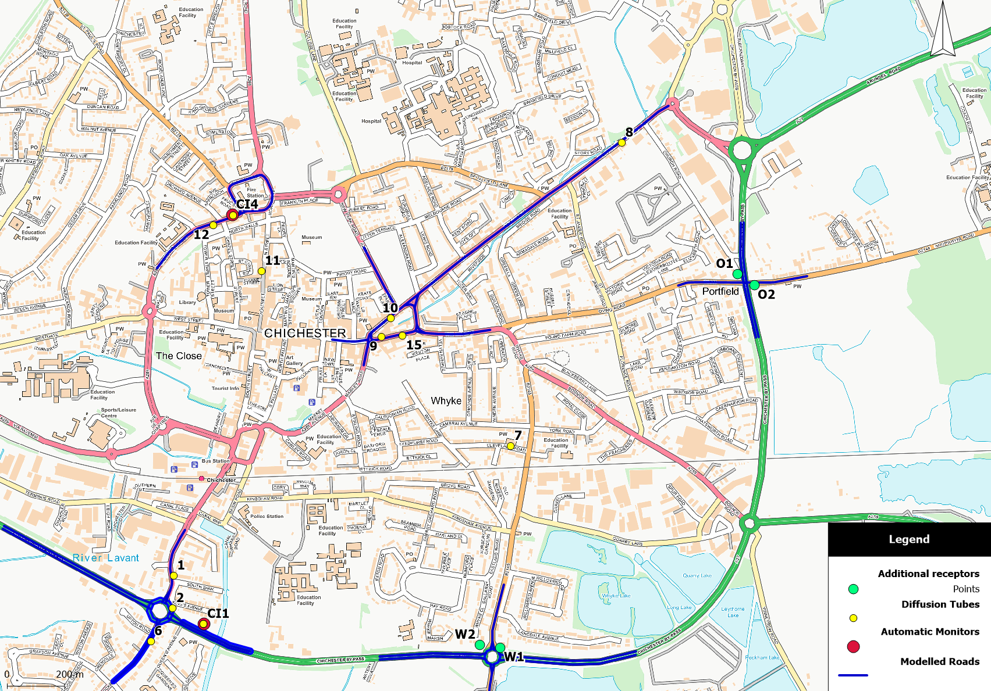
Figure 2: St Pancras AQMA and Hornet modelled links and receptors.
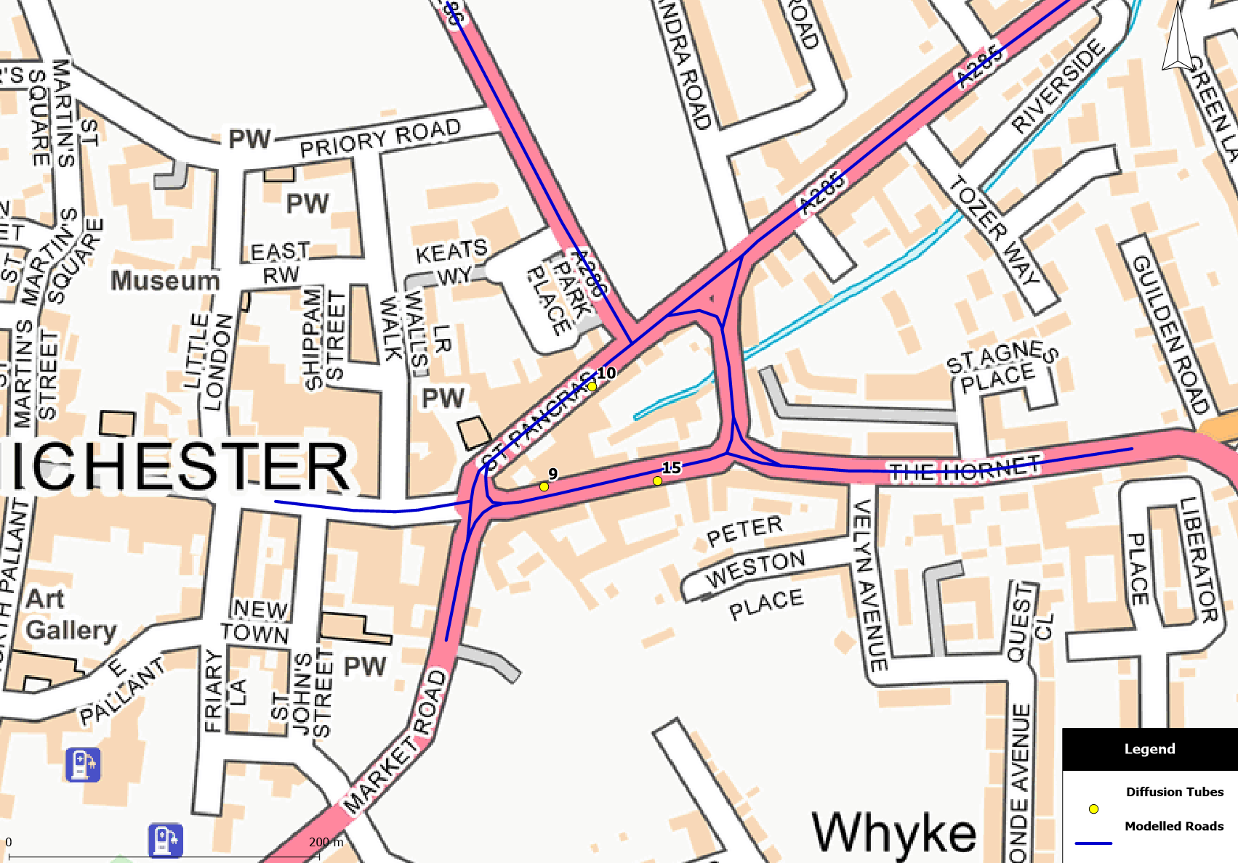
Figure 3: Orchard Street AQMA modelled links and receptors
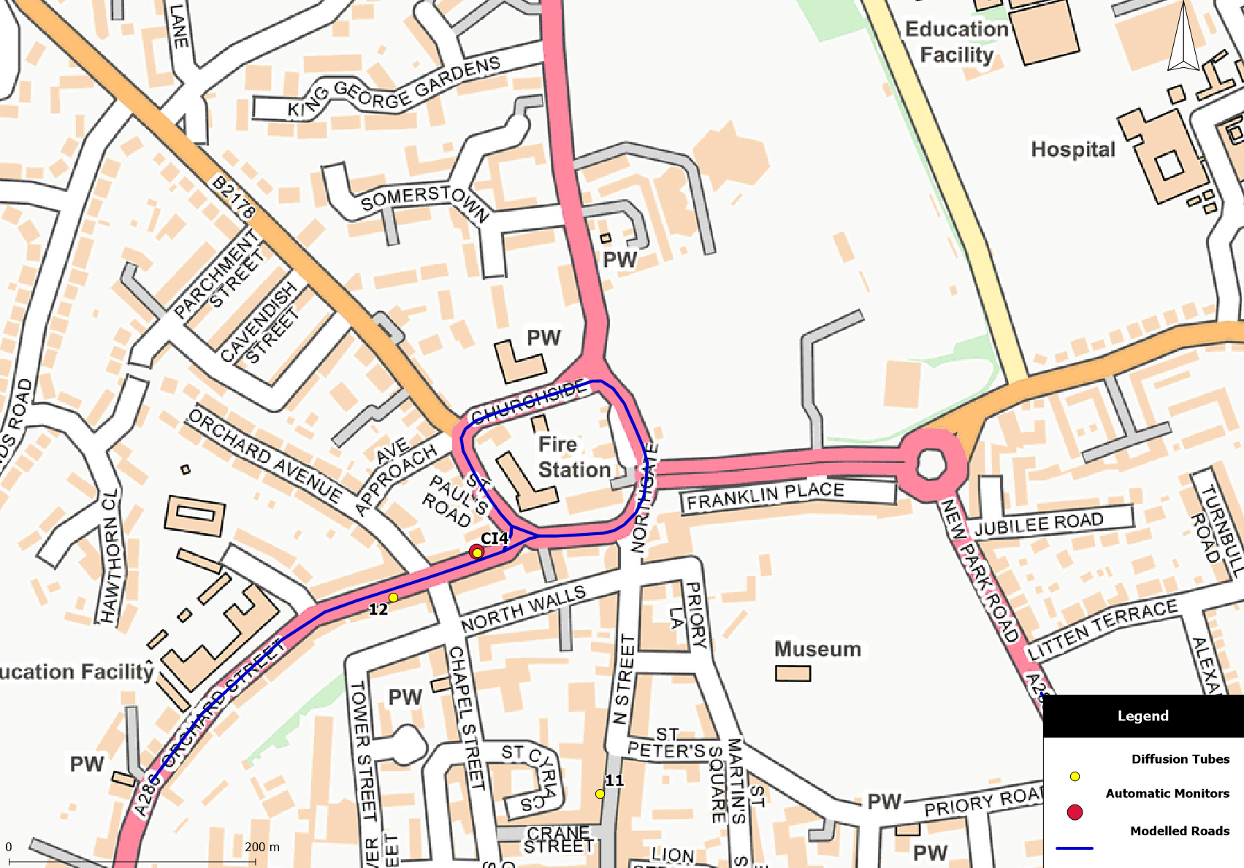
Figure 4: Oving Rd/A27 Intersection modelled links and receptors
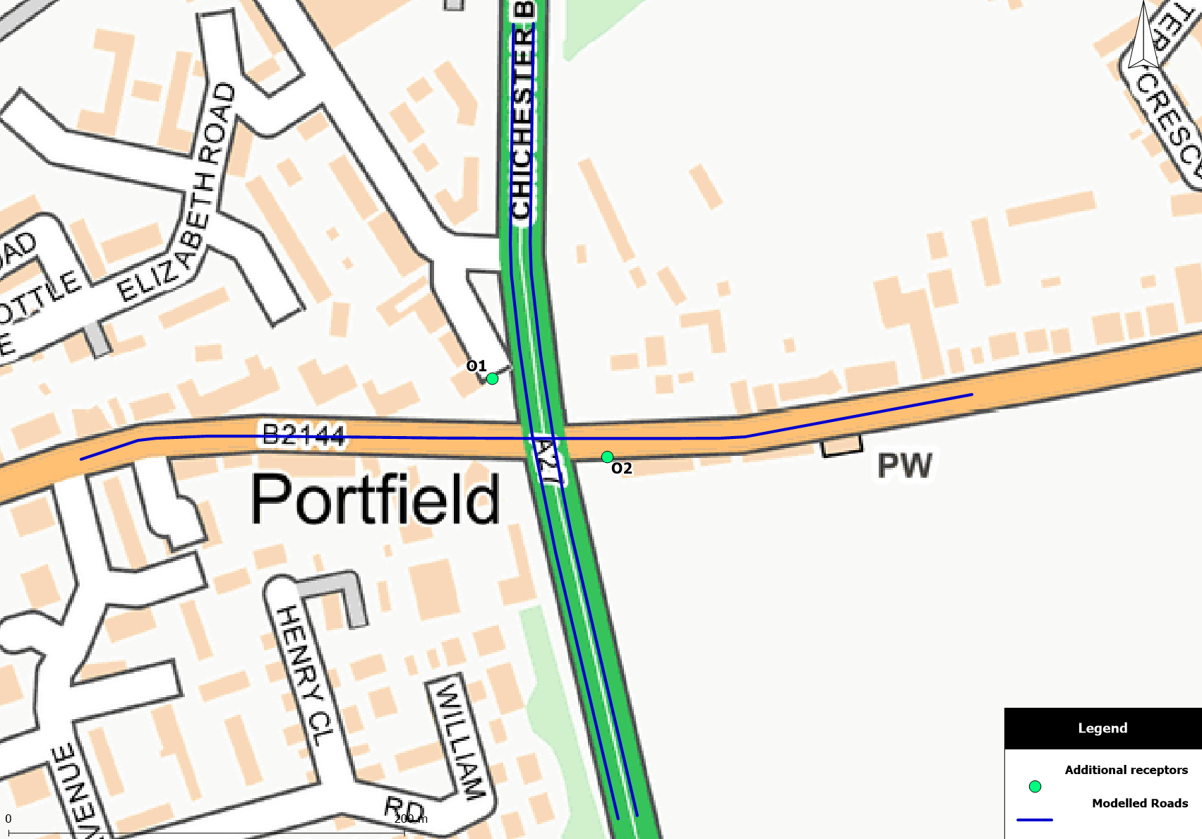
Figure 5: Stockbridge AQMA modelled links and receptors
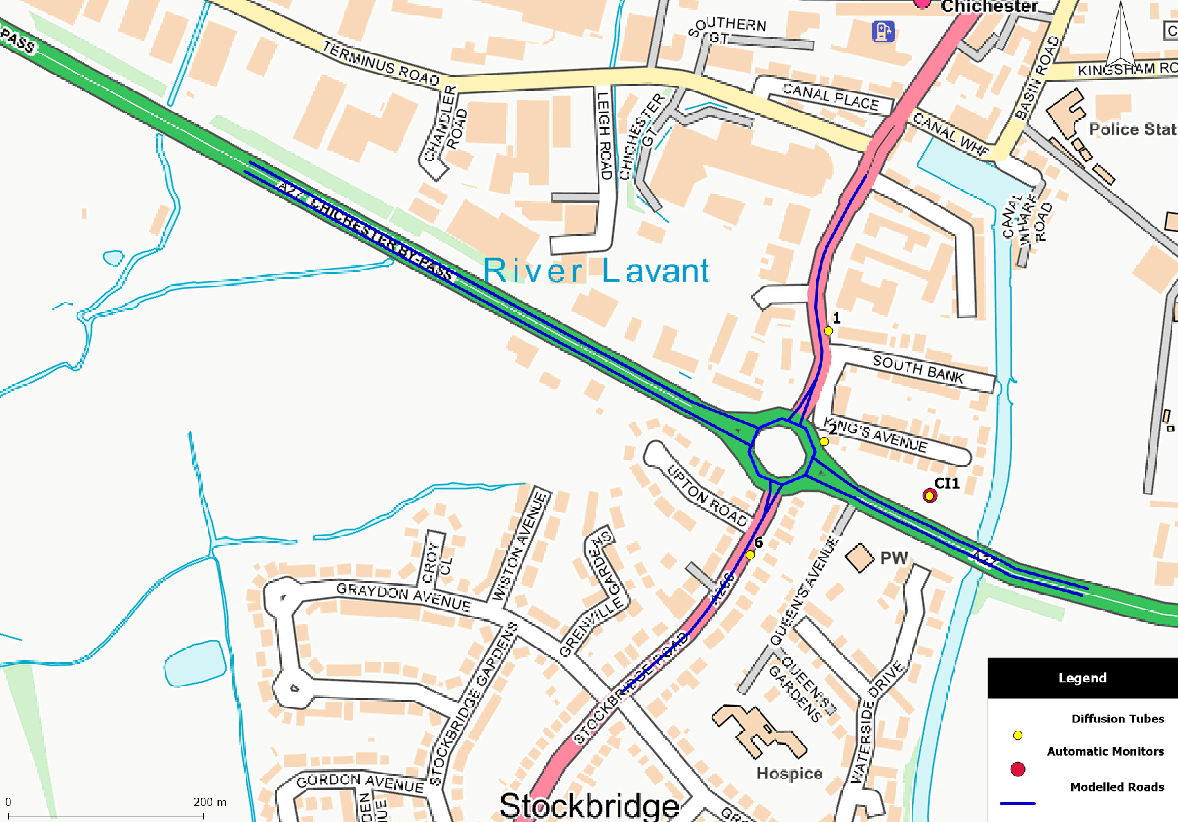
Figure 6: Whyke Roundabout modelled links and receptors 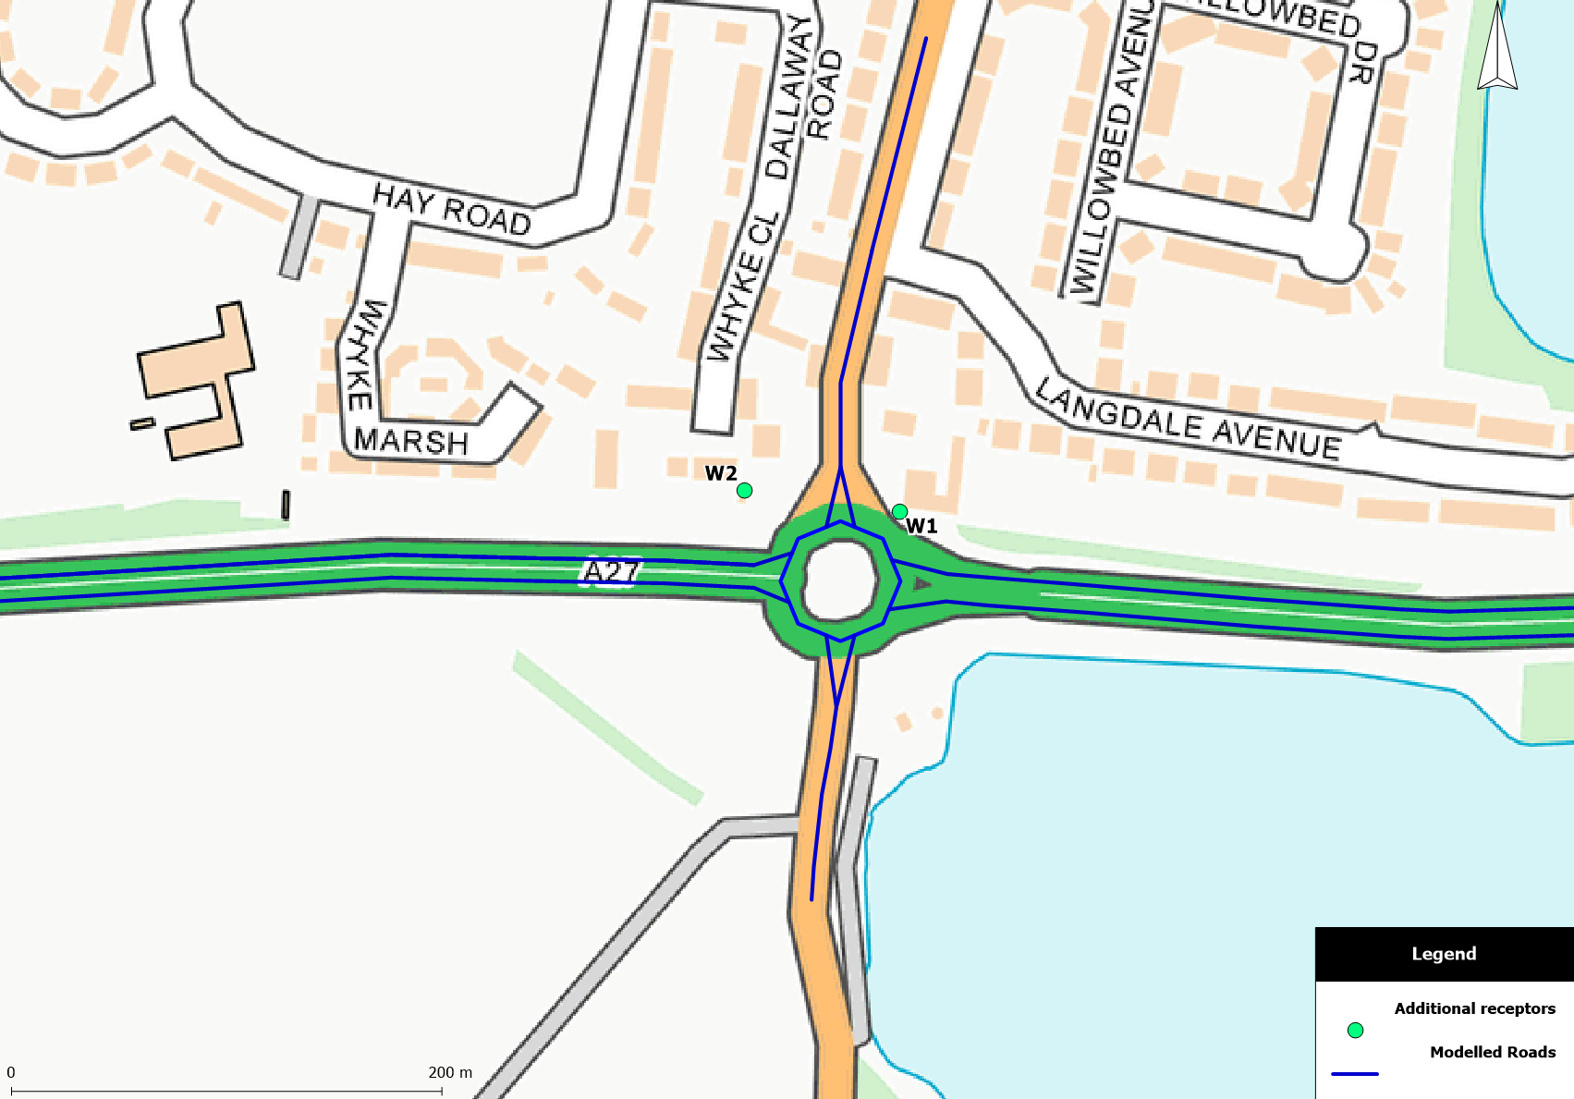
Figure 7: Midhurst modelled links and receptors
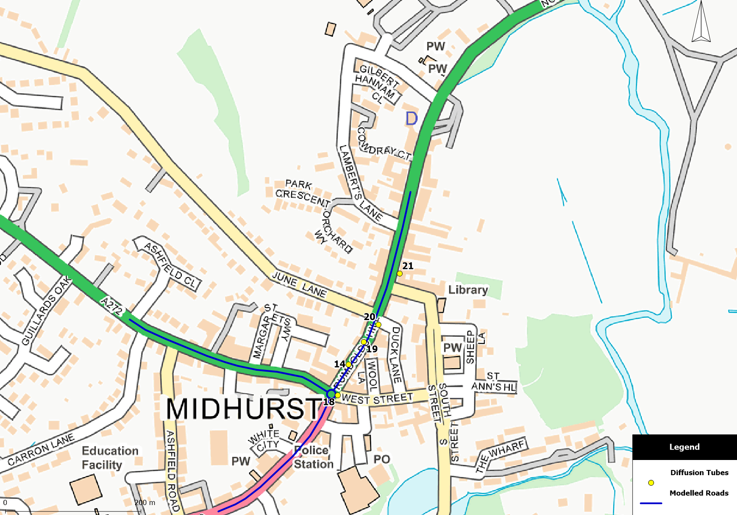

Figures 9 - 17: Chichester and Midhurst modelled annual mean NO₂ concentration contours (2024).
All figures Contains Ordnance Survey data © Crown copyright and database right 2019
Figure 9: St Pancras and Hornet – Bus LEZ annual mean NO₂ concentration contours.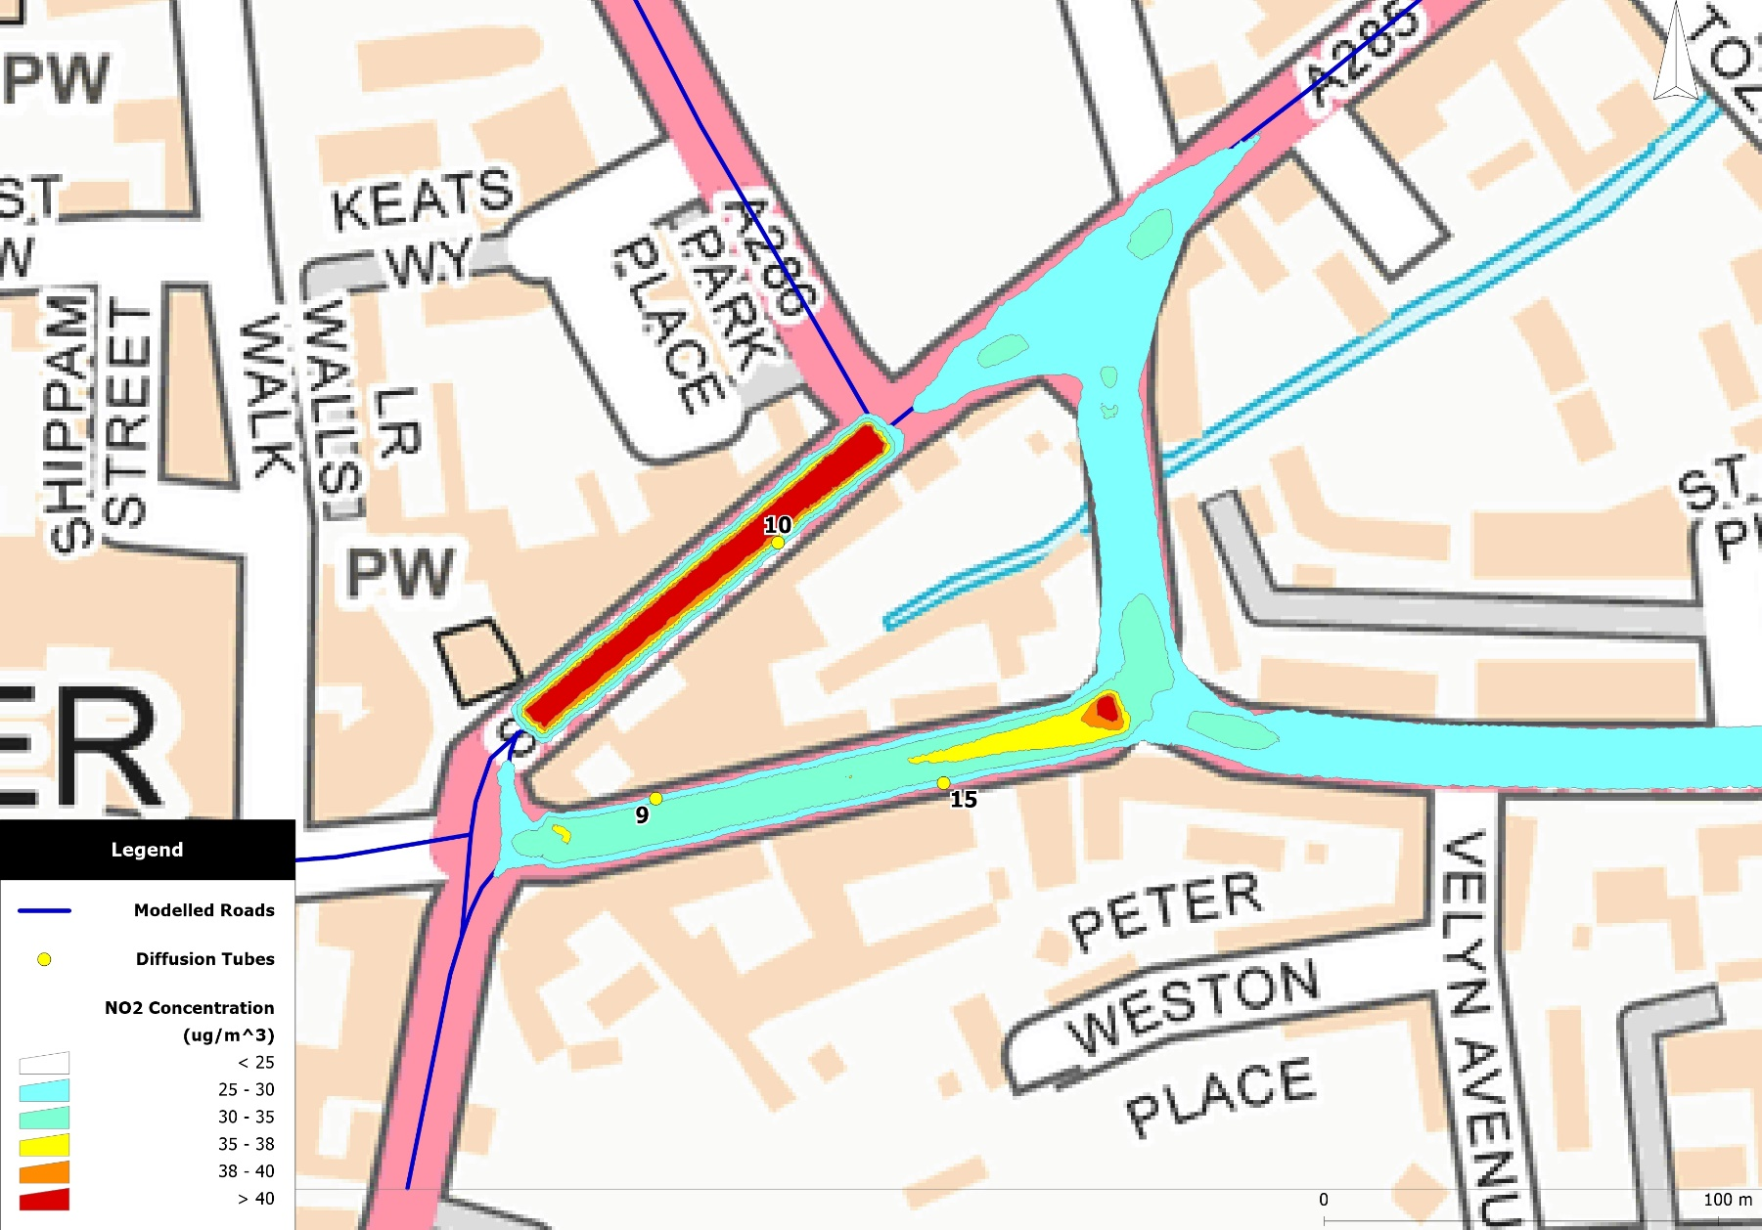
Figure 10: St Pancras and Hornet – 5% Modal Shift annual mean NO₂ concentration contours.
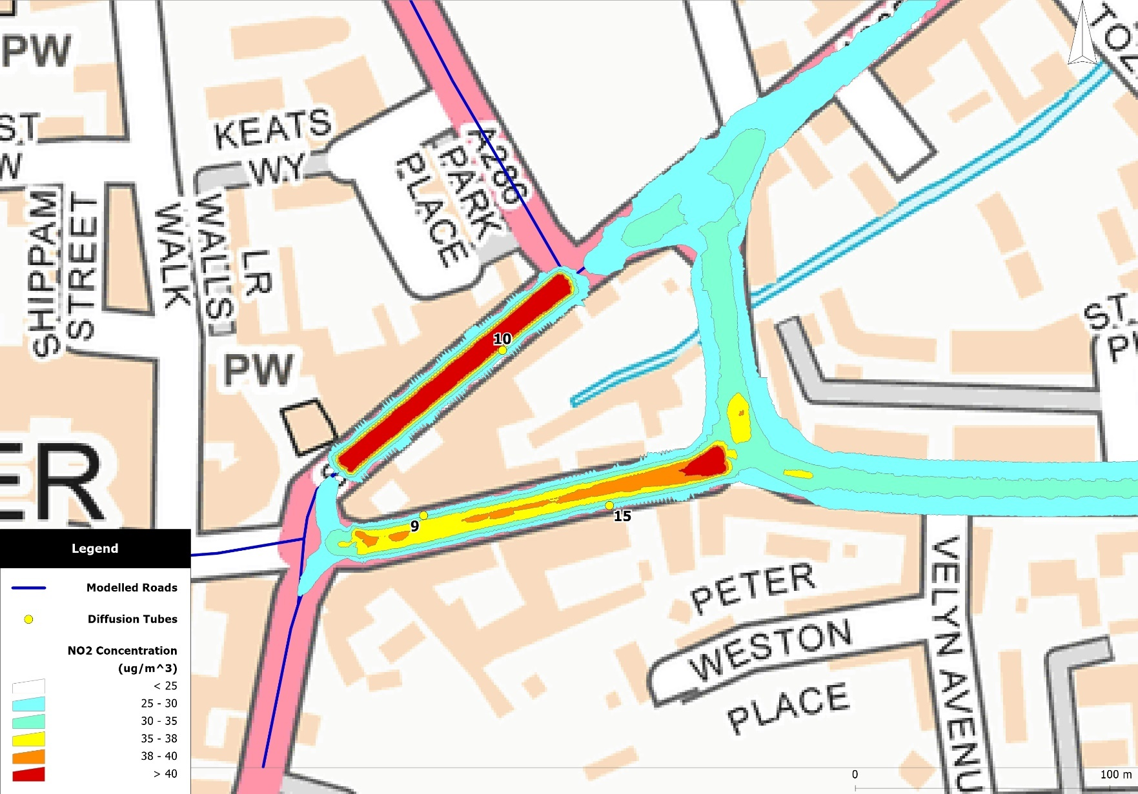
Figure 11: Oving Rd/A27 Intersection – Bus LEZ annual mean NO₂ concentration contours.
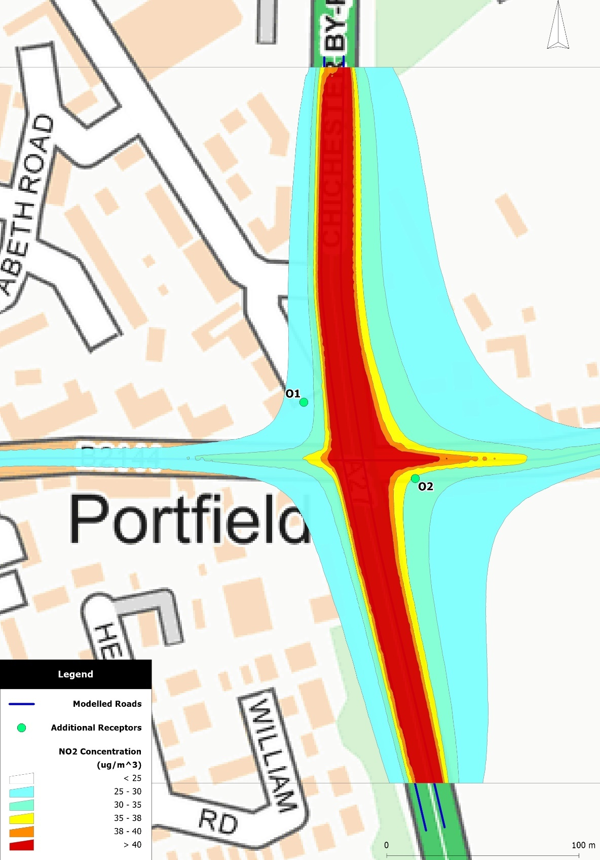

Figure 12: Oving Rd/A27 Intersection – 5% Modal Shift annual mean NO₂ concentration contours.
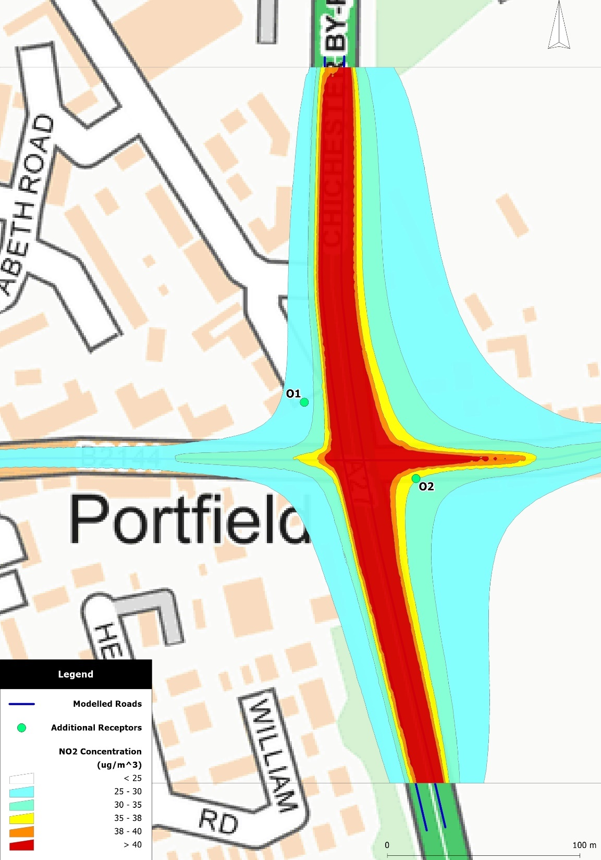

Figure 13: Stockbridge AQMA – Bus LEZ annual mean NO₂ concentration contours.
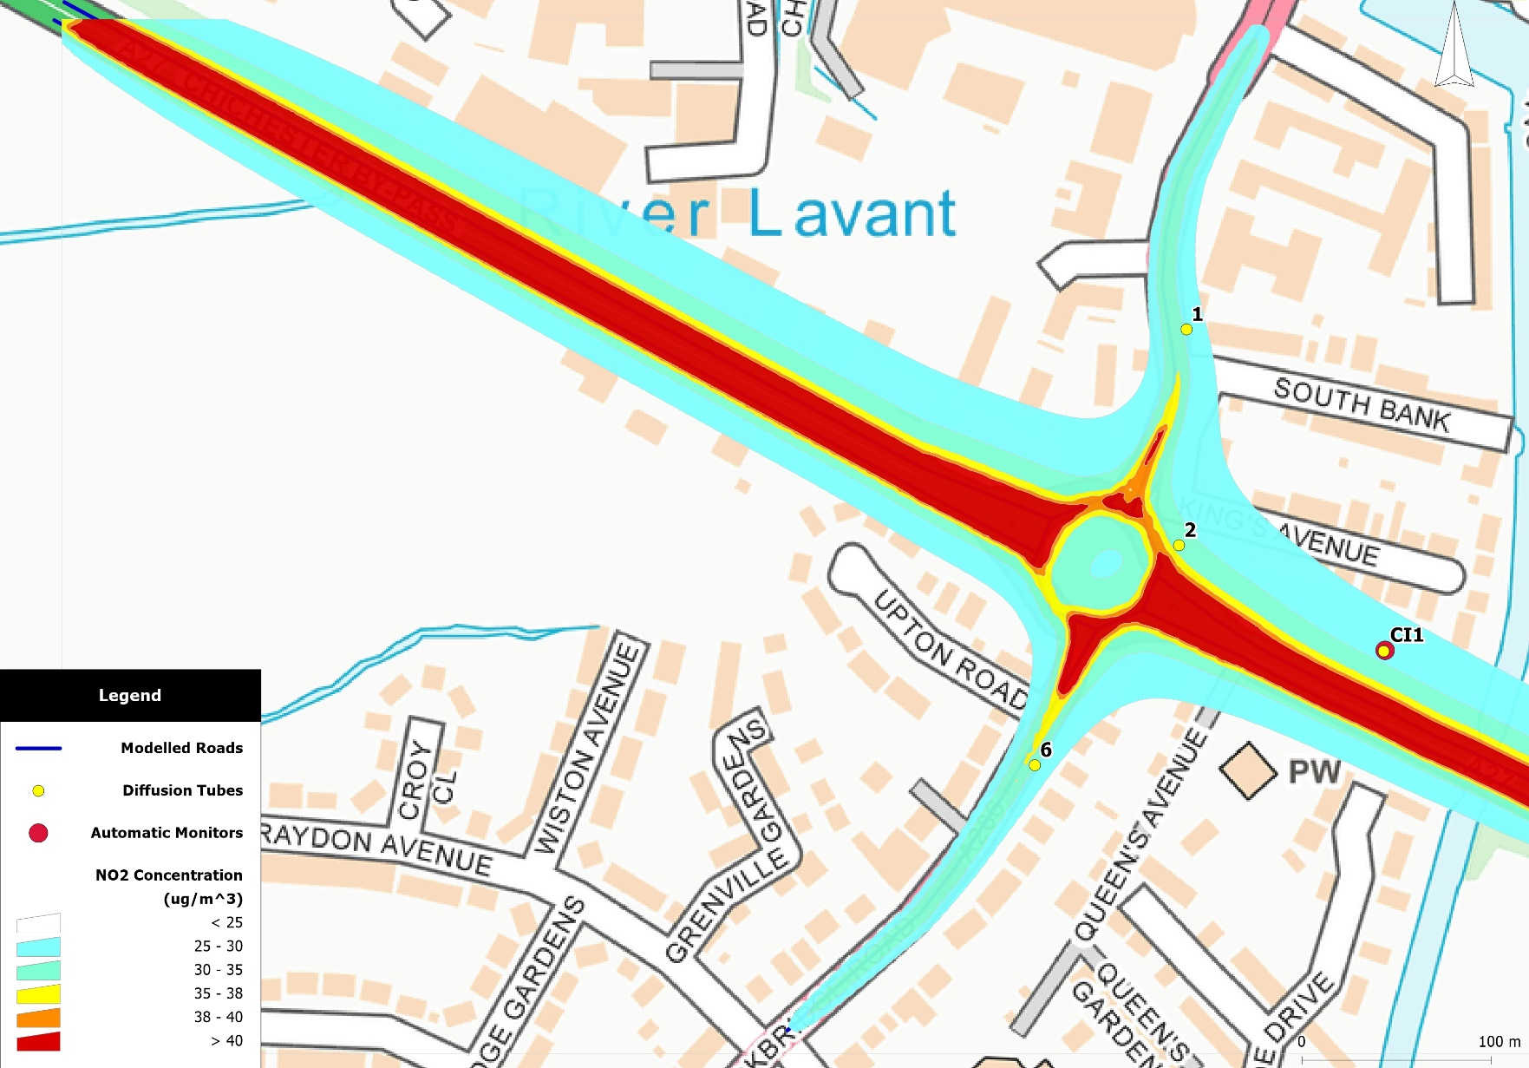
Figure 14: Stockbridge AQMA – 5% Modal Shift annual mean NO₂ concentration contours.
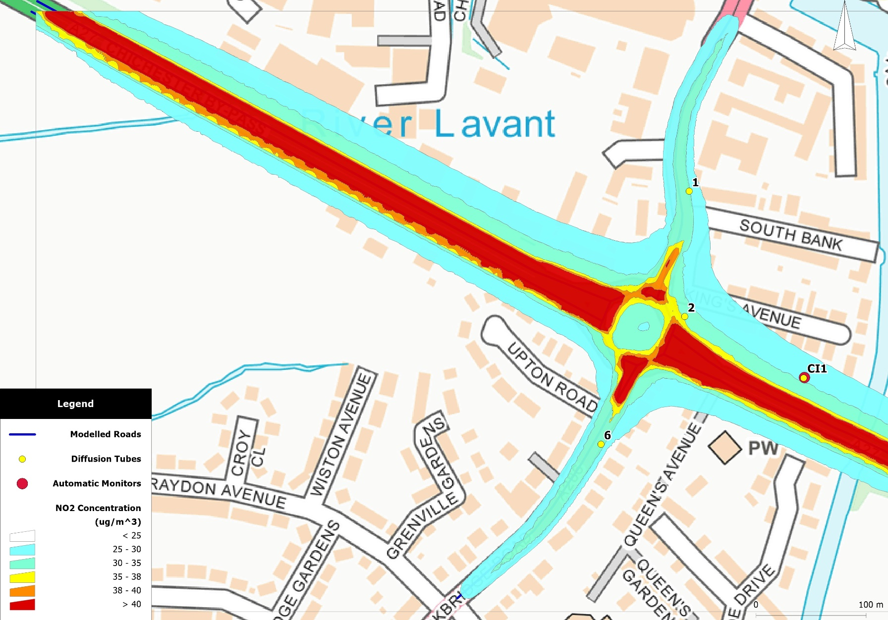
Figure 15: Whyke Roundabout – Bus LEZ annual mean NO₂ concentration contours.
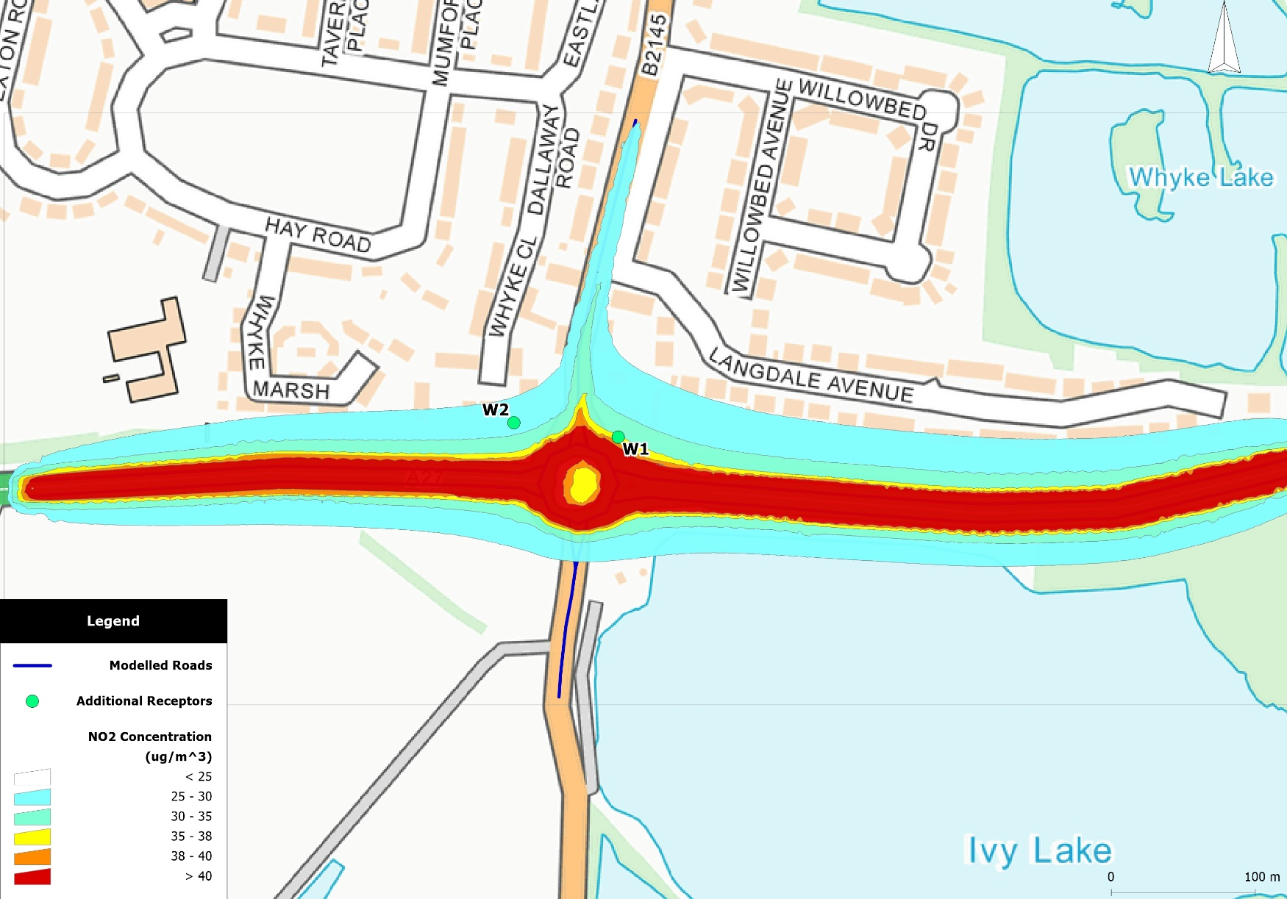
Figure 16: Whyke Roundabout – 5% Modal Shift annual mean NO₂ concentration contours.
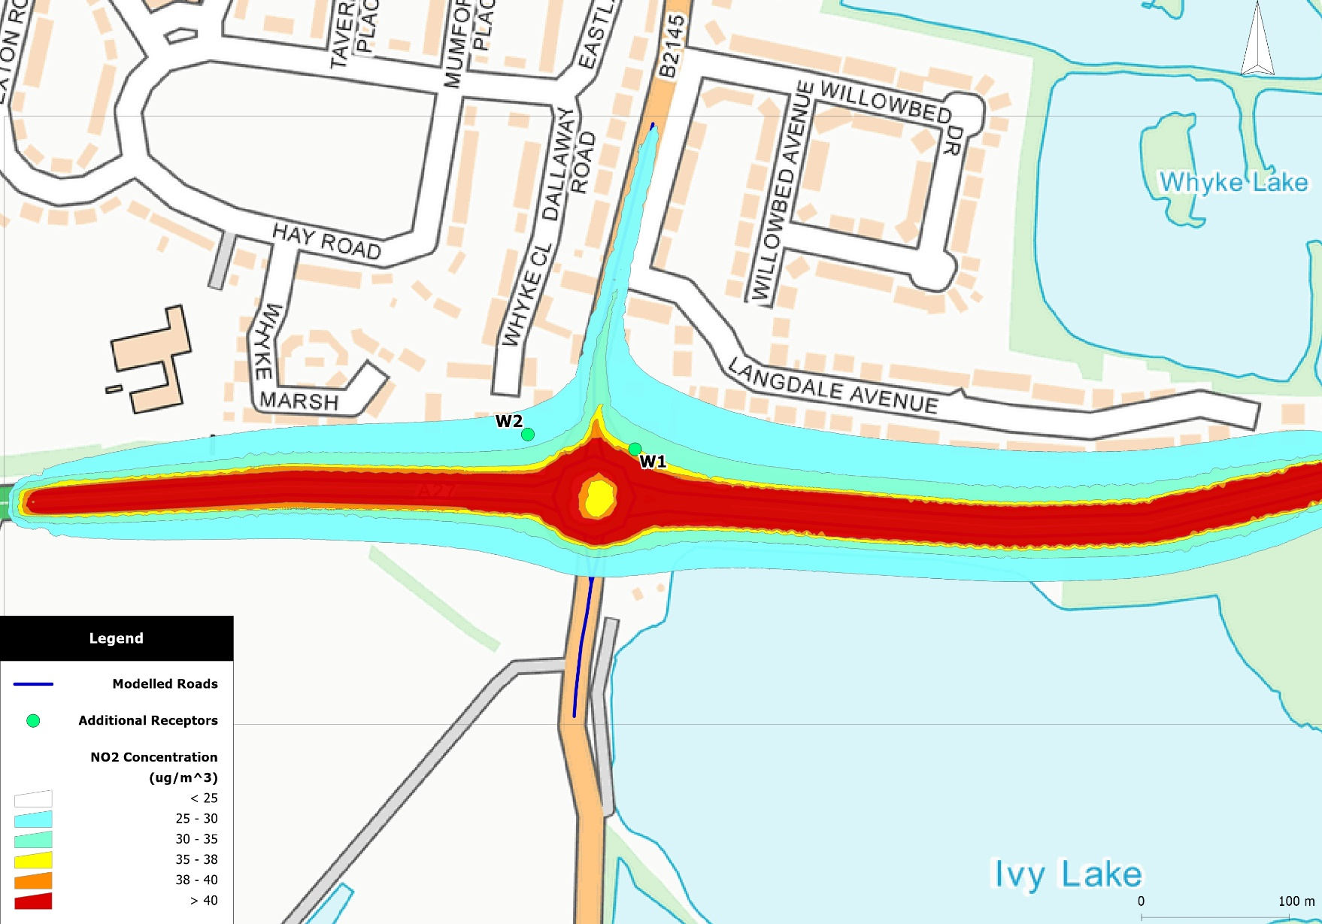

Figure 17: Midhurst – 5% Modal Shift annual mean NO₂ concentration contours.
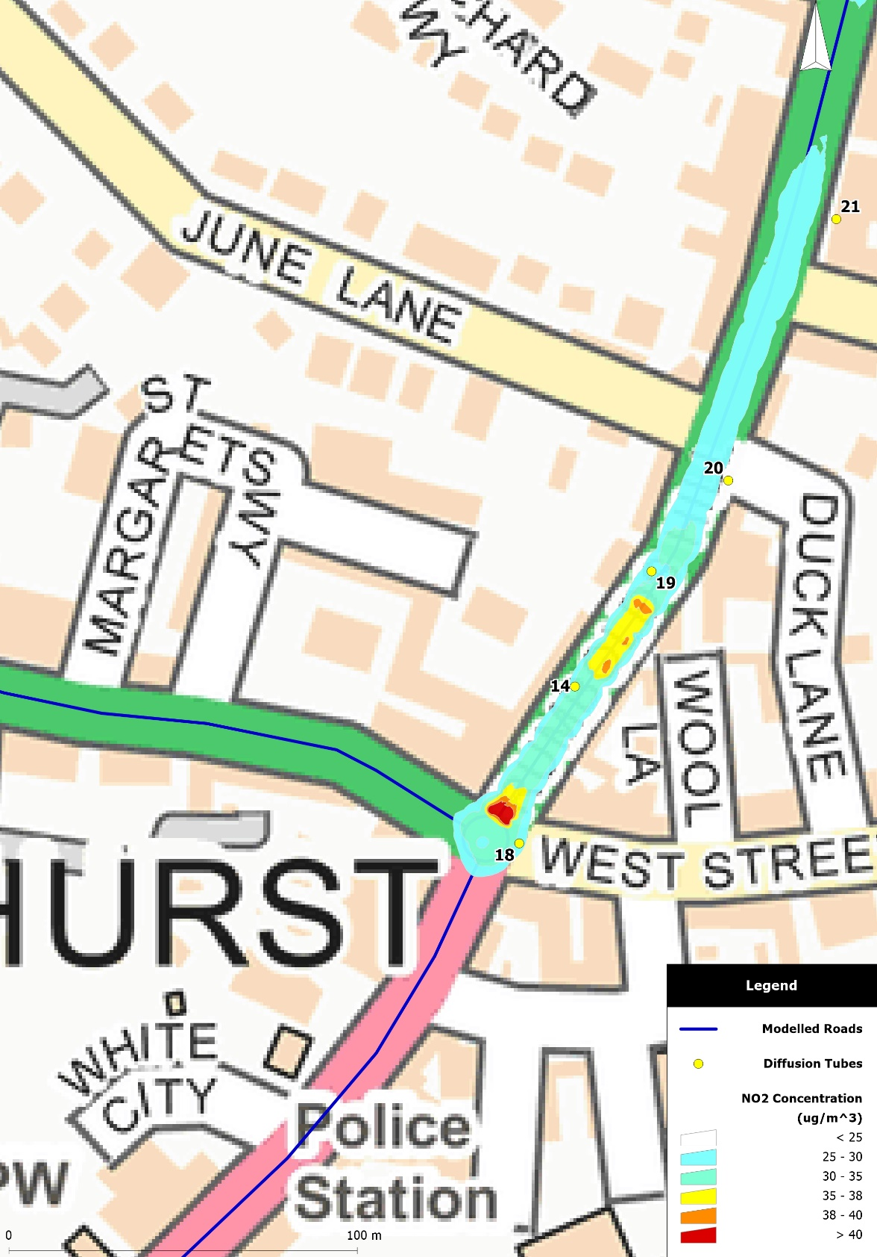

Appendix A: Receptor locations
Receptor locations
Discrete model receptors were positioned at the façades of buildings at selected locations and modelled at “breathing height”, which is, by convention, 1.5 metres above ground (or floor) level.
Table A.1: Receptor locations.
Receptor ID | Concentration NO₂ – annual mean (µg.m⁻³)
 | x | y | Location
Chichester
1 | 485773.91 | 103960.26 | Kings Ave/ Southbank Junction | Stockbridge Roundabout AQMA
2 | 485771.47 | 103847.47 | Claremont Court | Stockbridge Roundabout AQMA
(3,4,5) | 485880.84 | 103791.63 | AQMS on Chichester Bypass (A27) and Stockbridge Roundabout | Stockbridge Roundabout AQMA
6 | 485695.78 | 103730.9 | Stockbridge Rd South (A286) | Stockbridge Roundabout AQMA
8 | 487340.41 | 105474.71 | Westhampnett Rd | -
9 | 486502.25 | 104793.87 | The Hornet | (South of) St Pancras AQMA
10 | 486532.97 | 104860.06 | St Pancras | St Pancras AQMA
12 | 485913.44 | 105186.34 | 174 Orchard St | Orchard St AQMA
CI1 | 485880.84 | 103791.63 | Stockbridge, near to the Chichester Bypass and Stockbridge R’about | Stockbridge Roundabout AQMA
CI4 | 485981.41 | 105222.45 | Orchard St | Orchard St AQMA
15 | 486575.92 | 104799.25 | 32 The Hornet | (South of) St Pancras AQMA
Additional receptor locations in Chichester (not diffusion tubes)
W1 | 486916.28 | 103709.01 | Nursing Home, Whyke Rd (B2135) | NE of Whyke/A27 roundabout
W2 | 486843.81 | 103719.1 | 22/23 Whyke Close | NW of Whyke/A27 roundabout
O1 | 487745.06 | 105015.62 | Church Rd property | NW of Oving Rd/A27 intersection
O2 | 487803.03 | 104975.94 | 187/188 Oving Rd property | SE of Oving Rd/A27 intersection
Midhurst
14 | 488559.88 | 121478.29 | Rumbold’s Hill
18 | 488544.69 | 121434.01 | Rumbold’s Hill (Stationary Shop)
19 | 488583.53 | 121511.69 | Rumbold’s Hill (Natwest)
20 | 488601.94 | 121538.76 | Rumbold’s Hill (Nationwide)
21 | 488629.56 | 121614.62 | North Street (BHF)
Note: Receptor IDs correspond to those in the Chichester District Council’s LAQM Annual Status Report (2019); AQMS = (Automatic) Air Quality Monitoring Station.

Appendix B: Modelling results for PM₁₀ and PM_{2.5}
Table B.1: PM₁₀ baseline results
Receptor | Concentration PM₁₀ – annual mean (µg.m⁻³)
 | 2018 | 2020 | 2021 | 2022 | 2023 | 2024 | 2025
Chichester
1 | 19.6 | 19.5 | 19.5 | 19.5 | 19.5 | 19.5 | 19.5
2 | 20.7 | 20.6 | 20.6 | 20.6 | 20.6 | 20.6 | 20.6
(3,4,5) | 19.2 | 19.1 | 19.0 | 19.0 | 19.0 | 19.0 | 19.0
6 | 19.3 | 19.2 | 19.2 | 19.2 | 19.2 | 19.2 | 19.2
8 | 18.7 | 18.6 | 18.6 | 18.6 | 18.6 | 18.6 | 18.6
9 | 20.6 | 20.5 | 20.5 | 20.5 | 20.5 | 20.5 | 20.5
10 | 23.0 | 22.8 | 22.8 | 22.7 | 22.7 | 22.7 | 22.7
12 | 19.7 | 19.7 | 19.7 | 19.6 | 19.6 | 19.7 | 19.7
CI1 | 19.2 | 19.1 | 19.0 | 19.0 | 19.0 | 19.0 | 19.0
CI4 | 17.2 | 17.2 | 17.2 | 17.2 | 17.2 | 17.2 | 17.2
15 | 20.3 | 20.2 | 20.2 | 20.2 | 20.2 | 20.2 | 20.2
W1 | 21.7 | 21.6 | 21.6 | 21.6 | 21.6 | 21.6 | 21.7
W2 | 19.0 | 18.9 | 18.9 | 18.9 | 18.9 | 18.9 | 18.9
O1 | 18.6 | 18.5 | 18.5 | 18.5 | 18.5 | 18.6 | 18.6
O2 | 22.0 | 21.9 | 21.9 | 21.9 | 21.9 | 21.9 | 22.0
Midhurst
14 | 17.3 | 17.2 | 17.1 | 17.1 | 17.1 | 17.1 | 17.2
18 | 16.9 | 16.8 | 16.7 | 16.7 | 16.7 | 16.8 | 16.8
19 | 17.0 | 16.9 | 16.8 | 16.8 | 16.8 | 16.9 | 16.9
20 | 16.6 | 16.5 | 16.4 | 16.4 | 16.4 | 16.5 | 16.5
21 | 16.3 | 16.3 | 16.2 | 16.2 | 16.2 | 16.2 | 16.3
Table B.2: PM_{2.5} baseline results
Receptor | Concentration PM₁₀ – annual mean (µg.m⁻³)
 | 2018 | 2020 | 2021 | 2022 | 2023 | 2024 | 2025
Chichester
1 | 12.6 | 12.5 | 12.5 | 12.4 | 12.4 | 12.4 | 12.4
2 | 13.3 | 13.2 | 13.1 | 13.1 | 13.1 | 13.0 | 13.1
(3,4,5) | 12.4 | 12.3 | 12.2 | 12.2 | 12.2 | 12.2 | 12.2
6 | 12.5 | 12.4 | 12.3 | 12.3 | 12.3 | 12.3 | 12.3
8 | 12.5 | 12.4 | 12.3 | 12.3 | 12.3 | 12.3 | 12.3
9 | 13.7 | 13.6 | 13.5 | 13.5 | 13.5 | 13.5 | 13.5
10 | 15.1 | 14.9 | 14.8 | 14.8 | 14.7 | 14.7 | 14.7
12 | 13.1 | 13.0 | 13.0 | 12.9 | 12.9 | 12.9 | 12.9
CI1 | 12.4 | 12.3 | 12.2 | 12.2 | 12.2 | 12.2 | 12.2
CI4 | 11.6 | 11.6 | 11.6 | 11.5 | 11.5 | 11.5 | 11.5
15 | 13.5 | 13.4 | 13.4 | 13.3 | 13.3 | 13.3 | 13.3
W1 | 13.8 | 13.6 | 13.6 | 13.5 | 13.5 | 13.5 | 13.5
W2 | 12.2 | 12.1 | 12.1 | 12.0 | 12.0 | 12.0 | 12.0
O1 | 12.4 | 12.3 | 12.3 | 12.2 | 12.2 | 12.2 | 12.3
O2 | 14.7 | 14.6 | 14.5 | 14.5 | 14.5 | 14.5 | 14.5
Midhurst
14 | 11.6 | 11.5 | 11.4 | 11.4 | 11.4 | 11.4 | 11.4
18 | 11.4 | 11.3 | 11.2 | 11.1 | 11.1 | 11.1 | 11.2
19 | 11.4 | 11.3 | 11.2 | 11.2 | 11.2 | 11.2 | 11.3
20 | 11.2 | 11.1 | 11.0 | 11.0 | 11.0 | 11.0 | 11.0
21 | 11.0 | 10.9 | 10.9 | 10.8 | 10.8 | 10.8 | 10.9
Table B.3: PM₁₀ Bus LEZ scenario results
Receptor | Concentration PM₁₀ – annual mean (µg.m⁻³)
 | 2021 | 2022 | 2023 | 2024
Chichester
1 | 19.5 | 19.5 | 19.5 | 19.5
2 | 20.6 | 20.6 | 20.6 | 20.6
(3,4,5) | 19.0 | 19.0 | 19.0 | 19.0
6 | 19.2 | 19.2 | 19.2 | 19.2
8 | 18.6 | 18.6 | 18.6 | 18.6
9 | 20.5 | 20.5 | 20.5 | 20.5
10 | 22.8 | 22.7 | 22.7 | 22.7
12 | 19.6 | 19.6 | 19.6 | 19.7
CI1 | 19.0 | 19.0 | 19.0 | 19.0
CI4 | 17.2 | 17.2 | 17.2 | 17.2
15 | 20.2 | 20.2 | 20.2 | 20.2
W1 | 21.6 | 21.6 | 21.6 | 21.6
W2 | 18.9 | 18.9 | 18.9 | 18.9
O1 | 18.5 | 18.5 | 18.5 | 18.6
O2 | 21.9 | 21.9 | 21.9 | 21.9
Table B.4: PM_{2.5} Bus LEZ scenario results
Receptor | Concentration PM_{2.5} – annual mean (µg.m⁻³)
 | 2021 | 2022 | 2023 | 2024
Chichester
1 | 12.5 | 12.4 | 12.4 | 12.4
2 | 13.1 | 13.1 | 13.1 | 13.1
(3,4,5) | 12.2 | 12.2 | 12.2 | 12.2
6 | 12.3 | 12.3 | 12.3 | 12.3
8 | 12.3 | 12.3 | 12.3 | 12.3
9 | 13.5 | 13.5 | 13.5 | 13.5
10 | 14.8 | 14.8 | 14.7 | 14.8
12 | 13.0 | 12.9 | 12.9 | 12.9
CI1 | 12.2 | 12.2 | 12.2 | 12.2
CI4 | 11.6 | 11.5 | 11.5 | 11.5
15 | 13.4 | 13.3 | 13.3 | 13.3
W1 | 13.6 | 13.5 | 13.5 | 13.5
W2 | 12.1 | 12.0 | 12.0 | 12.0
O1 | 12.3 | 12.2 | 12.2 | 12.2
O2 | 14.5 | 14.5 | 14.5 | 14.5
Table B.5: PM₁₀ Modal Shift (2%) scenario results
Receptor | Concentration PM₁₀ – annual mean (µg.m⁻³)
 | 2021 | 2022 | 2023 | 2024
Chichester
1 | 19.4 | 19.4 | 19.4 | 19.4
2 | 20.5 | 20.5 | 20.5 | 20.5
(3,4,5) | 19.0 | 19.0 | 19.0 | 19.0
6 | 19.1 | 19.1 | 19.1 | 19.1
8 | 18.6 | 18.5 | 18.5 | 18.5
9 | 20.4 | 20.4 | 20.4 | 20.4
10 | 22.6 | 22.6 | 22.6 | 22.5
12 | 19.6 | 19.6 | 19.6 | 19.6
CI1 | 19.0 | 19.0 | 19.0 | 19.0
CI4 | 17.1 | 17.1 | 17.1 | 17.1
15 | 20.1 | 20.1 | 20.1 | 20.1
W1 | 21.5 | 21.5 | 21.5 | 21.5
W2 | 18.9 | 18.9 | 18.9 | 18.9
O1 | 18.5 | 18.5 | 18.5 | 18.5
O2 | 21.8 | 21.8 | 21.8 | 21.9
Midhurst
14 | 17.1 | 17.0 | 17.1 | 17.1
18 | 16.7 | 16.7 | 16.7 | 16.7
19 | 16.8 | 16.8 | 16.8 | 16.8
20 | 16.4 | 16.4 | 16.4 | 16.4
21 | 16.2 | 16.2 | 16.2 | 16.2

Table B.6: PM_{2.5} Modal Shift (2%) scenario results
Receptor | Concentration PM_{2.5} – annual mean (µg.m⁻³)
 | 2021 | 2022 | 2023 | 2024
Chichester
1 | 12.4 | 12.4 | 12.4 | 12.4
2 | 13.1 | 13.0 | 13.0 | 13.0
(3,4,5) | 12.2 | 12.2 | 12.1 | 12.1
6 | 12.3 | 12.3 | 12.3 | 12.2
8 | 12.3 | 12.3 | 12.3 | 12.3
9 | 13.5 | 13.5 | 13.5 | 13.4
10 | 14.8 | 14.7 | 14.7 | 14.6
12 | 12.9 | 12.9 | 12.9 | 12.9
CI1 | 12.2 | 12.2 | 12.1 | 12.1
CI4 | 11.5 | 11.5 | 11.5 | 11.5
15 | 13.3 | 13.3 | 13.3 | 13.3
W1 | 13.5 | 13.5 | 13.5 | 13.5
W2 | 12.0 | 12.0 | 12.0 | 12.0
O1 | 12.2 | 12.2 | 12.2 | 12.2
O2 | 14.5 | 14.5 | 14.5 | 14.5
Midhurst
14 | 11.4 | 11.3 | 11.3 | 11.3
18 | 11.2 | 11.1 | 11.1 | 11.1
19 | 11.2 | 11.2 | 11.2 | 11.1
20 | 11.0 | 11.0 | 10.9 | 10.9
21 | 10.8 | 10.8 | 10.8 | 10.8

Table B.7: PM₁₀ Modal Shift (5%) scenario results
Receptor | Concentration PM₁₀ – annual mean (µg.m⁻³)
 | 2021 | 2022 | 2023 | 2024
Chichester
1 | 19.3 | 19.3 | 19.3 | 19.4
2 | 20.4 | 20.4 | 20.4 | 20.5
(3,4,5) | 18.9 | 18.9 | 18.9 | 18.9
6 | 19.1 | 19.0 | 19.0 | 19.1
8 | 18.5 | 18.5 | 18.5 | 18.5
9 | 20.3 | 20.3 | 20.3 | 20.3
10 | 22.5 | 22.4 | 22.4 | 22.4
12 | 19.5 | 19.5 | 19.5 | 19.5
CI1 | 18.9 | 18.9 | 18.9 | 18.9
CI4 | 17.1 | 17.1 | 17.1 | 17.1
15 | 20.0 | 20.0 | 20.0 | 20.0
W1 | 21.4 | 21.4 | 21.4 | 21.4
W2 | 18.8 | 18.8 | 18.8 | 18.8
O1 | 18.4 | 18.4 | 18.4 | 18.5
O2 | 21.7 | 21.7 | 21.7 | 21.8
Midhurst
14 | 17.0 | 17.0 | 17.0 | 17.1
18 | 16.6 | 16.6 | 16.6 | 16.7
19 | 16.7 | 16.7 | 16.7 | 16.8
20 | 16.4 | 16.4 | 16.4 | 16.5
21 | 16.1 | 16.1 | 16.1 | 16.2
Table B.8: PM_{2.5} Modal Shift (5%) scenario results
Receptor | Concentration PM_{2.5} – annual mean (µg.m⁻³)
 | 2021 | 2022 | 2023 | 2024
Chichester
1 | 12.4 | 12.4 | 12.4 | 12.4
2 | 13.0 | 13.0 | 13.0 | 13.0
(3,4,5) | 12.1 | 12.1 | 12.1 | 12.1
6 | 12.2 | 12.2 | 12.2 | 12.2
8 | 12.3 | 12.2 | 12.2 | 12.2
9 | 13.4 | 13.4 | 13.4 | 13.4
10 | 14.7 | 14.6 | 14.6 | 14.6
12 | 12.9 | 12.8 | 12.8 | 12.8
CI1 | 12.1 | 12.1 | 12.1 | 12.1
CI4 | 11.5 | 11.5 | 11.5 | 11.5
15 | 13.3 | 13.2 | 13.2 | 13.2
W1 | 13.5 | 13.4 | 13.4 | 13.4
W2 | 12.0 | 12.0 | 12.0 | 12.0
O1 | 12.2 | 12.2 | 12.2 | 12.2
O2 | 14.4 | 14.4 | 14.4 | 14.4
Midhurst
14 | 11.3 | 11.3 | 11.3 | 11.3
18 | 11.1 | 11.1 | 11.1 | 11.1
19 | 11.2 | 11.1 | 11.1 | 11.1
20 | 11.0 | 10.9 | 10.9 | 10.9
21 | 10.8 | 10.8 | 10.8 | 10.8

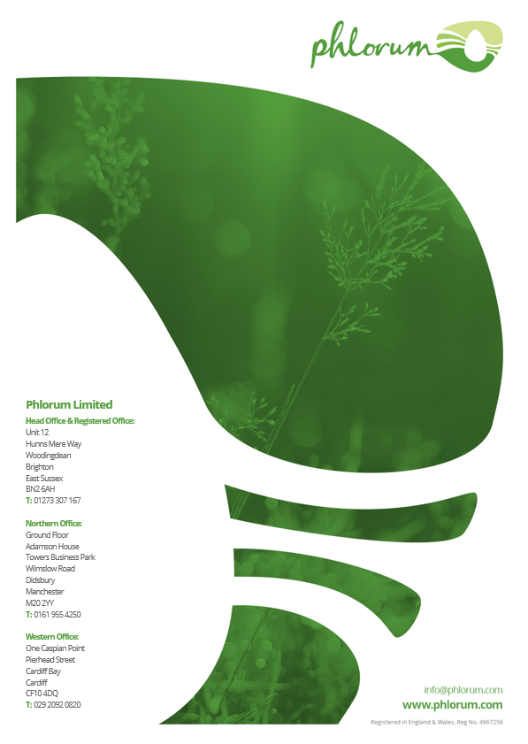

The annual mean 60µg.m⁻³ concentration value is used to indicate likely exceedances of the short-term (1-hour) AQS for NO₂.
HM Treasury (2019). www.gov.uk/government/publications/the-green-book-appraisal-and-evaluation-in-central-governent
The Chancellor announced over £200 million to transform bus services in the Spending Round for 2020/21.

