

2021 Air Quality Annual Status Report (ASR)
In fulfilment of Part IV of the Environment Act 1995 Local Air Quality Management
Date: July, 2021

Information | Chichester District Council
Local Authority Officer | Kate Simons  Simon Ballard
Department | Environmental Protection
Address | East Pallant House  1 East Pallant  Chichester  West Sussex  PO19 1TY
Telephone | 01243 521160
E-mail | ksimons@chichester.gov.uk  sballard@chichester.gov.uk
Report Reference Number | ASR 21
Date | July 2021

Executive Summary: Air Quality in Our Area

Air Quality in Chichester District
Air pollution is associated with a number of adverse health impacts. It is recognised as a contributing factor in the onset of heart disease and cancer. Additionally, air pollution particularly affects the most vulnerable in society: children, the elderly, and those with existing heart and lung conditions. There is also often a strong correlation with equalities issues because areas with poor air quality are also often less affluent areas,.

The mortality burden of air pollution within the UK is equivalent to 28,000 to 36,000 deaths at typical ages, with a total estimated healthcare cost to the NHS and social care of £157 million in 2017.

As reported last year, air quality in the majority of Chichester district is good however there are a few areas where elevated concentrations of pollutants occur. The main pollutant of concern under the Local Air Quality Management regime is nitrogen dioxide (NO₂) and the key local source is road traffic. Roads in and adjacent to Chichester city and in the centre of Midhurst are the key locations where elevated concentrations of NO₂ occur. The latest monitoring data indicates that levels have decreased over the last few years although the effects of the Covid 19 pandemic on traffic volumes are likely to have been a significant factor in the 2020 decrease. The AQMA locations are as follows:
- Stockbridge roundabout at the junction of the A27 and A286
- Orchard Street, Chichester
- St Pancras, Chichester
- Rumbolds Hill, Midhurst.
Before the pandemic, concentrations of NO₂ were showing a general year-on-year decrease (ie an improvement in air quality) however hotspots remain at the St Pancras and Rumbolds Hill AQMA areas.

We are aware of the health effects of and that there is a growing interest in the pollutant known as PM_{2.5}. This pollutant is not currently included in the statutory Local Air Quality Management regime which defines our air quality activities. Nevertheless the draft revised Air Quality Action Plan includes many actions which are designed to tackle both PM_{2.5} and NO₂. Through the Environment Bill the government is committed to the adoption of a binding PM_{2.5} standard and the council will consider its response once the government provides more detail in this regard.

Our Air Quality Action Plan (AQAP) 2015 has recently been reviewed and the revised document has just been the subject of a full public consultation. The revised AQAP 2021 incorporates the outcomes of air quality modelling undertaken in 2019-2020 and a review of approximately the last ten years’ worth of monitoring data. It is intended that the AQAP will be adopted in Autumn 2021. The draft revised document is available on request and will be available on the Council’s website once it has been adopted.

Air quality is recognized by the Council as an important public health issue which we are working with our partners to address. Our partners include other services in the Council (including Development Management, Parking Services and Estates), West Sussex County Council (WSCC) Departments (Public Health, Transport and Planning, Highways) and CDC is also a member of the Sussex Air Quality Partnership (SAQP) known as ‘Sussex-Air’ and we play an active role in this group.

We have adopted a Local Cycling and Walking Infrastructure Plan (LCWIP) for Chichester city (produced with Consultancy support funded by a grant award from the WSCC pooled Business Rates Fund) and are currently working with WSCC and neighbouring districts and boroughs to prioritise the infrastructure identified in the LCWIPs, to enable a WSCC bid to be made to the Active Travel Fund at the earliest time.

We continue to work with our planning policy team and are contributing to the review of the Chichester Local Plan. To this end, we are developing a GIS layer of proposed cycling infrastructure identified in the Chichester City LCWIP, the WSCC LCWIP and routes identified in WSCC STIP and LTIP work streams. The GIS layer will provide background evidence to assist in prioritising routes in the Council’s Infrastructure Business Plan, thus enabling funding to be allocated in future.

We are also funded to expand the car club by one further vehicle in the coming year and are working on the Council’s corporate project to assist staff green travel both to and from work and for work with a pilot car fleet (one EV) and ebikes.

Actions to Improve Air Quality
Whilst air quality has improved significantly in recent decades, and will continue to improve due to national policy, there are some areas where local action is needed to improve air quality further.
The Government’s 2019 Clean Air Strategy sets out the case for action, with goals even more ambitious than EU requirements to reduce exposure to harmful pollutants. The Road to Zero sets out the approach to reduce exhaust emissions from road transport through a number of mechanisms; this is extremely important given that Chichester District’s Air Quality Management Areas (AQMAs) are designated due to elevated concentrations heavily influenced by transport emissions.

Key completed actions during 2020 are as follows:
- Completion of the Chichester City Local Cycling and Walking Infrastructure Plan (LCWIP) including making it available for public consultation between 18 September and 16 October 2020 and adoption in April 2021.
- We have continued to run and maintain four air quality monitoring stations and publish the monitoring information at http://www.sussex-air.net – the air quality data is used to inform the air Alert daily air quality forecasting service (see measure 16 in Table 2.2).
- Completion of the revised Air Quality Action Plan 2021 including making it available for public consultation between 17 May and 28 June 2021. The Plan is due to be considered for adoption at Cabinet in October 2021.
- CDC has been a member of a Pan-West Sussex group of authorities who have worked collaboratively to assist in the production of individual LCWIPs. Joint training and advice has been received from Consultants contracted to WSCC. A joint methodology has been developed to prioritise LCWIP routes across the County in order that a bid to the Active Travel Fund can be made for the priority routes.
- We have been working to deliver a GIS layer for the emerging revised Local Plan. This layer will provide information to developers and other relevant organisations on where infrastructure is required within the district to improve cycling routes.
- CDC has been successful in bidding for additional funds from the WSCC pooled business rates fund and will use the funding to develop a feasibility/options appraisal report for one of the Chichester LCWIP priority routes.

Conclusions and Priorities
The 2020 monitoring of NO₂ and PM₁₀ shows no exceedances of Air Quality Standards at any of the four real-time monitoring stations. At all of the twenty diffusion tube locations the UK’s NO₂ air quality annual mean Objective of 40 µg/m³ was met (both within and outside AQMAs).

We are not aware of any new developments within the district that will have a significant impact on air quality moving forward. Nevertheless we are aware that there is development on going and that future traffic from such developments could have an impact on air quality.

We are considering revoking the AQMAs at Stockbridge roundabout and Orchard Street based on the air quality monitoring data over the last five years and air quality modelling data to 2025.

We have updated our AQAP and intend to adopt the revised document in October 2021. The Council’s priorities for the next five years are detailed in the document and summarised in Section 2.2 of this report. We are aware that the Government intends to adopt a binding PM_{2.5} standard over the period and will consider the Council’s response once more detail is available.

Local Engagement and How to get Involved
The public can get involved by supporting behavioural change initiatives such as car sharing, walking, cycling, using public transport, joining the Car Club, buying zero-emissions vehicles for personal and commercial travel, turning liquid fuelled vehicle engine’s off when stationary, supporting local groups such as the Chichester and District Cycle Forum, minimising wood burning and only burning dry, well-seasoned wood and composting instead of having bonfires wherever possible. Further information can be obtained by emailing: environmentalprotect@chichester.gov.uk

The Chichester and District Cycle Forum provides information on local cycling opportunities and campaigns on behalf of cyclists. The Forum is open to the public and further information can be obtained by emailing: environmentalprotect@chichester.gov.uk

Table of Contents
Executive Summary: Air Quality in Our Area i
Air Quality in Chichester District i
Actions to Improve Air Quality ii
Conclusions and Priorities iii
Local Engagement and How to get Involved iv
1 Local Air Quality Management 1
2 Actions to Improve Air Quality 2
2.1 Air Quality Management Areas 2
2.2 Progress and Impact of Measures to address Air Quality in Chichester District 5
2.3 PM_{2.5} – Local Authority Approach to Reducing Emissions and/or Concentrations 11
3 Air Quality Monitoring Data and Comparison with Air Quality Objectives and National Compliance 12
3.1 Summary of Monitoring Undertaken 12
3.1.1 Automatic Monitoring Sites 12
3.1.2 Non-Automatic Monitoring Sites 12
3.2 Individual Pollutants 12
3.2.1 Nitrogen Dioxide (NO₂) 13
3.2.2 Particulate Matter (PM₁₀) 14
3.2.3 Particulate Matter (PM_{2.5}) 15
3.2.4 Ozone (O₃) 15
Appendix A: Monitoring Results 18
Appendix B: Full Monthly Diffusion Tube Results for 2020 33
Appendix C: Supporting Technical Information / Air Quality Monitoring Data QA/QC 35
New or Changed Sources Identified Within Chichester District During 2020 35
Additional Air Quality Works Undertaken by Chichester District Council During 2020 35
QA/QC of Diffusion Tube Monitoring 35
Diffusion Tube Annualisation 35
Diffusion Tube Bias Adjustment Factors 35
NO₂ Fall-off with Distance from the Road 36
QA/QC of Automatic Monitoring 36
PM₁₀ and PM_{2.5} Monitoring Adjustment 37
Automatic Monitoring Annualisation 37
NO₂ Fall-off with Distance from the Road 37
Appendix D: Map(s) of Monitoring Locations and AQMAs 41
Appendix E: Summary of Air Quality Objectives in England 45
Appendix F: Impact of COVID-19 upon LAQM 46
Impacts of COVID-19 on Air Quality within Chichester District Council Area 47
Opportunities Presented by COVID-19 upon LAQM within Chichester District Council Area 47
Challenges and Constraints Imposed by COVID-19 upon LAQM within Chichester District Council Area 47
Glossary of Terms 50
References 52

Figures
Figure A.1 – Trends in Annual Mean NO₂ Concentrations at Automatic Monitoring Sites 24

Figure D.1 – Map of Non-Automatic Monitoring Sites in Chichester 41
Tables
Table 2.1 – Declared Air Quality Management Areas 3
Table 2.2 – Progress on Measures to Improve Air Quality 7

Table A.1 – Details of Automatic Monitoring Sites 18
Table A.2 – Details of Non-Automatic Monitoring Sites 19
Table A.3 – Annual Mean NO₂ Monitoring Results: Automatic Monitoring (µg/m³) 21
Table A.4 – Annual Mean NO₂ Monitoring Results: Non-Automatic Monitoring (µg/m³) 22
Table A.5 – 1-Hour Mean NO₂ Monitoring Results, Number of 1-Hour Means > 200µg/m³ 26
Table A.6 – Annual Mean PM₁₀ Monitoring Results (µg/m³) 29
Table A.7 – 24-Hour Mean PM₁₀ Monitoring Results, Number of PM₁₀ 24-Hour Means > 50µg/m³ 31

Table B.1 – NO₂ 2020 Diffusion Tube Results (µg/m³) 33

Table C.1 – Bias Adjustment Factor 36
Table C.2 – Annualisation Summary (concentrations presented in µg/m³) 38
Table C.3 – Local Bias Adjustment Calculation 39
Table C.4 – NO₂ Fall off With Distance Calculations (concentrations presented in µg/m³) 40

Table E.1 – Air Quality Objectives in England 61
Table F 1 - Impact Matrix 68

Local Air Quality Management

This report provides an overview of air quality in Chichester District during 2020. It fulfils the requirements of Local Air Quality Management (LAQM) as set out in Part IV of the Environment Act (1995) and the relevant Policy and Technical Guidance documents.

The LAQM process places an obligation on all local authorities to regularly review and assess air quality in their areas, and to determine whether or not the air quality objectives are likely to be achieved. Where an exceedance is considered likely the local authority must declare an Air Quality Management Area (AQMA) and prepare an Air Quality Action Plan (AQAP) setting out the measures it intends to put in place in pursuit of the objectives. This Annual Status Report (ASR) is an annual requirement showing the strategies employed by Chichester District Council to improve air quality and any progress that has been made.

The statutory air quality objectives applicable to LAQM in England are presented in Table E.1.

Actions to Improve Air Quality

Air Quality Management Areas
Air Quality Management Areas (AQMAs) are declared when there is an exceedance or likely exceedance of an air quality objective. After declaration, the authority should prepare an Air Quality Action Plan (AQAP) within 12 months setting out measures it intends to put in place in pursuit of compliance with the objectives.

A summary of AQMAs declared by Chichester District Council can be found in Table 2.1. The table presents a description of the four AQMA(s) that are currently designated within Chichester District. Appendix D: Maps of Monitoring Locations and AQMAs provides maps of AQMAs and also the air quality monitoring locations in relation to the AQMAs. The air quality objectives pertinent to the current AQMA designations are as follows:
- NO₂ annual mean

Based on the monitoring over the last five years and modelling to 2025 we propose to revoke the Orchard Street and Stockbridge AQMAs (see Section 3.2 for further details). The St Pancras and Rumbolds Hill AQMAs will remain though modelling suggests that air quality in those AQMAs will be compliant with the NO₂ annual mean Objective.

Table 2.1 – Declared Air Quality Management Areas
AQMA Name | Date of Declaration | Pollutants and Air Quality Objectives | One Line Description | Is air quality in the AQMA influenced by roads controlled by Highways England? | Level of Exceedance: Declaration | Level of Exceedance: Current Year |  | Name and Date of AQAP Publication | Web Link to AQAP
Stockbridge Roundabout AQMA | 24-Aug-06 | NO2 Annual Mean | An area encompassing the Stockbridge Roundabout at the junction of the Chichester bypass (A27) and Stockbridge Road (A286) | YES | 44.9 |  | 27 | CDC AQAP 2015 | https://www.chichester.gov.uk/pollutioncontrolairquality
Orchard Street AQMA | 17-May-07 | NO2 Annual Mean | An area along Orchard Street, Chichester at the eastern end of the street where it meets Northgate | NO | 40.7 |  | 22 | CDC AQAP 2015 | as above
St Pancras AQMA | 17-May-07 | NO2 Annual Mean | An area along St Pancras, Chichester between Eastgate Square and New Park Road. Note St Pancras forms a street canyon in this section. | NO | 48.3 |  | 34 | CDC AQAP 2015 | as above
Rumbolds Hill AQMA | 17-Jan-20 | NO2 Annual Mean | An area along Rumbolds Hill, Midhurst between the A272 at its southern end and the junction of North Street (A286) and Knockhundred Row at its northern end. | NO | 42 |  | 34 | CDC AQAP 2015 | as above
☒ Chichester District Council confirms the information on UK-Air regarding their AQMAs is up to date
☒ Chichester District Council confirms that all current AQAPs have been submitted to Defra

Progress and Impact of Measures to address Air Quality in Chichester District

Defra’s appraisal of last year’s ASR and our response is shown in the bullet points below:
- Defra’s comment: The council are advised to revise or create a new action plan every 5 years, although it is noted that the council are making a revised AQAP which will include actions relevant to the newly formed Rumbolds Hill AQMA (declared on 17th January 2020).
- CDC’s response: A revised AQAP has been completed and recently been consulted on (17 May – 28 June) which includes actions relevant to Rumbolds Hill, AQMA in Midhurst. Further information about the revised AQAP is detailed below.

Chichester District Council has taken forward a number of direct measures during the current reporting year (2020) in pursuit of improving local air quality. Details of all measures completed, in progress or planned are set out in Table 2.2. Twenty three measures are included within Table 2.2, with the type of measure and the progress Chichester District Council has made during the reporting year of 2020. Where there have been, or continue to be, barriers restricting the implementation of the measure, these are also presented within Table 2.2.

More detail on these measures can be found in our Air Quality Action Plan and Chichester City Local Cycling and Walking Infrastructure Plan (LCWIP). Key completed measures are:
- Completion of the revised Air Quality Action Plan 2021 including making it available for public consultation between 17 May and 28 June 2021. The Plan is due to be considered for adoption at Cabinet in October 2021.
- Completion of the Chichester City Local Cycling and Walking Infrastructure Plan (LCWIP) including making it available for public consultation between 18 September and 16 October 2020 and adoption in April 2021.
- We continue our partnership working with WSCC, Sussex-Air and Chichester & District Cycle Forum.
- We have continued to run and maintain 4 air quality monitoring stations and publish the monitoring information at http://www.sussex-air.net – this work is used within the air Alert forecasting service (see measure 16 in Table 2.2).

Chichester District Council (CDC) expects the following measures to be completed over the course of the next reporting year:
- To support our partners particularly WSCC with respect to prioritising cycling routes in the Chichester City LCWIP to enable bidding for Active Travel Funding during 2021/2022
- To expand the Car Club in Chichester city by tendering for an additional car to be in place by April 2022.
- Deliver a small fleet of electric bikes equipped such that staff can make work related journeys on them.
- Work to deliver a pilot pool car fleet for CDC to include ULEV and ZEV vehicles.
- Launch a low emissions salary sacrifice car scheme for staff to access.
- To complete a GIS layer of cycle routes for inclusion in the revised Local Plan.

CDC’s priorities for the coming period are to:
- Formally adopt the revised AQAP post public consultation
- To let a contract for a feasibility study/options appraisal of one of the higher priority routes within the Chichester City LCWIP to enable future bidding for funding to develop the route.
- Complete the development of a GIS layer to link to the revised Local Plan showing routes within CDC’s LCWIP report and the emerging WSCC LCWIP in order to inform future developers and other potential funders of infrastructure requirements within the district to enable increased active travel.
- Seek to associate the Sussex-air Air Quality and Emissions Guidance for Sussex with the Council’s planning process.
- To continue to work to implement our policy that ‘all new council cars and vans shall be electric unless there is a business case as to why not’.
- To bid for grant monies that facilitate the implementation of actions within the revised AQAP.
- To consider the decommissioning of real-time air quality monitoring at Orchard Street (NO₂) and Lodsworth (O₃).
- undeclare the Orchard Street and Stockbridge AQMAs.

The principal challenges and barriers to implementation that CDC anticipates facing are:
- The impact of the Covid 19 outbreak on resources within CDC, partner organisations and the local economy
- Availability of resources and funding for LCWIP and AQAP projects.

Progress on the following measures has been slower than expected due to:
- The majority of staff have been working remotely for the majority of 2020 and 2021 due to the Covid 19 outbreak and most communications since that time have been virtual. Resources in some teams have been redeployed which has delayed some work streams.
- The launch of an additional Car Club car has been delayed as it was felt to be inappropriate during the Covid 19 pandemic.

Whilst the measures stated above and in Table 2.2 will help to contribute towards compliance, Chichester District Council anticipates that further additional measures not yet prescribed will be required in subsequent years to achieve compliance and enable the revocation of St Pancras and Rumbolds Hill AQMAs. The Council is considering revoking the AQMAs at Stockbridge Roundabout and Orchard Street during 2021/2022, see section 3.2 for more details.
Table 2.2 – Progress on Measures to Improve Air Quality
Measure No. | Measure | Category | Classification | Year Measure Introduced | Estimated / Actual Completion Year | Organisations Involved | Funding Source | Defra AQ Grant Funding | Funding Status | Estimated Cost of Measure | Measure Status | Reduction in Pollutant / Emission from Measure | Key Performance Indicator | Progress to Date | Comments / Barriers to Implementation
1 | Set up Air Quality Working Group | Promoting Travel Alternatives | Other | Dec-08 | 2030 | CDC | CDC | NO | Not Funded |  | Implementation | N/A | 2 meetings per year | 12 meetings held to date | Part of West Sussex Air Quality group led by Public Health since 2018
2 | Cleaner vehicles | Promoting Low Emission Transport | Procuring alternative Refuelling infrastructure to promote Low Emission Vehicles, EV recharging, Gas fuel recharging | 2011 | 2025 | WSCC/CDC | WSCC/CDC | NO | Partially Funded | £50k - £100k | Completed |  | No. of electric vehicle recharging points | Installed a total of 18 recharging points in Chichester district having secured funding in 2019 from OLEV. Part of regional network of rapid charging points through Sussex-air project. | WSCC is leading a partnership of 6 of the 7 district and borough councils across the county seeking to procure a market based supplier to deliver a charge point network across the County under a Concession Contract. Given the nature of the procurement there is no requirement for any County Council investment. However, local authorities can bid for funds from The Office for Zero Emission Vehicles (OZEV) On-Street Residential Charging Scheme. The purpose of which is to increase the availability of on-street charging points in residential streets where off-street parking is not available. If sites identified by the delivery authorities are deemed uneconomical by the preferred supplier, the County Council will consider making a bid for this funding to support provision. CDC is watching the progress of this project and will get involved if a supplier is identified.
3 | Planning policy | Policy Guidance and Development Control | Air Quality Planning and Policy Guidance | 2010 | 2021 | CDC | CDC | NO | Not Funded |  | Implementation |  | No. of planning conditions imposed on planning consultations | Sussex-air produced Planning Guidance and Low Emissions Strategy and in discussion with CDC Policy Planners regarding adopting LES approach. Sussex-air has reviewed its guidance in 2020 and document has been submitted to CDC Environment Panel. Document to be adopted by end 2021. | WSCC revised parking standards (2019) are also applied as necessary (relating to EV charging points and cycle parking facilities)
4 | Cycling and walking initiatives | Promoting Travel Alternatives | Promotion of cycling | 2010 | 2021 | CDC/WSCC | CDC/WSCC | NO | Partially Funded | £50k - £100k | Implementation |  | % increase in cycling | Increased levels of cycling from 2019- 2020 on most routes. LCWIP for Chichester City completed 2020, consulted on and revised Jan 2021 and adopted April 2021. WSCC has produced strategic LCWIP which will be adopted in 2021. Successful bid by CDC for pooled business rates funding to fund this work (£70k). | Prioritisation of LCWIP routes across West Sussex to be delivered as part of partnership between WSCC and districts and boroughs in the County in 2021. Bid for ATF funding and Capability Fund monies by WSCC in 2021.
5 | Car Clubs | Alternatives to private vehicle use | Car Clubs | 2011 | 2022 | CDC/WSCC | CDC/Car Club Operator | NO | Partially Funded | £10k - 50k | Planning |  | Utilisation rate of cars to be 20% | 6 cars now available to book, development worker employed 2014-16 to promote Club, utilisation rate increasing throughout 2019 and ranged from 11 - 20% depending on car location. £13k monies available to fund new vehicle. | Pre Covid 19 outbreak we were planning that a new car would be introduced to the fleet during 2020, likely to be delayed until 2022
6 | School travel plans | Promoting Travel Alternatives | School Travel Plans | 2009/10 | 2030 | WSCC/CDC | WSCC | NO | Not Funded |  | Planning |  | % children travelling to school by sustainable means | During 2018 Living Streets project engaged with 5 primary schools in the District to support Walk to School scheme (WOW) and engaged students and staff at Chichester University (2 year project) | Living Streets project finished March 2021. 2021 Bid by WSCC to Capability Fund for £86k to be used across West Sussex to continue this work.
7 | WSCC and CDC travel plans | Promoting Travel Alternatives | Workplace Travel Planning | 2011/12 | 2030 | WSCC/CDC | WSCC/CDC | NO | Not Funded |  | Implementation |  | % WSCC and CDC staff travelling by sustainable means | WSCC grey fleet business mileage was 4.01 millionkm below 6.0 million km target. Easit scheme at WSCC and CDC to encourage rail use. Cycle to work scheme at CDC | Pool fleet mileage: Petrol pool – 176,507 km, Hybrid pool – 134,206 km. EV pool – 7,222 km Total 317,989 miles. Train travel 123,512 km at WSCC.
8 | Business travel plans | Promoting Travel Alternatives | Workplace Travel Planning | 2009 | 2030 | WSCC | WSCC | NO | Not Funded |  | Implementation |  | Travel Plan implemented within target time period | Over 43 Travel Plans submitted since 2009 and Travel Plan group set up attended by large organisations to work on joint measures. | No plans submitted in 2020
9 | Residential travel plans | Promoting Travel Alternatives | Personalised Travel Planning | 2009 | 2030 | WSCC | WSCC | NO | Not Funded |  | Implementation |  | Travel Plan implemented within target time period | Over 38 Travel Plans have been submitted since 2009 | Additional 4 plans during 2020
10 | TravelWise/smarter choices | Public Information | Via the Internet | 2009 | 2030 | WSCC/CDC | WSCC | NO | Not Funded |  | Implementation |  | No. of users of WSCC car share database for PO19 area | Steady increase in number of users of database for 2019 | Covid 19 has altered travel patterns in 2020 with employees working from home for majority of year.
11 | Cycle route information | Promoting Travel Alternatives | Promotion of cycling | 2009 | 2030 | CDC | CDC | NO | Not Funded |  | Implementation |  | No. of maps sold through Tourist Information or other outlets. | 5 route leaflets have been produced so far and over 1430 copies have been sold to date. | 33 maps sold in 2020 but museum was closed for nearly 50% of the year.
12 | Cycle journey planning | Public Information | Via the Internet | 2011 | 2030 | WSCC | WSCC | NO | Not Funded |  | Implementation |  | No. of journeys planned on website | Web link available on WSCC and CDC websites | 7994 journeys planned 2020-21 (84% increase on 2019)
13 | Public transport infrastructure | Transport Planning and Infrastructure | Public transport improvements-interchanges stations and services | 2011-15 | 2030 | WSCC | WSCC | NO | Funded | £50k - £100k | Implementation |  | Increase in use of public transport | RTPI displays installed at key locations across City | 7 RTPI displays installed in 2020/21 and 4 more planned for 2021/22 funded by CIL payments. 3 new bus shelters in 2020 provided by City Council.
14 | Cleaner buses | Promoting Low Emission Transport | Public Vehicle Procurement -Prioritising uptake of low emission vehicles | 2009 | 2030 | WSCC | WSCC | NO |  |  | Planning |  | % of Euro 5 buses | Two Euro 6 double deckers added to fleet in 2019. Emissions retrofitting project ongoing for 2020 for five Euro 4 and three Euro 3 buses | WSCC has committed along with bus operators to enter into an Enhanced Partnership from April 2022. The Partnership will be responsible for the delivery of annual Bus Service Improvement Plans (BSIPs) with the 2022/23 BSIP being drafted by the end of October. The BSIP will form part of a bid that the Partnership will make to central government for continued recovery funding as well as improvements from £3bn of new money. The BSIP will include the approach to achieving zero emission bus services.
15 | Licensing requirement for taxis | Promoting Low Emission Transport | Taxi Licensing conditions | 2011 | 2030 | CDC | CDC | NO | Not Funded |  | Implementation |  | No. of Euro 4 vehicles | For vehicles 5 years and over, MOT and fitness test required every 6 months | Action within revised AQAP to work to provide infrastructure to allow the introduction of EV taxis to fleet
16 | Forecasting, monitoring and public information | Public Information | Via other mechanisms | 2008 | 2030 | SAQP | SAQP | NO | Partially Funded |  | Implementation |  | No. of people registered to receive alerts | Over 1182 subscribers registered across Sussex | Increase of 30 subscribers during 2020
17 | AQ monitoring and traffic monitoring | Traffic Management | UTC, Congestion management, traffic reduction | 2008 | 2030 | CDC/WSCC | CDC/WSCC | NO | Not Funded |  | Implementation |  | Reduction in traffic volumes | Traffic flows between 2018 - 2019 have reduced by 3% in the Orchard St AQMA however the data was incomplete in the other two AQMAs so the flows could not be compared. | Traffic flows in 2020 reduced due to Covid 19 see Appendix F
18 | A27 by-pass improve-ments | Traffic Management | Strategic highway improvements, Re-prioritising road space away from cars, including Access management, Selective vehicle priority, bus priority, high vehicle occupancy lane | post 2025 | 2030 | HE | HE | NO | Not Funded |  | Planning |  | Reduction in congestion | HE re-consulted during 2017 on options for improving A27 around Chichester however no option chosen | No funds allocated for A27 improvements at the present time.
19 | Variable message signing (VMS) on A27 | Traffic Management | UTC, Congestion management, traffic reduction | pilot by 2020 | 2030 | HE | HE | NO | Not Funded |  |  |  | No. of warnings made per year | HE decision awaited | Awaiting outcome of A27 improvements decision
20 | Park and ride schemes in and around City | Alternatives to private vehicle use | Bus based Park & Ride | post 2020 | 2030 | CDC/WSCC | CDC/WSCC | NO | Not Funded |  |  |  | Reduce traffic in City centre by 3% | Linked to A27 improvements that have not yet been brought forward | Awaiting outcome of A27 improvements decision
21 | Speed limit changes - 20 mph as part of school safety zone | Traffic Management | Reduction of speed limits, 20mph zones | 2012/13 | 2015 | WSCC | WSCC | NO | Not Funded |  | Completed |  | Reduction in traffic queues within Orchard St AQMA area | Signs installed around schools and on nearby residential streets | Reductions in NO₂ within AQMA should be achieved through smoothing of traffic flow
22 | Blanket 20mph scheme on residential streets | Traffic Management | Reduction of speed limits, 20mph zones | 2013/14 | 2016 | WSCC | WSCC | NO | Funded |  | Completed |  | Reduced speed on residential streets | WSCC contracted officer to promote 20mph and work with schools and community and CDC hosted officer and provided support | Roads monitored before and after implementation and speed reductions achieved on some roads
23 | MOVA traffic signal optimisation | Traffic Management | UTC, Congestion management, traffic reduction | 2010 | 2015 | WSCC | WSCC | NO | Not Funded |  | Completed |  | Reduction in traffic queues within AQMAs | 2 new Puffins to replace existing crossings implemented | Improves emissions by eliminating ghost users and reducing red time

PM_{2.5} – Local Authority Approach to Reducing Emissions and/or Concentrations
As detailed in Policy Guidance LAQM.PG16 (Chapter 7), local authorities are expected to work towards reducing emissions and/or concentrations of PM_{2.5} (particulate matter with an aerodynamic diameter of 2.5µm or less). There is clear evidence that PM_{2.5} has a significant impact on human health, including premature mortality, allergic reactions, and cardiovascular diseases.

Data from the Public Health Outcomes Framework indicates that Chichester has one of the lowest fractions of mortality (4.5% in 2019) attributable to particulate pollution (PM_{2.5}) of any area in the South East. Nevertheless particulates cause statistically measurable harm to human health at any airborne concentration. Whilst the sources of such pollution is significantly related to non-local sources there are still many actions that can be taken at a local level that will assist in reducing airborne concentrations.

Chichester District Council and partners are taking the following measures to address PM_{2.5}:
- Measure 2 – cleaner vehicles – we have installed electric vehicle charging points across the district and have a procurement policy to encourage the use of electric vehicles where the business case is favourable. We plan to implement a pilot pool car fleet for CDC employees to include ULEV and ZEV vehicles in 2021/22.
- Measure 4 and 5 – we continue to promote cycling opportunities and use of the Car Club in responses to planning applications for large scale developments as cyclists and car club members are demonstrably more likely to have a reduced vehicle mileage and use alternative modes of transport.
- Measure 14 – cleaner buses - WSCC will continue to explore bids to the Zero Emission Bus Regional Area (ZEBRA) scheme to assist operators increase their fleets of zero emission vehicles. This opportunity is primarily focused where zero emission buses will make a notable positive impact on air quality.
- Measure 15 – taxi licensing conditions – The taxi licensing policy has been revised and adopted by full Council. Air quality considerations have been included as part of the review.

Within the draft revised AQAP 2021, the following measures have been suggested:
- Consider declaring Smoke Control Areas which would allow for regulatory oversight for the quality of firewood and stoves being sold. This mainly relates to tackling particulate emissions.
- To include in the Communications Plan for Air Quality a specific thread on domestic burning, bonfires, fire-pits, open-fires and wood burners.

Where considered appropriate we have recommended that construction environmental management plans (CEMP) are put in place at new developments which include dust control strategies.

Air Quality Monitoring Data and Comparison with Air Quality Objectives and National Compliance
This section sets out the monitoring undertaken within 2020 by Chichester District Council and how it compares with the relevant air quality objectives. In addition, monitoring results are presented for a five-year period between 2016 and 2020 to allow monitoring trends to be identified and discussed.

Summary of Monitoring Undertaken

Automatic Monitoring Sites
Chichester District Council undertook automatic (continuous) monitoring at four sites during 2020. Table A.1 in Appendix A shows the details of the automatic monitoring sites. NB. Local authorities do not have to report annually on the following pollutants: 1,3 butadiene, benzene, carbon monoxide and lead, unless local circumstances indicate there is a problem. The http://www.sussex-air.net page presents automatic monitoring results for Chichester District Council, with automatic monitoring results also available through the UK-Air website .
Maps showing the location of the monitoring sites are provided in Appendix D. Further details on how the monitors are calibrated and how the data has been adjusted are included in Appendix C.

Non-Automatic Monitoring Sites
Chichester District Council undertook non- automatic (i.e. passive) monitoring of NO₂ at 20 sites during 2020 (note at some locations there are co-located tubes). Table A.2 in Appendix A presents the details of the non-automatic sites.
Maps showing the location of the monitoring sites are provided in Appendix D. Further details on Quality Assurance/Quality Control (QA/QC) for the diffusion tubes, including bias adjustments and any other adjustments applied (e.g. annualisation and/or distance correction), are included in Appendix C.

Individual Pollutants
The air quality monitoring results presented in this section are, where relevant, adjusted for bias, annualisation (where the annual mean data capture is below 75% and greater than 25%), and distance correction. Further details on adjustments are provided in Appendix C though in any case the annualization is particularly important in this year’s data as Covid lockdown meant that all diffusion tube sites were suspended for x months during lockdown.

Nitrogen Dioxide (NO₂)
Table A.3 and Table A.4 in Appendix A compare the ratified and adjusted monitored NO₂ annual mean concentrations for the past five years with the air quality objective of 40µg/m³. Note that the concentration data presented represents the concentration at the location of the monitoring site, following the application of bias adjustment and annualisation, as required (i.e. the values are exclusive of any consideration to fall-off with distance adjustment).

For diffusion tubes, the full 2020 dataset of monthly mean values is provided in Appendix B. Note that the concentration data presented in Table B.1 includes distance corrected values, only where relevant.

Table A.5 in Appendix A compares the ratified continuous monitored NO₂ hourly mean concentrations for the past five years with the air quality objective of 200µg/m³, not to be exceeded more than 18 times per year.

Decreased economic activity due to Covid 19 and the effect of lockdown restrictions during 2020 has resulted in reduced vehicle trips during the year (see Appendix F). As such the data from 2020 is unlikely to be indicative of the long-term trend and readers should bear this in mind when reading the following sections of the report. Depending on how the UK emerges from the pandemic will mean that data indicative of the long-term trend is likely to be available in 2022 and/or 2023.

Data in Table A.3 indicates that there has been a decrease in the NO₂ annual mean concentration at the Stockbridge monitoring station (from 28 to 23µg/m³) and the air quality objective was not exceeded. The results at this location have been decreasing for the past five years (from 34 to 23µg/m³). The monitoring station is not within the AQMA and does not represent a location of relevant exposure however it is the only long term location available for the real-time monitoring near the Stockbridge AQMA. There are three co-located diffusion tubes at the monitoring station and the 2020 annual mean for these tubes was 24 µg/m³. As noted for the monitoring station the air quality objective was not exceeded. Results for the Claremont Court diffusion tube location (which is in the Stockbridge AQMA) have also decreased in the last year (from 33 to 27µg/m³). Results at Claremont Court have been decreasing over the last 5 years (from 42 to 27 µg/m³). It is suggested that this AQMA should be revoked based on this long term trend and air quality modelling to 2025.

At the Orchard Street monitoring station the NO₂ annual mean concentration was 16µg/m³. Results at this monitoring station have been decreasing over the last five years (from 29 to 16 µg/m³) and the air quality objective has never been exceeded. A diffusion tube has been co-located at the monitoring station for three years and the annual mean for this tube was 16 µg/m³ (previous years’ annual means have been 22 and 20 µg/m³). At another nearby diffusion tube location the annual mean was 22µg/m³ (average of the two co-located tubes). The results at this nearby diffusion tube location have been decreasing over the last five years (from 38 to 22µg/m³). Both the monitoring station and the diffusion tubes are located within the AQMA and represent relevant exposure. It is suggested that this AQMA should be revoked based on this long term trend and AQ modelling data to 2025 indicating that this trend is anticipated to continue. The Council is considering decommissioning the continuous monitoring station at this location however the diffusion tubes will remain in place.

At the Westhampnett Road monitoring station the NO₂ annual mean concentration was 19 µg/m³. This monitoring station was commissioned in February 2019 (therefore there is not a full year’s dataset for 2019) however there is a diffusion tube located to the east of the monitoring station, also on Westhampnett Road. The annual mean for the diffusion tube has been decreasing over the last five years (from 31 to 22 µg/m³). Neither the monitoring station nor the diffusion tube are located within an AQMA.

At the diffusion tube locations within the St Pancras AQMA, there were no exceedances of the air quality objective of 40µg/m³, the concentrations monitored were:
- St Pancras co-located diffusion tube annual mean 33µg/m³
- Nag’s Head diffusion tube annual mean 28µg/m³

At the diffusion tube locations within the Rumbolds Hill AQMA, there were no exceedences of the air quality objective of 40µg/m³, the concentrations monitored were:
- Rumbolds Hill co-located diffusion tube annual mean 34µg/m³
- Midhurst Stationery diffusion tube annual mean 22µg/m³
- Nat West Bank diffusion tube annual mean 30µg/m³
- Nationwide diffusion tube annual mean 29µg/m³

At all other diffusion tube monitoring sites within Chichester and Midhurst, the NO₂ concentration has decreased from 2019 to 2020 and all sites were compliant with the air quality objective. It is not intended that the locations of any of the diffusion tubes will be changed in the coming year.

From Table A.5 there have been no exceedances of the NO₂ 1-hour mean concentration at the Stockbridge, Orchard Street or Westhampnett Road monitoring stations for the last five years. The DEFRA guidance suggests that the 1-hour mean objective is unlikely to be breached unless the annual mean concentration is 60 µg/m³ or above.

Particulate Matter (PM₁₀)
Table A.6 in Appendix A: Monitoring Results compares the ratified and adjusted monitored PM₁₀ annual mean concentrations for the past five years with the air quality objective of 40µg/m³.
Table A.7 in Appendix A compares the ratified continuous monitored PM₁₀ daily mean concentrations for the past five years with the air quality objective of 50µg/m³, not to be exceeded more than 35 times per year.

From Table A.6, the annual mean concentration (18 µg/m³ in 2020) has varied over the last five years from 20 µg/m³ in 2016 to 18 µg/m³ in 2020) and is ly compliant with the air quality objective of 40 µg/m³. In addition the number of PM₁₀ daily mean concentrations exceeding the Objective has ranged over the last five years from a maximum of two in 2016 to zero in the last three years. The air quality objective (50 µg/m³ not to be exceeded more than 35 times per year) has therefore been met for the last five years. There are no current proposals to change the PM₁₀ monitoring undertaken.

Particulate Matter (PM_{2.5})
An estimate of PM_{2.5} has been derived using the methodology in Technical Guidance LAQM TG16 (box 7.7)
Step 1: Multiply the annual mean PM₁₀ concentration by the nationally derived correction factor: 18 x 0.7 = 12.6
Step 2: Estimated annual mean PM_{2.5} = 12.6µg/m³

Ozone (O₃)
Chichester District Council has been monitoring ozone in the rural village of Lodsworth for over 15 years. Ozone concentrations can become elevated when nitrogen dioxide and volatile compounds react in the presence of strong sunlight. CDC monitors this pollutant due to its importance with regard to public health and to provide information to the Sussex-air, air-Alert public information system (see Table 2.2 Measure no. 16).

The Table below compares the ratified and adjusted monitored O₃ concentrations and indicates that the number of exceedances of the running 8 hour mean (of 100 µg/m³ or 50ppb) was forty four for 2020. This has fluctuated over the last five years from sixteen in 2016 to forty four in 2020.
Table showing number of exceedances of running 8 hour mean ozone concentrations at Lodsworth monitoring station between 2016 and 2020
Site ID | Site Type | Valid Data Capture for Monitoring Period (%) ⁽¹⁾ | Valid Data Capture 2019 (%) ⁽²⁾ | O₃ - No more than 10 days where maximum rolling 8 hr mean >= 100 µg/m³
 |  |  |  | 2016 | 2017 | 2018 | 2019 | 2020
AR1 | Rural  (Lodsworth) |  | 97 | 16 | 15 | 36 | 10 | 44
(1) Data capture for the monitoring period, in cases where monitoring was only carried out for part of the year.
(2) Data capture for the full calendar year (e.g. if monitoring was carried out for 6 months, the maximum data capture for the full calendar year is 50%).

The latest data shows that the Objective was not achieved in 2020, this is presented in the graph below:

Figure showing ozone running 8 hour means at Lodsworth Monitoring station during 2020
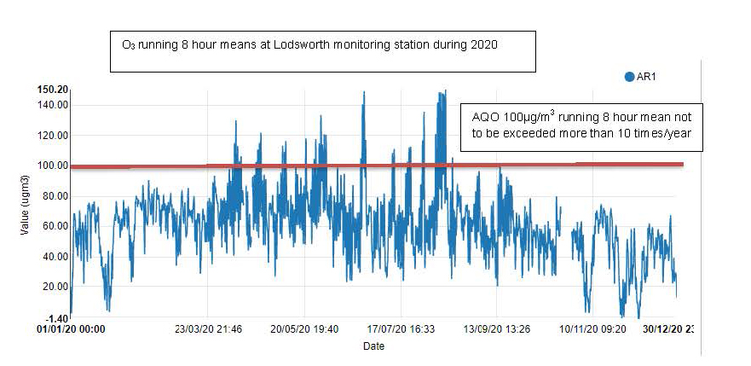

Comparison to the DEFRA banding below shows that in 2020 at Lodsworth there were 20 days when ‘moderate’ pollution occurred and no days when ‘high pollution’ occurred, see box for health messages of DEFRA pollution bands.

Table showing health messages of the DEFRA Pollution Bands
Pollution band and numerical index | Health messages for at-risk groups*
1 – 3 (low) | Enjoy your usual outdoor activities.
4 – 6 (moderate) | Adults and children with lung problems, and adults with heart problems, who experience symptoms, should consider reducing strenuous physical activity, particularly outdoors.
7 – 9 (high) | Adults and children with lung problems, and adults with heart problems, should reduce strenuous physical exertion, particularly outdoors, and particularly if they experience symptoms. People with asthma may find they need to use their reliever inhaler more often. Older people should also reduce physical exertion.
10 (very high) | Adults and children with lung problems, adults with heart problems, and older people, should avoid strenuous physical activity. People with asthma may find they need to use their reliever inhaler more often.
*Adults and children with heart or lung problems are at greater risk of symptoms.

The Council is considering decommissioning the ozone monitoring station in the coming year.

Appendix A: Monitoring Results
Table A.1 – Details of Automatic Monitoring Sites
Site ID | Site Name | Site Type | X OS Grid Ref (Easting) | Y OS Grid Ref (Northing) | Pollutants Monitored | In AQMA?  Which AQMA? | Monitoring Technique | Distance to Relevant Exposure (m) ⁽¹⁾ | Distance to kerb of nearest road (m) ⁽²⁾ | Inlet Height (m)
CI1 | Stockbridge | Suburban | 485881 | 103791 | NO₂; PM₁₀ | NO | chemilumin-escent/TEOM | 25 | 26 | 3
CI4 | Orchard Street | Roadside | 485982 | 105221 | NO₂ | YES (Orchard St AQMA) | Chemiluminescent | 9.8 | 3.75 | 2
AR1 | Lodsworth | Rural | 492396 | 123248 | O₃ | NO | UV | n/a | n/a | 2.1
CI5 | Westhampnett Road | Roadside | 487212 | 105372 | NO₂ | NO | Chemiluminescent | 11.8 | 4.2 | 1.9
Notes:
(1) 0m if the monitoring site is at a location of exposure (e.g. installed on the façade of a residential property)
(2) N/A if not applicable

Table A.2 – Details of Non-Automatic Monitoring Sites
Diffusion Tube ID | Site Name | Site Type | X OS Grid Ref (Easting) | Y OS Grid Ref (Northing) | Pollutants Monitored | In AQMA? Which AQMA? | Distance to Relevant Exposure (m) ⁽¹⁾ | Distance to kerb of nearest road (m) ⁽²⁾ | Tube Co-located with a Continuous Analyser? | Tube Height (m)
1 | Kings Ave/SouthbankJct | Roadside | 485776 | 103961 | NO2 | No | 11.0 | 2.3 | No | 3.0
2a, 2b | Claremont Court | Roadside | 485772 | 103847 | NO2 | Yes, Stockbridge Roundabout AQMA | 0.0 | 7.5 | No | 3.0
3, 4, 5 | Cabin | Suburban | 485880 | 103791 | NO2 | No | 25.0 | 26.0 | Yes | 2.7
6 | Stockbridge Road South | Roadside | 485696 | 103731 | NO2 | No | 14.0 | 2.0 | No | 2.9
7 | Cleveland Rd | Urban Background | 486953 | 104414 | NO2 | No | 18.0 | 1.8 | No | 2.8
8 | Westhampnett Road | Roadside | 487341 | 105474 | NO2 | No | 3.0 | 1.7 | No | 2.9
9a, 9b | Hornet | Roadside | 486502 | 104795 | NO2 | No | 0.0 | 1.8 | No | 3.1
10a, 10b | St Pancras | Roadside | 486533 | 104860 | NO2 | Yes, St Pancras AQMA | 0.0 | 2.0 | No | 3.0
11 | Arthur Purchase | Urban Background | 486082 | 105026 | NO2 | No | 0.0 | 6.0 | No | 2.7
12a, 12b | 174 Orchard St | Roadside | 485914 | 105185 | NO2 | Yes, Orchard Street AQMA | 0.0 | 2.0 | No | 2.7
13a, 13b | Rumbolds Hill | Roadside | 488561 | 121479 | NO2 | Yes, Rumbolds Hill AQMA | 0.5 | 1.5 | No | 3.4
14 | Sussex Cleaners | Roadside | 486575 | 104799 | NO2 | No | 0.0 | 1.8 | No | 3.0
15 | Nag's Head | Roadside | 496495 | 104845 | NO2 | Yes, St Pancras AQMA | 0.0 | 2.4 | No | 3.2
16 | Orchard St Cabin | Roadside | 485982 | 105221 | NO2 | Yes, Orchard Street AQMA | 9.8 | 3.8 | Yes | 2.0
17 | Midhurst Stationery | Roadside | 488545 | 121434 | NO2 | Yes, Rumbolds Hill AQMA | 1.8 | 0.6 | No | 2.8
18 | Nat West Bank | Roadside | 488583 | 121512 | NO2 | Yes, Rumbolds Hill AQMA | 9.9 | 1.1 | No | 3.0
19 | Nationwide | Roadside | 488605 | 121538 | NO2 | Yes, Rumbolds Hill AQMA | 0.5 | 2.2 | No | 2.7
20 | British Heart Foundation | Roadside | 488636 | 121613 | NO2 | No | 0.0 | 3.8 | No | 2.8
21 | Whyke Road | Roadside | 486899 | 103720 | NO2 | No | 20.0 | 1.7 | No | 2.4
22 | St Pauls Road | Roadside | 485957 | 105334 | NO2 | No | 0.0 | 2.1 | No | 2.1
Notes:
(1) 0m if the monitoring site is at a location of exposure (e.g. installed on the façade of a residential property).
(2) N/A if not applicable.

Table A.3 – Annual Mean NO₂ Monitoring Results: Automatic Monitoring (µg/m³)
Site ID | X OS Grid Ref (Easting) | Y OS Grid Ref (Northing) | Site Type | Valid Data Capture for Monitoring Period (%) ⁽¹⁾ | Valid Data Capture 2020 (%) ⁽²⁾ | 2016 | 2017 | 2018 | 2019 | 2020
CI1 | 485881 | 103791 | Suburban |  | 100 | 34 | 33 | 29 | 28 | 23
CI4 | 485982 | 105221 | Roadside |  | 99 | 29 | 23 | 22 | 21 | 16
CI5 | 487212 | 105372 | Roadside |  | 100 |  |  |  | 27 | 19
☒ Reported concentrations are those at the location of the monitoring site (annualised, as required), i.e. prior to any fall-off with distance correction
Notes:
The annual mean concentrations are presented as µg/m³.
Exceedances of the NO₂ annual mean objective of 40µg/m³ are shown in bold.
All means have been “annualised” as per LAQM.TG16 if valid data capture for the full calendar year is less than 75%. See Appendix C for details.
Concentrations are those at the location of monitoring and not those following any fall-off with distance adjustment.
(1) Data capture for the monitoring period, in cases where monitoring was only carried out for part of the year.
(2) Data capture for the full calendar year (e.g. if monitoring was carried out for 6 months, the maximum data capture for the full calendar year is 50%).

Table A.4 – Annual Mean NO₂ Monitoring Results: Non-Automatic Monitoring (µg/m³)
Diffusion Tube ID | X OS Grid Ref (Easting) | Y OS Grid Ref (Northing) | Site Type | Valid Data Capture for Monitoring Period (%) ⁽¹⁾ | Valid Data Capture 2020 (%) ⁽²⁾ | 2016 | 2017 | 2018 | 2019 | 2020
1 | 485776 | 103961 | Roadside | 82.7 | 82.7 | 33.0 | 29.0 | 27.0 | 25.0 | 20.8
2a, 2b | 485772 | 103847 | Roadside | 82.7 | 82.7 | 42.0 | 39.0 | 33.0 | 33.0 | 27.2
3, 4, 5 | 485880 | 103791 | Suburban | 92.3 | 82.7 | 34.0 | 33.0 | 29.0 | 28.0 | 24.4
6 | 485696 | 103731 | Roadside | 82.7 | 82.7 | 43.0 | 36.0 | 34.0 | 33.0 | 27.9
7 | 486953 | 104414 | Urban Background | 82.7 | 82.7 | 18.0 | 16.0 | 15.0 | 14.0 | 11.7
8 | 487341 | 105474 | Roadside | 82.7 | 82.7 | 31.0 | 30.0 | 29.0 | 27.0 | 21.6
9a, 9b | 486502 | 104795 | Roadside | 82.7 | 82.7 | 41.0 | 38.0 | 36.0 | 34.0 | 26.9
10a, 10b | 486533 | 104860 | Roadside | 82.7 | 82.7 | 51.0 | 44.0 | 45.0 | 42.0 | 33.3
11 | 486082 | 105026 | Urban Background | 82.7 | 82.7 | 20.0 | 18.0 | 17.0 | 17.0 | 13.1
12a, 12b | 485914 | 105185 | Roadside | 82.7 | 82.7 | 38.0 | 33.0 | 33.0 | 30.0 | 21.5
13a, 13b | 488561 | 121479 | Roadside | 82.7 | 82.7 | 51.0 | 49.0 | 42.0 | 40.0 | 33.5
14 | 486575 | 104799 | Roadside | 82.7 | 82.7 |  |  | 32.0 | 31.0 | 25.6
15 | 496495 | 104845 | Roadside | 82.7 | 82.7 |  |  | 38.0 | 37.0 | 28.3
16 | 485982 | 105221 | Roadside | 82.7 | 82.7 |  |  | 22.0 | 20.0 | 15.5
17 | 488545 | 121434 | Roadside | 82.7 | 82.7 |  |  | 28.0 | 26.0 | 22.0
18 | 488583 | 121512 | Roadside | 82.7 | 82.7 |  |  | 37.0 | 37.0 | 30.2
19 | 488605 | 121538 | Roadside | 82.7 | 82.7 |  |  | 38.0 | 33.0 | 29.0
20 | 488636 | 121613 | Roadside | 82.7 | 82.7 |  |  | 27.0 | 24.0 | 18.7
21 | 486899 | 103720 | Roadside | 82.7 | 82.7 |  |  |  |  | 25.1
22 | 485957 | 105334 | Roadside | 75 | 75.0 |  |  |  |  | 17.0
☒ Diffusion tube data has been bias adjusted
☒ Reported concentrations are those at the location of the monitoring site (bias adjusted and annualised, as required), i.e. prior to any fall-off with distance correction
Notes:
The annual mean concentrations are presented as µg/m³.
Exceedances of the NO₂ annual mean objective of 40µg/m³ are shown in bold.
NO₂ annual means exceeding 60µg/m³, indicating a potential exceedance of the NO₂ 1-hour mean objective are shown in bold and underlined.
Means for diffusion tubes have been corrected for bias. All means have been “annualised” as per LAQM.TG16 if valid data capture for the full calendar year is less than 75%. See Appendix C for details.
Concentrations are those at the location of monitoring and not those following any fall-off with distance adjustment.
(1) Data capture for the monitoring period, in cases where monitoring was only carried out for part of the year.
(2) Data capture for the full calendar year (e.g. if monitoring was carried out for 6 months, the maximum data capture for the full calendar year is 50%).

Figure A.1 – Trends in Annual Mean NO₂ Concentrations at Automatic Monitoring Sites

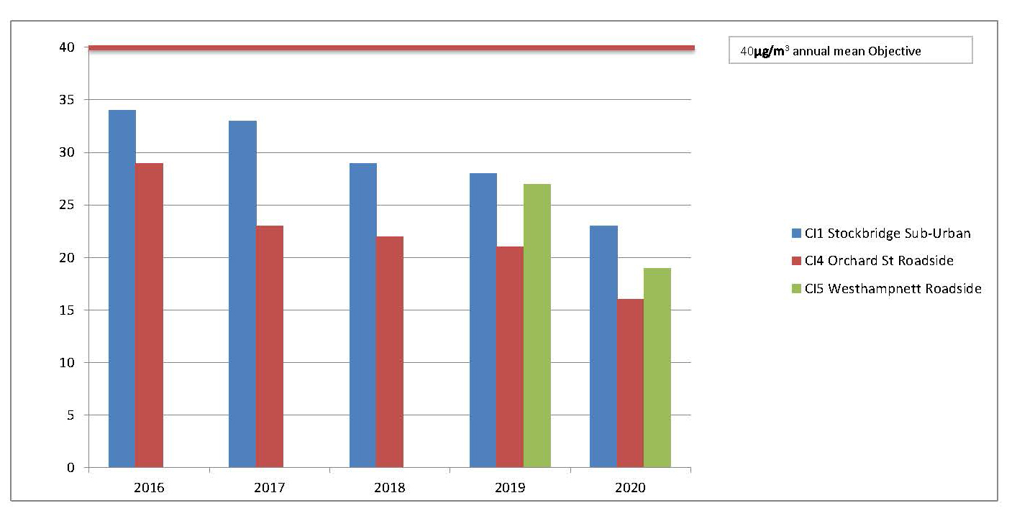

Figure A.2 – Trends in Annual Mean NO₂ Concentrations at Non Automatic Monitoring Sites
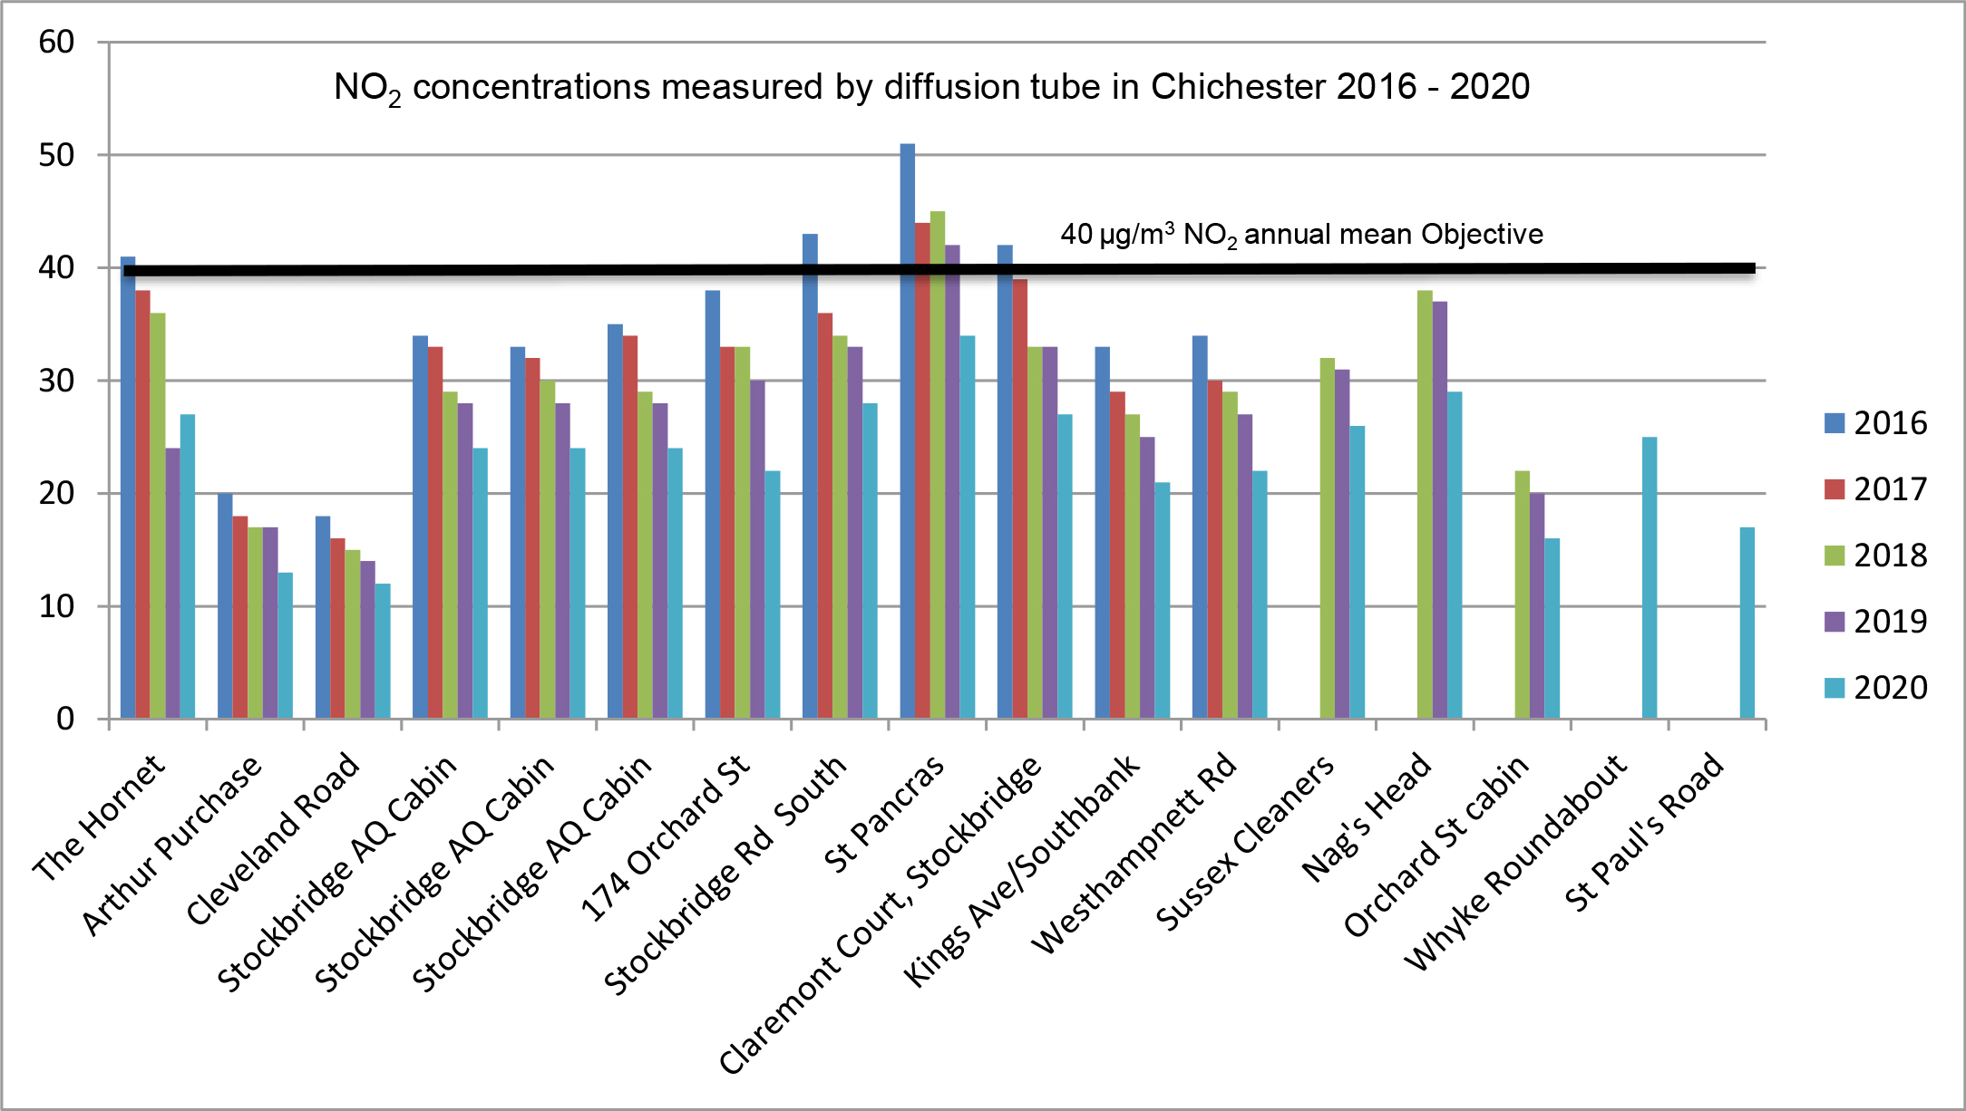

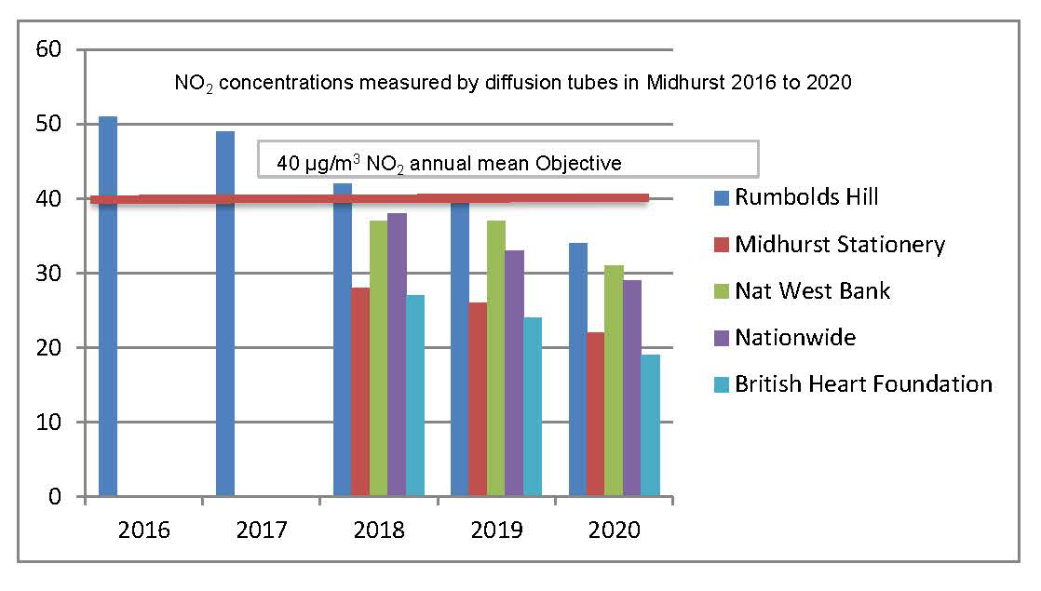

Table A.5 – 1-Hour Mean NO₂ Monitoring Results, Number of 1-Hour Means > 200µg/m³
Site ID | X OS Grid Ref (Easting) | Y OS Grid Ref (Northing) | Site Type | Valid Data Capture for Monitoring Period (%) ⁽¹⁾ | Valid Data Capture 2020 (%) ⁽²⁾ | 2016 | 2017 | 2018 | 2019 | 2020
CI1 | 485881 | 103791 | Suburban |  | 100 | 0 | 0 | 0 | 0 | 0
CI4 | 485982 | 105221 | Roadside |  | 99 | 0 | 0 | 0 | 0 | 0
CI5 | 487212 | 105372 | Roadside |  | 100 |  |  |  | 0 | 0
Notes:
Results are presented as the number of 1-hour periods where concentrations greater than 200µg/m³ have been recorded.
Exceedances of the NO₂ 1-hour mean objective (200µg/m³ not to be exceeded more than 18 times/year) are shown in bold.
If the period of valid data is less than 85%, the 99.8th percentile of 1-hour means is provided in brackets.
(1) Data capture for the monitoring period, in cases where monitoring was only carried out for part of the year.
(2) Data capture for the full calendar year (e.g. if monitoring was carried out for 6 months, the maximum data capture for the full calendar year is 50%).

Figure A.3 – Trends in Number of NO₂ 1-Hour Means > 200µg/m³
NO₂ hourly mean concentrations did not exceed Objective of 200µg/m³ at any of the CDC monitoring stations.

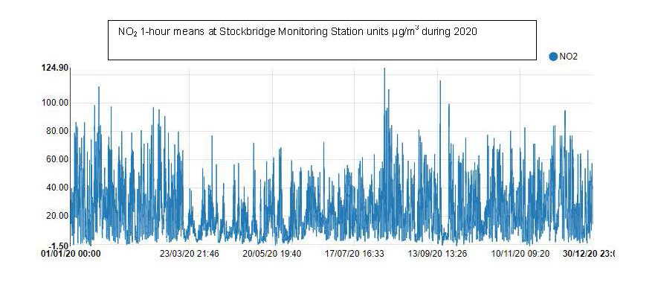

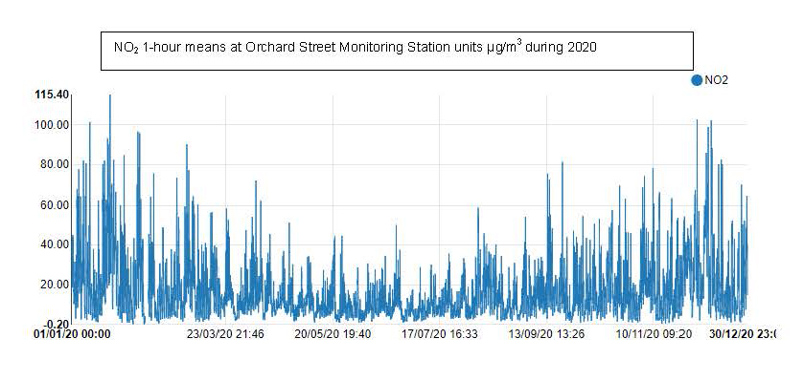

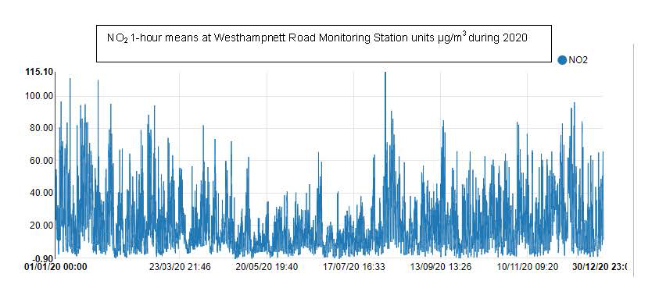

Table A.6 – Annual Mean PM₁₀ Monitoring Results (µg/m³)
Site ID | X OS Grid Ref (Easting) | Y OS Grid Ref (Northing) | Site Type | Valid Data Capture for Monitoring Period (%) ⁽¹⁾ | Valid Data Capture 2020 (%) ⁽²⁾ | 2016 | 2017 | 2018 | 2019 | 2020
CI1 | 485881 | 103791 | Suburban |  | 99 | 20 | 19 | 18 | 19 | 18
Notes:
The annual mean concentrations are presented as µg/m³.
Exceedances of the PM₁₀ annual mean objective of 40µg/m³ are shown in bold.
All means have been “annualised” as per LAQM.TG16 if valid data capture for the full calendar year is less than 75%. See Appendix C for details.
(1) Data capture for the monitoring period, in cases where monitoring was only carried out for part of the year.
(2) Data capture for the full calendar year (e.g. if monitoring was carried out for 6 months, the maximum data capture for the full calendar year is 50%).

Figure A.4 – Trends in Annual Mean PM₁₀ Concentrations
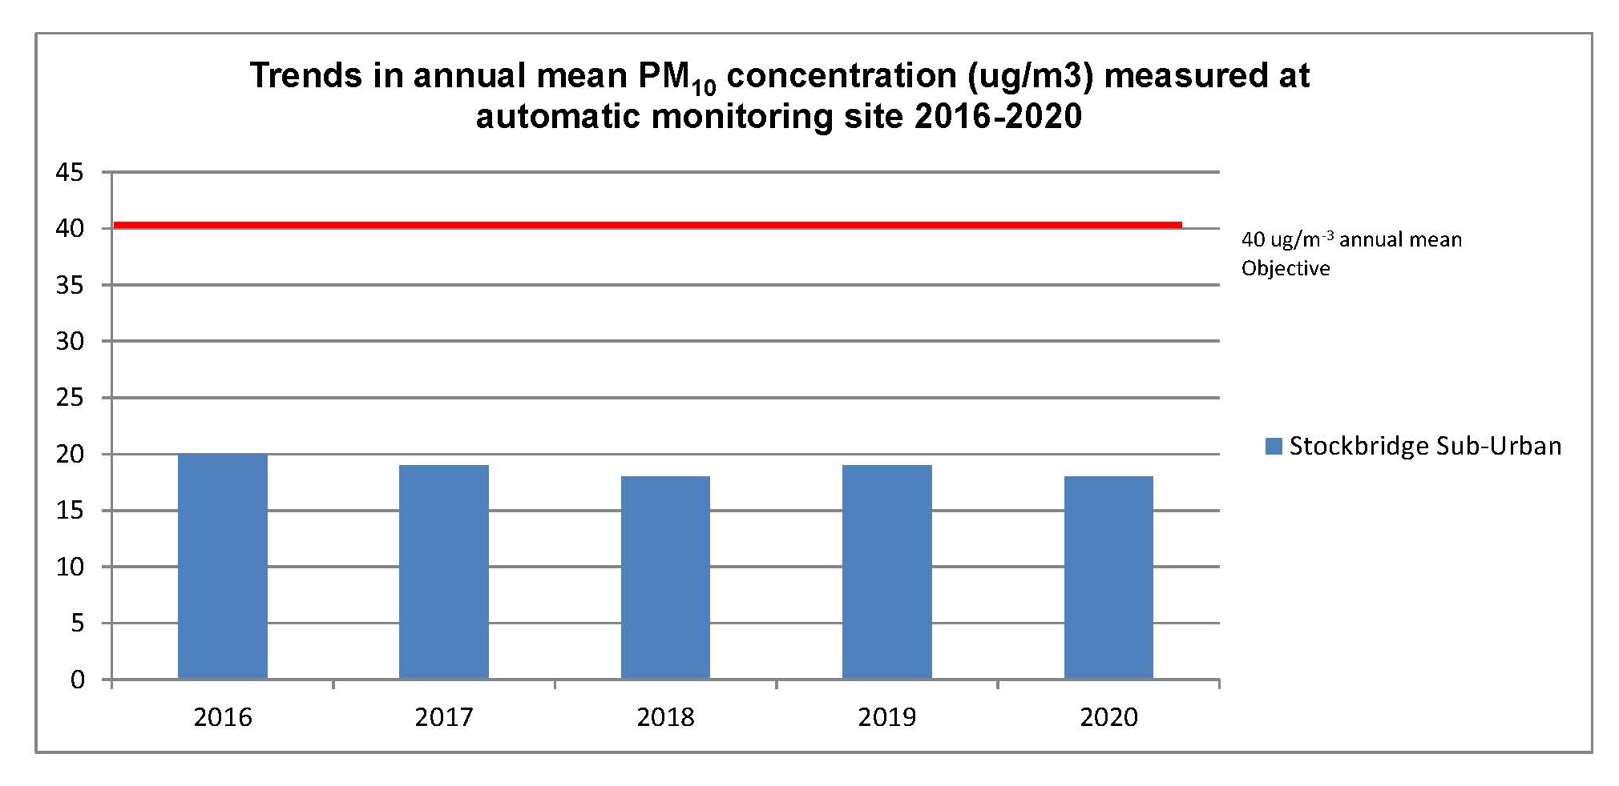

Table A.7 – 24-Hour Mean PM₁₀ Monitoring Results, Number of PM₁₀ 24-Hour Means > 50µg/m³
Site ID | X OS Grid Ref (Easting) | Y OS Grid Ref (Northing) | Site Type | Valid Data Capture for Monitoring Period (%) ⁽¹⁾ | Valid Data Capture 2020 (%) ⁽²⁾ | 2016 | 2017 | 2018 | 2019 | 2020
CI1 | 485881 | 103791 | Suburban |  | 99 | 2 | 1 | 0 | 0 | 0
Notes:
Results are presented as the number of 24-hour periods where daily mean concentrations greater than 50µg/m³ have been recorded.
Exceedances of the PM₁₀ 24-hour mean objective (50µg/m³ not to be exceeded more than 35 times/year) are shown in bold.
If the period of valid data is less than 85%, the 90.4th percentile of 24-hour means is provided in brackets.
(1) Data capture for the monitoring period, in cases where monitoring was only carried out for part of the year.
(2) Data capture for the full calendar year (e.g. if monitoring was carried out for 6 months, the maximum data capture for the full calendar year is 50%).

Figure A.5 – Trends in Number of 24-Hour Mean PM₁₀ Results > 50µg/m³
No exceedances of Objective (50µg/m³) during 2020
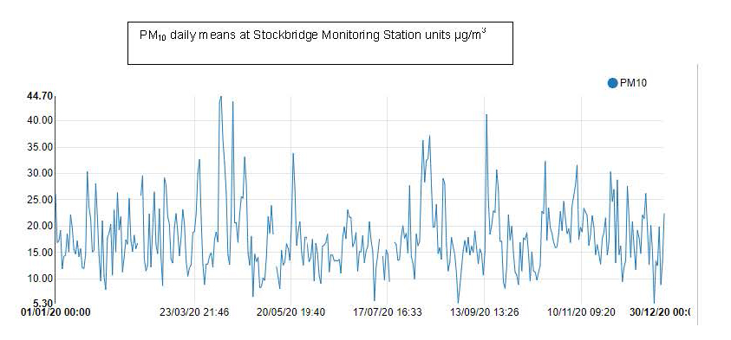

Appendix B: Full Monthly Diffusion Tube Results for 2020
Table B.1 – NO₂ 2020 Diffusion Tube Results (µg/m³)
DT ID | X OS Grid Ref (Easting) | Y OS Grid Ref (Easting) | Jan | Feb | Mar | Apr | May | Jun | Jul | Aug | Sep | Oct | Nov | Dec | Annual Mean: Raw Data | Annual Mean: Annualised and Bias Adjusted (0.79) | Annual Mean: Distance Corrected to Nearest Exposure | Comment
1 | 485776 | 103961 | 35.3 | 27.0 | 19.9 |  |  | 19.0 | 22.9 | 25.9 | 29.4 | 27.4 | 28.7 | 29.3 | 26.5 | 20.8
2a | 485772 | 103847 | 41.5 | 37.2 | 25.9 |  |  | 29.7 | 32.2 | 38.7 | 37.7 | 32.7 | 33.8 | 32.3 | - | - |  | Duplicate Site with 2a and 2b - Annual data provided for 2b only
2b | 485772 | 103847 | 42.8 | 34.7 | 30.8 |  |  | 34.6 | 33.0 | 38.3 | 36.5 | 34.6 | 34.9 | 29.5 | 34.6 | 27.2 |  | Duplicate Site with 2a and 2b - Annual data provided for 2b only
3 | 485880 | 103791 | 40.1 | 30.3 | 30.3 |  |  | 28.6 | 32.1 | 32.2 | 31.8 | 30.0 | 25.1 | 25.1 | - | - |  | Triplicate Site with 3, 4 and 5 - Annual data provided for 5 only
4 | 485880 | 103791 | 34.9 | 30.0 | 26.9 |  |  | 24.7 | 30.4 | 29.0 | 35.6 | 37.3 | 30.6 | 29.8 | - | - |  | Triplicate Site with 3, 4 and 5 - Annual data provided for 5 only
5 | 485880 | 103791 | 43.7 | 33.5 | 24.9 |  |  | 25.9 | 31.1 | 32.4 | 30.0 | 32.7 | 35.4 | 26.4 | 31.0 | 24.4 |  | Triplicate Site with 3, 4 and 5 - Annual data provided for 5 only
6 | 485696 | 103731 | 41.7 | 31.9 | 35.8 |  |  | 31.2 | 23.1 | 40.1 | 41.6 | 35.6 | 40.6 | 32.9 | 35.5 | 27.9
7 | 486953 | 104414 | 20.6 | 15.6 | 15.1 |  |  | 10.6 | 7.8 | 12.2 | 15.2 | 15.3 | 18.3 | 18.2 | 14.9 | 11.7
8 | 487341 | 105474 | 35.2 | 25.6 | 26.2 |  |  | 22.5 | 20.1 | 26.6 | 28.4 | 30.7 | 28.5 | 30.3 | 27.4 | 21.6
9a | 486502 | 104795 | 43.4 | 34.0 | 32.8 |  |  | 23.5 | 26.2 | 29.9 | 36.1 | 35.5 | 37.1 | 34.8 | - | - |  | Duplicate Site with 9a and 9b - Annual data provided for 9b only
9b | 486502 | 104795 | 49.0 | 34.4 | 31.5 |  |  | 23.7 | 24.7 | 35.5 | 40.0 | 37.3 | 37.3 | 35.7 | 34.1 | 26.9 |  | Duplicate Site with 9a and 9b - Annual data provided for 9b only
10a | 486533 | 104860 | 44.7 | 41.5 | 42.0 |  |  | 37.5 | 34.2 | 42.9 | 44.7 | 45.6 | 46.2 | 42.0 | - | - |  | Duplicate Site with 10a and 10b - Annual data provided for 10b only
10b | 486533 | 104860 | 52.2 | 34.7 | 41.3 |  |  | 37.5 | 32.7 | 46.6 | 44.5 | 45.7 | 47.6 | 41.7 | 42.3 | 33.3 |  | Duplicate Site with 10a and 10b - Annual data provided for 10b only
11 | 486082 | 105026 | 22.1 | 18.1 | 16.6 |  |  | 10.3 | 9.8 | 14.0 | 16.5 | 16.8 | 21.6 | 20.2 | 16.6 | 13.1
12a | 485914 | 105185 | 38.5 | 26.2 | 22.0 |  |  | 20.7 | 17.1 | 26.2 | 26.4 | 27.4 | 33.2 | 35.0 | - | - |  | Duplicate Site with 12a and 12b - Annual data provided for 12b only
12b | 485914 | 105185 | 39.5 | 29.0 | 25.2 |  |  | 19.8 | 16.2 | 26.4 | 26.7 | 23.5 | 34.2 | 32.9 | 27.3 | 21.5 |  | Duplicate Site with 12a and 12b - Annual data provided for 12b only
13a | 488561 | 121479 | 51.5 | 35.9 | 42.4 |  |  | 35.6 | 38.2 | 40.7 | 47.3 | 43.2 | 45.3 | 38.0 | - | - |  | Duplicate Site with 13a and 13b - Annual data provided for 13b only
13b | 488561 | 121479 | 52.5 | 44.1 | 39.9 |  |  | 33.5 | 36.7 | 44.4 | 50.1 | 43.9 | 44.6 | 41.9 | 42.5 | 33.5 |  | Duplicate Site with 13a and 13b - Annual data provided for 13b only
14 | 486575 | 104799 | 38.2 | 32.1 | 31.7 |  |  | 28.9 | 26.5 | 34.2 | 34.0 | 35.3 | 31.8 | 31.9 | 32.5 | 25.6
15 | 496495 | 104845 | 48.1 | 32.1 | 32.9 |  |  | 27.3 | 31.7 | 34.4 | 42.7 | 38.9 | 33.7 | 38.0 | 36.0 | 28.3
16 | 485982 | 105221 | 26.2 | 23.2 | 16.7 |  |  | 13.4 | 11.7 | 16.5 | 19.9 | 18.2 | 25.4 | 25.1 | 19.6 | 15.5
17 | 488545 | 121434 | 32.3 | 26.5 | 27.2 |  |  | 22.6 | 21.5 | 28.4 | 31.4 | 27.0 | 30.9 | 31.0 | 27.9 | 22.0
18 | 488583 | 121512 | 29.5 | 37.6 | 33.7 |  |  | 33.4 | 38.8 | 37.9 | 45.1 | 46.2 | 41.0 | 40.4 | 38.4 | 30.2
19 | 488605 | 121538 | 43.2 | 32.5 | 34.0 |  |  | 31.7 | 26.6 | 37.4 | 37.1 | 49.0 | 42.0 | 34.2 | 36.8 | 29.0
20 | 488636 | 121613 | 26.5 | 21.5 | 22.2 |  |  | 22.3 | 15.8 | 26.3 | 25.5 | 23.9 | 26.7 | 27.1 | 23.8 | 18.7
21 | 486899 | 103720 | 38.4 | 32.4 | 29.3 |  |  | 31.6 | 30.4 | 37.8 | 35.8 | 0.6 | 67.6 | 15.4 | 31.9 | 25.1
22 | 485957 | 105334 |  | 21.8 | 21.6 |  |  | 17.6 | 12.5 | 21.4 | 23.6 | 20.8 | 28.0 | 27.6 | 21.6 | 17.0
☒ All erroneous data has been removed from the NO₂ diffusion tube dataset presented in Table B.1
☒ Local bias adjustment factor used
☒ CDC confirms that all 2020 diffusion tube data has been uploaded to the Diffusion Tube Data Entry System
Notes:
Exceedances of the NO₂ annual mean objective of 40µg/m³ are shown in bold.
NO₂ annual means exceeding 60µg/m³, indicating a potential exceedance of the NO₂ 1-hour mean objective are shown in bold and underlined.
See Appendix C for details on bias adjustment and annualisation.

Appendix C: Supporting Technical Information / Air Quality Monitoring Data QA/QC

New or Changed Sources Identified Within Chichester District During 2020
Chichester District Council has not identified any new sources relating to air quality within the reporting year of 2020.

Additional Air Quality Works Undertaken by Chichester District Council During 2020
Chichester District Council has revised its Air Quality Action Plan (AQAP) during 2020 and the revised document has been issued for public consultation between 17 May and 28 June 2021. The revised AQAP includes detailed modelling and scenario testing of mitigation measures proposed and the conclusions support the proposed revocation of the Orchard Street and Stockbridge Roundabout AQMAs in Chichester. The modelling reports are available as stand- alone documents, see Appendix G.

QA/QC of Diffusion Tube Monitoring
Chichester District Council uses Gradko Environmental for supplying and analysing the diffusion tubes. The tube preparation method is 50% TEA/Acetone and ANA UKAS Method GLM7 and GLM9. CDC uses a local bias adjustment factor. The monitoring was completed in adherence with the 2020 Diffusion Tube Monitoring Calendar except for the months of April and May when no tubes were exposed due the lockdown restrictions associated with the Covid 19 pandemic.

Gradko Environmental uses the AIR NO₂ Proficiency Testing scheme for quality control. The result for 2020 was Satisfactory (Z score +/- 2) for 75% of results submitted (note not all testing was achieved in 2020 due to the Covid 19 pandemic).

Diffusion Tube Annualisation
All diffusion tube monitoring locations within Chichester District recorded data capture of 75% therefore it was not required to annualise any monitoring data. In addition, any sites with a data capture below 25% do not require annualisation.

Diffusion Tube Bias Adjustment Factors
The diffusion tube data presented within the 2020 ASR have been corrected for bias using an adjustment factor. Bias represents the overall tendency of the diffusion tubes to under or over-read relative to the reference chemiluminescence analyser. LAQM.TG16 provides guidance with regard to the application of a bias adjustment factor to correct diffusion tube monitoring. Triplicate co-location studies can be used to determine a local bias factor based on the comparison of diffusion tube results with data taken from NO_{x}/NO₂ continuous analysers. Alternatively, the national database of diffusion tube co-location surveys provides bias factors for the relevant laboratory and preparation method.
There are three diffusion tubes co-located with the Stockbridge (CI1) continuous analyser which are used to derive the local bias adjustment factor. Chichester District Council has applied a local bias adjustment factor of 0.79 to the 2020 monitoring data. A summary of bias adjustment factors used by CDC over the past five years is presented in Table C.1.
Table C.1 – Bias Adjustment Factor
Year | Local or National | If National, Version of National Spreadsheet | Adjustment Factor
2020 | Local | - | 0.79
2019 | Local | - | 0.84
2018 | Local | - | 0.85
2017 | Local | - | 0.933
2016 | Local | - | 1.106

NO₂ Fall-off with Distance from the Road
Wherever possible, local authorities should ensure that monitoring locations are representative of exposure. However, where this is not possible, the NO₂ concentration at the nearest location relevant for exposure should be estimated using the Diffusion Tube Data Processing Tool/NO₂ fall-off with distance calculator available on the LAQM Support website. Where appropriate, non-automatic annual mean NO₂ concentrations corrected for distance, are presented in Table B.1.
No diffusion tube NO₂ monitoring locations within Chichester district required distance correction during 2020.

QA/QC of Automatic Monitoring
All sites are visited by a CDC officer for calibration and filter changes on a bi-monthly basis. CDC has a service agreement with a third party who provides site maintenance, auditing, regular inspections and 48 call-out response if problems are encountered. Data is downloaded from all sites twice daily by ERG and is available to download online. CDC has a contract with ERG to calibrate and ratify all real time data collected. Data presented in the report has been ratified.

PM₁₀ and PM_{2.5} Monitoring Adjustment
ERG applies an approved Volatile Correction Model (VCM) correction to the PM₁₀ data (further details are available from ERG).

Automatic Monitoring Annualisation
All automatic monitoring locations within Chichester District recorded data capture of greater than 75% therefore it was not required to annualise any monitoring data. In addition, any sites with a data capture below 25% do not require annualisation.

NO₂ Fall-off with Distance from the Road
Wherever possible, local authorities should ensure that monitoring locations are representative of exposure. However, where this is not possible, the NO₂ concentration at the nearest location relevant for exposure should be estimated using the NO₂ fall-off with distance calculator available on the LAQM Support website. Where appropriate, non-automatic annual mean NO₂ concentrations corrected for distance, are presented in Table B.1.
No automatic NO₂ monitoring locations within Chichester District required distance correction during 2020.

Table C.2 – Annualisation Summary (concentrations presented in µg/m³)
No annualisation of diffusion tubes was required.
Table C.3 – Local Bias Adjustment Calculation
 | Local Bias Adjustment Input 1 | Local Bias Adjustment Input 2 | Local Bias Adjustment Input 3 | Local Bias Adjustment Input 4 | Local Bias Adjustment Input 5
Periods used to calculate bias | 10
Bias Factor A | 0.79 (0.73 - 0.86)
Bias Factor B | 27% (17% - 37%)
Diffusion Tube Mean (µg/m³) | 31.0
Mean CV (Precision) | 8.9%
Automatic Mean (µg/m³) | 24.5
Data Capture | 95%
Adjusted Tube Mean (µg/m³) | 25 (23-27)
 | Good Overall Precision
 | Good Overall Data Capture
 | 0.79
Notes:
A single local bias adjustment factor has been used to bias adjust the 2020 diffusion tube results.

Table C.4 – NO₂ Fall off With Distance Calculations (concentrations presented in µg/m³)
Distance adjustment not required.

Appendix D: Map(s) of Monitoring Locations and AQMAs

Figure D.1 – Map of Non-Automatic Monitoring Sites in Chichester
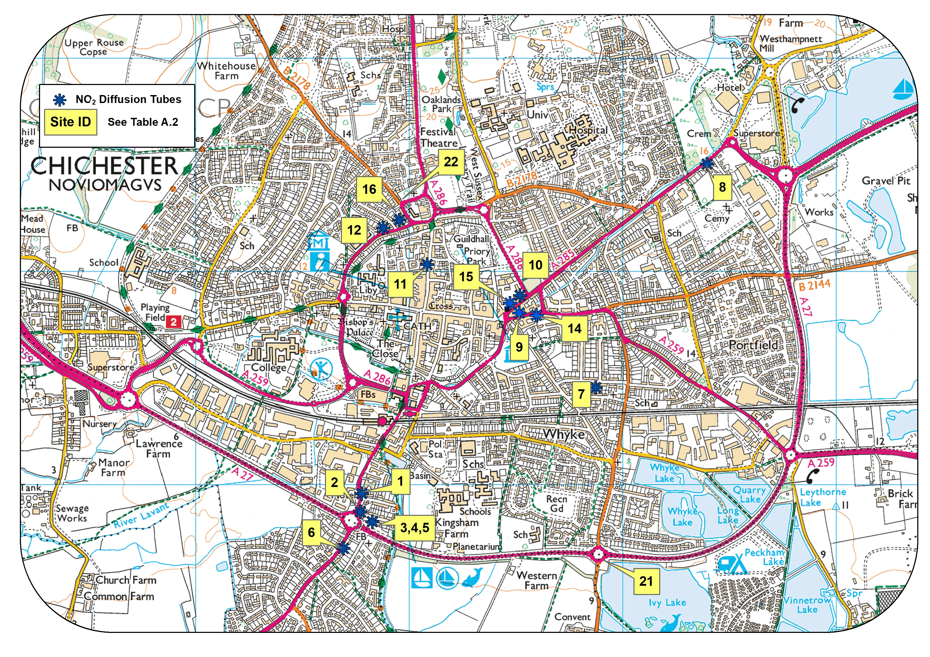
© Crown Copyright and database right 2020. Ordnance Survey 100018803
Figure D.2 – Map of Automatic and Non-Automatic Monitoring Sites at Stockbridge Roundabout AQMA, Chichester
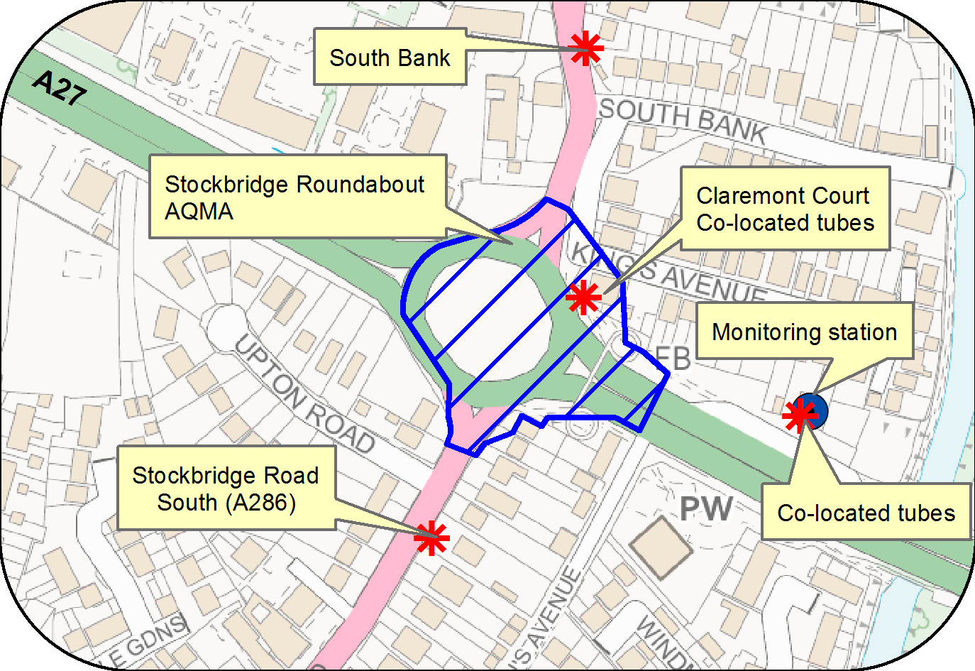
© Crown Copyright and database right 2020. Ordnance Survey 100018803
Figure D.3 – Map of Non-Automatic Monitoring Sites at St Pancras AQMA, Chichester
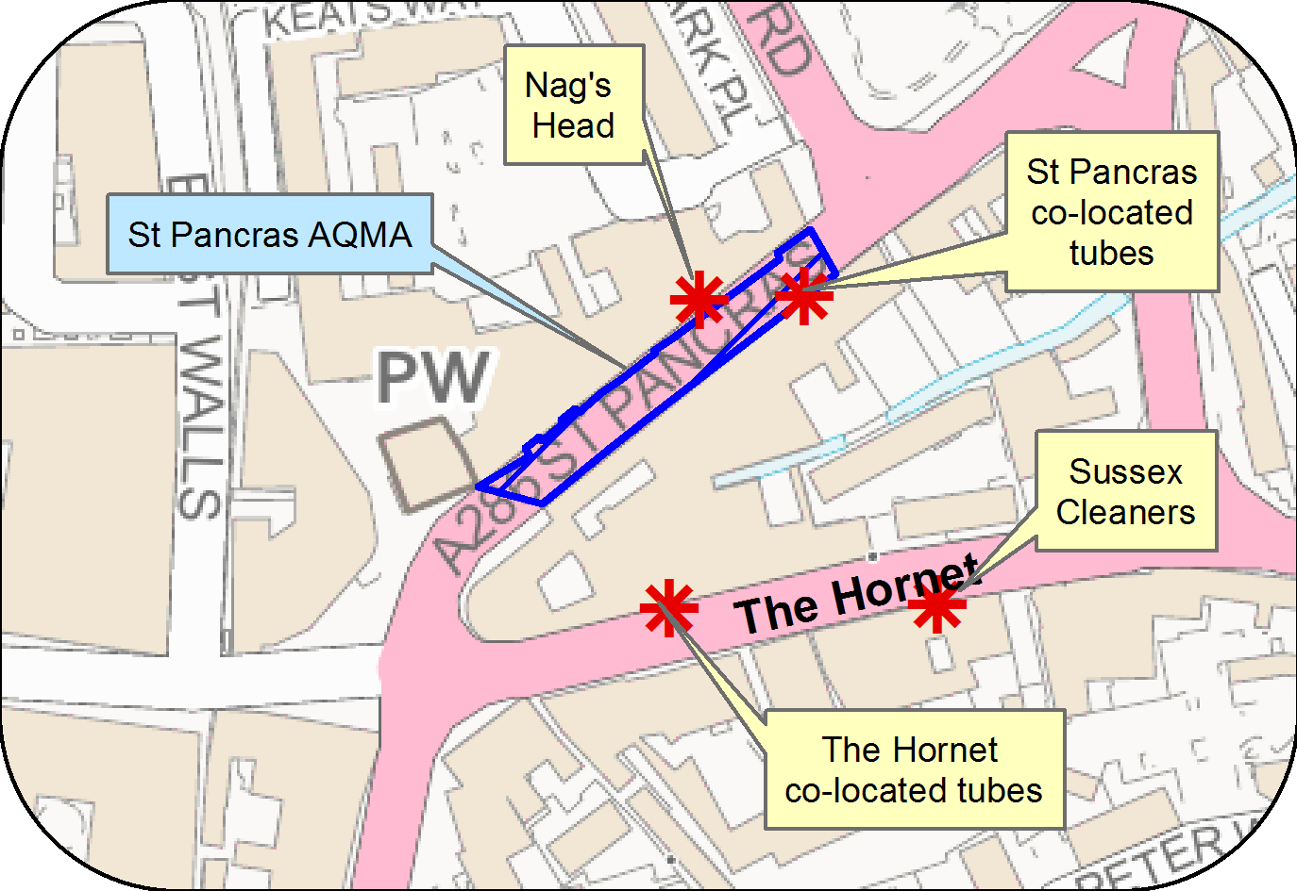
© Crown Copyright and database right 2020. Ordnance Survey 100018803

Figure D.4 – Map of Automatic and Non-Automatic Monitoring Sites at Orchard Street AQMA, Chichester
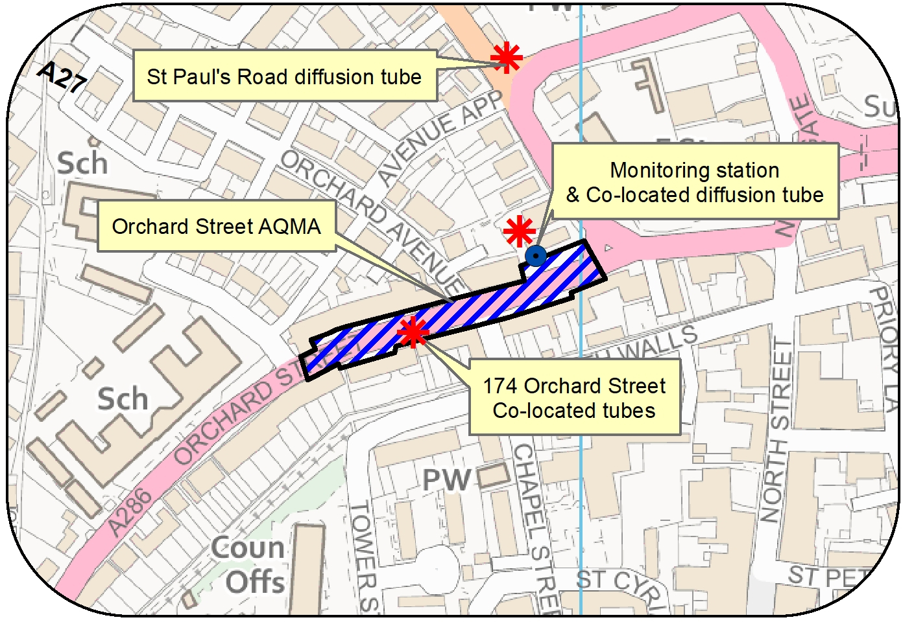
© Crown Copyright and database right 2020. Ordnance Survey 100018803
Figure D.5 – Map of Automatic and Non-Automatic Monitoring Sites at Westhampnett Road, Chichester
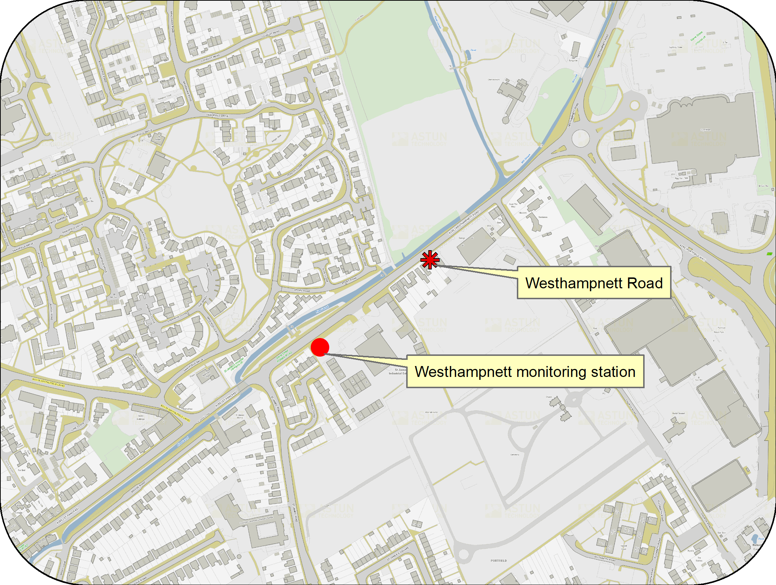
© Crown Copyright and database right 2020. Ordnance Survey 100018803
Figure D.6 – Map of Ozone Automatic Monitoring Site at Lodsworth

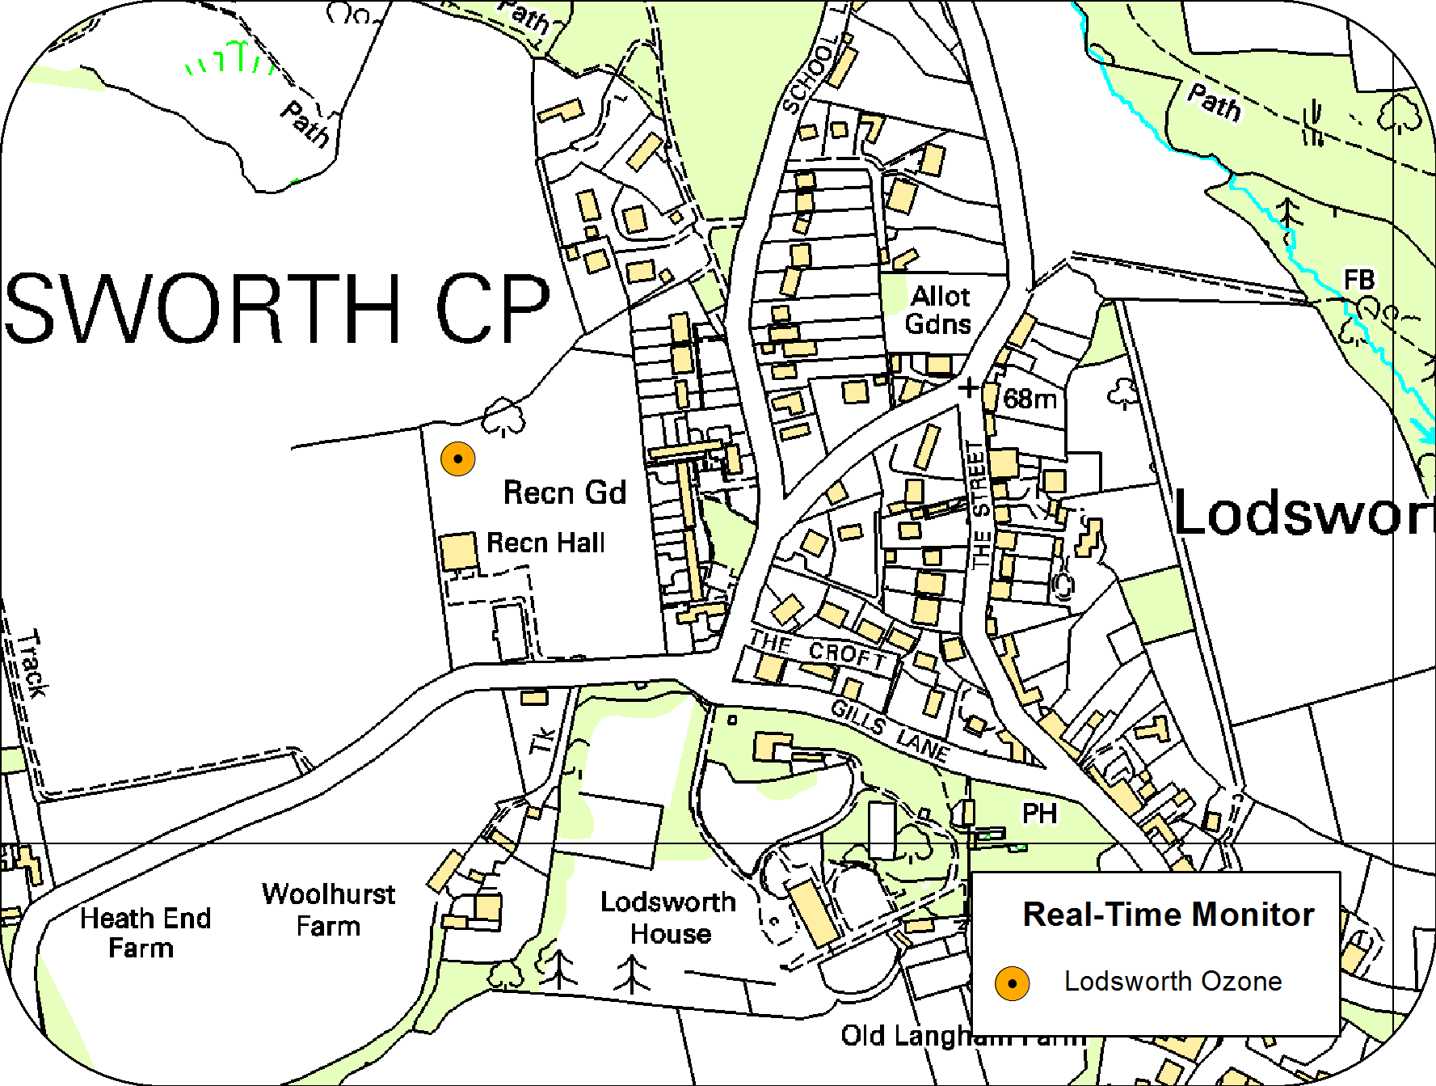
© Crown Copyright and database right 2020. Ordnance Survey 100018803

Figure D.7 – Map of Non Automatic Monitoring Sites at Rumbolds Hill AQMA, Midhurst

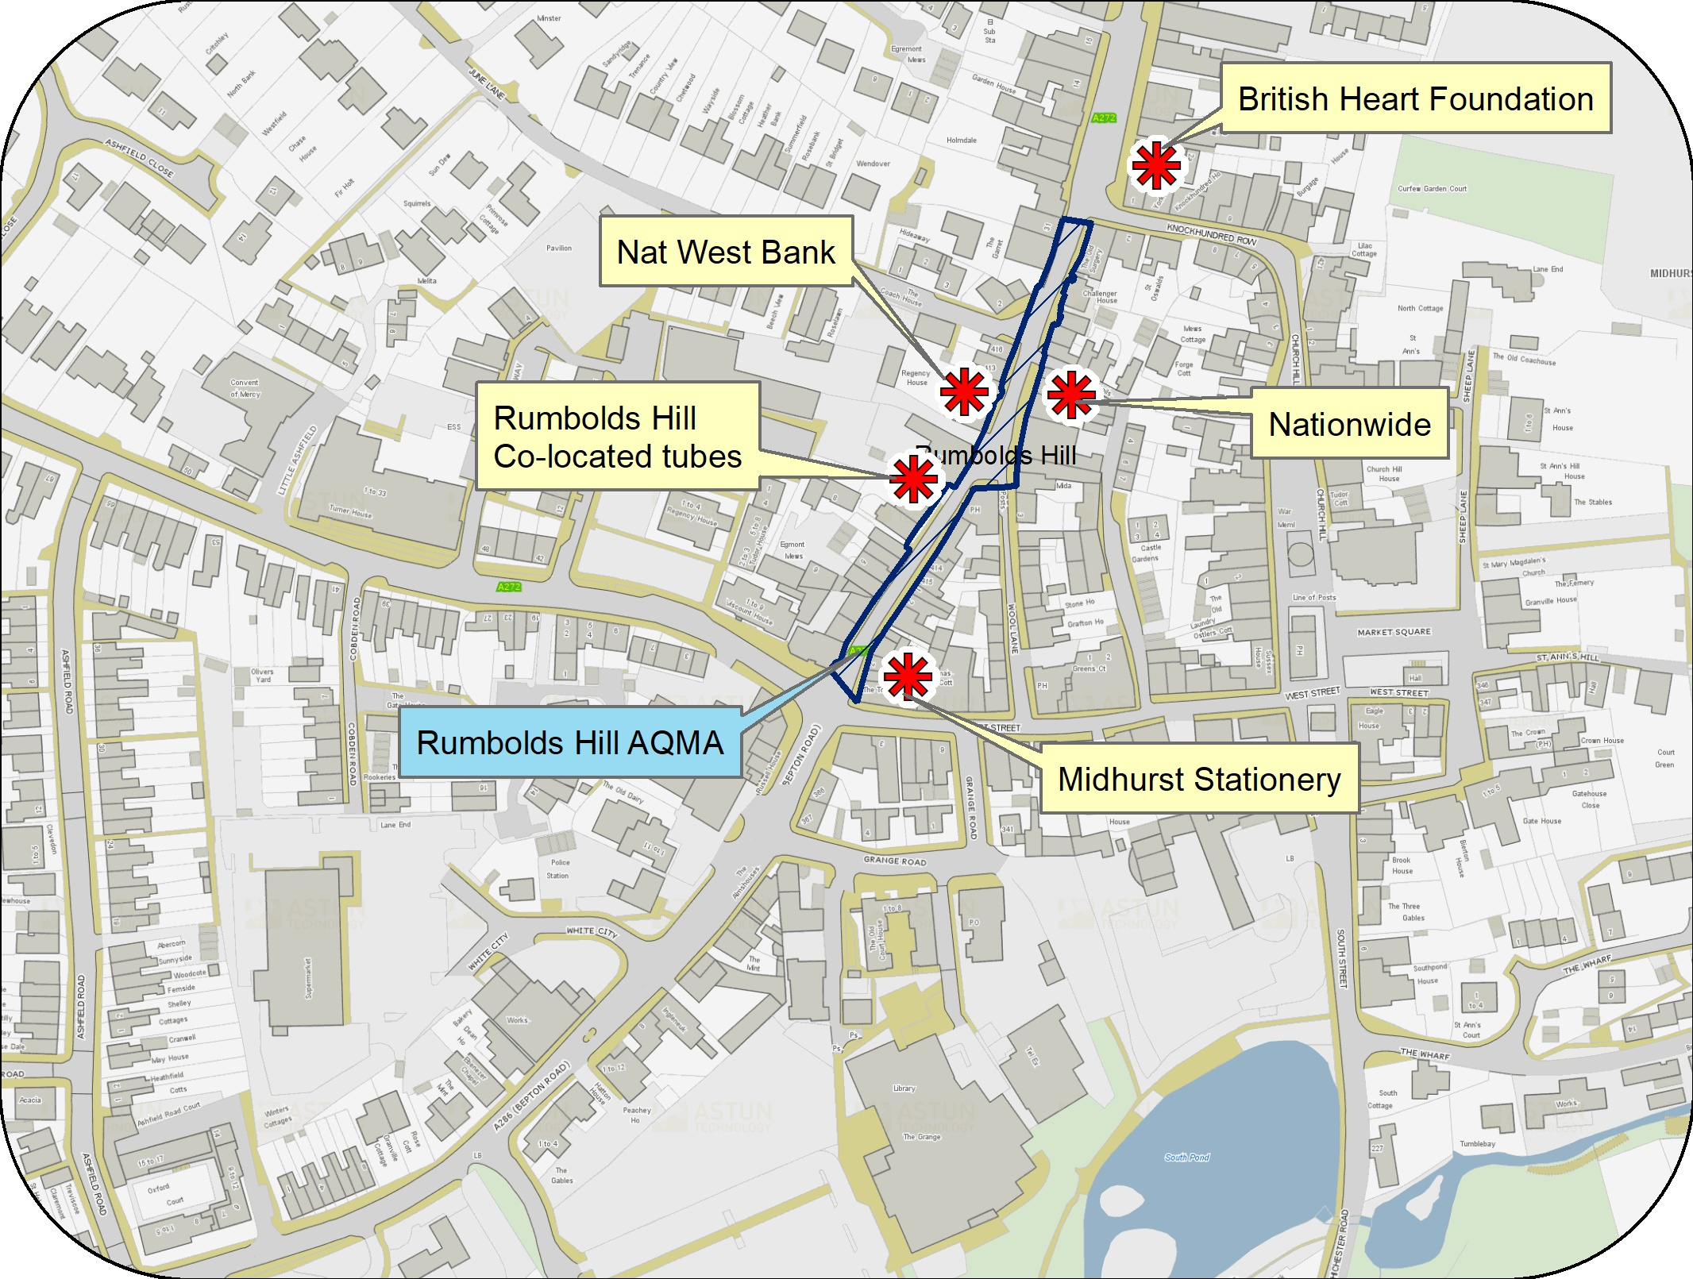
© Crown Copyright and database right 2020. Ordnance Survey 100018803

Appendix E: Summary of Air Quality Objectives in England
Table E.1 – Air Quality Objectives in England
Pollutant | Air Quality Objective: Concentration | Air Quality Objective: Measured as
Nitrogen Dioxide (NO₂) | 200µg/m³ not to be exceeded more than 18 times a year | 1-hour mean
Nitrogen Dioxide (NO₂) | 40µg/m³ | Annual mean
Particulate Matter (PM₁₀) | 50µg/m³, not to be exceeded more than 35 times a year | 24-hour mean
Particulate Matter (PM₁₀) | 40µg/m³ | Annual mean
Sulphur Dioxide (SO₂) | 350µg/m³, not to be exceeded more than 24 times a year | 1-hour mean
Sulphur Dioxide (SO₂) | 125µg/m³, not to be exceeded more than 3 times a year | 24-hour mean
Sulphur Dioxide (SO₂) | 266µg/m³, not to be exceeded more than 35 times a year | 15-minute mean

Appendix F: Impact of COVID-19 upon LAQM

COVID-19 has had a significant impact on society and its related economic activity. Inevitably, COVID-19 has also indirectly had an impact on the environment, with implications for air quality at local, regional and national scales.

Responding to COVID-19 presented various challenges for Local Authorities with respect to undertaking their statutory LAQM duties in the 2021 reporting year. Recognising this, Defra provided various advice updates throughout 2020 to English authorities, particularly concerning the potential disruption to air quality monitoring programmes, implementation of Air Quality Action Plans (AQAPs) and LAQM statutory reporting requirements. Defra has also issued supplementary guidance for LAQM reporting in 2021 to assist local authorities in preparing their 2021 ASR. Where applicable, this advice has been followed.

Despite the challenges that the pandemic has given rise to, the events of 2020 have also provided Local Authorities with an opportunity to quantify the air quality impacts associated with wide-scale and extreme intervention, most notably in relation to emissions of air pollutants arising from road traffic. The vast majority (>95%) of AQMAs declared within the UK are related to road traffic emissions, where attainment of the annual mean objective for nitrogen dioxide (NO₂) is considered unlikely. On 23rd March 2020, the UK Government released official guidance advising all members of public to stay at home, with work-related travel only permitted when absolutely necessary. During this initial national lockdown (and to a lesser extent other national and regional lockdowns that followed), marked reductions in vehicle traffic were observed; Department for Transport (DfT) data suggests reductions in vehicle traffic of up to 70% were experienced across the UK by mid-April, relative to pre COVID-19 levels.

This reduction in travel in turn gave rise to a reduction of air pollutant emissions associated with road traffic, i.e. nitrous oxides (NO_{x}), and exhaust and non-exhaust particulates (PM). The Air Quality Expert Group (AQEG) estimated that during the initial lockdown period in 2020, within urbanised areas of the UK reductions in NO₂ annual mean concentrations were between 20 and 30% relative to pre-pandemic levels, which represents an absolute reduction of between 10 to 20µg/m³ if expressed relative to annual mean averages. During this period, changes in PM_{2.5} concentrations were less marked than those of NO₂. PM_{2.5} concentrations are affected by both local sources and the transport of pollution from wider regions, often from well beyond the UK. Through analysis of AURN monitoring data for 2018-2020, AQEG have detailed that PM_{2.5} concentrations during the initial lockdown period are of the order 2 to 5µg/m³ lower relative to those that would be expected under business-as-usual conditions.
As restrictions are gradually lifted, the challenge is to understand how these air quality improvements can benefit the long-term health of the population.

Impacts of COVID-19 on Air Quality within Chichester District Council Area
Traffic counters at locations within all three of the Chichester AQMAs were in operation in 2020 and have allowed a comparison of traffic numbers during the period April to August 2020 compared to previous years. At two of the Chichester AQMAs reductions in traffic were 67% in April, 57% in May and 47% in June (at the third AQMA location the counter was not in operation over this period). For the rest of 2020, traffic volumes at all three AQMAs remained below the previous year’s level until after August. Data from the Orchard Street counter indicated that the AADT value for 2020 was 29% lower than for the previous year. (Annual AADT data was not available at the other two AQMA counter locations).

The NO₂ annual mean concentration at the Orchard St monitoring station was 24% lower for 2020 than 2019 and concentrations at the diffusion tube sites in Orchard Street were 20% and 26% lower (sites 12 and 16). A similar trend was shown at the Stockbridge roundabout AQMA where there was an 18% reduction in NO₂ annual mean concentration at the Stockbridge monitoring station and an 18% reduction in the diffusion tubes co-located at the AQMA (sites 2a and 2b) from 2019 to 2020.

Across the monitoring network, diffusion tube results for the months of June and July (after the first lockdown ended) generally show lower concentrations of NO₂ at sites within AQMAs than during the months prior to the lockdown (January and February).

Opportunities Presented by COVID-19 upon LAQM within Chichester District Council Area
No LAQM related opportunities have arisen as a consequence of COVID-19 within Chichester District Council area.

Challenges and Constraints Imposed by COVID-19 upon LAQM within Chichester District Council Area
With reference to Table F.1, the impact rating for each category is as follows:
- Automatic Monitoring – Data Capture (%) – impact rating NONE
- Automatic Monitoring – QA/QC Regime – impact rating SMALL
- Passive Monitoring – Data Capture (%) – impact rating NONE
- Passive Monitoring Bias Adjustment Factor – impact rating NONE
- Passive Monitoring Adherence to Changeover Dates – impact rating NONE
- Passive Monitoring Storage of Tubes – impact rating SMALL
- AQAP – Measure Implementation – impact rating SMALL
- AQAP – New AQAP Development – impact rating SMALL

With reference to Measure 5 in Table 2.2, the implementation of enlarging the Car Club fleet has been delayed as a result of a down turn in the use of the Car Club. It is planned that this measure is implemented in 2021/2022 (impact rating Medium).

With reference to Measure 10 in Table 2.2, the number of users of WSCC car share database – details have not been made available yet for 2020 however it is anticipated that the number of users will have decreased due to staff being required to work from home where possible.

Table F 1 – Impact Matrix
Category | Impact Rating: None | Impact Rating: Small | Impact Rating: Medium | Impact Rating: Large
Automatic Monitoring – Data Capture (%) | More than 75% data capture | 50 to 75% data capture | 25 to 50% data capture | Less than 25% data capture
Automatic Monitoring – QA/QC Regime | Adherence to requirements as defined in LAQM.TG16 | Routine calibrations taken place frequently but not to normal regime. Audits undertaken alongside service and maintenance programmes | Routine calibrations taken place infrequently and service and maintenance regimes adhered to. No audit achieved | Routine calibrations not undertaken within extended period (e.g. 3 to 4 months). Interruption to service and maintenance regime and no audit achieved
Passive Monitoring – Data Capture (%) | More than 75% data capture | 50 to 75% data capture | 25 to 50% data capture | Less than 25% data capture
Passive Monitoring – Bias Adjustment Factor | Bias adjustment undertaken as normal | <25% impact on normal number of available bias adjustment colocation studies (2020 vs 2019) | 25-50% impact on normal number of available bias adjustment studies (2020 vs 2019) | >50% impact on normal number of available bias adjustment studies (2020 vs 2019) and/or applied bias adjustment factor studies not considered representative of local regime
Passive Monitoring – Adherence to Changeover Dates | Defra diffusion tube exposure calendar adhered to | Tubes left out for two exposure periods | Tubes left out for three exposure periods | Tubes left out for more than three exposure periods
Passive Monitoring – Storage of Tubes | Tubes stored in accordance with laboratory guidance and analysed promptly. | Tubes stored for longer than normal but adhering to laboratory guidance | Tubes unable to be stored according to be laboratory guidance but analysed prior to expiry date | Tubes stored for so long that they were unable to be analysed prior to expiry date. Data unable to be used
AQAP – Measure Implementation | Unaffected | Short delay (<6 months) in development of a new AQAP, but is on-going | Long delay (>6 months) in development of a new AQAP, but is on-going | No progression in development of a new AQAP
AQAP – New AQAP Development | Unaffected | Short delay (<6 months) in development of a new AQAP, but is on-going | Long delay (>6 months) in development of a new AQAP, but is on-going | No progression in development of a new AQAP

Glossary of Terms
Abbreviation | Description
AQAP | Air Quality Action Plan - A detailed description of measures, outcomes, achievement dates and implementation methods, showing how the local authority intends to achieve air quality limit values’
AQMA | Air Quality Management Area – An area where air pollutant concentrations exceed / are likely to exceed the relevant air quality objectives. AQMAs are declared for specific pollutants and objectives
ASR | Annual Status Report
CCTV | Closed circuit television
CDC | Chichester District Council
Defra | Department for Environment, Food and Rural Affairs
DMRB | Design Manual for Roads and Bridges – Air quality screening tool produced by Highways England
EU | European Union
EV | Electric vehicle
FDMS | Filter Dynamics Measurement System
HE | Highways England
IAAQG | Inter Authority Air Quality Group
LAQM | Local Air Quality Management
LES | Low Emissions Strategy
MOVA | Microprocessor Optimised Vehicle Actuation
NHS | National Health Service
NO₂ | Nitrogen Dioxide
NO_{x} | Nitrogen Oxides
OLEV | Office of Low Emission Vehicles
O₃ | Ozone
PM₁₀ | Airborne particulate matter with an aerodynamic diameter of 10µm or less
PM_{2.5} | Airborne particulate matter with an aerodynamic diameter of 2.5µm or less
QA/QC | Quality Assurance and Quality Control
RTPI | Real Time Passenger Information
SAQP | Sussex Air Quality Partnership
SO₂ | Sulphur Dioxide
UTC | Urban Transport Controls
VCM | Volatile correction measurement
VMS | Variable message signing
WSCC | West Sussex County Council

References
- Local Air Quality Management Technical Guidance LAQM.TG16. April 2021. Published by Defra in partnership with the Scottish Government, Welsh Assembly Government and Department of the Environment Northern Ireland.
- Local Air Quality Management Policy Guidance LAQM.PG16. May 2016. Published by Defra in partnership with the Scottish Government, Welsh Assembly Government and Department of the Environment Northern Ireland.
- West Sussex Walking and Cycling Strategy 2016 – 2026 produced by WSCC.
- Chichester City Local Cycling and Walking Infrastructure Plan 2021 produced by Transport Initiatives and PJA.
- Draft Revised CDC Air Quality Action Plan 2021 – 2026 produced by CDC February 2021.

Public Health England. Air Quality: A Briefing for Directors of Public Health, 2017
Defra. Air quality and social deprivation in the UK: an environmental inequalities analysis, 2006
Defra. Air quality appraisal: damage cost guidance, July 2020
Public Health England. Estimation of costs to the NHS and social care due to the health impacts of air pollution: summary report, May 2018
Small particles less than 2.5µm diameter.
Strategic Transport Investment Programme
Local Transport Improvement Programme
Defra. Clean Air Strategy, 2019
DfT. The Road to Zero: Next steps towards cleaner road transport and delivering our Industrial Strategy, July 2018
It should be noted that we do not have a full year’s data for 2016 as the analyser was replaced due to a fault.
The Environmental Research Group (ERG) part of the School of Biomedical and Health Sciences at Imperial College London, a leading provider of air quality information and research in the UK
www.sussex-air.net
The units are in microgrammes of pollutant per cubic metre of air (µg/m³).
Prime Minister’s Office, COVID-19 briefing on the 31st of May 2020
Air Quality Expert Group, Estimation of changes in air pollution emissions, concentrations and exposure during the COVID-19 outbreak in the UK, June 2020

