

2020 Air Quality Annual Status Report (ASR)

In fulfilment of Part IV of the

Environment Act 1995

Local Air Quality Management

June 2020

|  |  |
| --- | --- |
| Local Authority Officer | Kate Simons  Simon Ballard |
| Department | Environmental Protection |
| Address | East Pallant House  1 East Pallant  Chichester  West Sussex  PO19 1TY |
| Telephone | 01243 521160 |
| E-mail | [ksimons@chichester.gov.uk](mailto:ksimons@chichester.gov.uk)  sballard@chichester.gov.uk |
| Report Reference number | ASR 20 |
| Date | June 2020 |

# Executive Summary: Air Quality in Our Area

## Air Quality in Chichester District

Air pollution is associated with a number of adverse health impacts. It is recognised as a contributing factor in the onset of heart disease and cancer. Additionally, air pollution particularly affects the most vulnerable in society: children and older people, and those with heart and lung conditions. There is also often a strong correlation with equalities issues, because areas with poor air quality are also often the less affluent areas[1],[2].

The annual health cost to society of the impacts of particulate matter alone in the UK is estimated to be around £16 billion[3].

Air quality in the majority of Chichester district is good however there are a few areas where elevated concentrations of pollutants occur. The main pollutant of concern in relation to statutory air quality standards is nitrogen dioxide (NO2) for which the key source is road traffic, particularly on roads in and adjacent to Chichester city and in the centre of Midhurst. Concentrations of NO2 have shown a slight decrease over the last few years however there are still hotspots in Chichester and Midhurst where exceedances of the national air quality Objective for NO2 occur. The hotspots in Chichester are within Air Quality Management Areas (AQMAs) and in Midhurst a new AQMA was recently declared in Rumbolds Hill. The AQMA locations are as follows:

* Stockbridge roundabout at the junction of the A27 and A286
* Orchard Street, Chichester
* St Pancras, Chichester
* Rumbolds Hill, Midhurst.

Our current Air Quality Action Plan (AQAP) was adopted in 2015 and is currently being reviewed, see our [pollution control and air quality webpage](https://www.chichester.gov.uk/pollutioncontrolairquality)

The revised AQAP will incorporate the outcomes of the air quality modelling that was commissioned during 2019 and a longer review of the monitoring data.

Air quality is recognised by the Council as an important public health issue but not one we can improve on our own. We are working actively with other services in the Council and with partners at West Sussex County Council (WSCC) notably the Public Health team and Highways, Transport and Planning Colleagues and through WSCC’s Inter Authority Air Quality Group (IAAQG). CDC is also a member of the Sussex Air Quality Partnership (SAQP) known as ‘Sussex Air’ and we play an active role in this group.

We have been working with neighbouring authorities and WSCC to produce a Local Cycling and Walking Infrastructure Plan (LCWIP) for Chichester and contracted a consultancy in April 2019 to assist with this project (funded by a grant award from the WSCC pooled business rates fund). The draft report is complete and it is intended that it will go out for public consultation in September 2020 before adoption early in 2021. LCWIPs are a new strategic approach to identifying cycling and walking improvements required at the local level. They enable a long-term approach to developing networks and routes and form a vital part of the Government’s strategy to increase the number of trips made on foot or bicycle.

We continue to work with our planning policy team and continue to contribute to the review of the Chichester Local Plan. A supplementary Planning Guidance note is being developed to provide clarity to the interpretation of air quality policies in the draft revised Local Plan. This work has been undertaken in collaboration with colleagues in SAQP.

## Actions to Improve Air Quality

Key completed actions during 2019 are as follows:

* Chichester District Council (CDC) installed eighteen electric vehicle charging points across Chichester District within its car parks. These are publicly available and are publicised [on our website](https://www.chichester.gov.uk/electricparking).
* CDC has been a member of a Pan-West Sussex group of authorities contributing to the WSCC Local Cycling and Walking Infrastructure Plan (LCWIP) and two of the routes that feature within the WSCC Plan are strategic routes that terminate in Chichester city. This work will continue during 2020 and it is intended that a joint methodology for prioritisation of LCWIP routes will be developed as part of this group for use by each district and borough.
* CDC commissioned consultants to produce a Chichester LCWIP in April 2019 and the report has been drafted and is due to be completed in June 2020 and consulted on in September 2020.
* CDC commissioned consultants to undertake air quality modelling in order to inform the revised AQAP. This work has included source apportionment and scenario testing in order to help prioritise actions within the revised AQAP. This work is on-going.
* CDC has bid for additional funds from the WSCC pooled business rates fund in order to contribute to work on its revised AQAP.

## Conclusions and Priorities

The 2019 monitoring of NO2 and PM10 shows no exceedances of Air Quality Standards at any of the real-time monitoring stations. There are two diffusion tube locations where the UK’s NO2 air quality Objective of 40µg/m3 was equalled or exceeded, namely:

* St Pancras, within the St Pancras AQMA, Chichester
* Rumbolds Hill, Midhurst within the recently declared Rumbolds Hill AQMA.

These locations were also highlighted last year as places where the Objective was exceeded. Additional diffusion monitoring tubes were deployed near these locations during 2018 and 2019 in order to supplement the data and to enable a better understanding of the spatial extent of pollution in these areas.

All other diffusion tube monitoring locations outside of AQMAs are compliant with the NO2 Objective and annual concentrations measured were generally similar or lower than values in 2018.

It is not intended to revoke any of the AQMAs at this time. We have a watching brief on the monitoring data for the Orchard Street AQMA where the results show there is the possibility of undeclaring this AQMA in the future.

## Local Engagement and How to get Involved

The public can get involved by supporting behavioural change initiatives (eg joining the Car Club, car sharing and walking, cycling, using public transport, turning their vehicle’s engine off when stationary, minimising wood burning and only burning dry, well-seasoned wood and composting instead of having garden bonfires wherever possible). Further information can be obtained by emailing: [airquality@chichester.gov.uk](mailto:airquality@chichester.gov.uk)

The Chichester and District Cycle Forum provides information on local cycling opportunities and campaigns on behalf of cyclists. The Forum is open to the public and further information can be obtained by emailing [cycle@chichester.gov.uk](mailto:cycle@chichester.gov.uk)

**Table of Contents**

Executive Summary: Air Quality in Our Area i

Air Quality in Chichester District i

Actions to Improve Air Quality ii

Conclusions and Priorities ii

Local Engagement and How to get Involved iii

1 Local Air Quality Management 1

2 Actions to Improve Air Quality 2

2.1 Air Quality Management Areas 2

2.2 Progress and Impact of Measures to address Air Quality in Chichester District 5

2.3 PM2.5 – Local Authority Approach to Reducing Emissions and/or Concentrations 11

3 Air Quality Monitoring Data and Comparison with Air Quality Objectives and National Compliance 12

3.1 Summary of Monitoring Undertaken 12

3.1.1 Automatic Monitoring Sites 12

3.1.2 Non-Automatic Monitoring Sites 12

3.2 Individual Pollutants 12

3.2.1 Nitrogen Dioxide (NO2) 12

3.2.2 Particulate Matter (PM10) 14

3.2.3 Particulate Matter (PM2.5) 15

3.2.4 Ozone (O3) 15

Comparison to the DEFRA banding below shows that in 2019 at Lodsworth there were 10 days when ‘moderate pollution’ occurred and no days when ‘high pollution’ occurred, see box for health messages of DEFRA pollution bands. 16

**Health messages of the DEFRA Pollution Bands** 16

Appendix A: Monitoring Results 18

Appendix B: Full Monthly Diffusion Tube Results for 2019 31

Appendix C: Supporting Technical Information / Air Quality Monitoring Data QA/QC 33

Appendix D: Maps of Monitoring Locations and AQMAs 36

Appendix E: Summary of Air Quality Objectives in England 40

Glossary of Terms 41

References 43

**List of Tables**

Table 2.1 – Declared Air Quality Management Areas 3

Table 2.2 – Progress on Measures to Improve Air Quality 8

Table A.1 - Details of Automatic Monitoring Sites 18

Table A.2 – Details of Non-Automatic Monitoring Sites 19

Table A.3 – Annual Mean NO2 Monitoring Results 21

Table A.4 – 1-Hour Mean NO2 Monitoring Results 24

Table A.5 – Annual Mean PM10 Monitoring Results 27

Table A.6 – 24-Hour Mean PM10 Monitoring Results 29

Table B.1 - NO2 Monthly Diffusion Tube Results - 2019 31

Table E.1 – Air Quality Objectives in England 40

**List of Figures**

Figure A.1 – Trends in Annual Mean NO2 Concentrations 23

Figure A.2 – Trends in Number of NO2 1-Hour Means > 200µg/m3 25

Figure A.3 - Trends in NO2 diffusion tubes 2015 - 2019 ……………………………….26

Figure A.4 – Trends in Annual Mean PM10 Concentrations 28

Figure A.4 – Trends in Number of 24-Hour Mean PM10 Results >50µg/m3 30

# Local Air Quality Management

This report provides an overview of air quality in Chichester District during 2019. It fulfils the requirements of Local Air Quality Management (LAQM) as set out in Part IV of the Environment Act (1995) and the relevant Policy and Technical Guidance documents.

The LAQM process places an obligation on all local authorities to regularly review and assess air quality in their areas, and to determine whether or not the air quality objectives are likely to be achieved. Where an exceedance is considered likely the local authority must declare an Air Quality Management Area (AQMA) and prepare an Air Quality Action Plan (AQAP) setting out the measures it intends to put in place in pursuit of the objectives. This Annual Status Report (ASR) is an annual requirement showing the strategies employed by Chichester District Council to improve air quality and any progress that has been made.

The statutory air quality objectives applicable to LAQM in England can be found in Table E.1 inAppendix E.

# Actions to Improve Air Quality

## Air Quality Management Areas

Air Quality Management Areas (AQMAs) are declared when there is an exceedance or likely exceedance of an air quality objective. After declaration, the authority must prepare an Air Quality Action Plan (AQAP) within 12-18 months setting out measures it intends to put in place in pursuit of compliance with the objectives.

A summary of AQMAs declared by Chichester District Council can be found in Table 2.1. Further information related to declared or revoked AQMAs, including maps of AQMA boundaries is [available online](https://www.chichester.gov.uk/pollutioncontrolairquality).

Alternatively, see Appendix D: Maps of Monitoring Locations and AQMAs, which provides for a map of air quality monitoring locations in relation to the AQMAs.

Monitoring data for our Orchard Street, Chichester AQMA indicates that air quality  
there is compliant with all Objectives. As such we have a watching brief over the next  
year with a view to the possibility of undeclaring this AQMA.

We have declared a new AQMA at Rumbolds Hill, Midhurst. A revised AQAP is currently being drafted which will include actions that are relevant to Midhurst.

Table 2.1 – Declared Air Quality Management Areas

|  |  |  |  |  |  |  |  |  |  |  |  |  |  |  |
| --- | --- | --- | --- | --- | --- | --- | --- | --- | --- | --- | --- | --- | --- | --- |
| **AQMA Name** | **Date of Declaration** | **Pollutants and Air Quality Objectives** | **City / Town** | **One Line Description** | **Is air quality in the AQMA influenced by roads controlled by Highways England?** | **Level of Exceedance (maximum monitored/modelled concentration at a location of relevant exposure)** | | | | | | **Action Plan** | | |
| **At Declaration** | **Now** | | | | | **Name** | **Date of Publication** | **Link** | |
| Stockbridge Roundabout AQMA | 24-08-06 | NO2 Annual Mean | Chichester | An area encompassing the Stockbridge Roundabout at the junction of the Chichester bypass (A27) and Stockbridge Road (A286) | YES | 44.9 | µg/m3 | 33 | | µg/m3 | | CDC AQAP | 2015 | [Pollution Control Air Quality](https://www.chichester.gov.uk/pollutioncontrolairquality) | | |
| Orchard Street AQMA | 17-05-07 | NO2 Annual Mean | Chichester | An area along Orchard Street, Chichester at the eastern end of the street where it meets Northgate | NO | 40.7 | µg/m3 | 30 | µg/m3 | | CDC AQAP | | 2015 | as above | | |
| St Pancras AQMA | 17-05-07 | NO2 Annual Mean | Chichester | An area along St Pancras, Chichester between Eastgate Square and New Park Road. Note St Pancras forms a street canyon in this section. | NO | 48.3 | µg/m3 | 42 | µg/m3 | | CDC AQAP | | 2015 | as above | | |
| Rumbolds Hill AQMA | 17-Jan-20 | NO2 Annual Mean | Midhurst | An area along Rumbolds Hill, Midhurst between the A272 at its southern end and the junction of North Street (A286) and Knockhundred Row at its northern end. | NO | 42 | µg/m3 | 40 | µg/m3 | | CDC AQAP | | 2015 | as above | | |

**Chichester District Council confirms the information on UK-Air regarding their AQMA(s) is up to date**

## 

## Progress and Impact of Measures to address Air Quality in Chichester District

Defra’s appraisal of last year’s ASR and our response is shown in the table below:

| Defra’s comment | CDC response |
| --- | --- |
| The 2018 monitoring indicated that two sites were exceeding the annual mean Objective NO2 concentration. Of these sites, one is within the St Pancras AQMA and one site at Rumbolds Hill, Midhurst, is not within a current AQMA. Exceedances have been measured at Rumbolds Hill over the past 3 years and the Council plans to declare the area an AQMA in 2019 | An AQMA has since been declared at Rumbolds Hill and further details are given in Table 2.1 |
| The Council has commissioned detailed air quality modelling of discrete areas of Chichester and Midhurst in 2019 and the modelling will be reported in next year’s ASR. | The modelling is reported in this year’s ASR, see below, and has informed the necessity (and extent) of the Rumbolds Hill AQMA and any amendments or additional AQMAs in Chichester. |
| Defra suggested that Section 2.3 could make reference to the Public Health Outcomes Framework, and the local indicator for PM2.5 in the district | Additional information has been added to Section 2.3 as suggested. |
| Defra noted the local bias adjustment factor used by the Council has decreased from 0.93 in 2017 to 0.85 in 2018. Should local factors continue to decrease, the Council may wish to consider using the national factor, if deemed more appropriate. | This year’s local bias adjustment factor is 0.84 which is only a marginal decrease from last year therefore CDC will continue to use the local bias adjustment factor. |

Chichester District Council has taken forward a number of direct measures during the current reporting year of 2019 in pursuit of improving local air quality. Details of all measures completed, in progress or planned are set out in Table 2.2.

More detail on these measures can be found in our Action Plan. Key completed measures are:

* Installation of eighteen EV charging points across the District including at Chichester and Midhurst where the AQMAs are located.
* Detailed modelling of air quality in Chichester and Midhurst has been carried out and the result of this work is being used to develop actions within the revised Air Quality Action Plan.
* A Local Cycling and Walking Infrastructure Plan (LCWIP) has been drafted and will be finalised during 2020. We have worked in partnership with West Sussex County Council (WSCC) and other districts and boroughs in the county on aspects of this work and it is intended that a county-wide prioritisation framework will be developed in 2020 in order to rank our schemes against other schemes within the county to inform future infrastructure planning.
* We continue our partnership working with Sussex Air, IAAQG and Chichester and District Cycle Forum.

Chichester District Council (CDC) expects the following measures to be completed over the course of the next reporting year:

* To complete the air quality modelling
* To produce and consult on the revised Air Quality Action Plan
* To finalise the Supplementary Policy Document on air quality to enable the air quality impact of new development to be properly considered during the planning process
* To expand the Car Club in Chichester city (which was originally set up using Defra funding). We hope to let a tender for an additional car to be put in place during 2021.
* To support our partners particularly WSCC with respect to prioritising routes in the WSCC and CDC LCWIP documents.

CDC’s priorities for the coming year are:

* To complete the revised Air Quality Action Plan
* To finalise the Local Cycling and Walking Infrastructure Plan (LCWIP) and work the planning policy team to enable the routes to be prioritised within the Council’s infrastructure business plan.

The principal challenges and barriers to implementation that CDC anticipates facing are:

* The impact of the Covid 19 outbreak on resources within CDC and the local economy
* Availability of funding for infrastructure projects

Progress on the following measures has been slower than expected due to:

* Staff have been working remotely since March 2020 due to the Covid 19 outbreak and all communications since that time have been ‘virtual’. Resources in some teams have been redeployed which has delayed some work streams.

Whilst the measures stated above and in Table 2.2 will help to contribute towards compliance, Chichester District Council anticipates that further additional measures not yet prescribed will be required in subsequent years to achieve compliance and enable the revocation of all four AQMAs within the District.

Table 2.2 – Progress on Measures to Improve Air Quality

|  |  |  |  |  |  |  |  |  |  |  |  |
| --- | --- | --- | --- | --- | --- | --- | --- | --- | --- | --- | --- |
| **Measure No.** | **Measure** | **EU Category** | **EU Classification** | **Date Measure Introduced** | **Organisations involved** | **Funding Source** | **Key Performance Indicator** | **Reduction in Pollutant / Emission from Measure** | **Progress to Date** | **Estimated / Actual Completion Date** | **Comments / Barriers to implementation** |
| 1 | Set up Air Quality Working Group | Promoting Travel Alternatives | Other | Dec-08 | CDC | CDC | 2 meetings per year | N/A | 12 meetings held to date | Ongoing | Part of West Sussex Air Quality group led by Public Health since 2018 |
| 2 | Cleaner vehicles | Promoting Low Emission Transport | Procuring alternative Refuelling infrastructure to promote Low Emission Vehicles, EV recharging, Gas fuel recharging | 2011 | WSCC/CDC | WSCC/  CDC | No. of electric vehicle recharging points |  | Installed a total of 18 recharging points in Chichester district having secured funding in 2019 from OLEV. Part of regional network of rapid charging points through Sussex-air project. | Completed | Funding was complicated by the need to make charging points cost neutral as far as possible |
| 3 | Planning policy | Policy Guidance and Development Control | Air Quality Planning and Policy Guidance | ongoing | CDC | CDC | No. of planning conditions imposed on planning consultations |  | Sussex-air produced Planning Guidance and Low Emissions Strategy and in discussion with CDC Policy Planners regarding adopting LES approach. Sussex-air has reviewed its guidance in 2019 | 2019-20 | WSCC revised parking standards in March 2019 which are also applied as conditions where applicable |
| 4 | Cycling and walking initiatives | Promoting Travel Alternatives | Promotion of cycling | 2010 | CDC/WSCC | CDC/  WSCC | % increase in cycling |  | Similar levels of cycling from 2018- 2019 on most routes. LCWIP for Chichester City drafted and WSCC have produced strategic LCWIP. | Chichester LCWIP to be completed June 2020 | Prioritisation of LCWIP routes across West Sussex to be delivered as part of partnership between WSCC and districts and boroughs in the County in 2020 |
| 5 | Car Clubs | Alternatives to private vehicle use | Car Clubs | 2011 | CDC/WSCC | CDC/Car Club Operator | Utilisation rate of cars to be 20% |  | 6 cars now available to book, development worker employed 2014-16 to promote Club, utilisation rate increasing throughout 2019 and ranged from 11 - 20% depending on car location. | ongoing | Pre Covid 19 outbreak we were planning that a new car would be introduced to the fleet during 2020 |
| 6 | School travel plans | Promoting Travel Alternatives | School Travel Plans | 2009/10 | WSCC/CDC | WSCC | % children travelling to school by sustainable means |  | During 2017/18 Living Streets project engaged with 5 primary schools in the District to support Walk to School scheme (WOW) and engaged students and staff at Chichester University (2 year project) | Mar-20 |  |
| 7 | WSCC and CDC travel plans | Promoting Travel Alternatives | Workplace Travel Planning | 2011/12 | WSCC/CDC | WSCC/  CDC | % WSCC and CDC staff travelling by sustainable means |  | WSCC grey fleet business mileage was 5.75 million miles below 6.0 million miles target. Easit scheme at WSCC and CDC to encourage rail use. Cycle to work scheme at CDC | Ongoing | Includes 21,462 miles using electric pool cars (4 available at WSCC) |
| 8 | Business travel plans | Promoting Travel Alternatives | Workplace Travel Planning | 2009 | WSCC | WSCC | Travel Plan implemented within target time period |  | Over 43 Travel Plans submitted since 2009 and Travel Plan group set up attended by large organisations to work on joint measures. | Ongoing | Additional 8 plans during 2019 |
| 9 | Residential travel plans | Promoting Travel Alternatives | Personalised Travel Planning | 2009 | WSCC | WSCC | Travel Plan implemented within target time period |  | Over 34 Travel Plans have been submitted since 2009 | Ongoing | Additional 4 plans during 2019 |
| 10 | TravelWise/smarter choices | Public Information | Via the Internet | 2009 | WSCC/CDC | WSCC | No. of users of WSCC car share database for PO19 area |  | Steady increase in number of users of database for 2019 | Ongoing | 1879 journeys into PO19 area using car share scheme in 2019 |
| 11 | Cycle route information | Promoting Travel Alternatives | Promotion of cycling | 2009 | CDC | CDC | No. of maps sold through Tourist Information or other outlets. |  | 5 route leaflets have been produced so far and over 1400 copies have been sold to date. 47 leaflets sold in 2019 | Ongoing | 47 maps sold in 2019 |
| 12 | Cycle journey planning | Public Information | Via the Internet | 2011 | WSCC | WSCC | No. of journeys planned on website |  | Web link available on WSCC and CDC websites | Ongoing | 4354 journeys planned 2019-20 |
| 13 | Public transport infrastructure | Transport Planning and Infrastructure | Public transport improvements-interchanges stations and services | 2011-15 | WSCC | WSCC | Increase in use of public transport |  | RTPI displays installed at key locations across City | Ongoing | 8 RTPI displays installed in 2018-19 and 12 more planned for 2020. |
| 14 | Cleaner buses | Promoting Low Emission Transport | Public Vehicle Procurement -Prioritising uptake of low emission vehicles | 2009 | WSCC | WSCC | % of Euro 5 buses |  | Two Euro 6 double deckers added to fleet in 2019. Emissions retrofitting project ongoing for 2020 for five Euro 4 and three Euro 3 buses | Ongoing | retrofitting will upgrade to Euro 6 emissions standard |
| 15 | Licensing requirement for taxis | Promoting Low Emission Transport | Taxi Licensing conditions | 2011 | CDC | CDC | No. of Euro 4 vehicles |  | For vehicles 5 years and over, MOT and fitness test required every 6 months | Ongoing |  |
| 16 | Forecasting, monitoring and public information | Public Information | Via other mechanisms | 2008 | SAQP | SAQP | No. of people registered to receive alerts |  | Over 1161 subscribers registered across Sussex | Ongoing | inc of 154 subscribers during 2019 |
| 17 | AQ monitoring and traffic monitoring | Traffic Management | UTC, Congestion management, traffic reduction | 2008 | CDC/WSCC | CDC/  WSCC | Reduction in traffic volumes |  | Traffic flows between 2018 - 2019 have reduced by 3% in the Orchard St AQMA however the data was incomplete in the other two AQMAs so the flows could not be compared. | Ongoing |  |
| 18 | A27 by-pass improve-ments | Traffic Management | Strategic highway improvements, Re-prioritising road space away from cars, including Access management, Selective vehicle priority, bus priority, high vehicle occupancy lane | post 2025 | HE | HE | Reduction in congestion |  | HE re-consulted during 2017 on options for improving A27 around Chichester however no option chosen | 2025 | No funds allocated for A27 improvements at the present time. |
| 19 | Variable message signing (VMS) on A27 | Traffic Management | UTC, Congestion management, traffic reduction | pilot by 2020 | HE | HE | No. of warnings made per year |  | HE decision awaited | Ongoing | Awaiting outcome of A27 improvements decision |
| 20 | Park and ride schemes in and around City | Alternatives to private vehicle use | Bus based Park & Ride | post 2020 | CDC/WSCC | CDC/  WSCC | Reduce traffic in City centre by 3% |  | Linked to A27 improvements that have not yet been brought forward | Ongoing |  |
| 21 | Speed limit changes - 20 mph as part of school safety zone | Traffic Management | Reduction of speed limits, 20mph zones | 2012/13 | WSCC | WSCC | Reduction in traffic queues within Orchard St AQMA area |  | Signs installed around schools and on nearby residential streets | Completed | Reductions in NO2 within AQMA could be achieved through smoothing of traffic flow |
| 22 | Blanket 20mph scheme on residential streets | Traffic Management | Reduction of speed limits, 20mph zones | 2013/14 | WSCC | WSCC | Reduced speed on residential streets |  | WSCC contracted officer to promote 20mph and work with schools and community and CDC hosted officer and provided support | Completed | Roads monitored before and after implementation and speed reductions achieved on some roads |
| 23 | MOVA traffic signal optimisation | Traffic Management | UTC, Congestion management, traffic reduction | 2010 | WSCC | WSCC | Reduction in traffic queues within AQMAs |  | 2 new Puffins to replace existing crossings implemented | Completed | Improves emissions by eliminating ghost users and reducing red time |

## PM2.5 – Local Authority Approach to Reducing Emissions and/or Concentrations

As detailed in Policy Guidance LAQM.PG16 (Chapter 7), local authorities are expected to work towards reducing emissions and/or concentrations of PM2.5 (particulate matter with an aerodynamic diameter of 2.5µm or less). There is clear evidence that PM2.5 has a significant impact on human health, including premature mortality, allergic reactions, and cardiovascular diseases.

Data from the Public Health Outcomes Framework indicates that the ‘fraction of mortality attributable to particulate air pollution’ was 5.0 % for Chichester district (2018 data). This compares to the National average for England of 5.2% and the range across districts and boroughs within West Sussex of 5.0 – 5.8%.

Chichester District Council is taking the following measures to address PM2.5:

* Measure 15 – taxi licensing conditions – since 2011 we have required vehicles that are 5 years old and over to have MOT and fitness tests every 6 months. The taxi licensing policy is currently under review and air quality considerations will be considered as part of the review.
* Measure 14 – cleaner buses – fleet managers report that upgrades to the fleet are ongoing in order to introduce cleaner buses. WSCC continues to engage with them to promote any funding opportunities that may enable upgrades to the fleet.
* Measure 2 – cleaner vehicles – we have installed electric vehicle charging points across the district and have a procurement policy to encourage the use of electric vehicles where the business case is favourable.

We have been working in partnership with West Sussex Public Health and WSCC to run an anti-idling campaign outside schools and at level crossings across West and East Sussex. Signs have been placed at suitable locations with anti-idling messages to raise awareness about this issue.

Where considered appropriate we have recommended that construction environmental management plans (CEMP) are put in place at new developments which include dust control strategies.

During 2019 we publicised the air quality impacts of burning wet wood in domestic fireplaces and wood burning stoves and provided public information to enable people to procure seasoned wood that has a moisture content of below 20%.

# Air Quality Monitoring Data and Comparison with Air Quality Objectives and National Compliance

## Summary of Monitoring Undertaken

### Automatic Monitoring Sites

This section sets out what monitoring has taken place and how it compares with objectives.

Chichester District Council undertook automatic (continuous) monitoring at 4 sites during 2019 (note one site, CI5 was commissioned in February 2019 therefore data for a full year is not yet available). Table A.1 in Appendix A shows the details of the sites.

Maps showing the location of the monitoring sites are provided in Appendix D. Further details on how the monitors are calibrated and how the data has been adjusted are included in Appendix C.

### Non-Automatic Monitoring Sites

Chichester District Council undertook non- automatic (passive) monitoring of NO2 at 18 sites during 2019 (note at some locations there are co-located tubes). Table A.2 in Appendix A shows the details of the sites. A new site was added in November 2019, data from this site will be reported in next year’s ASR.

Maps showing the location of the monitoring sites are provided in Appendix D. Further details on Quality Assurance/Quality Control (QA/QC) for the diffusion tubes, including bias adjustments and any other adjustments applied (e.g. “annualisation” and/or distance correction), are included in Appendix C.

## Individual Pollutants

The air quality monitoring results presented in this section are, where relevant, adjusted for bias[4], “annualisation” (where the data capture falls below 75%), and distance correction[5]. Further details on adjustments are provided in Appendix C.

### Nitrogen Dioxide (NO2)

Table A.3 in Appendix A compares the ratified and adjusted monitored NO2 annual mean concentrations for the past 5 years with the air quality objective of 40µg/m3. Note that the concentration data presented in Table A.3 represents the concentration at the location of the monitoring site, following the application of bias adjustment and annualisation, as required (i.e. the values are exclusive of any consideration to fall-off with distance adjustment).

For diffusion tubes, the full 2019 dataset of monthly mean values is provided in Appendix B. Note that the concentration data presented in Table B.1 includes distance corrected values, only where relevant.

Table A.4 in Appendix A compares the ratified continuous monitored NO2 hourly mean concentrations for the past 5 years with the air quality objective of 200µg/m3, not to be exceeded more than 18 times per year.

Data in Table A.3 indicates that there has been a decrease in the NO2 annual mean concentration at the Stockbridge monitoring station (from 29 to 28µg/m3) and the air quality objective was not exceeded. The results at this location have been broadly similar for the past five years, ranging from 28 - 34µg/m3 and since 2015 have shown a downward trend. The monitoring station is not within the AQMA and does not represent a location of relevant exposure however it is the only suitable long term location available for the real-time monitoring near the Stockbridge AQMA. There are three co-located diffusion tubes at the monitoring station and the 2019 annual means for these tubes were all 28µg/m3. As noted for the monitoring station the air quality objective was not exceeded. Results for the Claremont Court diffusion tube location (which is within the Stockbridge AQMA) show no change from 2018 to 2019 at 33 µg/m3 (as an average of two co-located tubes). Results at Claremont Court have ranged from 33 – 42µg/m3 over the last five years so monitoring will be continued at this location to determine the long term trend within this AQMA.

At the Orchard Street monitoring station the NO2 annual mean concentration was 21 µg/m3. Results at this monitoring station have ranged from 21 - 29µg/m3 over the last five years and the air quality objective has never been exceeded. It should be noted that the analyser at the monitoring station was replaced in September 2016 due to a fault with the previous analyser, therefore we do not have a full year’s data for 2016 or any data for 2015. A diffusion tube has been co-located at the monitoring station for two years and the annual mean for this tube was 20µg/m3. At another nearby diffusion tube location the annual mean was 30µg/m3 (average of the two co-located tubes). The results at this diffusion tube location have ranged from 30 - 38µg/m3 over the last five years. Both the monitoring station and the diffusion tubes are located within the AQMA and represent relevant exposure. We will continue monitoring at Orchard Street however there remains the possibility of undeclaring the AQMA in the future.

At the Westhampnett Road monitoring station the NO2 annual mean concentration was 27µg/m3. This monitoring station was commissioned in February 2019 so a full year’s data is not available for 2019. The nearest diffusion tube to the monitoring station is located east of the monitoring station but also on Westhampnett Road. The annual mean at this location has ranged from 27 - 31µg/m3 over the last five years. Neither the monitoring station nor the diffusion tube are located within an AQMA however they are sited on a busy arterial route into Chichester which is also used by a large number of pedestrians.

At two of the diffusion tube locations, the air quality objective of 40µg/m3 was equalled or exceeded, namely:

* St Pancras, within the St Pancras AQMA
* Rumbolds Hill, Midhurst – within the Rumbolds Hill AQMA declared in January 2020

At two other locations, the diffusion tube annual means were close to the air quality objective. At the Nag’s Head, Chichester the annual mean was 37µg/m3 (this tube is within the St Pancras AQMA) and at the Nat West Bank site, Midhurst the annual mean was also 37µg/m3 . This tube is within the newly declared Rumbolds Hill AQMA. Monitoring will continue at the Midhurst monitoring locations to determine the ongoing trend within this AQMA.

The data for the Stockbridge AQMA (eg the Claremont Court diffusion tubes) indicates that the NO2 concentration has stayed the same from 2018 to 2019 at 33µg/m3. Results at Claremont Court have ranged from 33 – 42µg/m3 over the last five years so monitoring will be continued at this location to determine the long term trend within this AQMA.

The data for the St Pancras AQMA (eg the St Pancras tubes and the Nag’s Head tube) indicates the air quality objective continues to be exceeded so monitoring will continue at these locations to establish the ongoing trend. The diffusion tube data within The Hornet, near the St Pancras AQMA (eg The Hornet tubes and the Sussex Cleaners tube) was compliant with the air quality objective.

The data for the Orchard Street AQMA (eg the co-located tube and the tube at 174 Orchard Street) indicates that the air quality objective has not been exceeded for the last five years. We intend to maintain a watching brief at this location to determine the need to undeclare this AQMA in the future.

At all the other diffusion tube monitoring sites the NO2 concentration has decreased from 2018 to 2019 (with the exception of Arthur Purchase in Chichester where the concentration has remained the same) and all sites were compliant with the air quality objective.

From Table A.4 there have been no exceedances of the NO 1-hour mean concentration at the Stockbridge, Orchard Street or Westhampnett Road monitoring stations for the last five years. The DEFRA guidance suggests that the 1-hour mean objective is unlikely to be breached unless the annual mean concentration is 60µg/m3 or above.

### Particulate Matter (PM10)

Table A.5 in Appendix A compares the ratified and adjusted monitored PM10 annual mean concentrations for the past 5 years with the air quality objective of 40µg/m3.

Table A.6 in Appendix A compares the ratified continuous monitored PM10 daily mean concentrations for the past 5 years with the air quality objective of 50µg/m3, not to be exceeded more than 35 times per year.

From Table A.5, the annual mean concentration (19µg/m3 in 2019) has varied over the last five years from a maximum of 21µg/m3 (2015) to 18µg/m3 (2018) and is compliant with the air quality objective of 40µg/m3 . In addition the number of PM10 daily mean concentrations exceeding the Objective has varied over the last five years from a maximum of 3 in 2015 to zero in 2019. The air quality objective (50µg/m3 not to be exceeded more than 35 times per year) has therefore been met for the last five years.

### Particulate Matter (PM2.5)

Using the methodology stated in Chapter 7 of the Technical Guidance LAQM TG16 sections 7.107-7.111, the estimated PM2.5 concentration in Chichester is 13.3µg/m3. This compares to 10µg/m3 measured at two other Sussex sites (Worthing and Eastbourne).

### Ozone (O3)

Chichester District Council has been monitoring ozone in the rural village of Lodsworth for over ten years. Ozone concentrations can become elevated when nitrogen dioxide and volatile organic compounds react in the presence of strong sunlight. CDC monitors this pollutant due to its importance with regard to public health and to provide information to the Sussex-air, air-Alert public information system (see Table 2.2 Measure no. 16).

The Table below compares the ratified and adjusted monitored O3 concentrations and indicates that the number of exceedances of the running 8 hour mean (of 100µg/m3 or 50 ppb) was ten for 2019 and has fluctuated over the last five years from seven in 2015 to thirty six in 2018.

| **Site ID** | **Site Type** | **Valid Data Capture for Monitoring Period (%) (1)** | **Valid Data Capture 2019 (%) (2)** | **O3 - No more than 10 days where maximum rolling 8 hr mean >= 100 µg/m3** | | | | |
| --- | --- | --- | --- | --- | --- | --- | --- | --- |
| **2015** | **2016** | **2017** | **2018** | **2019** |
| AR1 | Rural  (Lodsworth) |  | 88 | 7 | 16 | 15 | 36 | 10 |

(1) Data capture for the monitoring period, in cases where monitoring was only carried out for part of the year.

(2) Data capture for the full calendar year (e.g. if monitoring was carried out for 6 months, the maximum data capture for the full calendar year is 50%).

The latest data shows that the Objective was achieved in 2019 as there were ten exceedances of the running 8 hour mean during the year, see below.

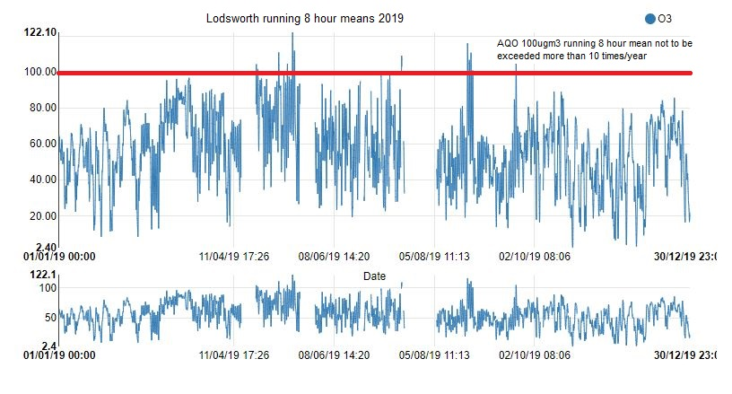

Comparison to the DEFRA banding below shows that in 2019 at Lodsworth there were 10 days when ‘moderate pollution’ occurred and no days when ‘high pollution’ occurred, see box for health messages of DEFRA pollution bands.

**Health messages of the DEFRA Pollution Bands**

|  |  |
| --- | --- |
| Pollution band and numerical index | Health messages for at-risk groups* |
| 1 – 3 (low) | Enjoy your usual outdoor activities. |
| 4 – 6 (moderate) | Adults and children with lung problems, and adults with heart problems, who experience symptoms, should consider reducing strenuous physical activity, particularly outdoors. |
| 7 – 9 (high) | Adults and children with lung problems, and adults with heart problems, should reduce strenuous physical exertion, particularly outdoors, and particularly if they experience symptoms. People with asthma may find they need to use their reliever inhaler more often. Older people should also reduce physical exertion. |
| 10 (very high) | Adults and children with lung problems, adults with heart problems, and older people, should avoid strenuous physical activity. People with asthma may find they need to use their reliever inhaler more often. |
| *\*Adults and children with heart or lung problems are at greater risk of symptoms.* | |

NB. Local authorities are no longer obliged to report annually on the following pollutants: 1,3 butadiene, benzene, carbon monoxide and lead, unless local circumstances indicate there is an issue. National monitoring results are available at https://uk-air.defra.gov.uk/data/

# Appendix A: Monitoring Results

Table A.1 - Details of Automatic Monitoring Sites

|  |  |  |  |  |  |  |  |  |  |  |
| --- | --- | --- | --- | --- | --- | --- | --- | --- | --- | --- |
| **Site ID** | **Site Name** | **Site Type** | **X OS Grid Ref (Easting)** | **Y OS Grid Ref (Northing)** | **Pollutants Monitored** | **In AQMA?** | **Monitoring Technique** | **Distance to Relevant Exposure (m) (1)** | **Distance to kerb of nearest road (m) (2)** | **Inlet Height (m)** |
|
| CI1 | Stockbridge | Suburban | 485881 | 103791 | NO2; PM10 | NO | chemilumin-escent/TEOM | 25 | 26 | 3 |
| CI4 | Orchard Street | Roadside | 485982 | 105221 | NO2 | YES (Orchard St AQMA) | Chemiluminescent | 9.8 | 3.75 | 2 |
| AR1 | Lodsworth | Rural | 492396 | 123248 | O3 | NO | UV | n/a | n/a | 2.1 |
| CI5 | Westhampnett Road | Roadside | 487212 | 105372 | NO2 | NO | Chemiluminescent | 11.8 | 4.2 | 1.9 |

**Notes:**

(1) 0m if the monitoring site is at a location of exposure (e.g. installed on the façade of a residential property)

(2) N/A if not applicable

Table A.2 – Details of Non-Automatic Monitoring Sites

|  |  |  |  |  |  |  |  |  |  |  |
| --- | --- | --- | --- | --- | --- | --- | --- | --- | --- | --- |
| **Site ID** | **Site Name** | **Site Type** | **X OS Grid Ref (Easting)** | **Y OS Grid Ref (Northing)** | **Pollutants Monitored** | **In AQMA?** | **Distance to Relevant Exposure (m) (1)** | **Distance to kerb of nearest road (m) (2)** | **Tube collocated with a Continuous Analyser?** | **Height (m)** |
|
| 1 | Kings Ave/Southbank Jct | Roadside | 485776 | 103961 | NO2 | N | 11 | 2.25 | NO | 3 |
| 2 | Claremont Court | Roadside | 485772 | 103847 | NO2 | Y (Stockbridge roundabout AQMA) | 0 | 7.5 | NO | 3 |
| 3 | Cabin | Suburban | 485880 | 103791 | NO2 | N | 25 | 26 | YES | 2.7 |
| 4 | Cabin | Suburban | 485880 | 103791 | NO2 | N | 25 | 26 | YES | 2.7 |
| 5 | Cabin | Suburban | 485880 | 103791 | NO2 | N | 25 | 26 | YES | 2.7 |
| 6 | Stockbridge Road South | Roadside | 485696 | 103731 | NO2 | N | 14 | 2 | NO | 2.85 |
| 7 | Cleveland Rd | Urban Background | 486953 | 104414 | NO2 | N | 18 | 1.8 | NO | 2.8 |
| 8 | Westhampnett Road | Roadside | 487341 | 105474 | NO2 | N | 3 | 1.65 | NO | 2.85 |
| 9 | Hornet | Roadside | 486502 | 104795 | NO2 | N | 0 | 1.8 | NO | 3.1 |
| 10 | St Pancras | Roadside | 486533 | 104860 | NO2 | Y (St Pancras AQMA) | 0 | 2 | NO | 3 |
| 11 | Arthur Purchase | Urban Background | 486082 | 105026 | NO2 | N | 0 | 6 | NO | 2.7 |
| 12 | 174 Orchard St | Roadside | 485914 | 105185 | NO2 | Y (Orchard St AQMA) | 0 | 2 | NO | 2.65 |
| 14 | Rumbolds Hill, Midhurst | Roadside | 488561 | 121479 | NO2 | Y (Rumbolds Hill AQMA) | 0.5 | 1.5 | NO | 3.4 |
| 15 | Sussex Cleaners | Roadside | 486575 | 104799 | NO2 | N | 0 | 1.82 | NO | 2.95 |
| 16 | Nag's Head | Roadside | 496495 | 104845 | NO2 | Y (St Pancras AQMA) | 0 | 2.38 | NO | 3.23 |
| 17 | Orchard St cabin | Roadside | 485982 | 105221 | NO2 | Y (Orchard St AQMA) | 9.8 | 3.75 | YES | 1.95 |
| 18 | Midhurst Stationery | Roadside | 488545 | 121434 | NO2 | Y (Rumbolds Hill AQMA) | 1.8 | 0.62 | NO | 2.79 |
| 19 | Nat West Bank | Roadside | 488583 | 121512 | NO2 | Y (Rumbolds Hill AQMA) | 9.9 | 1.07 | NO | 2.97 |
| 20 | Nationwide | Roadside | 488605 | 121538 | NO2 | Y (Rumbolds Hill AQMA) | 0.5 | 2.15 | NO | 2.7 |
| 21 | British Heart Foundation | Roadside | 488636 | 121613 | NO2 | N | 0 | 3.8 | NO | 2.79 |

**Notes:**

(1) 0m if the monitoring site is at a location of exposure (e.g. installed on the façade of a residential property)

(2) N/A if not applicable

Table A.3 – Annual Mean NO2 Monitoring Results

|  |  |  |  |  |  |  |  |  |  |  |  |
| --- | --- | --- | --- | --- | --- | --- | --- | --- | --- | --- | --- |
| **Site ID** | **X OS Grid Ref (Easting)** | **Y OS Grid Ref (Northing)** | **Site Type** | **Monitoring Type** | **Valid Data Capture for Monitoring Period (%) (1)** | **Valid Data Capture 2019 (%) (2)** | **NO2 Annual Mean Concentration (µg/m3) (3) (4)** | | | | |
| **2015** | **2016** | **2017** | **2018** | **2019** |
| CI1 | 485881 | 103791 | Suburban | Automatic |  | 97 | 34 | 34 | 33 | 29 | 28 |
| CI4 | 485982 | 105221 | Roadside | Automatic |  | 100 | x | 29 | 23 | 22 | 21 |
| CI5 | 487212 | 105372 | Roadside | Automatic |  | 88 | x | x | x | x | 27 |
| 1 | 485776 | 103961 | Roadside | Diffusion Tube |  | 100 | 30 | 33 | 29 | 27 | 25 |
| 2 | 485772 | 103847 | Roadside | Diffusion Tube |  | 100 | **42** | **42** | 39 | 33 | 33 |
| 3 | 485880 | 103791 | Suburban | Diffusion Tube |  | 100 | 34 | 34 | 33 | 29 | 28 |
| 4 | 485880 | 103791 | Suburban | Diffusion Tube |  | 100 | 34 | 33 | 32 | 30 | 28 |
| 5 | 485880 | 103791 | Suburban | Diffusion Tube |  | 100 | 34 | 35 | 34 | 29 | 28 |
| 6 | 485696 | 103731 | Roadside | Diffusion Tube |  | 100 | **41** | **43** | 36 | 34 | 33 |
| 7 | 486953 | 104414 | Urban Background | Diffusion Tube |  | 56 | 17 | 18 | 16 | 15 | 14 |
| 8 | 487341 | 105474 | Roadside | Diffusion Tube |  | 100 | 30 | 31 | 30 | 29 | 27 |
| 9 | 486502 | 104795 | Roadside | Diffusion Tube |  | 100 | **40** | **41** | 38 | 36 | 34 |
| 10 | 486533 | 104860 | Roadside | Diffusion Tube |  | 100 | **46** | **51** | **44** | **45** | **42** |
| 11 | 486082 | 105026 | Urban Background | Diffusion Tube |  | 100 | 18 | 20 | 18 | 17 | 17 |
| 12 | 485914 | 105185 | Roadside | Diffusion Tube |  | 100 | 33 | 38 | 33 | 33 | 30 |
| 14 | 488561 | 121479 | Roadside | Diffusion Tube |  | 92 | **48** | **51** | **49** | **42** | **40** |
| 15 | 486575 | 104799 | Roadside | Diffusion Tube |  | 100 | x | x | x | 32 | 31 |
| 16 | 496495 | 104845 | Roadside | Diffusion Tube |  | 100 | x | x | x | 38 | 37 |
| 17 | 485982 | 105221 | Roadside | Diffusion Tube |  | 92 | x | x | x | 22 | 20 |
| 18 | 488545 | 121434 | Roadside | Diffusion Tube |  | 92 | x | x | x | 28 | 26 |
| 19 | 488583 | 121512 | Roadside | Diffusion Tube |  | 92 | x | x | x | 37 | 37 |
| 20 | 488605 | 121538 | Roadside | Diffusion Tube |  | 92 | x | x | x | 38 | 33 |
| 21 | 488636 | 121613 | Roadside | Diffusion Tube |  | 92 | x | x | x | 27 | 24 |

**Diffusion tube data has been bias corrected**

**Annualisation has been conducted where data capture is <75%**

**Reported concentrations are those at the location of the monitoring site (bias adjusted and annualised, as required), i.e. prior to any fall-off with distance adjustment**

**Notes:**

Exceedances of the NO2 annual mean objective of 40µg/m3 are shown in **bold**.

(1) Data capture for the monitoring period, in cases where monitoring was only carried out for part of the year.

(2) Data capture for the full calendar year (e.g. if monitoring was carried out for 6 months, the maximum data capture for the full calendar year is 50%).

(3) Means for diffusion tubes have been corrected for bias. All means have been “annualised” as per Boxes 7.9 and 7.10 in LAQM.TG16 if valid data capture for the full calendar year is less than 75%. See Appendix C for details.

(4) Concentrations are those at the location of monitoring and not those following any fall-off with distance adjustment.

Figure A.1 – Trends in Annual Mean NO2 Concentrations at Stockbridge, Orchard St and Westhampnett Rd monitoring

Stations

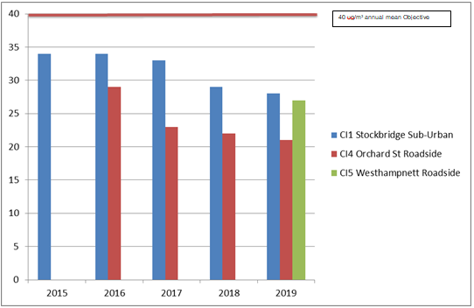

Table A.4 – 1-Hour Mean NO2 Monitoring Results

|  |  |  |  |  |  |  |  |  |  |  |  |
| --- | --- | --- | --- | --- | --- | --- | --- | --- | --- | --- | --- |
| **Site ID** | **X OS Grid Ref (Easting)** | **Y OS Grid Ref (Northing)** | **Site Type** | **Monitoring Type** | **Valid Data Capture for Monitoring Period (%) (1)** | **Valid Data Capture 2019 (%) (2)** | **NO2 1-Hour Means > 200µg/m3 (3)** | | | | |
| **2015** | **2016** | **2017** | **2018** | **2019** |
| CI1 | 485881 | 103791 | Suburban | Automatic |  | 97 | 0 | 0 | 0 | 0 | 0 |
| CI4 | 485982 | 105221 | Roadside | Automatic |  | 100 | x | 0 | 0 | 0 | 0 |
| CI5 | 487212 | 105372 | Roadside | Automatic |  | 88 | x | x | x | x | 0 |

**Notes:**

Exceedances of the NO2 1-hour mean objective (200µg/m3 not to be exceeded more than 18 times/year) are shown in **bold.**

(1) Data capture for the monitoring period, in cases where monitoring was only carried out for part of the year.

(2) Data capture for the full calendar year (e.g. if monitoring was carried out for 6 months, the maximum data capture for the full calendar year is 50%).

(3) If the period of valid data is less than 85%, the 99.8th percentile of 1-hour means is provided in brackets.

Figure A.2 – Trends in Number of NO2 1-Hour Means > 200µg/m3

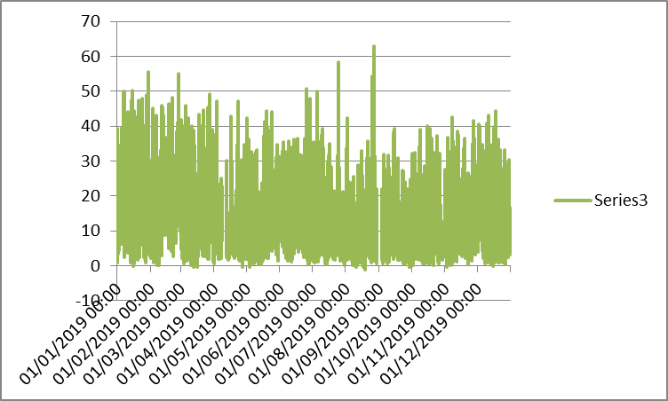

Stockbridge monitoring station

Units µg/m3

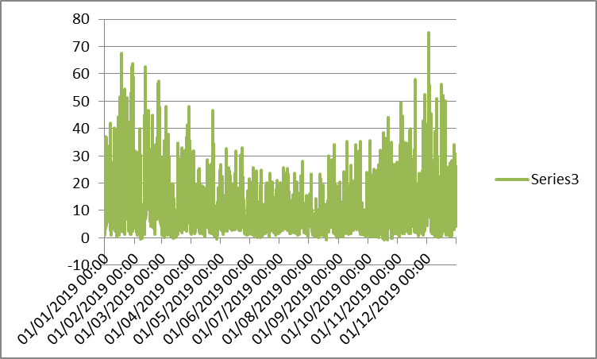

Orchard St monitoring station

Units µg/m3

Figure A.3 – Trends in NO2 diffusion tubes 2015 – 2019

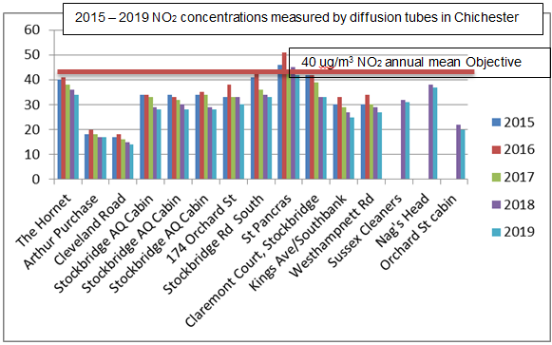

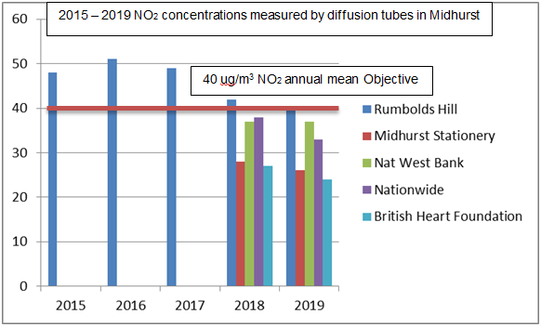

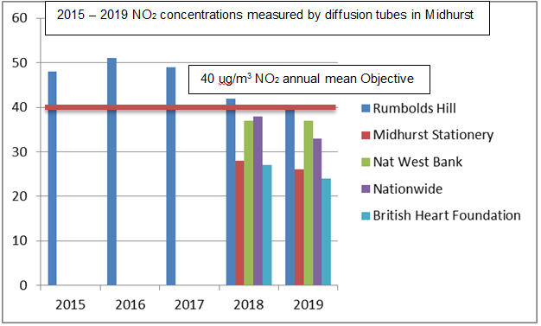

Table A.5 – Annual Mean PM10 Monitoring Results

|  |  |  |  |  |  |  |  |  |  |  |
| --- | --- | --- | --- | --- | --- | --- | --- | --- | --- | --- |
| **Site ID** | **X OS Grid Ref (Easting)** | **Y OS Grid Ref (Northing)** | **Site Type** | **Valid Data Capture for Monitoring Period (%) (1)** | **Valid Data Capture 2019 (%) (2)** | **PM10 Annual Mean Concentration (µg/m3) (3)** | | | | |
| **2015** | **2016** | **2017** | **2018** | **2019** |
| CI1 | 485881 | 103791 | Suburban |  | 99 | 21 | 20 | 19 | 18 | 19 |

**Notes:**

Exceedances of the PM10 annual mean objective of 40µg/m3 are shown in **bold.**

(1) Data capture for the monitoring period, in cases where monitoring was only carried out for part of the year.

(2) Data capture for the full calendar year (e.g. if monitoring was carried out for 6 months, the maximum data capture for the full calendar year is 50%).

(3) All means have been “annualised” as per Boxes 7.9 and 7.10 in LAQM.TG16, valid data capture for the full calendar year is less than 75%. See Appendix C for details.

Figure A.4 – Trends in Annual Mean PM10 Concentrations

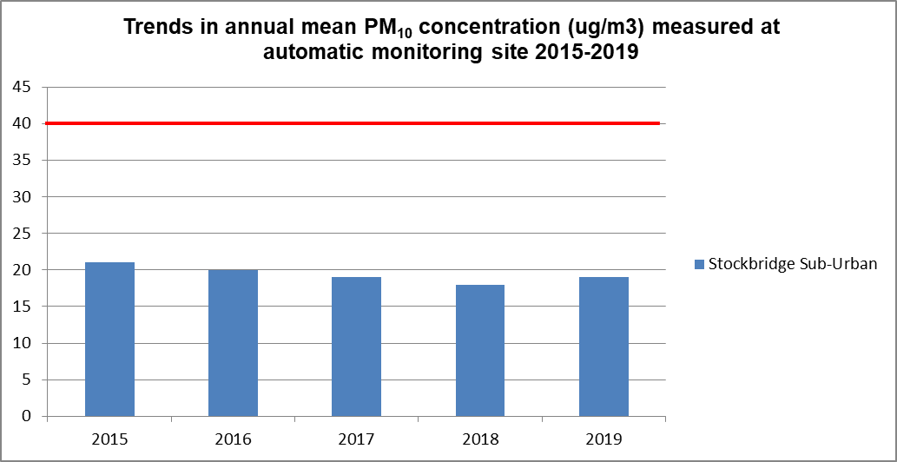

40 ug/m3 annual mean Objective

Table A.6 – 24-Hour Mean PM10 Monitoring Results

|  |  |  |  |  |  |  |  |  |  |  |
| --- | --- | --- | --- | --- | --- | --- | --- | --- | --- | --- |
| **Site ID** | **X OS Grid Ref (Easting)** | **Y OS Grid Ref (Northing)** | **Site Type** | **Valid Data Capture for Monitoring Period (%) (1)** | **Valid Data Capture 2019 (%) (2)** | **PM10 24-Hour Means > 50µg/m3 (3)** | | | | |
| **2015** | **2016** | **2017** | **2018** | **2019** |
| CI1 | 485881 | 103791 | Suburban |  | 99 | 3 | 2 | 1 | 0 | 0 |

**Notes:**

Exceedances of the PM10 24-hour mean objective (50µg/m3 not to be exceeded more than 35 times/year) are shown in **bold.**

(1) Data capture for the monitoring period, in cases where monitoring was only carried out for part of the year.

(2) Data capture for the full calendar year (e.g. if monitoring was carried out for 6 months, the maximum data capture for the full calendar year is 50%).

(3) If the period of valid data is less than 85%, the 90.4th percentile of 24-hour means is provided in brackets.

Figure A.5 – Trends in Number of 24-Hour Mean PM10 Results >50µg/m3

PM10 daily means at Stockbridge Monitoring station

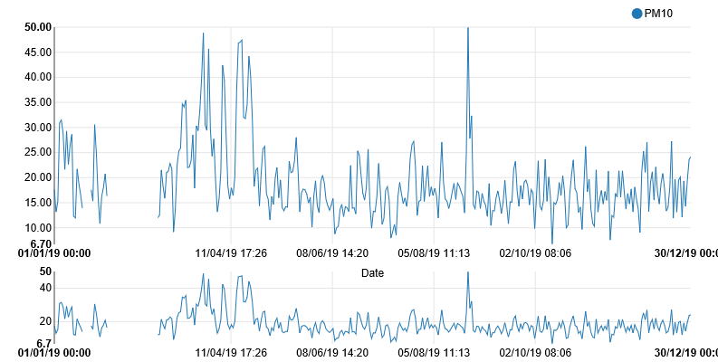

Units are µg/m3 – no exceedances of Objective (50µg/m3) during 2019

# Appendix B: Full Monthly Diffusion Tube Results for 2019

Table B.1 - NO2 Monthly Diffusion Tube Results - 2019

|  |  |  |  |  |  |  |  |  |  |  |  |  |  |  |  |  |  |
| --- | --- | --- | --- | --- | --- | --- | --- | --- | --- | --- | --- | --- | --- | --- | --- | --- | --- |
| **Site ID** | **X OS Grid Ref (Easting)** | **Y OS Grid Ref (Northing)** | **NO2 Mean Concentrations (µg/m3)** | | | | | | | | | | | | | | |
| **Jan** | **Feb** | **Mar** | **Apr** | **May** | **Jun** | **Jul** | **Aug** | **Sep** | **Oct** | **Nov** | **Dec** | **Annual Mean** | | |
| **Raw Data** | **Bias Adjusted (0.84) and Annualised (1)** | **Distance Corrected to Nearest Exposure (2)** |
| 1 | 485776 | 103961 | 36.7 | 36.9 | 28.8 | 31.1 | 28.1 | 29.8 | 31.2 | 31.1 | 30.2 | 13.5 | 36.7 | 29.8 | 30.3 | 25.4 | **-** |
| 2 | 485772 | 103847 | 43.1 | 43.2 | 33.9 | 41.5 | 38.3 | 41.5 | 41.2 | 39.1 | 40.5 | 35.0 | 39.6 | 40.8 | 39.8 | 33.3 | **-** |
| 2a | 485772 | 103847 | 42.6 | 45.6 | 35.8 | 39.4 | 41.3 | 43.2 | 41.8 | 43.0 | 37.4 | 37.8 | 37.2 | 35.4 | 40.0 | 33.5 | **-** |
| 3 | 485880 | 103791 | 38.1 | 39.2 | 41.2 | 22.3 | 26.6 | 34.9 | 32.0 | 39.4 | 31.2 | 29.5 | 31.8 | 33.3 | 33.3 | 27.8 | **-** |
| 4 | 485880 | 103791 | 37.7 | 41.5 | 38.1 | 25.8 | 24.6 | 32.2 | 34.3 | 39.3 | 32.6 | 30.7 | 30.6 | 38.0 | 33.8 | 28.2 | **-** |
| 5 | 485880 | 103791 | 42.1 | 43.1 | 40.0 | 17.7 | 28.5 | 36.4 | 34.4 | 36.1 | 37.5 | 33.2 | 30.3 | 21.2 | 33.4 | 27.9 | **-** |
| 6 | 485696 | 103731 | 55.9 | 52.3 | 32.4 | 44.2 | 34.4 | 24.7 | 43.8 | 37.0 | 44.2 | 30.1 | 42.5 | 31.6 | 39.4 | 33.0 | **-** |
| 7 | 486953 | 104414 | 25.6 | A | A | 19.5 | 12.3 | 12.4 | 11.6 | A | 12.2 | 13.2 | A | A | 15.2 | 14.0 | **-** |
| 8 | 487341 | 105474 | 38.9 | 38.7 | 32.0 | 36.2 | 26.6 | 28.1 | 32.8 | 31.3 | 30.7 | 31.3 | 33.8 | 26.7 | 32.3 | 27.0 | **-** |
| 9 | 486502 | 104795 | 51.4 | 47.6 | 36.9 | 46.4 | 37.3 | 32.8 | 36.6 | 34.7 | 44.1 | 41.8 | 44.9 | 39.9 | 41.2 | 34.4 | **-** |
| 9a | 486502 | 104795 | 52.8 | 48.7 | 37.9 | 41.2 | 36.6 | 29.5 | 37.0 | 36.1 | 46.0 | 39.3 | 49.1 | 36.3 | 40.9 | 34.2 | **-** |
| 10 | 486533 | 104860 | 48.0 | 59.7 | 46.1 | 52.6 | 48.0 | 51.9 | 55.3 | 48.6 | 45.7 | 45.1 | 51.2 | 50.2 | 50.2 | **42.0** | **-** |
| 10a | 486553 | 104860 | 54.5 | 59.4 | 46.8 | 49.9 | 48.6 | 53.2 | 54.8 | 53.6 | 45.5 | 41.0 | 49.0 | 48.1 | 50.4 | **42.1** | **-** |
| 11 | 486082 | 105026 | 26.2 | 31.8 | 17.2 | 20.7 | 14.5 | 15.6 | 15.5 | 15.0 | 16.8 | 19.1 | 24.9 | 23.7 | 20.1 | 16.8 | **-** |
| 12 | 485914 | 105185 | 40.3 | 51.7 | 29.2 | 40.5 | 29.7 | 33.3 | 34.4 | 30.6 | 29.3 | 30.6 | 36.2 | 37.2 | 35.2 | 29.5 | **-** |
| 12a | 485914 | 105185 | 40.1 | 55.6 | 31.7 | 41.5 | 28.8 | 31.3 | 34.9 | 31.3 | 28.9 | 31.6 | 41.6 | 35.7 | 36.1 | 30.2 | **-** |
| 14 | 488561 | 121479 | 59.8 | 54.9 | A | 43.4 | 45.8 | 46.8 | 50.6 | 43.6 | 49.3 | A | 44.1 | 38.2 | 47.7 | 39.8 | **-** |
| 14a | 488561 | 121479 | 57.1 | 50.7 | A | 43.2 | 43.2 | 50.3 | 50.8 | 43.8 | 50.1 | 42.2 | 47.2 | 36.2 | 46.8 | 39.1 | **-** |
| 15 | 486575 | 104799 | 38.2 | 45.6 | 38.1 | 36.3 | 31.5 | 37.0 | 37.4 | 38.5 | 34.4 | 37.3 | 39.4 | 37.9 | 37.6 | 31.5 | **-** |
| 16 | 496495 | 104845 | 51.7 | 49.1 | 44.9 | 44.5 | 42.4 | 38.3 | 39.9 | 39.8 | 43.6 | 44.9 | 49.4 | 46.4 | 44.6 | 37.3 | **-** |
| 17 | 485982 | 105221 | 31.3 | A | 25.4 | 26.3 | 17.3 | 18.9 | 19.8 | 18.7 | 19.4 | 22.6 | 30.7 | 26.9 | 23.4 | 19.5 | **-** |
| 18 | 488545 | 121434 | 40.6 | 37.9 | A | 30.3 | 30.9 | 27.8 | 32.9 | 26.6 | 30.3 | 27.9 | 34.2 | 26.0 | 31.4 | 26.3 | **-** |
| 19 | 488583 | 121512 | 49.8 | 49.9 | A | 42.2 | 39.9 | 49.1 | 46.2 | 43.7 | 45.9 | 41.4 | 40.5 | 41.2 | 44.5 | 37.2 | 33.3 |
| 20 | 488605 | 121538 | 41.3 | 48.0 | A | 48.9 | 37.0 | 41.9 | 43.6 | 31.7 | 36.5 | 37.0 | 45.4 | 28.0 | 39.9 | 33.4 | **-** |
| 21 | 488636 | 121613 | 28.8 | 34.1 | A | 33.7 | 26.6 | 27.9 | 29.8 | 25.5 | 23.0 | 22.9 | 37.0 | 23.5 | 28.4 | 23.8 | **-** |

**Local bias adjustment factor used**

**Annualisation has been conducted where data capture is <75%**

**Where applicable, data has been distance corrected for relevant exposure in the final column**

**Notes:**

Exceedances of the NO2 annual mean objective of 40µg/m3 are shown in **bold**.

NO2 annual means exceeding 60µg/m3, indicating a potential exceedance of the NO2 1-hour mean objective are shown in **bold and underlined.**

(1) See Appendix C for details on bias adjustment and annualisation.

(2) Distance corrected to nearest relevant public exposure.

# Appendix C: Supporting Technical Information / Air Quality Monitoring Data QA/QC

**Significant changes to sources**No significant changes were noted to sources of pollution. Additional diffusion tube monitoring commenced at the end of 2019, the results of which will be reported in next year’s ASR.

**Detailed dispersion modelling/monitoring campaigns in the District**

A contract was let in early 2019 to model air quality in discrete locations in Chichester and one location in Midhurst. The results of this work have resulted in an Air Quality Management Area (AQMA) being declared in Rumbolds Hill, Midhurst. The results of the source apportionment will be used in the review of the Air Quality Action Plan in order to prioritise the actions put forward to improve air quality.

**Additional Evidence gathered**

None noted.

**QA/QC of Automatic Monitoring**

All sites are visited by an officer for calibration and filter changes on a bi-monthly basis. CDC has a service agreement with a third party who provides site maintenance, auditing, regular inspections and 48-hour callout response if problems are encountered at the sites. Data is downloaded from all sites twice daily by the ERG[6] and is available to download online[7]. CDC has a contract with ERG to calibrate and ratify all real time data collected. ERG applies a VCM correction to the PM10 data and a screen shot of the correction is shown below. The graph shows the CDC TEOM data in blue and the VCM correction is shown as a dotted red line.

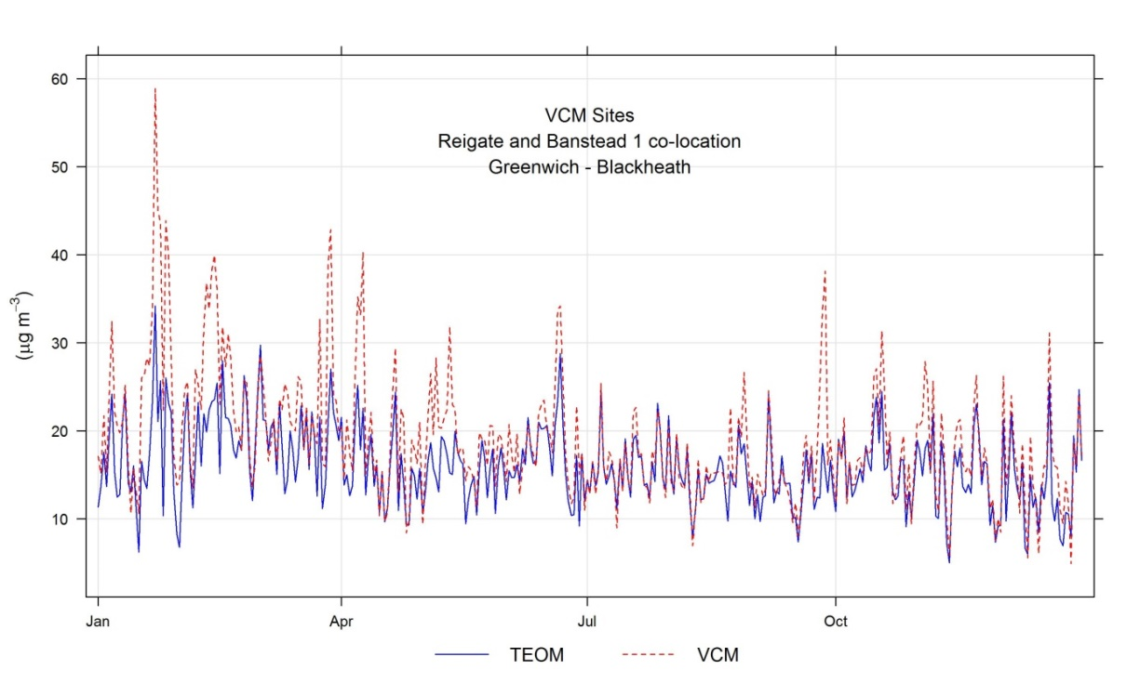

For more information please contact the ERG helpdesk[8].

**QA/QC Diffusion Tube Data**

Chichester District Council uses Gradko Environmental for supplying and analysing the diffusion tubes. The tube preparation method is 50% TEA/Acetone and ANA UKAS Method GLM 7 and GLM 9. CDC uses a local bias adjustment factor.

**Factor from Local Co-location Studies**

Three diffusion tubes are co-located with the Stockbridge monitoring station. These are used to calculate a bias-correction for the NO2 diffusion tubes. The automatic monitoring station’s data is quality assured by ERG. The annual average concentrations from the three co-located tubes are compared to the annual average real time data derived concentration for the same period. A factor can then be derived to correct all other diffusion tube data. The ‘bias correction’ calculation is as per the table below.

|  |  |
| --- | --- |
| Annual mean (automatic monitor) a,b,c | = 28µg/m3 |
| Annual average mean (NO2 diffusion tubes) d | = 33.5 µg/m3 |
| Correction factor calculation | = 28/33.5  = 0.84 |

a 1st January 2019 – 31st December 2019

b Real-time data capture for 2019 = 100%

c All data ratified by Environmental Research Group

d Diffusion tube data capture for the period Jan - Dec = 100%

**QA/QC of Diffusion Tube Monitoring**

CDC has confirmed by checking the web site provided that Gradko Environmental uses the AIR NO2 Proficiency Testing scheme for quality control. The result for 2019 was Satisfactory (Z score +/- 2) for 95% of results submitted. For more information please contact Gradko Environmental[9].

**Distance calculations for roadside diffusion sites where monitoring is not carried out at a location of relevant exposure**

Using the NO2 fall off with distance calculator on the LAQM website, the following sites have had a distance calculation applied:

**Nat West Bank, Midhurst**

Nat West Bank results

**Annualisation of diffusion tube results**

Where data capture is less than 75% the diffusion tube means have been annualised. The tube at Cleveland Road (site ID 7) required annualisation – this was carried out in accordance with Box 7.10 in LAQM TG16, see table below. A background diffusion site with more than 85% data capture was chosen (Arthur purchase site ID 11, see Table B1).

| Monitoring period | Arthur Purchase (B1) | Cleveland Road (D1) | B1 when D1 is available |
| --- | --- | --- | --- |
| January | 26.20 | 25.55 | 26.2 |
| February | 31.85 |  |  |
| March | 17.19 |  |  |
| April | 20.67 | 19.49 | 20.67 |
| May | 14.52 | 12.31 | 14.52 |
| June | 15.55 | 12.38 | 15.55 |
| July | 15.54 | 11.56 | 15.54 |
| August | 14.95 |  |  |
| September | 16.82 | 12.22 | 16.82 |
| October | 19.10 | 13.22 | 19.10 |
| November | 24.95 |  |  |
| December | 23.71 |  |  |
| Average | 20.1 (Am) | 15.2 (M) | 18.34 (Pm) |

**Ratio of annual mean to period mean R = Am/Pm = 20.1/18.34 = 1.096**

**Annualised average for Cleveland Road site D1 = M x R = 15.2 x 1.096 = 16.65**

**Applying the bias correction of 0.84 annualised mean for Cleveland Road is:**

**16.65 x 0.84 = 14**

# Appendix D: Maps of Monitoring Locations and AQMAs

Figure D.1 Stockbridge Roundabout AQMA, monitoring station and diffusion tube locations

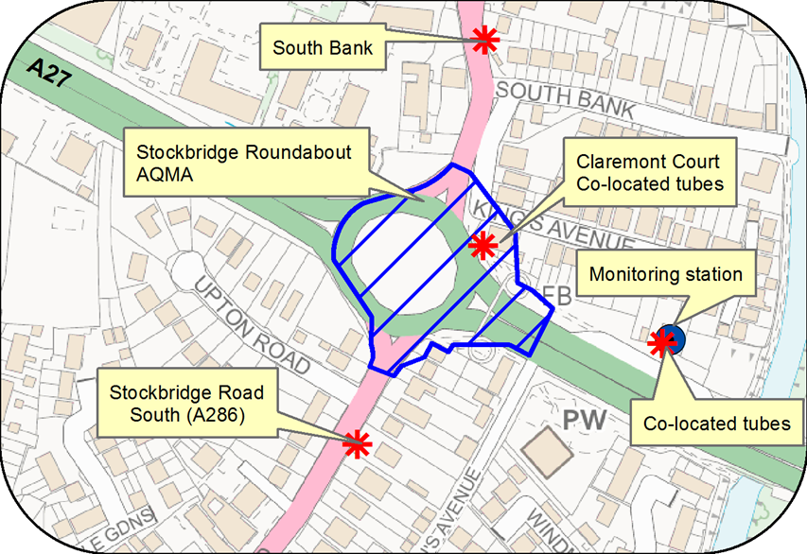

© Crown Copyright and database right 2019. Ordnance Survey 100018803

Figure D.2 Orchard Street AQMA, monitoring station and diffusion tube locations

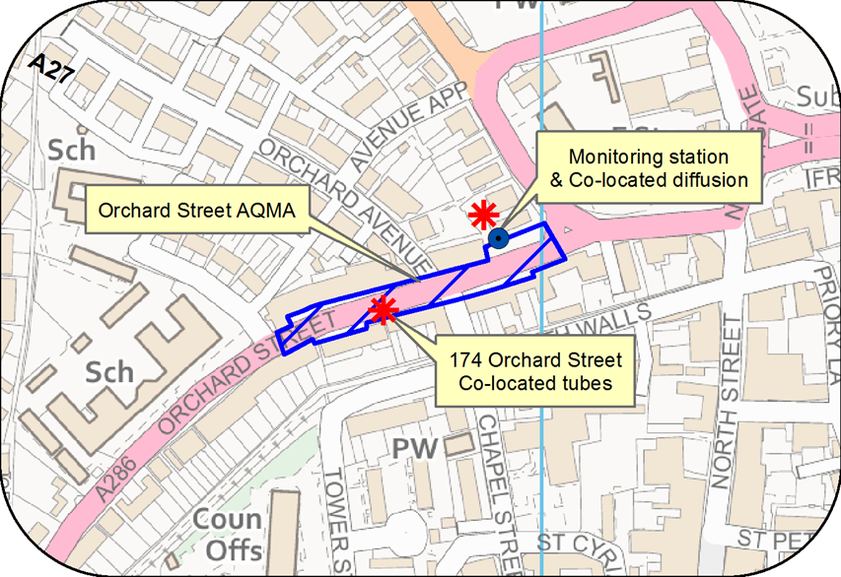

© Crown Copyright and database right 2019. Ordnance Survey 100018803

Figure D.3 St Pancras AQMA and diffusion tube locations

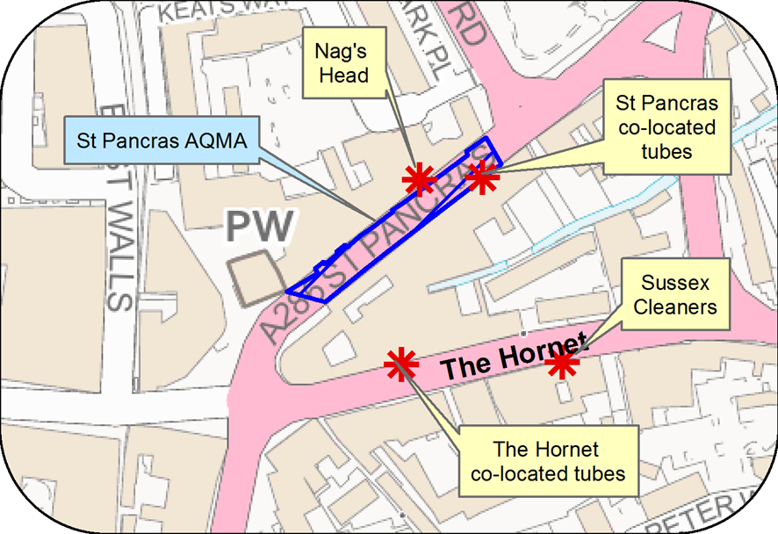

© Crown Copyright and database right 2019. Ordnance Survey 100018803

Figure D.4 Map of diffusion tube sites in Chichester

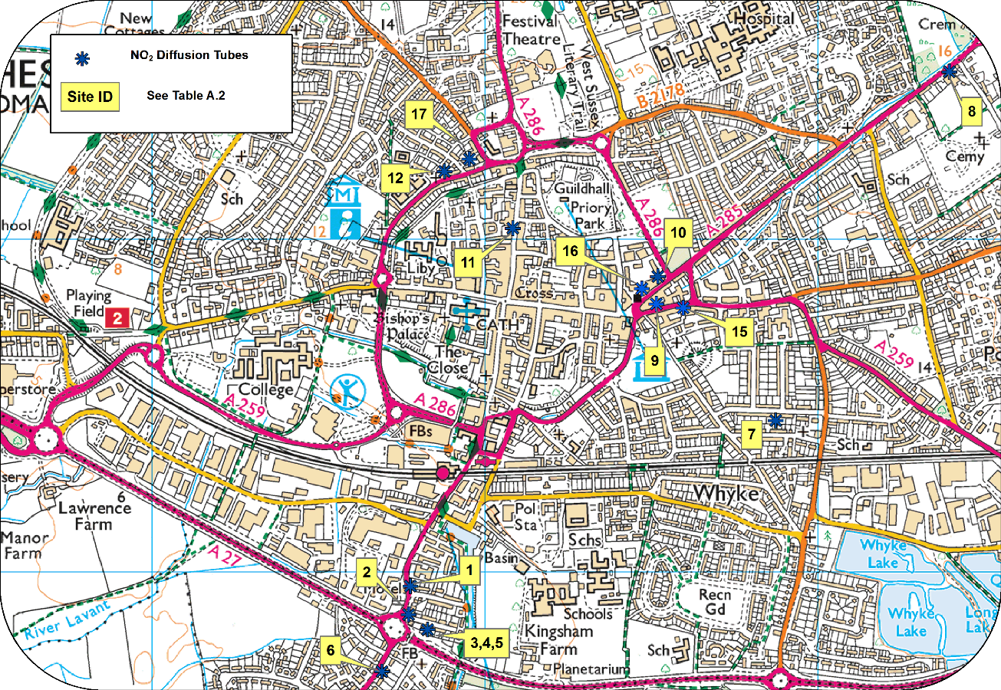

© Crown Copyright and database right 2019. Ordnance Survey 100018803

Figure D.5 Location of ozone monitoring station in Lodsworth

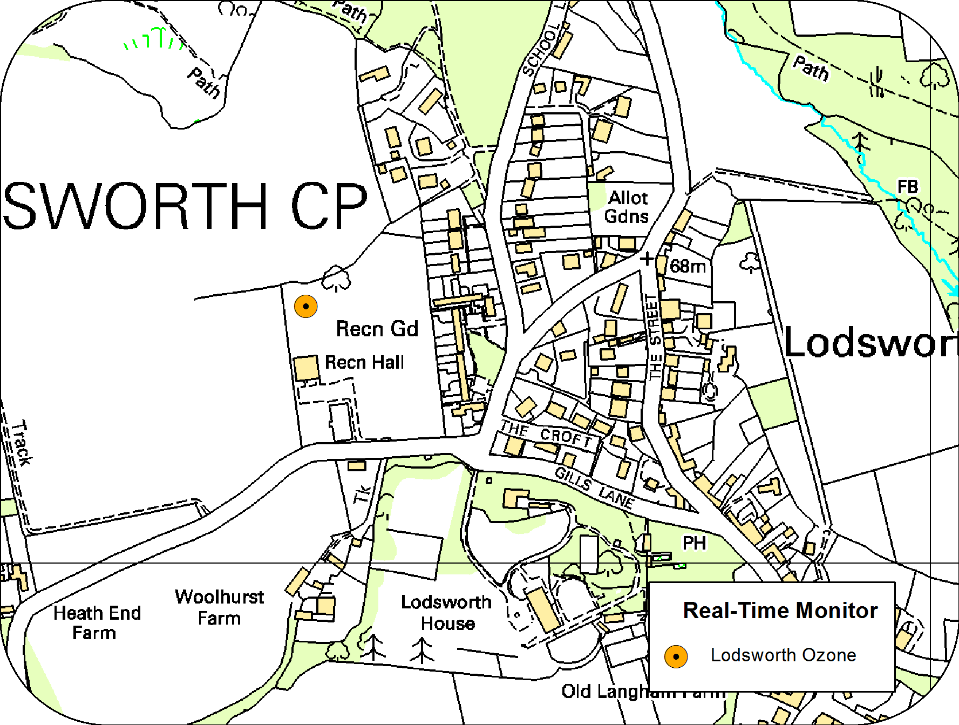

© Crown Copyright and database right 2019. Ordnance Survey 100018803

Figure D.6 Rumbolds Hill AQMA and diffusion tube locations in Midhurst

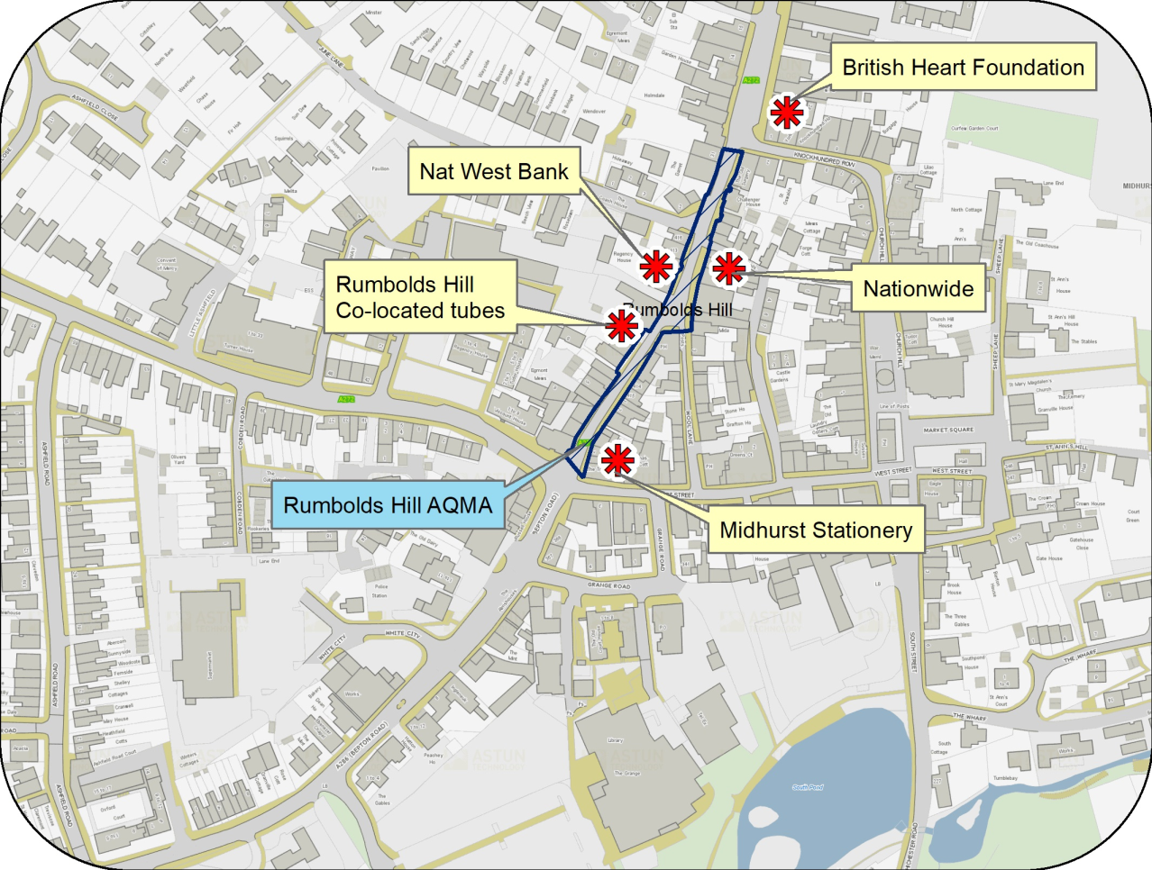

© Crown Copyright and database right 2019. Ordnance Survey 100018803

Figure D.7 Westhampnett Road, Chichester monitoring station and diffusion tube location

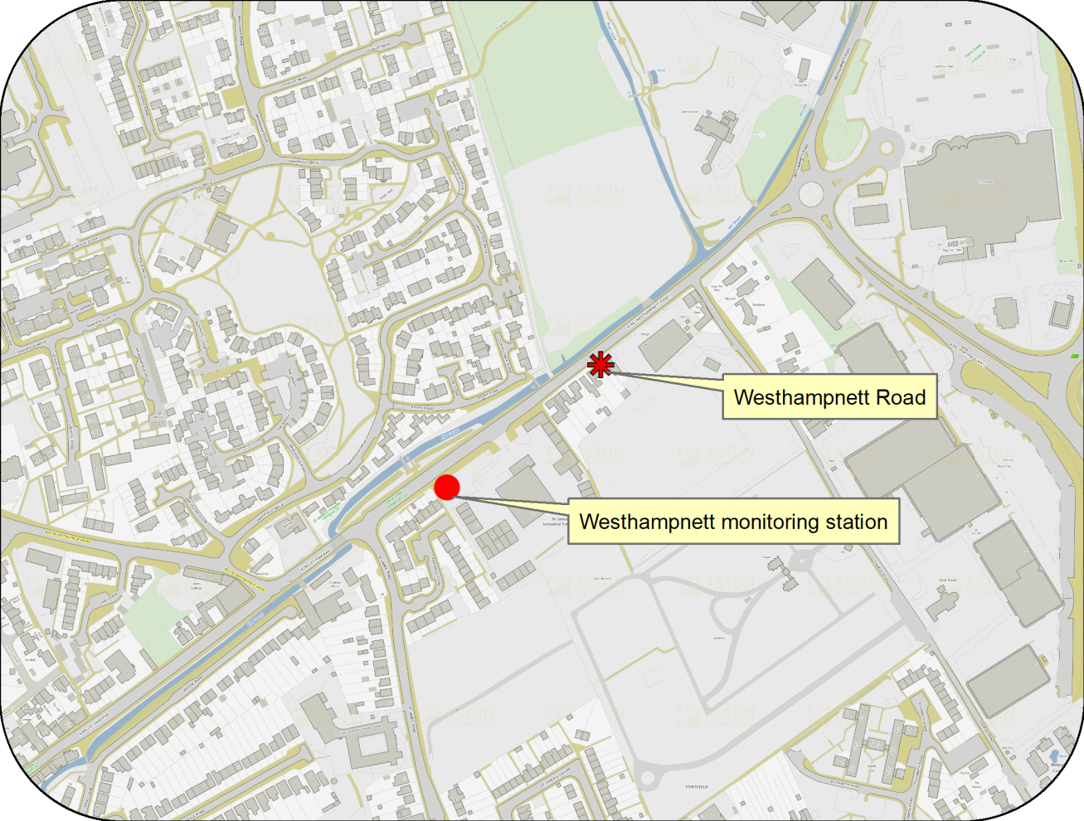

© Crown Copyright and database right 2019. Ordnance Survey 100018803

# Appendix E: Summary of Air Quality Objectives in England

Table E.1 – Air Quality Objectives in England

| **Pollutant** | **Air Quality Objective[10]** | |
| --- | --- | --- |
| **Concentration** | **Measured as** |
| Nitrogen Dioxide (NO2) | 200 µg/m3 not to be exceeded more than 18 times a year | 1-hour mean |
| 40 µg/m3 | Annual mean |
| Particulate Matter (PM10) | 50 µg/m3, not to be exceeded more than 35 times a year | 24-hour mean |
| 40 µg/m3 | Annual mean |
| Sulphur Dioxide (SO2) | 350 µg/m3, not to be exceeded more than 24 times a year | 1-hour mean |
| 125 µg/m3, not to be exceeded more than 3 times a year | 24-hour mean |
| 266 µg/m3, not to be exceeded more than 35 times a year | 15-minute mean |

# Glossary of Terms

|  |  |
| --- | --- |
| **Abbreviation** | **Description** |
| AQAP | Air Quality Action Plan - A detailed description of measures, outcomes, achievement dates and implementation methods, showing how the local authority intends to achieve air quality limit values’ |
| AQMA | Air Quality Management Area – An area where air pollutant concentrations exceed / are likely to exceed the relevant air quality objectives. AQMAs are declared for specific pollutants and objectives |
| ASR | Air quality Annual Status Report |
| CCTV | Closed circuit television |
| CDC | Chichester District Council |
| Defra | Department for Environment, Food and Rural Affairs |
| DMRB | Design Manual for Roads and Bridges – Air quality screening tool produced by Highways England |
| EU | European Union |
| EV | Electric vehicle |
| FDMS | Filter Dynamics Measurement System |
| HE | Highways England |
| IAAQG | Inter Authority Air Quality Group |
| LAQM | Local Air Quality Management |
| LES | Low Emissions Strategy |
| MOVA | Microprocessor Optimised Vehicle Actuation |
| NHS | National Health Service |
| NO2 | Nitrogen Dioxide |
| NOx | Nitrogen Oxides |
| OLEV | Office of Low Emission Vehicles |
| O3 | Ozone |
| PM10 | Airborne particulate matter with an aerodynamic diameter of 10µm (micrometres or microns) or less |
| PM2.5 | Airborne particulate matter with an aerodynamic diameter of 2.5µm or less |
| QA/QC | Quality Assurance and Quality Control |
| RTPI | Real Time Passenger Information |
| SAQP | Sussex Air Quality Partnership |
| SO2 | Sulphur Dioxide |
| UTC | Urban Transport Controls |
| VCM | Volatile correction measurement |
| VMS | Variable message signing |
| WSCC | West Sussex County Council |

# References

Towards Better Air Quality: an Air Quality Action Plan for Chichester District Council 2015-20 produced by Chichester District Council

West Sussex Walking and Cycling Strategy 2016 – 2026 produced by WSCC

Draft West Sussex Local Cycling and Walking Infrastructure Plan (LCWIP) December 2019

1. Environmental equity, air quality, socioeconomic status and respiratory health, 2010
2. Air quality and social deprivation in the UK: an environmental inequalities analysis, 2006
3. Defra.abatement cost guidance for valuing changes in air quality, May 2013
4. <https://laqm.defra.gov.uk/bias-adjustment-factors/bias-adjustment.html>
5. Fall-off with distance correction criteria is provided in paragraph 7.77, LAQM.TG(16)
6. The Environmental Research Group (ERG), part of the School of Biomedical and Health Sciences at King’s College London, a leading provider of air quality information and research in the UK.
7. www.sussex-air.net
8. Contact ERG on 020 7848 4022
9. Contact Gradko on 01962 860331
10. The units are in microgrammes of pollutant per cubic metre of air (µg/m3).