

2019 Air Quality Annual Status Report (ASR)

In fulfilment of Part IV of the

Environment Act 1995

Local Air Quality Management

June 2019

|  |  |
| --- | --- |
| Local Authority Officer | Kate Simons  Simon Ballard |
| Department | Environmental Protection |
| Address | East Pallant House  1 East Pallant  Chichester  West Sussex  PO19 1TY |
| Telephone | 01243 521160 |
| E-mail | [ksimons@chichester.gov.uk](mailto:ksimons@chichester.gov.uk)  [sballard@chichester.gov.uk](mailto:sballard@chichester.gov.uk) |
| Report Reference number | ASR 19 |
| Date | 30 June 2019 |

# Executive Summary: Air Quality in Our Area

## Air Quality in Chichester District

Air pollution is associated with a number of adverse health impacts. It is recognised as a contributing factor in the onset of heart disease and cancer. Additionally, air pollution particularly affects the most vulnerable in society: children and older people, and those with heart and lung conditions. There is also often a strong correlation with equalities issues, because areas with poor air quality are also often the less affluent areas[1],[2].

The annual health cost to society of the impacts of particulate matter alone in the UK is estimated to be around £16 billion[3].

The air quality in Chichester district is generally good however there are areas where elevated concentrations of pollutants occur. The key source of local air pollution is road traffic, particularly on roads in and adjacent to Chichester city and on Rumbold’s Hill within Midhurst. The principal pollutant of concern is nitrogen dioxide (NO2). Although concentrations of NO2 show a slight decrease over the last few years there are still hotspots in Chichester and Midhurst where exceedances of the national air quality Objective for NO2 occur. The hotspots in Chichester are mainly within or close to the Air Quality Management Areas (AQMAs). In Midhurst there is an area of exceedance within the town centre where we are moving towards declaration of a further AQMA. The existing AQMAs are as follows:

• Stockbridge roundabout at the junction with the A27 and A286

• Orchard Street, Chichester

• St Pancras, Chichester

Our current Air Quality Action Plan (AQAP) was adopted in 2015 and is available [here](http://www.chichester.gov.uk/pollutioncontrolairquality). The AQAP is being revised during 2019-20 and we have let a contract to undertake revised air quality modelling within Chichester and Midhurst. The modelling includes source apportionment and scenario testing and as such it is our intention that the actions in the revised AQAP will be prioritised.

Air quality is seen by the Council as an important public health issue but it is not something we can improve on our own. We are working actively with other services within the Council, partners at West Sussex County Council (WSCC) including the Public Health team and the Sussex Air Quality Partnership (SAQP) to tackle this issue. WSCC have set-up a pan West Sussex Inter Authority Air Quality Group. CDC has taken the terms of reference through Cabinet and a Cabinet member and a senior officer attend the group.

We are working with neighbouring authorities and WSCC to produce a Local Cycling and Walking Infrastructure Plan (LCWIP) for Chichester City. We have contracted a consultancy to assist with this project which has been funded by a successful bid to the WSCC pooled business rates fund. The draft LCWIP should be completed in early 2020. Once produced, we intend that the LCWIP will inform our Infrastructure Development Plan to help enable prioritise infrastructure provision across the district. CDC is currently reviewing its Local Plan. We are working with our policy planning team to ensure that air quality policies in the Plan are robustly present. To this end we have actively contributed to a pan-Sussex working group on the development of a draft Supplementary Planning Guidance note to provide clarity to the interpretation of the air quality policy in the draft Revised Local Plan.

Since our first AQAP dated 2008, we have won in excess of £374k of grant monies from a variety of sources. Key projects that have been delivered include Chichester’s first car club, installation of two electric vehicle charging points, 140 additional bike parking spaces in the city centre, delivered training to over 150 cyclists to ride more confidently/maintain their bikes and provided data to the air-Alert forecasting service (coordinated by SAQP).

## Actions to Improve Air Quality

Key completed actions during 2018 are as follows:

* Chichester District Council (CDC) has rolled out across the organisation its whole life costing (WLC) model and ‘reporting by exception form’ to support the Cabinet resolution to replace cars and vans with EVs unless there is a business reason as to why not.
* Using the WLC model to justify the procurement, CDC has replaced two diesel vans for its Parking Services fleet with two electric vehicles;
* CDC has submitted a grant application to OLEV in support of our Cabinet resolution to install eighteen electric vehicle charging bays across Chichester District.
* CDC delivered a new air quality monitoring station at the end of 2018 on Westhampnett Road, Chichester. This location was chosen as there are a number of commercial and residential developments being constructed on the eastern side of the Chichester which will use this route to access the City. The road passes close to existing residential properties.
* CDC drafted its air quality policy within its draft Revised Local Plan and a Supplementary Policy Document is in draft.
* CDC is funded to expand the car club in Chichester. The tender invite document is written and we will invite submissions in the summer. The car’s location will be at a local community centre adding to the existing six car club fleet in Chichester.
* Using grant monies CDC has funded a feasibility study for conversion of a footpath to dual-use and provided a grant to a local organisation in support of their work to deliver an ambitious length of bike path.

## Conclusions and Priorities

This year’s NO2 and PM10 monitoring shows no exceedances of Air Quality Standards at either of the monitoring stations[4]. There are two diffusion tube locations where the NO2 air quality objective of 40 µg/m3 was exceeded, namely:

* St Pancras, within the St Pancras AQMA, Chichester
* Rumbold’s Hill, Midhurst - not within an AQMA.

The above two diffusion tube locations’ exceedances is consistent with the last few years data. As a result additional diffusion tube monitoring commenced in December 2017 in Midhurst and further diffusion tubes were installed in Chichester and Midhurst in January 2018. At the Nag’s Head PH location (in the St Pancras AQMA) the results are close to exceeding the Objective and at two locations near the Rumbold’s Hill location, the results are just compliant with the Objective. The additional monitoring locations will help us to understand the spatial extent of the pollution.

Detailed air quality modelling of discrete areas of Chichester and Midhurst was contracted in February 2019. This modelling will be reported in next year’s ASR and will inform the necessity (and extent) of the Rumbolds Hill AQMA and any amendments or additional AQMAs in Chichester.

All other diffusion tube monitoring locations outside of AQMAs were compliant with the NO2 Objective.

It is not intended to revoke any of the AQMAs at this time and the air quality modelling will inform the shape of an AQMA in Midhurst to be declared in 2019. Nevertheless the monitoring data in the Orchard Street AQMA indicates the possibility of undeclaring this AQMA and we have a watching brief on this issue for the next few years.

## Local Engagement and How to get Involved

The public can get involved by supporting behavioural change initiatives (eg joining the Car Club, car sharing and walking, cycling, using public transport, turning their vehicle’s engine off when stationary, minimising wood burning and only burning dry, well-seasoned wood and composting instead of having garden bonfires wherever possible). Further information can be obtained by emailing: [airquality@chichester.gov.uk](mailto:airquality@chichester.gov.uk)

The Chichester and District Cycle Forum provides information on local cycling opportunities and campaigns on behalf of cyclists. The Forum is open to the public and further information can be obtained by emailing [cycle@chichester.gov.uk](mailto:cycle@chichester.gov.uk)

**Table of Contents**

Executive Summary: Air Quality in Our Area i

Air Quality in Chichester District i

Actions to Improve Air Quality ii

Conclusions and Priorities iii

Local Engagement and How to get Involved iii

1 Local Air Quality Management 1

2 Actions to Improve Air Quality 2

2.1 Air Quality Management Areas 2

2.2 Progress and Impact of Measures to address Air Quality in Chichester District Council 4

2.3 PM2.5 – Local Authority Approach to Reducing Emissions and/or Concentrations 11

3 Air Quality Monitoring Data and Comparison with Air Quality Objectives and National Compliance 12

3.1 Summary of Monitoring Undertaken 12

3.1.1 Automatic Monitoring Sites 12

3.1.2 Non-Automatic Monitoring Sites 12

3.2 Individual Pollutants 12

3.2.1 Nitrogen Dioxide (NO2) 12

3.2.2 Particulate Matter (PM10) 14

3.2.3 Ozone (O3) 14

Comparison to the DEFRA banding below shows that in 2018 at Lodsworth there were 34 days when ‘moderate pollution’ occurred, see box for health messages of DEFRA pollution bands. 15

**Health messages of the DEFRA Pollution Bands** 15

Appendix A: Monitoring Results 17

Appendix B: Full Monthly Diffusion Tube Results for 2018 31

Appendix C: Supporting Technical Information / Air Quality Monitoring Data QA/QC 33

Appendix D: Map(s) of Monitoring Locations and AQMAs 38

Appendix E: Summary of Air Quality Objectives in England 41

Glossary of Terms 42

References 44

**List of Tables**

Table 2.1 – Declared Air Quality Management Areas 3

Table 2.2 – Progress on Measures to Improve Air Quality 6

Table A.1 – Details of Automatic Monitoring Sites 17

Table A.2 – Details of Non-Automatic Monitoring Sites 18

Table A.3 – Annual Mean NO2 Monitoring Results 20

Table A.4 – 1-Hour Mean NO2 Monitoring Results 23

Table A.5 - Annual Mean PM10 Monitoring Results…………………………………… 28

Table A.6 - 24 hr Mean PM10 Monitoring Results……………………………………… 30

Table B.1 – NO2 Monthly Diffusion Tube Results - 2018 31

Table E.1 – Air Quality Objectives in England 41

**List of Figures**

Figure A.1 – Trends in Annual Mean NO2 Concentrations 22

Figure A.2 – Trends in Number of NO2 1-Hour Means > 200µg/m3 24

Figure A.3 – Trends in NO2 diffusion tubes 2013 - 2018 28

Figure A.4 – Trends in Annual Mean PM10 Concentrations 30

Figure A.5 – Trends in Number of 24-Hour Mean PM10 Results >50µg/m3

# Local Air Quality Management

This report provides an overview of air quality in Chichester District during 2018. It fulfils the requirements of Local Air Quality Management (LAQM) as set out in Part IV of the Environment Act (1995) and the relevant Policy and Technical Guidance documents.

The LAQM process places an obligation on all local authorities to regularly review and assess air quality in their areas, and to determine whether or not the air quality objectives are likely to be achieved. Where an exceedance is considered likely the local authority must declare an Air Quality Management Area (AQMA) and prepare an Air Quality Action Plan (AQAP) setting out the measures it intends to put in place in pursuit of the objectives. This Annual Status Report (ASR) is an annual requirement showing the strategies employed by Chichester District Council to improve air quality and any progress that has been made.

The statutory air quality objectives applicable to LAQM in England can be found in **Error! Reference source not found.** inAppendix E.

# Actions to Improve Air Quality

## Air Quality Management Areas

Air Quality Management Areas (AQMAs) are declared when there is an exceedance or likely exceedance of an air quality objective. After declaration, the authority must prepare an Air Quality Action Plan (AQAP) within 12-18 months setting out measures it intends to put in place in pursuit of compliance with the objectives.

A summary of AQMAs declared by Chichester District Council can be found in Table 2.1. Further information related to declared or revoked AQMAs, including maps of AQMA boundaries are available online [on our website.](http://www.chichester.gov.uk/pollutioncontrolairquality)

Alternatively, see Appendix D: Map(s) of Monitoring Locations and AQMAs, which provides maps of air quality monitoring locations in relation to the AQMA(s).

We propose to declare a new AQMA in Rumbold’s Hill, Midhurst (see monitoring section). We are currently carrying out computer modelling of air quality to help confirm the extent of the exceedance, and source apportionment and scenario testing will be carried out to prioritise actions within the revised AQAP

Monitoring data for our Orchard Street, Chichester AQMA indicates that air quality there is compliant with all Objectives. As such we have a watching brief over the next two years with a view to the possibility of undeclaring this AQMA.

Table 2.1 – Declared Air Quality Management Areas

|  |  |  |  |  |  |  |  |  |  |  |  |  |  |
| --- | --- | --- | --- | --- | --- | --- | --- | --- | --- | --- | --- | --- | --- |
| **AQMA Name** | **Date of Declaration** | **Pollutants and Air Quality Objectives** | **City / Town** | **One Line Description** | **Is air quality in the AQMA influenced by roads controlled by Highways England?** | **Level of Exceedance (maximum monitored/modelled concentration at a location of relevant exposure)** | | | | | **Action Plan** | | |
| **At Declaration** | | **Now** | | **Name** | | **Date of Publication** | **Link** | |
| AQMA Stockbridge Roundabout | 24-Aug-06 | NO2 Annual Mean | Chichester | An area encompassing the Stockbridge Roundabout at the junction of the Chichester bypass (A27) and Stockbridge Road (A286) | YES | 44.9 | µg/m3 | 33 | µg/m3 | CDC AQAP | | 2015 | http://www.chichester.gov.uk/pollutioncontrolairquality#plan | | |
| AQMA Orchard Street | 17-May-07 | NO2 Annual Mean | Chichester | An area along Orchard Street, Chichester at the eastern end of the street where it meets Northgate | NO | 40.7 | µg/m3 | 33 | µg/m3 | CDC AQAP | | 2015 | as above | | |
| AQMA St Pancras | 17-May-07 | NO2 Annual Mean | Chichester | An area along St Pancras, Chichester between Eastgate Square and New Park Road. Note St Pancras forms a street canyon in this section | NO | 48.3 | µg/m3 | 45 | µg/m3 | CDC AQAP | | 2015 | as above | | |

**Chichester District Council confirms the information on UK-Air regarding their AQMA(s) is up to date**

## 

## Progress and Impact of Measures to address Air Quality in Chichester District Council

Defra’s appraisal of last year’s ASR concluded that the 2017 monitoring suggested exceedances within the St Pancras AQMA and at two further locations outside AQMAs (The Hornet, close to St Pancras AQMA and Rumbold’s Hill, Midhurst). It noted that additional monitoring had been established at these locations to increase the dataset. The results of this additional monitoring are detailed in this report and in addition a contract has recently been let to model these locations, further details are given below.

Defra considered that the results at Orchard Street were at a level that the status of this AQMA should be reviewed and considered for revocation – commentary regarding this point is provided in this year’s ASR, see section 3.2.1.

Defra also welcomed the proposal to review the Action Plan – further information about this is given below.

A number of technical queries were raised which we responded to in our response of 22 August 2018. Defra confirmed that all actions had been completed in its response of 23 August 2018.

Chichester District Council has taken forward a number of direct measures during the current reporting year of 2018 in pursuit of improving local air quality. Details of all measures completed, in progress or planned are set out in Table 2.2.

More detail on these measures can be found in our Action Plan. Key completed measures are:

* Chichester District Council (CDC) has replaced two of its fleet vehicles with electric vehicles (for use by its Parking Services Team);
* CDC delivered a new air quality monitoring station at the end of 2018 on Westhampnett Road, Chichester. This location was chosen as there are a number of commercial and residential developments being constructed on the eastern side of the Chichester which will use this route to access the City. The route passes close to existing residential properties.
* CDC finalised its air quality policy within its emerging Local Plan and a Supplementary Policy Document is drafted.

Chichester District Council expects the following measures to be completed over the course of the next reporting year:

* Promoting low emission transport: we have a funded Cabinet resolution to install up to ten EV charging points across the District. We have submitted an OLEV bid for additional funding for additional points and subject to the grant award aim to deliver these during 2019.
* Alternatives to private car use: we plan to expand the Car Club in Chichester city which was originally set up using Defra funding. We will let a tender for an additional car to be put in place during 2019.
* We are working in partnership with West Sussex Public Health and West Sussex County Council to reduce idling at rail level crossings and school drop off zones and signs to alert drivers have been deployed at suitable locations within the District.
* A contract was let in early 2019 to model air quality in discrete locations in Chichester and one location in Midhurst. The results of this work will feed into the review of the Air Quality Action Plan and next year’s ASR.

Chichester District Council’s priorities for the coming year are:

* To complete work on a Local Cycling and Walking Infrastructure Plan (LCWIP) for Chichester to enable the cycling and walking network to be developed and priorities for infrastructure to be established. Funding was agreed during 2018 to tender for this work and a Consultancy was contracted in May 2019 to assist with this work.
* To finalise the Supplementary Policy Document on air quality to enable the air quality impact of new development to be properly considered during the planning process.
* To review the Air Quality Action Plan.

The principal challenges and barriers to implementation that Chichester District Council anticipates facing are:

* Availability of funding for infrastructure projects.

Progress on the following measures has been slower than expected due to:

* Continuing delays to the decision on improvements to the A27 by Highways England mean that there is increasing congestion on the A27 trunk road, leading to traffic diverting through Chichester with resulting impacts on local air quality in the City.

Whilst the measures stated above and in Table 2.2 will help to contribute towards compliance, Chichester District Council anticipates that further additional measures not yet prescribed will be required in subsequent years to achieve compliance and enable the revocation of all three AQMAs within the District.

Table 2.2 – Progress on Measures to Improve Air Quality

|  |  |  |  |  |  |  |  |  |  |  |  |
| --- | --- | --- | --- | --- | --- | --- | --- | --- | --- | --- | --- |
| **Measure No.** | **Measure** | **EU Category** | **EU Classification** | **Organisations involved and Funding Source** | **Planning Phase** | **Implementation Phase** | **Key Performance Indicator** | **Reduction in Pollutant / Emission from Measure** | **Progress to Date** | **Estimated / Actual Completion Date** | **Comments / Barriers to implementation** |
| 1 | Set up Air Quality Working Group | Promoting Travel Alternatives | Other | CDC | June/Dec 2008 | Dec-08 | 2 meetings per year | N/A | 12 meetings held to date | Ongoing | meeting held in July 2018 |
| 2 | Cleaner vehicles | Promoting Low Emission Transport | Procuring alternative Refuelling infrastructure to promote Low Emission Vehicles, EV recharging, Gas fuel recharging | WSCC/CDC | 2010 | 2011 | No. of electric vehicle recharging points |  | 2 recharging points in Chichester, secured funding to install additional charging points during 2018-19. Part of regional network of rapid charging points through Sussex-air project | 2019-20 | WSCC has purchased four electric cars and an electric van and installed charge points in its car park. CDC has replaced two diesel vehicles with electric vehicles in 2018. Awaiting outcome of OLEV bid to fund additional charging points. |
| 3 | Planning policy | Policy Guidance and Development Control | Low Emissions Strategy | CDC | 2010/11 | ongoing | No. of planning conditions imposed on planning consultations |  | Sussex-air produced Planning Guidance and Low Emissions Strategy and in discussion with CDC Policy Planners regarding adopting LES approach. Sussex-air is reviewing its guidance and refreshed document due in 2019 | 2019-20 | Local Plan has to be reviewed within 5 years - aim to have new policy in place within updated Plan. Draft policy in place. |
| 4 | Cycling and walking initiatives | Promoting Travel Alternatives | Promotion of cycling | CDC/WSCC | 2009 | 2010 | % increase in cycling |  | Slight decrease in cycling from 2017- 2018. Funding secured to deliver LCWIP for Chichester City. Cycle track at Medmerry completed in 2018. | LCWIP to be completed Dec 2019 | Once LCWIP in place, bids for funding can be made for cycle infrastructure improvements |
| 5 | Car Clubs | Alternatives to private vehicle use | Car Clubs | CDC | 2010 | 2011 | Utilisation rate of cars to be 20% |  | 6 cars now available to book, development worker employed 2014-16 to promote Club, utilisation rate increasing throughout 2018 and 22% by Dec 18 | 2019-20 | Two cars added in Dec 2017 at site within housing development. Additional site identified for new car to be added during 2019-20. |
| 6 | School travel plans | Promoting Travel Alternatives | School Travel Plans | WSCC/CDC | 2008/9 | 2009/10 | % children travelling to school by sustainable means |  | During 2017/18 Living Streets project engaged with 5 primary schools in the District to support Walk to School scheme (WOW) and engaged students and staff at Chichester University | Mar-20 | 1 school travel plan commented on during 2018 |
| 7 | WSCC and CDC travel plans | Promoting Travel Alternatives | Workplace Travel Planning | WSCC/CDC | 2010 | 2011/12 | % WSCC and CDC staff travelling by sustainable means |  | Grey fleet business mileage was 5.35 million miles below 6.0 million miles target. Easit scheme at WSCC and CDC to encourage rail use. Cycle to work scheme at CDC | Ongoing |  |
| 8 | Business travel plans | Promoting Travel Alternatives | School Travel Plans | WSCC | 2009 | Ongoing | Travel Plan implemented within target time period |  | Over 35 Travel Plans submitted since 2009 and Travel Plan group set up attended by large organisations to work on joint measures. | Ongoing | 6 commented on during 2018 |
| 9 | Residential travel plans | Promoting Travel Alternatives | Personalised Travel Planning | WSCC | 2009 | Ongoing | Travel Plan implemented within target time period |  | Over 30 Travel Plans have been submitted since 2009 | Ongoing | 5 commented on during 2018 |
| 10 | TravelWise/ smarter choices | Public Information | Via leaflets | WSCC/CDC | 2009 | Ongoing | No. of users of WSCC car share database for PO19 area |  | Steady increase in number of users of database for 2018 | Ongoing |  |
| 11 | Cycle route information | Promoting Travel Alternatives | Promotion of cycling | CDC | 2009 | Ongoing | No. of maps sold through Tourist Information or other outlets. |  | 5 route leaflets have been produced so far and over 1360 copies have been sold to date. 64 leaflets sold in 2018 | Ongoing | 64 maps sold in 2018 |
| 12 | Cycle journey planning | Public Information | Via the Internet | WSCC | 2010 | 2011 | No. of journeys planned on website |  | Web link available on WSCC and CDC websites | Ongoing | 4500 journeys planned 2018-19 |
| 13 | Public transport infrastructure | Transport Planning and Infrastructure | Public transport improvements-interchanges stations and services | WSCC | 2010 | 2011-15 | Increase in use of public transport |  | RTPI displays installed at key locations across City | Ongoing | 8 RTPI displays installed in 2018-19 and more planned for 2019-20. Total within Chichester now 17. |
| 14 | Cleaner buses | Promoting Low Emission Transport | Public Vehicle Procurement -Prioritising uptake of low emission vehicles | WSCC | 2009 | Ongoing | % of Euro 5 buses |  | Stagecoach has 60% of fleet Euro 5 and replaced older Euro 2 buses with Euro 4 and 5 buses during 2017 | Ongoing | Need to promote cleaner buses to other bus companies |
| 15 | Licensing requirement for taxis | Promoting Low Emission Transport | Taxi Licensing conditions | CDC | 2009/10 | 2011 | No. of Euro 4 vehicles |  | For vehicles 5 years and over, MOT and fitness test required every 6 months | Ongoing |  |
| 16 | Forecasting, monitoring and public information | Public Information | Via other mechanisms | SAQP | 2008 | Ongoing | No. of people registered to receive alerts |  | Over 1071 subscribers registered across Sussex | Ongoing | inc of 36 subscribers during 2018 |
| 17 | AQ monitoring and traffic monitoring | Traffic Management | UTC, Congestion management, traffic reduction | CDC/WSCC | 2008 | Ongoing | Reduction in traffic volumes |  | Traffic flows between 2017 - 2018 have reduced by 8% in Stockbridge AQMA and have increased slightly (1%) in the Orchard St AQMA. | Ongoing |  |
| 18 | A27 by-pass improve-ments | Traffic Management | Strategic highway improvements, Re-prioritising road space away from cars, including Access management, Selective vehicle priority, bus priority, high vehicle occupancy lane | HE | Ongoing | Post 2020 | Reduction in congestion |  | HE re-consulted during 2017 on options for improving A27 around Chichester however no option chosen | 2025 | No funds allocated for A27 improvements at the present time. |
| 19 | Variable message signing (VMS) on A27 | Traffic Management | UTC, Congestion management, traffic reduction | HE | 2009 | pilot by 2020 | No. of warnings made per year |  | HE decision awaited | Ongoing | Awaiting outcome of A27 improvements decision |
| 20 | Park and ride schemes in and around City | Alternatives to private vehicle use | Bus based Park & Ride | CDC | Post 2015 | Post 2018 | Reduce traffic in City centre by 3% |  | Linked to A27 improvements that have not yet been brought forward | Ongoing | CDC parking strategy under review |
| 21 | Speed limit changes - 20 mph as part of school safety zone | Traffic Management | Reduction of speed limits, 20mph zones | WSCC | 2009 | 2012/13 | Reduction in traffic queues within Orchard St AQMA area |  | Signs installed around schools and on nearby residential streets | Completed | Reductions in NO2 within AQMA could be achieved through smoothing of traffic flow |
| 22 | Blanket 20mph scheme on residential streets | Traffic Management | Reduction of speed limits, 20mph zones | WSCC | 2012/13 | 2013/14 | Reduced speed on residential streets |  | WSCC contracted officer to promote 20mph and work with schools and community and CDC hosted officer and provided support | Completed | Roads monitored before and after implementation and speed reductions achieved on some roads |
| 23 | MOVA traffic signal optimisation | Traffic Management | UTC, Congestion management, traffic reduction | WSCC | 2009/10 | 2010 | Reduction in traffic queues within AQMAs |  | 2 new Puffins to replace existing crossings implemented | Completed | Improves emissions by eliminating ghost users and reducing red time |

## PM2.5 – Local Authority Approach to Reducing Emissions and/or Concentrations

As detailed in Policy Guidance LAQM.PG16 (Chapter 7), local authorities are expected to work towards reducing emissions and/or concentrations of PM2.5 (particulate matter with an aerodynamic diameter of 2.5µm or less). There is clear evidence that PM2.5 has a significant impact on human health, including premature mortality, allergic reactions, and cardiovascular diseases.

Chichester District Council is taking the following measures to address PM2.5:

* Measure 15 – taxi licensing conditions – since 2011 we have required vehicles that are 5 years old and over to have MOT and fitness tests every 6 months. The taxi licensing policy is currently under review and air quality considerations will be considered as part of the review.
* Measure 14 – cleaner buses – fleet managers report that upgrades to the fleet are ongoing in order to introduce cleaner buses. WSCC continues to engage with them to promote any funding opportunities that may enable upgrades to the fleet.

We are working in partnership with West Sussex Public Health and WSCC to run an anti-idling campaign outside schools and at level crossings across West and East Sussex. Signs have been placed at suitable locations with anti-idling messages to raise awareness about this issue.

Where considered appropriate we have recommended that construction environmental management plans (CEMP) are put in place at new developments which include dust control strategies.

# Air Quality Monitoring Data and Comparison with Air Quality Objectives and National Compliance

## Summary of Monitoring Undertaken

### Automatic Monitoring Sites

This section sets out what monitoring has taken place and how it compares with objectives.

Chichester District Council undertook automatic (continuous) monitoring at three sites during 2018. Table A.1 in Appendix A shows the details of the sites.

Maps showing the location of the monitoring sites are provided in Appendix D. Further details on how the monitors are calibrated and how the data has been adjusted are included in Appendix C.

### Non-Automatic Monitoring Sites

Chichester District Council undertook non- automatic (passive) monitoring of NO2 at 18 sites during 2018 (note at some locations there are co-located tubes). Table A.2 in Appendix A shows the details of the sites.

Maps showing the location of the monitoring sites are provided in Appendix D. Further details on Quality Assurance/Quality Control (QA/QC) for the diffusion tubes, including bias adjustments and any other adjustments applied (e.g. “annualisation” and/or distance correction), are included in Appendix C.

## Individual Pollutants

The air quality monitoring results presented in this section are, where relevant, adjusted for bias, “annualisation” and distance correction. Further details on adjustments are provided in Appendix C.

### Nitrogen Dioxide (NO2)

Table A.3 in Appendix A compares the ratified and adjusted monitored NO2 annual mean concentrations for the past 5 years with the air quality objective of 40µg/m3.

For diffusion tubes, the full 2018 dataset of monthly mean values is provided in Appendix B.

Table A.4 in Appendix A compares the ratified continuous monitored NO2 hourly mean concentrations for the past 5 years with the air quality objective of 200µg/m3, not to be exceeded more than 18 times per year.

Data in Table A.3 indicates that there has been a decrease in the NO2 annual mean concentration at the Stockbridge monitoring station (from 33 to 29µg/m3) and the air quality objective was not exceeded. The results at this location have been broadly similar for the past five years, ranging from 29 - 34µg/m3 and since 2015 have shown a downward trend. The monitoring station is not within the AQMA and does not represent a location of relevant exposure however it is the only suitable long term location available for real-time monitoring near the Stockbridge AQMA. There are three co-located diffusion tubes at the monitoring station and the 2018 annual means for these tubes ranged from 29 - 30µg/m3. As noted for the monitoring station, the air quality objective was not exceeded. Results for the Claremont Court diffusion tube location (which is within the Stockbridge AQMA) show a reduction from 2017 to 2018 from 39 to 33µg/m3 ( as an average of two co-located tubes). Results at Claremont Court have ranged from 33 - 42µg/m3 over the last 5 years so monitoring will be continued at this location to determine the long term trend within this AQMA.

At the Orchard Street monitoring station the NO2 annual mean concentration was 22 µg/m3. Results at this monitoring station have ranged from 22 - 34µg/m3 over the last five years and the air quality objective has never been exceeded. It should be noted that the analyser at the monitoring station was replaced in September 2016 as the previous analyser had become faulty therefore we do not have a full year’s data for 2016 or any data for 2015. A diffusion tube has been co-located at the monitoring station for the last year and the annual mean for this tube was also 22µg/m3. At another nearby diffusion tube location, the annual mean was 33µg/m3 (average of the two co-located tubes). The results at this diffusion tube location have ranged from 33 - 39µg/m3 over the last five years. Both the monitoring station and the diffusion tubes are located within the AQMA and represent relevant exposure. We will continue monitoring at Orchard Street where there remains the possibility of undeclaring the AQMA.

At two of the diffusion tube locations, the air quality objective of 40µg/m3 was exceeded, namely:

* St Pancras, within the St Pancras AQMA
* Rumbold’s Hill, Midhurst – not within a current AQMA. Additional monitoring has been undertaken near this location to determine the extent of this exceedance to enlarge the dataset, see below.

At three other locations, the diffusion tube annual means were close to the air quality objective. At the Nag’s Head, Chichester the annual mean was 38µg/m3 (this tube is within the St Pancras AQMA) and at the Nationwide and Nat West Bank sites, Rumbolds Hill, Midhurst the annual means were 38 and 37µg/m3 respectively. We now have over three years’ data for the Rumbold’s Hill site in Midhurst and a year’s data for the additional sites near this site. A contract has been let to model air quality in this area and the results are expected within a few months. This data will be used to determine the extent of an Air Quality Management Area at Rumbold’s Hill.

The data for the Stockbridge AQMA (eg the Claremont Court diffusion tubes) indicates that the NO2 concentration has decreased from 2017 to 2018 from 39 to 33µg/m3 . Results at this location have ranged from 39 - 42µg/m3 over the previous five years so monitoring at this location will be continued to establish the ongoing trend.

The data for the St Pancras AQMA (ie the St Pancras tubes and the Nag’s Head tube) indicates the air quality objective continues to be exceeded so monitoring will continue at these locations to establish the ongoing trend. The diffusion tube data within The Hornet, near the St Pancras AQMA (ie The Hornet tubes and the Sussex Cleaners tube) was compliant with the the air quality objective.

At the other diffusion tube monitoring sites the NO2 concentration has decreased from 2017 to 2018 and all sites were compliant with the NO2 air quality objective of 40 µg/m3.

From Table A.4 there have been no exceedances of the NO 1-hour mean concentration at the Stockbridge or Orchard Street monitoring stations for the last five years. The DEFRA guidance suggests that the 1-hour mean objective is unlikely to be breached unless the annual mean concentration is 60µg/m3 or above.

### Particulate Matter (PM10)

**Error! Reference source not found.** in Appendix A compares the ratified and adjusted monitored PM10 annual mean concentrations for the past 5 years with the air quality objective of 40µg/m3.

Table A.5 in Appendix A compares the ratified continuous monitored PM10 daily mean concentrations for the past 5 years with the air quality objective of 50µg/m3, not to be exceeded more than 35 times per year.

From Table A.5, the annual mean concentration has varied over the last 5 years from a maximum of 21µg/m3 (2015) to 18µg/m3 (2018) and is compliant with the air quality objective of 40µg/m3. In addition the number of PM10 daily mean concentrations exceeding the Objective has varied over the last 5 years, from a maximum of 3 in 2015 to 0 in 2018. The air quality objective (50µg/m3 not to be exceeded more than 35 times per year) has therefore been met for the last 5 years.

### Ozone (O3)

Chichester District Council has been monitoring ozone in the rural village of Lodsworth for over ten years. Ozone concentrations can become elevated when nitrogen dioxide and volatile organic compounds react in the presence of strong sunlight. CDC monitors this pollutant due to its importance with regard to public health and to provide information to the Sussex-air, air-Alert public information system (see Table 2.2 Measure no. 16).

The Table below compares the ratified and adjusted monitored O3 concentrations and indicates that the number of exceedances of the running 8 hour mean (of 100µg/m3 or 50 ppb) has fluctuated over the last five years from seven in 2015 to thirty four in 2018.

| **Site ID** | **Site Type** | **Valid Data Capture for Monitoring Period (%) (1)** | **Valid Data Capture 2018 (%) (2)** | **O3 - No more than 10 days where maximum rolling 8 hr mean >= 100 µg/m3** | | | | |
| --- | --- | --- | --- | --- | --- | --- | --- | --- |
| **2014** | **2015** | **2016** | **2017** | **2018** |
| AR1 | Rural  (Lodsworth) |  | 97 | 17 | 7 | 16 | 15 | 34 |

(1) Data capture for the monitoring period, in cases where monitoring was only carried out for part of the year.

(2) Data capture for the full calendar year (e.g. if monitoring was carried out for 6 months, the maximum data capture for the full calendar year is 50%).

The latest data shows that the Objective was not achieved in 2018 as there were more than ten exceedances of the running 8 hour mean during the year, see below.

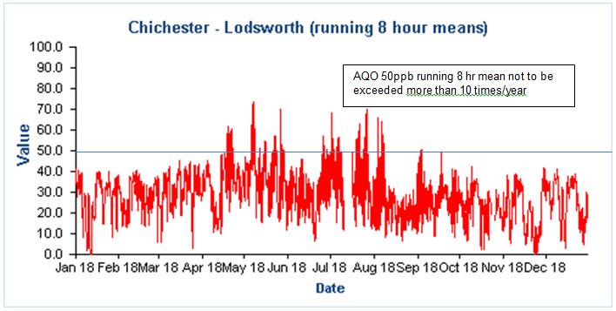

Comparison to the DEFRA banding below shows that in 2018 at Lodsworth there were 34 days when ‘moderate pollution’ occurred, see box for health messages of DEFRA pollution bands.

**Health messages of the DEFRA Pollution Bands**

|  |  |
| --- | --- |
| Pollution band and numerical index | Health messages for at-risk groups* |
| 1 – 3 (low) | Enjoy your usual outdoor activities. |
| 4 – 6 (moderate) | Adults and children with lung problems, and adults with heart problems, who experience symptoms, should consider reducing strenuous physical activity, particularly outdoors. |
| 7 – 9 (high) | Adults and children with lung problems, and adults with heart problems, should reduce strenuous physical exertion, particularly outdoors, and particularly if they experience symptoms. People with asthma may find they need to use their reliever inhaler more often. Older people should also reduce physical exertion. |
| 10 (very high) | Adults and children with lung problems, adults with heart problems, and older people, should avoid strenuous physical activity. People with asthma may find they need to use their reliever inhaler more often. |
| *\*Adults and children with heart or lung problems are at greater risk of symptoms.* | |

NB. Local authorities are no longer obliged to report annually on the following pollutants: 1,3 butadiene, benzene, carbon monoxide and lead, unless local circumstances indicate there is an issue. National monitoring results are available at https://uk-air.defra.gov.uk/data/

# Appendix A: Monitoring Results

Table A.1 – Details of Automatic Monitoring Sites

|  |  |  |  |  |  |  |  |  |  |  |
| --- | --- | --- | --- | --- | --- | --- | --- | --- | --- | --- |
| **Site ID** | **Site Name** | **Site Type** | **X OS Grid Ref** | **Y OS Grid Ref** | **Pollutants Monitored** | **In AQMA?** | **Monitoring Technique** | **Distance to Relevant Exposure (m) (1)** | **Distance to kerb of nearest road (m) (2)** | **Inlet Height (m)** |
| CI1 | Stockbridge | Suburban | 485881 | 103791 | NO2; PM10 | NO | chemilumin-escent/TEOM | 25 | 26 | 3 |
| CI4 | Orchard Street | Roadside | 485982 | 105221 | NO2 | YES | Chemiluminescent | 10 | 3.75 | 2 |
| AR1 | Lodsworth | Rural | 492396 | 123248 | O3 | NO | UV | n/a | n/a | 2.1 |

**Notes:**

(1) 0m if the monitoring site is at a location of exposure (e.g. installed on the façade of a residential property).

(2) N/A if not applicable.

Table A.2 – Details of Non-Automatic Monitoring Sites

|  |  |  |  |  |  |  |  |  |  |  |
| --- | --- | --- | --- | --- | --- | --- | --- | --- | --- | --- |
| **Site ID** | **Site Name** | **Site Type** | **X OS Grid Ref** | **Y OS Grid Ref** | **Pollutants Monitored** | **In AQMA?** | **Distance to Relevant Exposure (m) (1)** | **Distance to kerb of nearest road (m) (2)** | **Tube collocated with a Continuous Analyser?** | **Height (m)** |
| 1 | Kings Ave/Southbank Jct | Roadside | 485776 | 103961 | NO2 | N | 11 | 2.25 | N | 3 |
| 2 | Claremont Court | Roadside | 485772 | 103847 | NO2 | Y | 0 | 7.5 | N | 3 |
| 3 | Cabin | Suburban | 485880 | 103791 | NO2 | N | 25 | 26 | Y | 2.7 |
| 4 | Cabin | Suburban | 485880 | 103791 | NO2 | N | 25 | 26 | Y | 2.7 |
| 5 | Cabin | Suburban | 485880 | 103791 | NO2 | N | 25 | 26 | Y | 2.7 |
| 6 | Stockbridge Road South | Roadside | 485696 | 103731 | NO2 | N | 14 | 2 | N | 2.85 |
| 7 | Cleveland Rd | Urban Background | 486953 | 104414 | NO2 | N | 18 | 1.8 | N | 2.8 |
| 8 | Westhampnett Road | Roadside | 487341 | 105474 | NO2 | N | 3 | 1.65 | N | 2.85 |
| 9 | Hornet | Roadside | 486502 | 104795 | NO2 | N | 0 | 1.8 | N | 3.1 |
| 10 | St Pancras | Roadside | 486533 | 104860 | NO2 | Y | 0 | 2 | N | 3 |
| 11 | Arthur Purchase | Urban Background | 486082 | 105026 | NO2 | N | 0 | 6 | N | 2.7 |
| 12 | 174 Orchard St | Roadside | 485914 | 105185 | NO2 | Y | 0 | 2 | N | 2.65 |
| 14 | Rumbold’s Hill, Midhurst | Roadside | 488561 | 121479 | NO2 | N | 0.5 | 1.5 | N | 3.4 |
| 15 | Sussex Cleaners | Roadside | 486575 | 104799 | NO2 | NO | 0 | 1.82 | NO | 2.95 |
| 16 | Nag's Head | Roadside | 496495 | 104845 | NO2 | YES | 0 | 2.38 | NO | 3.23 |
| 17 | Orchard St cabin | Roadside | 485982 | 105221 | NO2 | YES | 10 | 3.75 | YES | 1.95 |
| 18 | Midhurst Stationery | Roadside | 488545 | 121434 | NO2 | NO | 1.8 | 0.62 | NO | 2.79 |
| 19 | Nat West Bank | Roadside | 488583 | 121512 | NO2 | NO | 8.6 | 1.07 | NO | 2.97 |
| 20 | Nationwide | Roadside | 488605 | 121538 | NO2 | NO | 0.5 | 2.15 | NO | 2.7 |
| 21 | British Heart Foundation | Roadside | 488636 | 121613 | NO2 | NO | 0 | 3.8 | NO | 2.79 |

**Notes:**

(1) 0m if the monitoring site is at a location of exposure (e.g. installed on/adjacent to the façade of a residential property).

(2) N/A if not applicable.

Table A.3 – Annual Mean NO2 Monitoring Results

|  |  |  |  |  |  |  |  |  |  |
| --- | --- | --- | --- | --- | --- | --- | --- | --- | --- |
| **Site ID** | **Site Type** | **Monitoring Type** | **Valid Data Capture for Monitoring Period (%) (1)** | **Valid Data Capture 2018 (%) (2)** | **NO2 Annual Mean Concentration (µg/m3) (3)** | | | | |
| **2014** | **2015** | **2016** | **2017** | **2018** |
| CI1 | Suburban | Automatic |  | 100 | 33 | 34 | 34 | 33 | 29 |
| CI4 | Roadside | Automatic |  | 100 | 34 | x | 29 | 23 | 22 |
| 1 | Roadside | Diffusion Tube |  | 100 | 32 | 30 | 33 | 29 | 27 |
| 2 | Roadside | Diffusion Tube |  | 100 | **42** | **42** | **42** | 39 | 33 |
| 3 | Suburban | Diffusion Tube |  | 100 | 33 | 34 | 34 | 33 | 29 |
| 4 | Suburban | Diffusion Tube |  | 100 | 33 | 34 | 33 | 32 | 30 |
| 5 | Suburban | Diffusion Tube |  | 100 | 33 | 34 | 35 | 34 | 29 |
| 6 | Roadside | Diffusion Tube |  | 100 | **41** | **41** | **43** | 36 | 34 |
| 7 | Urban Background | Diffusion Tube |  | 92 | 16 | 17 | 18 | 16 | 15 |
| 8 | Roadside | Diffusion Tube |  | 100 | 31 | 30 | 31 | 30 | 29 |
| 9 | Roadside | Diffusion Tube |  | 100 | 38 | **40** | **41** | 38 | 36 |
| 10 | Roadside | Diffusion Tube |  | 100 | **52** | **46** | **51** | **44** | **45** |
| 11 | Urban Background | Diffusion Tube |  | 100 | 18 | 18 | 20 | 18 | 17 |
| 12 | Roadside | Diffusion Tube |  | 100 | 39 | 33 | 38 | 33 | 33 |
| 14 | Roadside | Diffusion Tube |  | 92 | x | **48** | **51** | **49** | **42** |
| 15 | Roadside | Diffusion Tube |  | 92 | x | x | x | x | 32 |
| 16 | Roadside | Diffusion Tube |  | 92 | x | x | x | x | 38 |
| 17 | Roadside | Diffusion Tube |  | 92 | x | x | x | x | 22 |
| 18 | Roadside | Diffusion Tube |  | 100 | x | x | x | x | 28 |
| 19 | Roadside | Diffusion Tube |  | 100 | x | x | x | x | 37 |
| 20 | Roadside | Diffusion Tube |  | 92 | x | x | x | x | 38 |
| 21 | Roadside | Diffusion Tube |  | 92 | x | x | x | x | 27 |

**Diffusion tube data has been bias corrected**

**Notes:**

Exceedances of the NO2 annual mean objective of 40µg/m3 are shown in **bold**.

(1) Data capture for the monitoring period, in cases where monitoring was only carried out for part of the year.

(2) Data capture for the full calendar year (e.g. if monitoring was carried out for 6 months, the maximum data capture for the full calendar year is 50%).

(3) Means for diffusion tubes have been corrected for bias. All means have been “annualised” as per Boxes 7.9 and 7.10 in LAQM.TG16 if valid data capture for the full calendar year is less than 75%. See Appendix C for details.

Figure A.1 – Trends in Annual Mean NO2 Concentrations

Bar chart showing trends in annual mean NO2 concentrations  at Stockbridge and Orchard St monitoring stations 


Table A.4 – 1-Hour Mean NO2 Monitoring Results

|  |  |  |  |  |  |  |  |  |  |
| --- | --- | --- | --- | --- | --- | --- | --- | --- | --- |
| **Site ID** | **Site Type** | **Monitoring Type** | **Valid Data Capture for Monitoring Period (%) (1)** | **Valid Data Capture 2018 (%) (2)** | **NO2 1-Hour Means > 200µg/m3 (3)** | | | | |
| **2014** | **2015** | **2016** | **2017** | **2018** |
| CI1 | Suburban | Automatic |  | 100 | 0 | 0 | 0 | 0 | 0 |
| CI4 | Roadside | Automatic |  | 100 | 0 | x | 0 | 0 | 0 |

**Notes:**

Exceedances of the NO2 1-hour mean objective (200µg/m3 not to be exceeded more than 18 times/year) are shown in **bold.**

(1) Data capture for the monitoring period, in cases where monitoring was only carried out for part of the year.

(2) Data capture for the full calendar year (e.g. if monitoring was carried out for 6 months, the maximum data capture for the full calendar year is 50%).

(3) If the period of valid data is less than 85%, the 99.8th percentile of 1-hour means is provided in brackets.

Figure A.2 – Trends in Number of NO2 1-Hour Means > 200µg/m3

There have been no 1 hour mean concentrations that exceed the 200µg/m3 (100 ppb) Objective in 2018 at either monitoring station

**Stockbridge/A27 Chichester bypass hourly means 2018 (units ppb)**

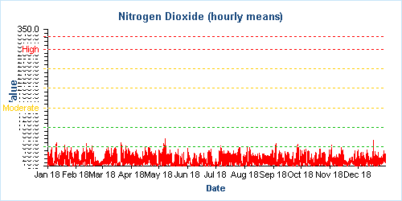

**Orchard Street, Chichester hourly means 2018 (units ppb)**

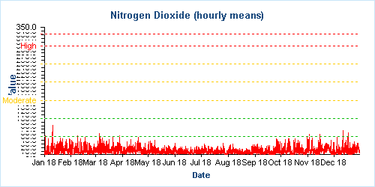

Figure A.3 – Trends in NO2 diffusion tubes 2013 - 2018

Original diffusion tube locations

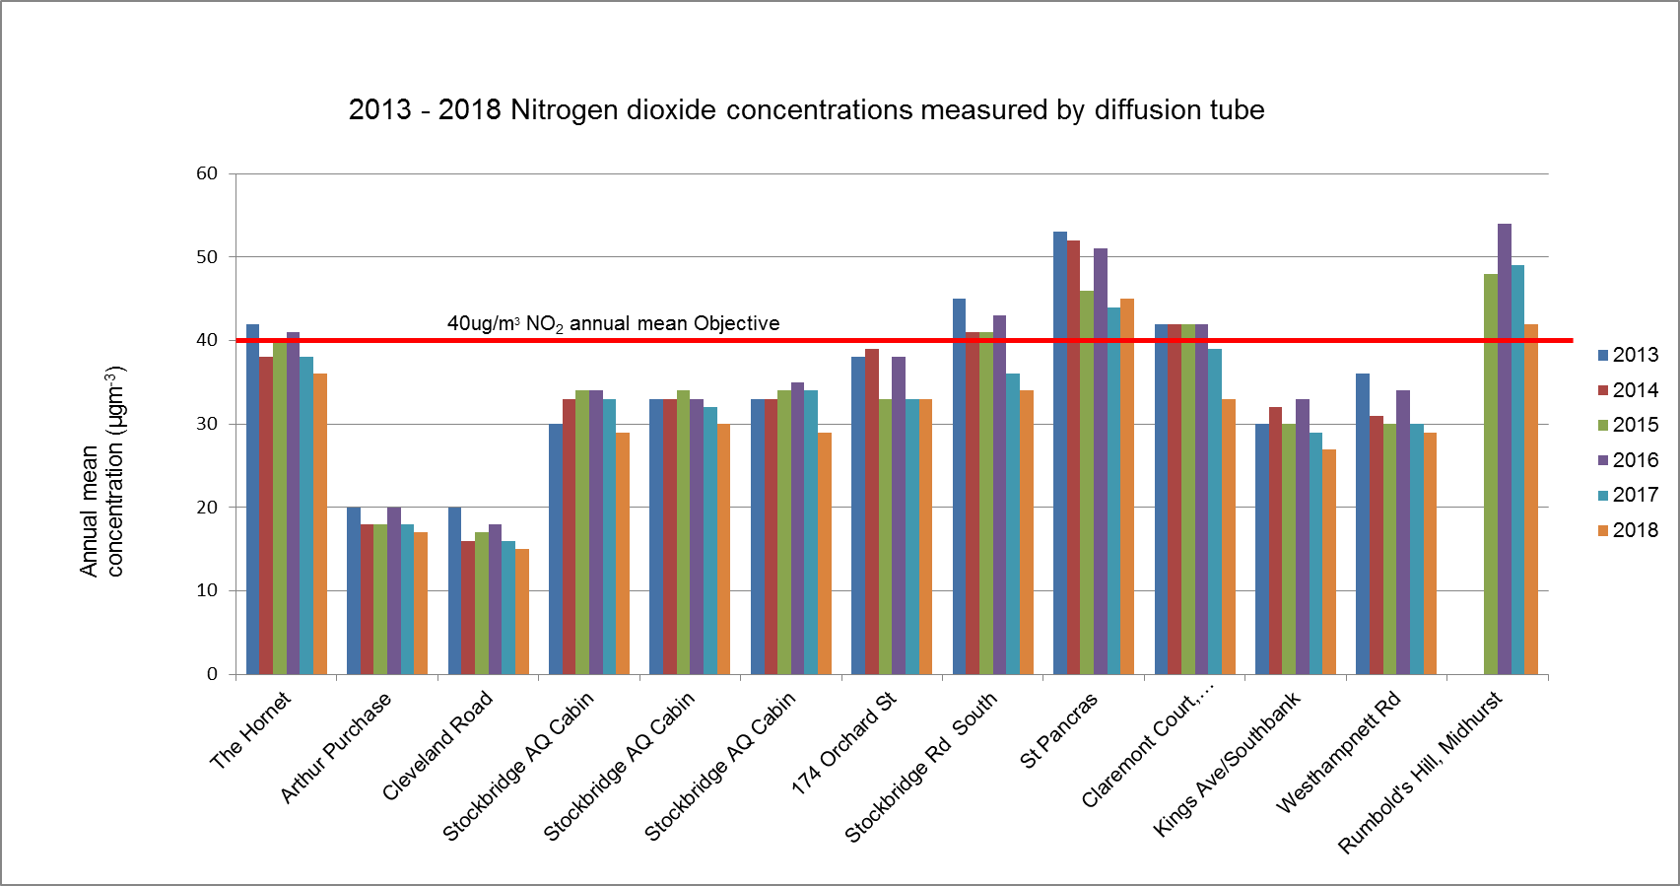

New diffusion tube locations started in 2018

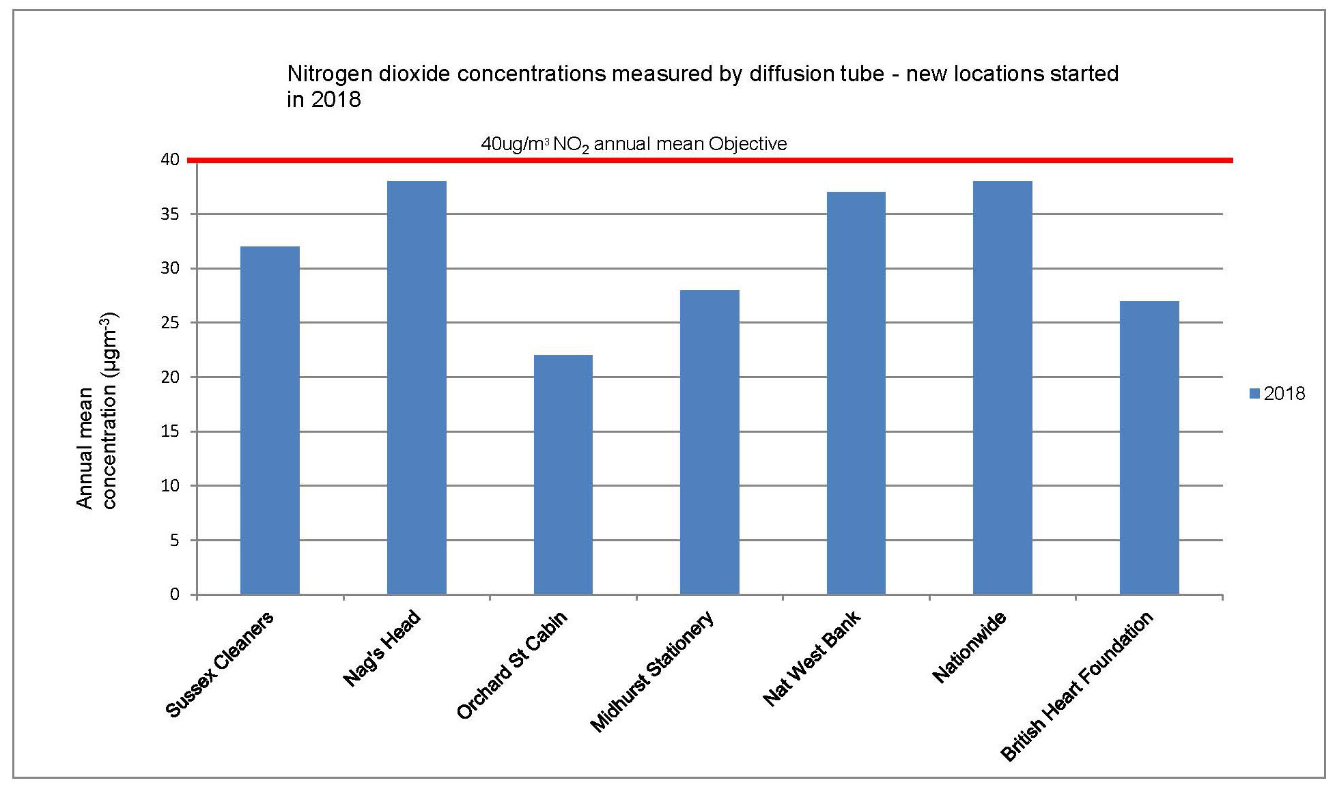

Table A.5 – Annual Mean PM10 Monitoring Results at Stockbridge monitoring station

|  |  |  |  |  |  |  |  |  |
| --- | --- | --- | --- | --- | --- | --- | --- | --- |
| Site ID | **Site Type** | **Valid Data Capture for Monitoring Period (%) (1)** | **Valid Data Capture 2018 (%) (2)** | **PM10 Annual Mean Concentration (µg/m3) (3)** | | | | |
| **2014** | **2015** | **2016** | **2017** | **2018** |
| CI1 | Suburban |  | 100 | 20 | 21 | 20 | 19 | 18 |

**Notes:**

Exceedances of the PM10 annual mean objective of 40µg/m3 are shown in **bold.**

(1) Data capture for the monitoring period, in cases where monitoring was only carried out for part of the year.

(2) Data capture for the full calendar year (e.g. if monitoring was carried out for 6 months, the maximum data capture for the full calendar year is 50%).

(3) All means have been “annualised” as per Boxes 7.9 and 7.10 in LAQM.TG16, valid data capture for the full calendar year is less than 75%. See Appendix C for details.

Figure A.4 – Trends in Annual Mean PM10 Concentrations at Stockbridge monitoring station

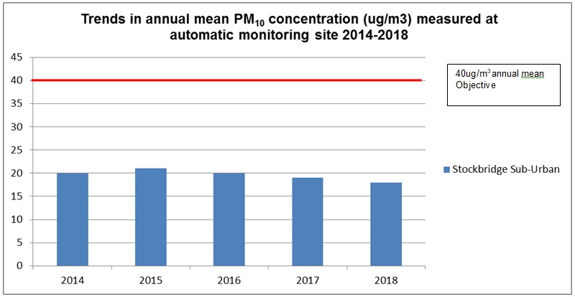

Table A.5 – 24-Hour Mean PM10 Monitoring Results

|  |  |  |  |  |  |  |  |  |
| --- | --- | --- | --- | --- | --- | --- | --- | --- |
| **Site ID** | **Site Type** | **Valid Data Capture for Monitoring Period (%) (1)** | **Valid Data Capture 2018 (%) (2)** | **PM10 24-Hour Means > 50µg/m3 (3)** | | | | |
| **2014** | **2015** | **2016** | **2017** | **2018** |
| CI1 | Suburban |  | 100 | 2 | 3 | 2 | 1 | 0 |

**Notes:**

Exceedances of the PM10 24-hour mean objective (50µg/m3 not to be exceeded more than 35 times/year) are shown in **bold.**

(1) Data capture for the monitoring period, in cases where monitoring was only carried out for part of the year.

(2) Data capture for the full calendar year (e.g. if monitoring was carried out for 6 months, the maximum data capture for the full calendar year is 50%).

(3) If the period of valid data is less than 85%, the 90.4th percentile of 24-hour means is provided in brackets.

Figure A.5 – Trends in Number of 24-Hour Mean PM10 Results >50µg/m3 at Stockbridge monitoring station

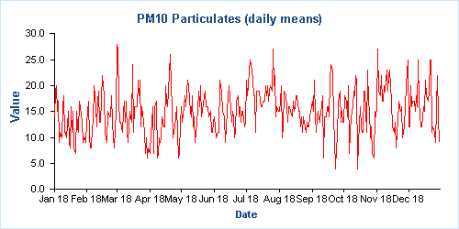

Units are µg/m3 – no exceedances of Objective (50µg/m3) during 2018

# Appendix B: Full Monthly Diffusion Tube Results for 2018

Table B.1 – NO2 Monthly Diffusion Tube Results - 2018

|  |  |  |  |  |  |  |  |  |  |  |  |  |  |  |  |
| --- | --- | --- | --- | --- | --- | --- | --- | --- | --- | --- | --- | --- | --- | --- | --- |
| **Site ID** | **NO2 Mean Concentrations (µg/m3)** | | | | | | | | | | | | | | |
| **Jan** | **Feb** | **Mar** | **Apr** | **May** | **Jun** | **Jul** | **Aug** | **Sep** | **Oct** | **Nov** | **Dec** | **Annual Mean** | | |
| **Raw Data** | **Bias Adjusted (0.85) and Annualised (1)** | **Distance Corrected to Nearest Exposure (2)** |
| 1 | 14.4 | 29.6 | 33.5 | 34.5 | 32.1 | 32.3 | 37.6 | 32.3 | 30.9 | 37.6 | 33.2 | 29.1 | 31.4 | 26.8 | 21.4 |
| 2 | 26.2 | 30.5 | 37.1 | 41.8 | 40.3 | 41.7 | 42.0 | 42.4 | 37.4 | 41.3 | 37.3 | 37.3 | 37.9 | 32.0 | 32.0 |
| 2a |  | 30.72 | 35.06 | 41.86 | 45.58 | 39.84 | 43.48 | 44.44 | 40.57 | 42.74 | 36.61 | 39.25 | 40.0 | 34.0 | 34.0 |
| 3 | 27.77 | 27.25 | 33.55 | 38.73 | 28.3 | 31.84 | 39.38 | 41.29 | 32.92 | 34.23 | 32.5 | 34.81 | 33.5 | 29.0 | n/a |
| 4 | 25.71 | 33.22 | 39.68 | 40.15 | 28.74 | 31.25 | 39.14 | 41.46 | 34.76 | 36.75 | 29.23 | 36.77 | 34.7 | 30.0 | n/a |
| 5 | 20.71 | 31.89 | 37.82 | 35.3 | 29.87 | 34.15 | 37.76 | 39.45 | 34.09 | 36.78 | 33.07 | 35.83 | 33.9 | 29.0 | n/a |
| 6 | 27.94 | 39.83 | 45.85 | 40.31 | 40.31 | 41.32 | 39.78 | 37 | 36.69 | 44.57 | 46.98 | 35.94 | 39.7 | 34.0 | 23.6 |
| 7 | 19.09 | 24.37 | 20.77 | 20.47 | 15.21 | 14.69 | 14.48 | 12.22 | 14.28 | 21.81 | 22.24 | A | 18.1 | 15.0 | n/a |
| 8 | 26.92 | 33.73 | 45.17 | 35.14 | 32 | 33.58 | 37.52 | 20.69 | 35.07 | 37.96 | 38.47 | 37.43 | 34.5 | 29.0 | 27.1 |
| 9 | 30.11 | 45.43 | 45.6 | 43.79 | 37.58 | 39.42 | 44.99 | 36.34 | 36.74 | 46.93 | 40.96 | 40.16 | 40.7 | 35.0 | 35.0 |
| 9a |  | 49.93 | 45.67 | 38.87 | 40.12 | 39.61 | 46.93 | 36.91 | 39.76 | 47.55 | 42.02 | 41 | 42.6 | 36.0 | 36.0 |
| 10 | 34.74 | 45.07 | 54.46 | 60.09 | 43.36 | 57.85 | 68.44 | 52.57 | 48.91 | 54.77 | 53.85 | 49.77 | 52.0 | **44.0** | **44.0** |
| 10a |  | 47.73 | 61.84 | 53.39 | 53.47 | 57.4 | 63.46 | 54.35 | 45.22 | 54.1 | 55.18 | 49.17 | 54.1 | **46.0** | **46.0** |
| 11 | 21.52 | 21.13 | 24.55 | 22.09 | 17.71 | 15.92 | 15.89 | 15.56 | 18.05 | 22.17 | 24.38 | 20.66 | 20.0 | 17.0 | n/a |
| 12 | 30.14 | 37.79 | 43.98 | 39.93 | 34.15 | 35.53 | 44.27 | 30.79 | 32.76 | 41.81 | 42.07 | 39.34 | 37.7 | 32.0 | 32.0 |
| 12a |  | 40.92 | 45.53 | 45.16 | 36.51 | 36.62 | 44.21 | 33.76 | 33.08 | 41.69 | 47.48 | 40.21 | 40.5 | 34.0 | 34.0 |
| 14 | 33.74 | 47.46 | 49.69 | 45.57 | 50.18 | 46.74 | 59.93 | 47.67 | 51.55 | 55.47 | A | 43.04 | 48.3 | **41.0** | **41.0** |
| 14a |  | 44.77 | 50.43 | 48.1 | 47.98 | 48.81 | 67.8 | 47.74 | 46.92 | 53.28 | A | 43.25 | 49.9 | **42.0** | **42.0** |
| 15 |  | 31.76 | 41.32 | 45.2 | 32.76 | 37.29 | 39.86 | 35.42 | 35.41 | 36.01 | 39.41 | 43.16 | 38.0 | 32.0 | 32.0 |
| 16 |  | 46.03 | 39.9 | 43.68 | 48.36 | 45.69 | 52.81 | 40.74 | 44.2 | 50.48 | 40.19 | 40.51 | 44.8 | 38.0 | 38.0 |
| 17 |  | 31.78 | 30.56 | 17.16 | 20.7 | 21.38 | 22.98 | 29.88 | 20.42 | 25.89 | 30.38 | 30.83 | 25.6 | 22.0 | 19.7 |
| 18 | 25.35 | 35.57 | 34.41 | 30.76 | 35.06 | 35.02 | 39.63 | 25.34 | 28.94 | 37.42 | 35.04 | 28.71 | 32.6 | 28.0 | 23.6 |
| 19 | 28.98 | 43.82 | 45.22 | 42.87 | 39.65 | 42.11 | 50.56 | 45.38 | 44.65 | 49.92 | 45.64 | 43.54 | 43.5 | 37.0 | 25.7 |
| 20 |  | 43.34 | 47.41 | 46.09 | 45.65 | 44.51 | 52.77 | 38.42 | 42.06 | 44.73 | 48.69 | 38.24 | 44.7 | 38.0 | 36.6 |
| 21 |  | 31.54 | 36.37 | 35.26 | 32.4 | 32.43 | 38.48 | 26.43 | 27.93 | 30.49 | 37.36 | 24.41 | 32.1 | 27.0 | 27.0 |

**Local bias adjustment factor used**

**Where applicable, data has been distance corrected for relevant exposure**

n/a – where bias adjusted mean does not exceed the annual mean objective of 40 µg/m3 and the site is background or suburban no distance correction has been calculated.

Sites 2a, 9a, 10a, 12a and 14a represent co-located tubes

**Notes:**

Exceedances of the NO2 annual mean objective of 40µg/m3 are shown in **bold**.

(1) See Appendix C for details on bias adjustment and annualisation.

(2) Distance corrected to nearest relevant public exposure.

# Appendix C: Supporting Technical Information / Air Quality Monitoring Data QA/QC

**Significant changes to sources**No significant changes were noted to sources of pollution however additional monitoring is being undertaken within Chichester and Midhurst, see section 2.2 as a result of feedback from DEFRA to the previous ASR.

**Detailed dispersion modelling/monitoring campaigns in the District**

A contract was let in early 2019 to model air quality in discrete locations in Chichester and one location in Midhurst. The results of this work will feed into the review of the Air Quality Action Plan and next year’s ASR.

**Additional Evidence gathered**

None noted.

**QA/QC of Automatic Monitoring**

All sites are visited by an officer for calibration and filter changes on a bi-monthly basis. CDC has a service agreement with a third party who provides site maintenance, auditing, regular inspections and 48-hour callout response if problems are encountered at the sites. Data is downloaded from all sites twice daily by the ERG[5] and is available to download online[6]. CDC has a contract with ERG to calibrate and ratify all real time data collected. ERG applies a VCM correction to the PM10 data and a screen shot of the correction is shown below. The graph shows the CDC TEOM data in blue and the VCM correction as a dotted red line.

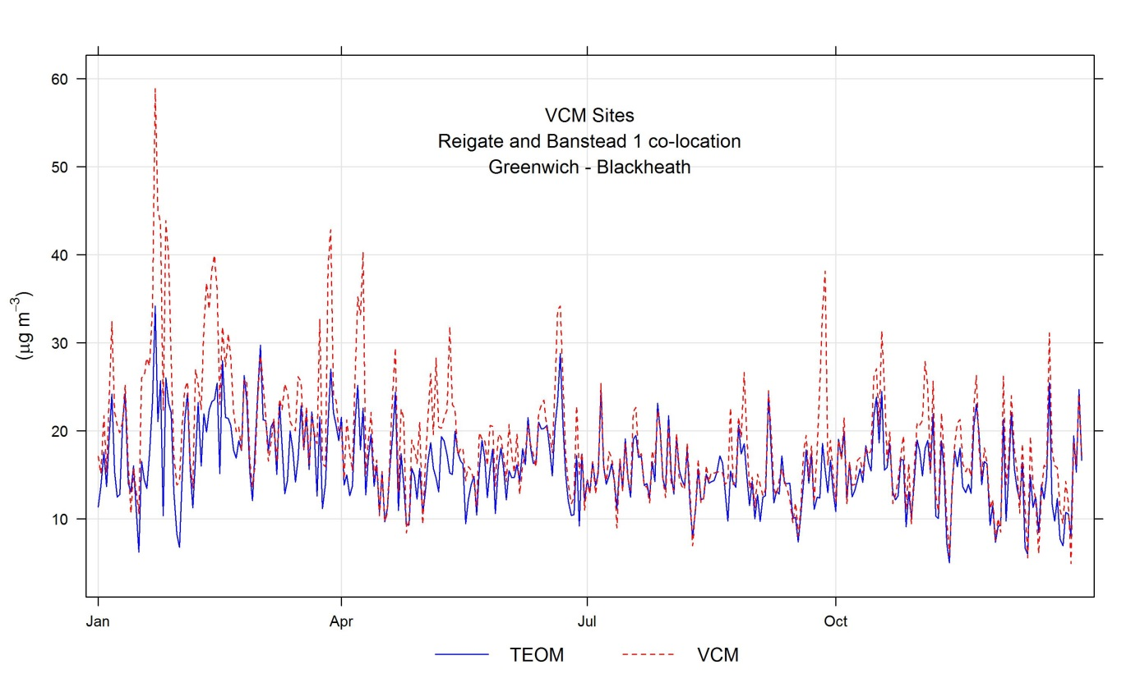

For more information please contact the ERG helpdesk[7].

**QA/QC Diffusion Tube Data**

Chichester District Council uses Gradko Environmental for supplying and analysing the diffusion tubes. The tube preparation method is 50% TEA/Acetone and ANA UKAS Method GLM 7 and GLM 9. CDC uses a local bias adjustment factor.

**Factor from Local Co-location Studies**

Three diffusion tubes are co-located with the Stockbridge monitoring station. These are used to calculate a bias-correction for the NO2 diffusion tubes. The automatic monitoring station’s data is quality assured by ERG. The annual average concentrations from the three co-located tubes are compared to the annual average real time data derived concentration for the same period. A factor can then be derived to correct all other diffusion tube data. The ‘bias correction’ calculation is as per the table below.

|  |  |
| --- | --- |
| Annual mean (automatic monitor) a,b,c | = 29µg/m3 |
| Annual average mean (NO2 diffusion tubes) d | = 34.1µg/m3 |
| Correction factor calculation | = 29/34.1  = 0.85 |

a 1st January 2018 – 31st December 2018

b Real-time data capture for 2018 = 100%

c All data ratified by Environmental Research Group

d Diffusion tube data capture for the period Jan - Dec = 92-100%

**QA/QC of Diffusion Tube Monitoring**

CDC has confirmed by checking the web site provided that Gradko Environmental uses the Workplace Scheme for Proficiency (WASP) indicator rating for quality control. The result for 2018 was Satisfactory (Z score +/- 2) for 100% of results submitted. For more information please contact Gradko Environmental[8].

**Distance calculations for roadside diffusion sites where monitoring is not carried out at a location of relevant exposure**

Using the NO2 fall off with distance calculator on the LAQM website, the following sites have had a distance calculation applied:

**King’s Avenue/Southbank**Kings Avenue/Southbank

**Stockbridge Road South**

Strockbridge Road South

**Westhampnett Road**

Westhampnett Road

**Orchard Street Cabin**

Orchard Street Cabin

**Midhurst Stationery**

Midhurst Stationery

**Nat West Bank**

Natwest Bank

**Nationwide**

Nationwide

# Appendix D: Map(s) of Monitoring Locations and AQMAs

Figure D.1 Stockbridge Roundabout AQMA, monitoring station and diffusion tube locations

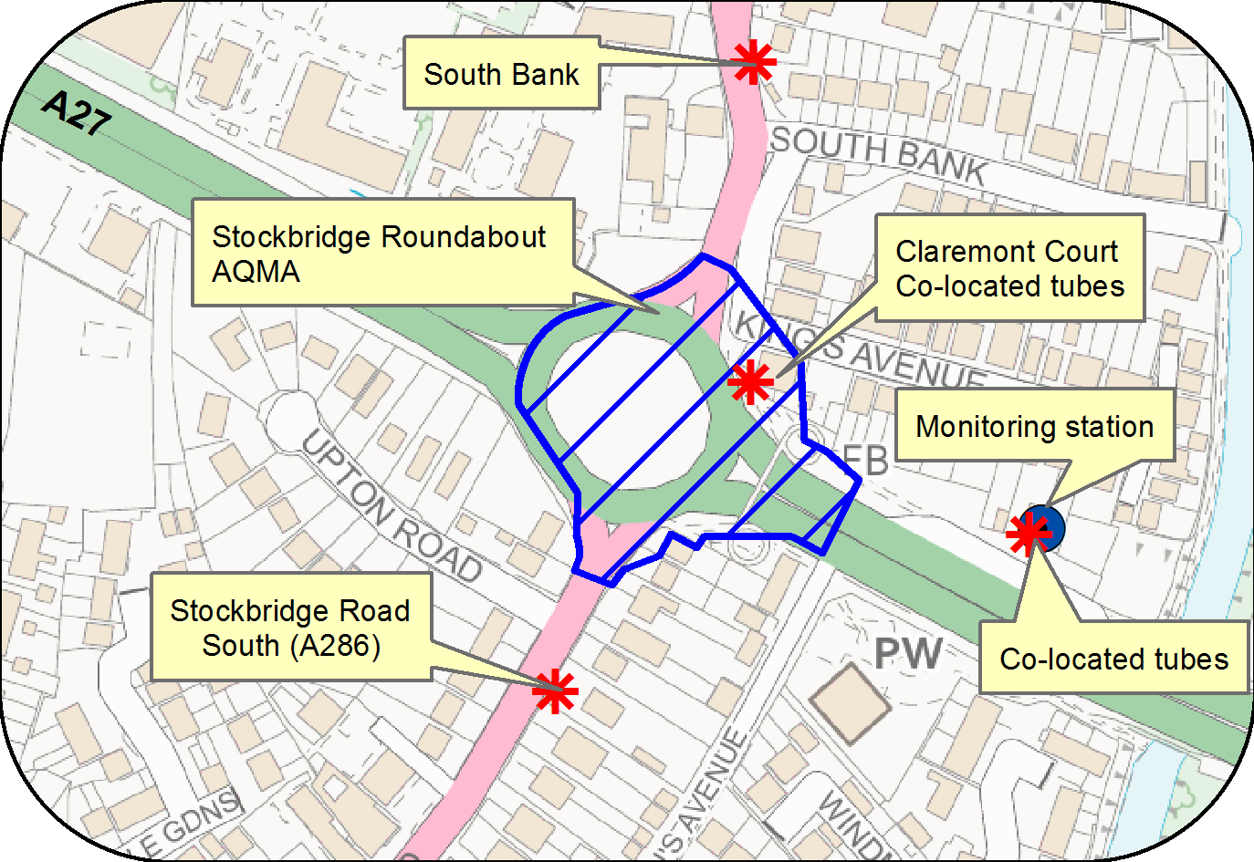

© Crown Copyright and database right 2018. Ordnance Survey 100018803

Figure D.2 Orchard Street AQMA, monitoring station and diffusion tube locations

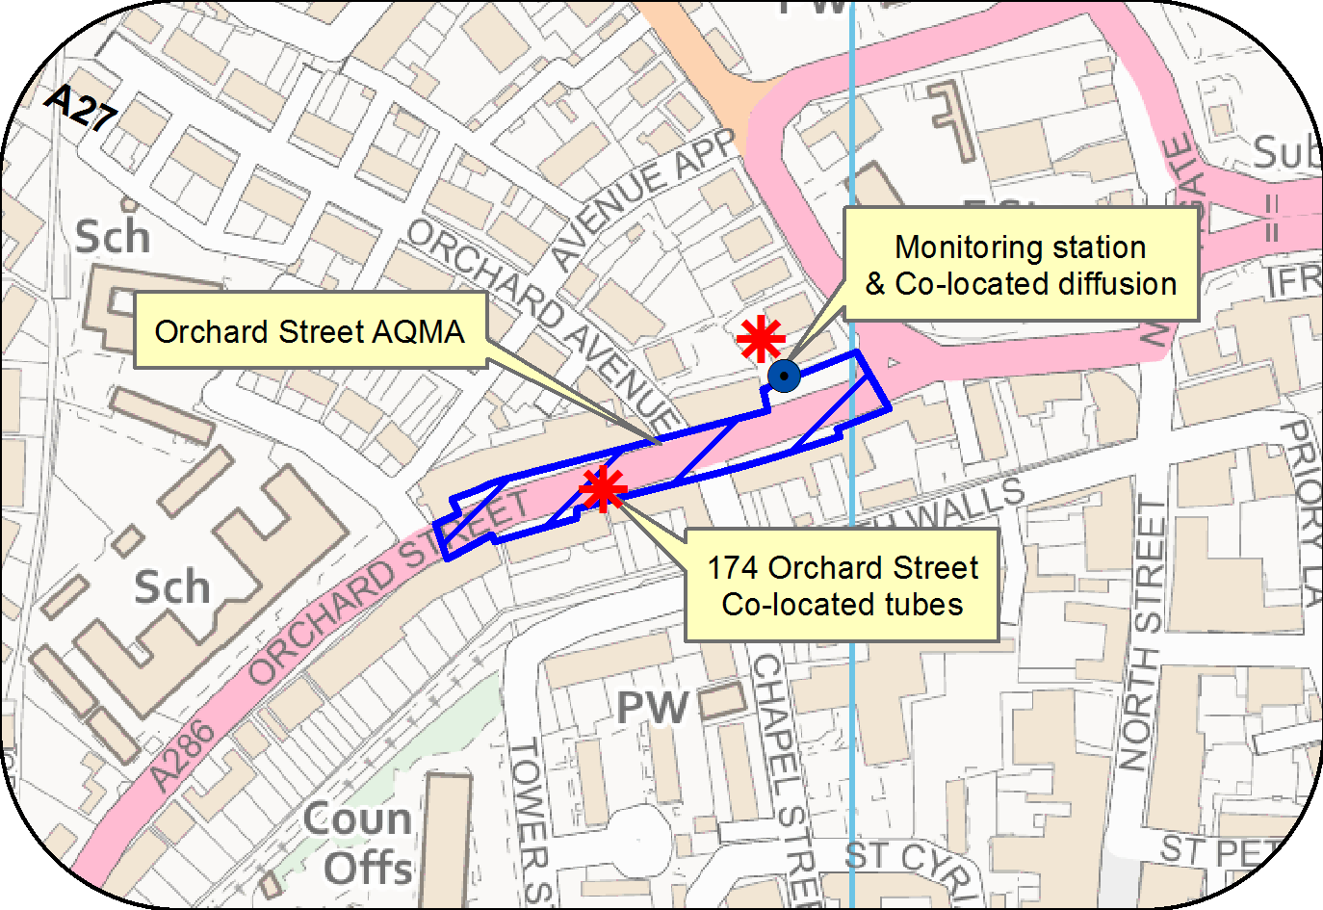

© Crown Copyright and database right 2018. Ordnance Survey 100018803

Figure D.3 St Pancras AQMA and diffusion tube locations

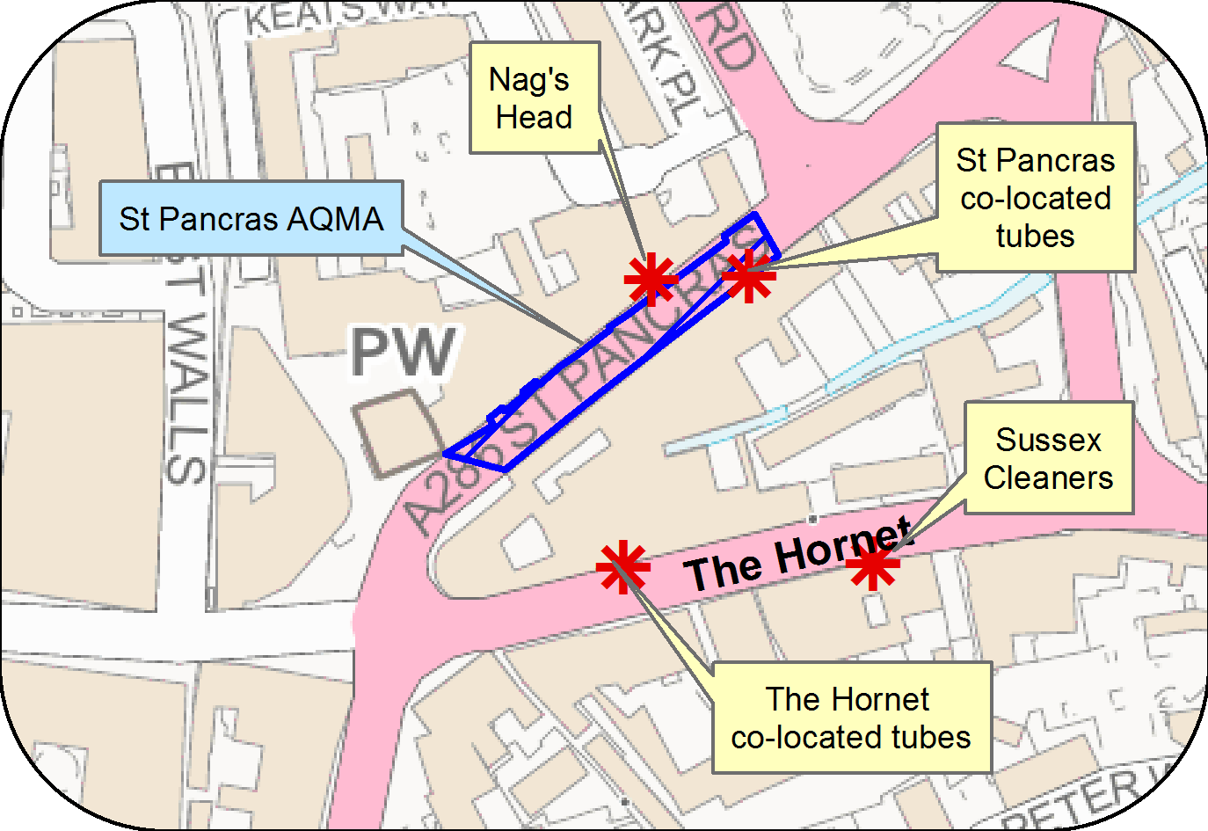

© Crown Copyright and database right 2018. Ordnance Survey 100018803

Figure D.4 Map of diffusion tube sites in Chichester

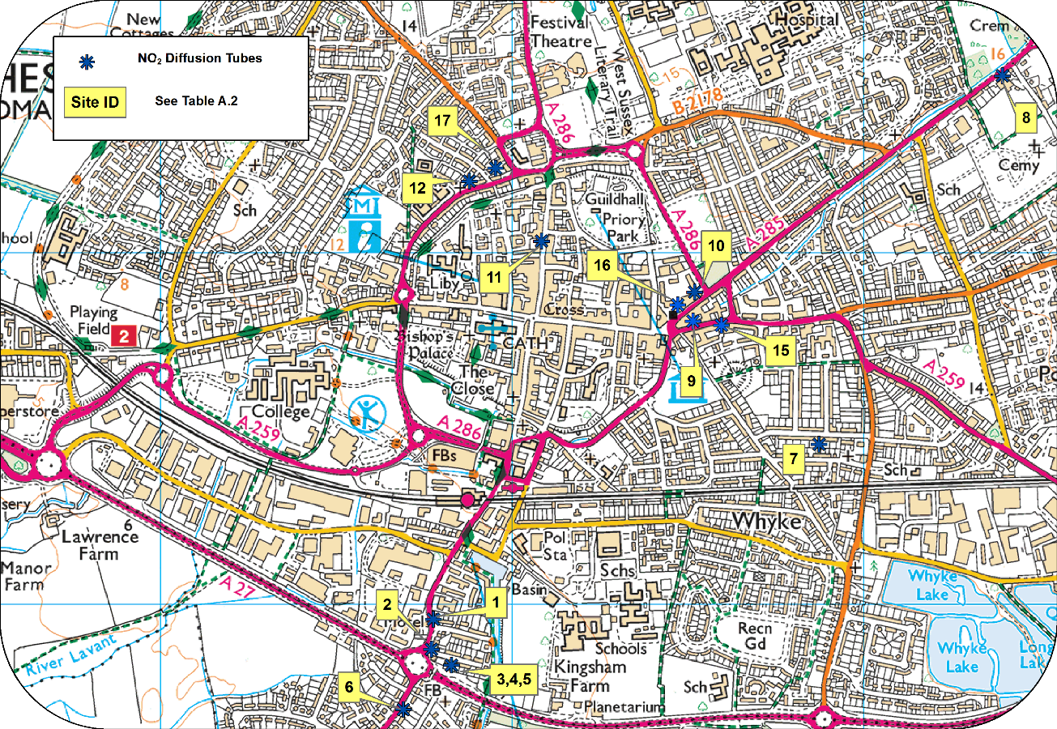

© Crown Copyright and database right 2018. Ordnance Survey 100018803

Figure D.5 Location of ozone monitoring station in Lodsworth

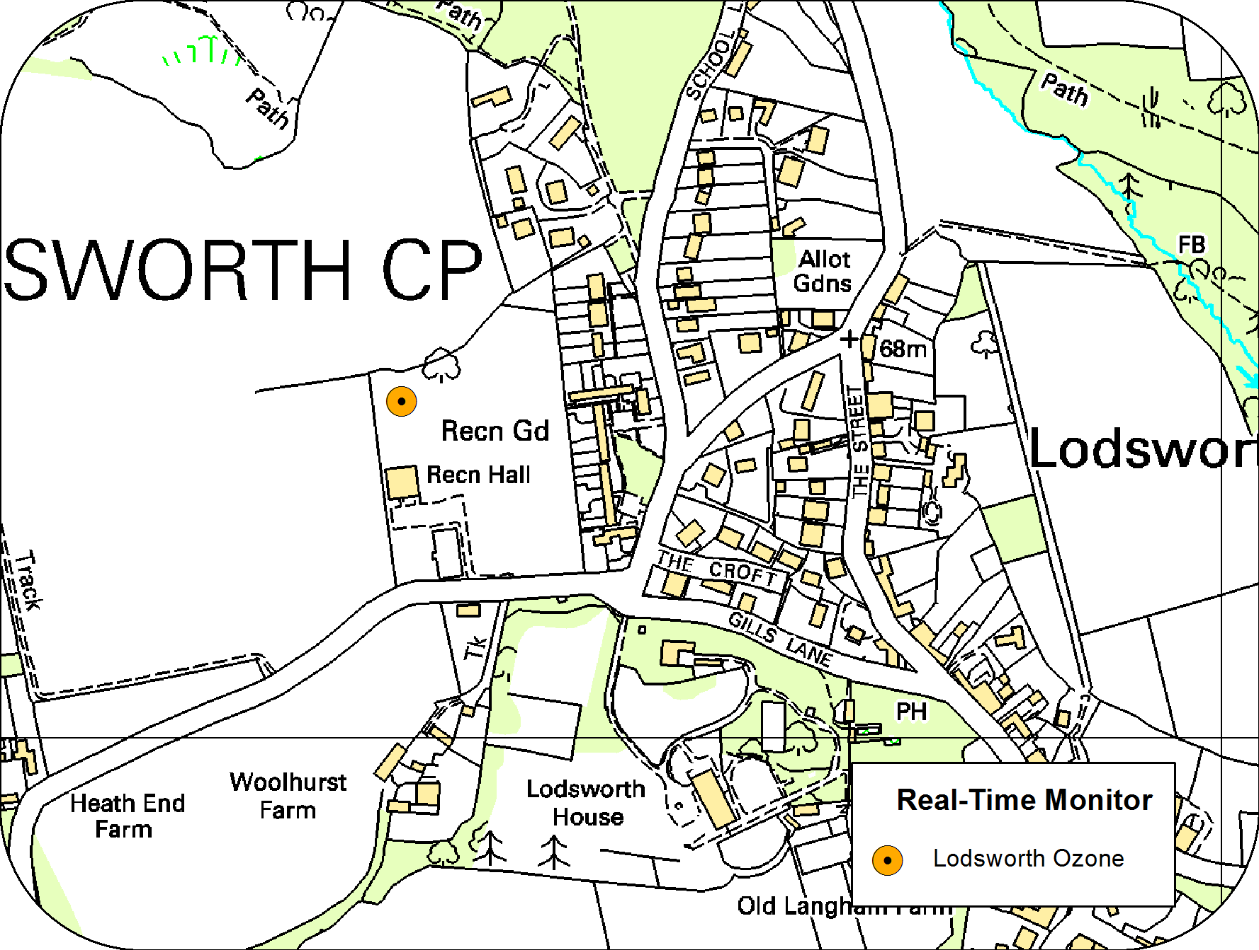

© Crown Copyright and database right 2018. Ordnance Survey 100018803

Figure D.6 Map of diffusion tube sites at Rumbold’s Hill, Midhurst

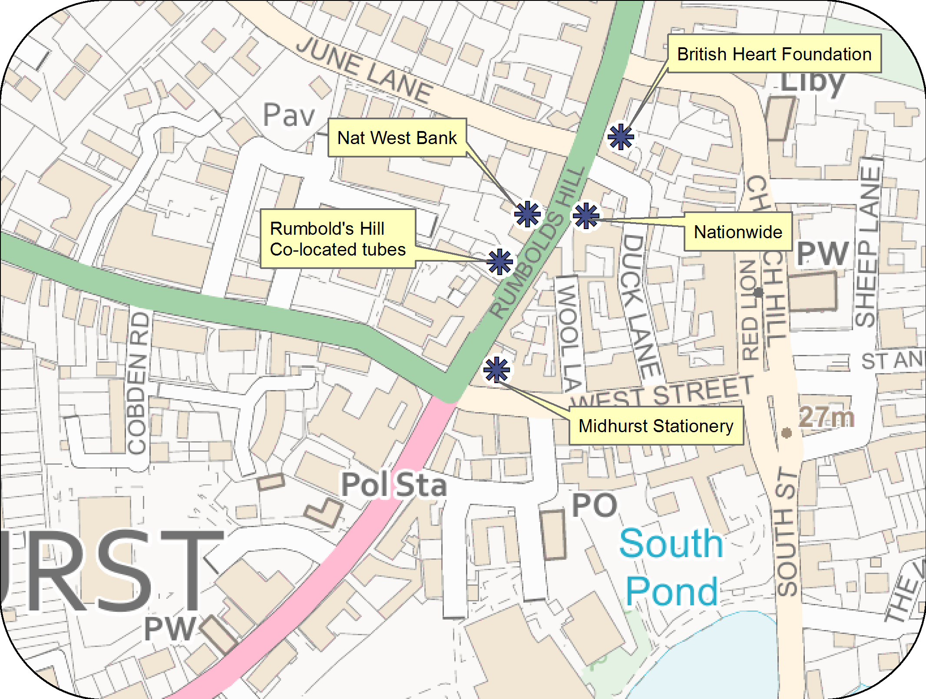

© Crown Copyright and database right 2018. Ordnance Survey 100018803

# Appendix E: Summary of Air Quality Objectives in England

Table E.1 – Air Quality Objectives in England

| **Pollutant** | **Air Quality Objective[9]** | |
| --- | --- | --- |
| **Concentration** | **Measured as** |
| Nitrogen Dioxide (NO2) | 200 µg/m3 not to be exceeded more than 18 times a year | 1-hour mean |
| 40 µg/m3 | Annual mean |
| Particulate Matter (PM10) | 50 µg/m3, not to be exceeded more than 35 times a year | 24-hour mean |
| 40 µg/m3 | Annual mean |
| Sulphur Dioxide (SO2) | 350 µg/m3, not to be exceeded more than 24 times a year | 1-hour mean |
| 125 µg/m3, not to be exceeded more than 3 times a year | 24-hour mean |
| 266 µg/m3, not to be exceeded more than 35 times a year | 15-minute mean |

# Glossary of Terms

|  |  |
| --- | --- |
| **Abbreviation** | **Description** |
| AQAP | Air Quality Action Plan - A detailed description of measures, outcomes, achievement dates and implementation methods, showing how the local authority intends to achieve air quality limit values’ |
| AQMA | Air Quality Management Area – An area where air pollutant concentrations exceed / are likely to exceed the relevant air quality objectives. AQMAs are declared for specific pollutants and objectives |
| ASR | Air quality Annual Status Report |
| CCTV | Closed circuit television |
| CDC | Chichester District Council |
| Defra | Department for Environment, Food and Rural Affairs |
| DfT | Department for Transport |
| DMRB | Design Manual for Roads and Bridges – Air quality screening tool produced by Highways England |
| EU | European Union |
| EV | Electric vehicle |
| FDMS | Filter Dynamics Measurement System |
| HE | Highways England |
| LAQM | Local Air Quality Management |
| LES | Low Emissions Strategy |
| LSTF | Local Sustainable Transport Fund |
| MOVA | Microprocessor Optimised Vehicle Actuation |
| NHS | National Health Service |
| NO2 | Nitrogen Dioxide |
| NOx | Nitrogen Oxides |
| OLEV | Office of Low Emission Vehicles |
| O3 | Ozone |
| PM10 | Airborne particulate matter with an aerodynamic diameter of 10µm (micrometres or microns) or less |
| PM2.5 | Airborne particulate matter with an aerodynamic diameter of 2.5µm or less |
| QA/QC | Quality Assurance and Quality Control |
| RTPI | Real Time Passenger Information |
| SAQP | Sussex Air Quality Partnership |
| SO2 | Sulphur Dioxide |
| UTC | Urban Transport Controls |
| VCM | Volatile correction measurement |
| VMS | Variable message signing |
| WSCC | West Sussex County Council |

# References

Towards Better Air Quality: An Air Quality Action Plan for Chichester District Council 2015-20 produced by Chichester District Council

West Sussex Walking and Cycling Strategy 2016 – 2026 produced by WSCC

1. Environmental equity, air quality, socioeconomic status and respiratory health, 2010
2. Air quality and social deprivation in the UK: an environmental inequalities analysis, 2006
3. Defra.Abatement cost guidance for valuing changes in air quality, May 2013
4. The new monitoring station on Westhampnett Road has not yet been monitoring for long enough for us to include it in this year’s report.
5. The Environmental Research Group (ERG), part of the School of Biomedical and Health Sciences at King’s College London, a leading provider of air quality information and research in the UK.
6. www.sussex-air.net
7. Contact ERG on 020 7848 4022
8. Contact Gradko on 01962 860331
9. The units are in microgrammes of pollutant per cubic metre of air (µg/m3).