

2018 Air Quality Annual Status Report (ASR)

In fulfilment of Part IV of the

Environment Act 1995

Local Air Quality Management

July 2018

|  |  |
| --- | --- |
| Local Authority Officer | Kate Simons  Simon Ballard |
| Department | Environmental Protection |
| Address | East Pallant House  1 East Pallant  Chichester  West Sussex  PO19 1TY |
| Telephone | 01243 521160 |
| E-mail | [ksimons@chichester.gov.uk](mailto:ksimons@chichester.gov.uk)  sballard@chichester.gov.uk |
| Report Reference number | ASR 18 |
| Date | 2 July 2018 |

# Executive Summary: Air Quality in Our Area

## Air Quality in Chichester District

Air pollution is associated with a number of adverse health impacts. It is recognised as a contributing factor in the onset of heart disease and cancer. Additionally, air pollution particularly affects the most vulnerable in society: children and older people, and those with heart and lung conditions. There is also often a strong correlation with equalities issues, because areas with poor air quality are also often the less affluent areas[1],[2].

The annual health cost to society of the impacts of particulate matter alone in the UK is estimated to be around £16 billion[3].

In general, air quality within Chichester district is generally good however there are areas where elevated concentrations of pollutants occur. The main source of air pollution is from road transport particularly on roads in and adjacent to Chichester and also on one road in the centre of Midhurst. The principal pollutant of concern is nitrogen dioxide (NO2). Concentrations of NO2 show a slight decrease over the last 5 years but there are still hotspots in Chichester and Midhurst where exceedances of the national air quality Objective for NO2 occur. The hotspots in Chichester principally occur within or close to the Air Quality Management Areas (AQMAs) and in Midhurst there is a new area of exceedance within the town centre. AQMAs have been declared at three locations as follows:

• Stockbridge roundabout at the junction with the A27 and A286

• Orchard Street, Chichester

• St Pancras, Chichester

Our current Air Quality Action Plan (AQAP) was adopted in 2015 and is available here: <http://www.chichester.gov.uk/pollutioncontrolairquality>

Air quality is seen by the Council as an important public health issue but it is not something we can improve on our own. We are working actively with other services within the Council, partners at West Sussex County Council (WSCC) including the Public Health team and the Sussex Air Quality Partnership (SAQP) to tackle this issue.

Since our first AQAP dated 2008, we have won in excess of £290k of grant monies from a variety of sources. Key projects that have been delivered include Chichester’s first car club, installation of two electric vehicle charging points, 140 additional bike parking spaces in the city centre, delivered training to over 150 cyclists to ride more confidently/maintain their bikes and provided data to the air-Alert forecasting service (coordinated by SAQP).

In September 2017 we were awarded Department for Transport (Dft) funded support to assist in the production of a Local Cycling and Walking Infrastructure Plan (LCWIP). We are working with neighbouring authorities and WSCC to deliver this project and the detailed work is programmed to commence in September 2018. We will be undertaking the initial work during the summer of 2018 to enable us to be at stage 3 of the project by September. Once produced, the LCWIP will inform our Infrastructure Development Plan which enables infrastructure provision across the district. CDC is also reviewing its Local Plan and we are working with our policy planning team to ensure that air quality policies in the Plan are robust and suitably ambitious.

## Actions to Improve Air Quality

We have worked with partners on a number of projects over the last year including:

* Delivery of an upgrade to a section of path to dual use within one of the City’s parks (Jubilee Gardens) completed in April 2018
* Replacement of two electric vehicle charging points outside the Council offices, completed January 2018.
* We delivered a programme of cycling initiatives such as guided rides, cycle confidence training and bike maintenance courses to encourage people. During 2017 over 70 people accessed at least one of these initiatives.
* We are working with the Council’s Parking Services to deliver additional electric vehicle (EV) charging points across the district.
* We have worked with a number of Council services to produce a business case for replacement of fleet vehicles with electric vehicles. This strategy has been adopted by the Council and it is anticipated that our Parking Service will replace up to two of their vehicles with electric vehicles during 2018.

## Conclusions and Priorities

This year’s NO2 monitoring shows no exceedances of Air Quality Standards at either of the monitoring stations. There are two diffusion tube locations where the air quality objective of 40 µg/m3 was exceeded, namely:

* St Pancras, within the St Pancras AQMA, Chichester
* Rumbold’s Hill, Midhurst - not within an AQMA. This tube has been in place for 30 months. Additional monitoring has been implemented near this location in order to determine the extent of the exceedance of the Objective.

The above two diffusion tube locations showed similar trends last year. In response to feedback from DEFRA regarding last year’s ASR, additional monitoring commenced in December 2017 (at one location in Midhurst near the existing site) and further diffusion tubes were installed in Chichester and Midhurst in January 2018. This additional monitoring will be reported in the ASR for 2019 when a full years’ data is available. It is intended to commission detailed modelling of both Chichester and Midhurst in 2019 in order to determine the need to either alter the existing AQMAs and/or declare an AQMA at Midhurst and The Hornet, Chichester.

At the other 9 diffusion tube locations not within AQMAs there were no exceedences of the air quality objective of 40 µg/m3 (although the result at The Hornet is close to the Objective at 38.3 µg/m3.

We are currently working on a number of actions to improve air quality across the district, see Table 2.2 and our priorities for the coming year to address air quality include:

* Delivery of a new air quality monitoring station in Chichester during 2018 to provide additional data. The location of the station has been chosen in order to monitor the impact of increasing traffic on the eastern side of the City.
* Finalising a policy for inclusion within the revised Local Plan to enable air quality to be weighed appropriately within the land use planning process.
* To understand and respond to potentially significant changes to the local road network, including; possible future improvements to the A27 and the Southern Gateway redevelopment and also trips related to any published new Local Plan housing numbers.
* Production of a Local Cycling and Walking Infrastructure Plan for Chichester city. Detailed work on this project will commence in September 2018 and the project is expected to be completed by December 2019.

## Local Engagement and How to get Involved

The Council was represented on a community group working up an option to present to Highways England to improve the A27 Chichester bypass. Consultants were employed to facilitate this process and the findings were presented to Highways England in June 2018. A final decision has not been made on a preferred route and Government funding has not yet been committed.

The public can get involved by supporting behavioural change initiatives (eg joining the Car Club, car sharing and walking, cycling or using public transport wherever possible. Further information can be obtained by emailing: [airquality@chichester.gov.uk](mailto:airquality@chichester.gov.uk)

The Chichester and District Cycle Forum provides information on local cycling opportunities and campaigns on behalf of cyclists. The Forum is open to the public and further information can be obtained by emailing [cycle@chichester.gov.uk](mailto:cycle@chichester.gov.uk)

**Table of Contents**

Executive Summary: Air Quality in Our Area i

Air Quality in Chichester District i

Actions to Improve Air Quality ii

Conclusions and Priorities ii

Local Engagement and How to get Involved iii

1 Local Air Quality Management 1

2 Actions to Improve Air Quality 2

2.1 Air Quality Management Areas 2

2.2 Progress and Impact of Measures to address Air Quality in Chichester District 5

2.3 PM2.5 – Local Authority Approach to Reducing Emissions and/or Concentrations 12

3 Air Quality Monitoring Data and Comparison with Air Quality Objectives and National Compliance 13

3.1 Summary of Monitoring Undertaken 13

3.1.1 Automatic Monitoring Sites 13

3.1.2 Non-Automatic Monitoring Sites 13

3.2 Individual Pollutants 13

3.2.1 Nitrogen Dioxide (NO2) 13

3.2.2 Particulate Matter (PM10) 15

3.2.3 Ozone (O3) 15

Comparison to the DEFRA banding below shows that in 2017 at Lodsworth there were 14 days when ‘moderate pollution’ occurred and one ‘high pollution’ day, see box for health messages of DEFRA pollution bands. 16

**Health messages of the DEFRA Pollution Bands** 16

Appendix A: Monitoring Results 17

Appendix B: Full Monthly Diffusion Tube Results for 2017 29

Appendix C: Supporting Technical Information / Air Quality Monitoring Data QA/QC 31

Appendix D: Map(s) of Monitoring Locations and AQMAs 35

Appendix E: Summary of Air Quality Objectives in England 38

Glossary of Terms 39

References 41

**List of Tables**

Table 2.1 – Declared Air Quality Management Areas 3

Table 2.2 – Progress on Measures to Improve Air Quality 8

**List of Figures**

| **Figure A.1 – Annual Mean NO2 Concentrations at monitoring stations** | 21 |
| --- | --- |
| **Figure A.2 – Trends in Number of NO2 1-Hour Means > 200µg/m3 (100 ppb)** | 23 |
| **Figure A.3 – Trends in NO2 diffusion tubes 2012 – 2017** | 24 |
| **Figure A.4 – Annual Mean PM10 Concentrations at Stockbridge monitoring site** | 26 |
| **Figure A.5 Number of 24-Hour Mean PM10 Results >50µg/m3 at Stockbridge monitoring site** | 28 |

# Local Air Quality Management

This report provides an overview of air quality in Chichester District during 2017. It fulfils the requirements of Local Air Quality Management (LAQM) as set out in Part IV of the Environment Act (1995) and the relevant Policy and Technical Guidance documents.

The LAQM process places an obligation on all local authorities to regularly review and assess air quality in their areas, and to determine whether or not the air quality objectives are likely to be achieved. Where an exceedance is considered likely the local authority must declare an Air Quality Management Area (AQMA) and prepare an Air Quality Action Plan (AQAP) setting out the measures it intends to put in place in pursuit of the objectives. This Annual Status Report (ASR) is an annual requirement showing the strategies employed by Chichester District Council to improve air quality and any progress that has been made.

The statutory air quality objectives applicable to LAQM in England can be found in Table E.1 inAppendix E.

# Actions to Improve Air Quality

## Air Quality Management Areas

Air Quality Management Areas (AQMAs) are declared when there is an exceedance or likely exceedance of an air quality objective. After declaration, the authority must prepare an Air Quality Action Plan (AQAP) within 12-18 months setting out measures it intends to put in place in pursuit of compliance with the objectives.

A summary of AQMAs declared by Chichester District Council can be found in Table 2.1. Further information related to declared or revoked AQMAs, including maps of AQMA boundaries are available online at

<http://www.chichester.gov.uk/pollutioncontrolairquality>

Alternatively, see Appendix D: Map(s) of Monitoring Locations and AQMAs, which provides maps of air quality monitoring locations in relation to the AQMAs.

Table 2.1 – Declared Air Quality Management Areas

|  |  |  |  |  |  |  |  |  |  |  |  |  |
| --- | --- | --- | --- | --- | --- | --- | --- | --- | --- | --- | --- | --- |
| **AQMA Name** | **Date of Declaration** | **Pollutants and Air Quality Objectives** | **City / Town** | **One Line Description** | **Is air quality in the AQMA influenced by roads controlled by Highways England?** | **Level of Exceedance (maximum monitored/modelled concentration at a location of relevant exposure)** | | | | **Action Plan** | | |
| **At Declaration** | | **Now** | | **Name** | **Date of Publication** | **Link** | |
| AQMA Stockbridge Roundabout | 24-Aug-06 | NO2 Annual Mean | Chichester | An area encompassing the Stockbridge Roundabout at the junction of the Chichester bypass (A27) and Stockbridge Road (A286) | YES | 44.9 | µg/m3 | 39 | µg/m3 | CDC AQAP | 2015 | <http://www.chichester.gov.uk/>  pollutioncontrolairquality | |
| AQMA Orchard Street | 17-May-07 | NO2 Annual Mean | Chichester | An area along Orchard Street, Chichester at the eastern end of the street where it meets Northgate | NO | 40.7 | µg/m3 | 33 | µg/m3 | CDC AQAP | 2015 | as above | |
| AQMA St Pancras | 17-May-07 | NO2 Annual Mean | Chichester | An area along St Pancras, Chichester between Eastgate Square and New Park Road. Note St Pancras forms a street canyon in this section | NO | 48.3 | µg/m3 | 44 | µg/m3 | CDC AQAP | 2015 | as above | |

**CDC confirms the information on UK-Air regarding their AQMA(s) is up to date**

## Progress and Impact of Measures to address Air Quality in Chichester District

DEFRA has recommended that CDC provides double tubes at more than one location for each AQMA. Additional diffusion tubes have been deployed within the existing AQMAs. As this monitoring commenced in December 2017 and January 2018 the results will be reported in the 2019 ASR. Additional monitoring also commenced in the vicinity of Rumbold’s Hill in Midhurst to validate the exceedance in this location. See Appendix D for maps of the 2017 monitoring locations. Defra also recommended that the maps would be more useful if they were at a higher resolution to show road names – the maps have been updated accordingly.

The appraisal raised a query regarding the bias adjustment factor used in the report. The factor reported in Table B.1 was incorrect and should have been 1.115 as was detailed in Appendix C. The appraisal suggested that screen shots of the VCM corrections applied to the PM10 data captured by the TEOM monitoring should be provided – these are included within Appendix C.

We are working with partners in WSCC highways and CDC planning policy teams to focus on actions that are going to be the most effective and will be reconsidering the prioritisation of measures in the Air Quality Action Plan (AQAP). We aim to update the action plan during 2019 following the increased monitoring and subsequent re-modelling for Chichester City and Midhurst (which we have scheduled for early 2019).

Chichester District Council has taken forward a number of direct measures during the current reporting year of 2017 in pursuit of improving local air quality. Details of all measures completed, in progress or planned are set out in Table 2.2.

More detail on these measures can be found in our Action Plan. Key completed measures are:

* Alternatives to private car use: the Car Club originally set up using Defra funding has continued to grow and two additional cars were added in December 2017 at a new housing development in the north of Chichester (bringing the total to six cars). A location has been agreed for another vehicle in the eastern part of the City and it is hoped that it will be in place within 12 months.
* Promoting travel alternatives: during 2017 we continued to promote cycling through activities including guided cycle rides, bike maintenance courses, cycle confidence training and engaged with over 70 people during the year.
* Promoting low emission transport: we upgraded two EV charging points outside the Council offices with a double headed charging point and have a funded Cabinet resolution to install up to ten EV charging points across the District. We are working with our Car Parks Service to establish where EV charging points can be installed and hope to deliver these during 2018.
* A short section of path through Jubilee Park in Chichester has been upgraded and augmented in order to remove a collision risk and regularise dual use in this location. These works were completed in April 2018.

Chichester District Council expects the following measures to be completed over the course of the next reporting year:

* Promoting low emission transport: Chichester District Council intends to replace some of its fleet vehicles with electric vehicles over the next 12 months (where the business case for this kind of vehicle is attractive).
* Work in partnership with West Sussex Public Health and West Sussex County Council to raise awareness of the facts around poor air quality and how to reduce the sources of air pollution. This work is likely to focus on the co-benefits of active travel to health and wellbeing and how to reduce exposure to air pollution during episodes of poor air quality (through promotion of the airAlert service).

Chichester District Council’s priorities for the coming year are:

* To finalise air quality policy for incorporation in the revised Local Plan in order to enable the air quality impact of new development to be properly considered and to provide a policy ‘hook’ from which we can associate a Supplementary Policy Document once the revised Local Plan is adopted.
* To commence work on a Local Cycling and Walking Infrastructure Plan (LCWIP) for Chichester to enable the cycling and walking network to be developed and priorities for infrastructure to be established.
* To deliver a new air quality monitoring station in Chichester during 2018 on Westhampnett Road, Chichester. The location of the station has been chosen in order to monitor the impact of increasing traffic on the eastern side of the City.

The principal challenges and barriers to implementation of measures within the AQAP that Chichester District Council anticipates facing are:

* Continuing delays to the decision on improvements to the A27 by Highways England mean that there is increasing congestion on the A27 trunk road, leading to traffic diverting through Chichester with resulting impacts on local air quality in the City.
* Availability of funding for infrastructure projects.

Progress on the following measures has been slower than expected:

* Installing EV charging points within CDC car parks was delayed while a business case was established for the EVCPs to be “cost neutral” to the Council.

Whilst the measures stated above and in Table 2.2 will help to contribute towards compliance, Chichester District Council anticipates that further additional measures not yet prescribed will be required in subsequent years to achieve compliance and enable the revocation of all three AQMAs within the District.

Table 2.2 – Progress on Measures to Improve Air Quality

|  |  |  |  |  |  |  |  |  |  |  |  |
| --- | --- | --- | --- | --- | --- | --- | --- | --- | --- | --- | --- |
| **Measure No.** | **Measure** | **EU Category** | **EU Classification** | **Organisations involved and Funding Source** | **Planning Phase** | **Implementation Phase** | **Key Performance Indicator** | **Reduction in Pollutant / Emission from Measure** | **Progress to Date** | **Estimated / Actual Completion Date** | **Comments / Barriers to implementation** |
| 1 | Set up Air Quality Working Group | Promoting Travel Alternatives | Other | CDC | June/Dec 2008 | Dec-08 | 2 meetings per year | N/A | 11 meetings held to date | Ongoing | meetings held in Sept 2017 and January 2018 |
| 2 | Cleaner vehicles | Promoting Low Emission Transport | Procuring alternative Refuelling infrastructure to promote Low Emission Vehicles, EV recharging, Gas fuel recharging | WSCC/CDC | 2010 | 2011 | No. of electric vehicle recharging points |  | 2 recharging points in Chichester, secured funding to install additional charging points during 2018-19. Part of regional network of rapid charging points through Sussex-air project | 2018-19 | WSCC has purchased one EV and one hybrid. CDC aiming to replace some diesel vehicles during 2018 |
| 3 | Planning policy | Policy Guidance and Development Control | Low Emissions Strategy | CDC | 2010/11 | ongoing | No. of planning conditions imposed on planning consultations |  | Sussex-air produced Planning Guidance and Low Emissions Strategy and in discussion with CDC Policy Planners regarding adopting LES approach. Sussex-air is reviewing its guidance and refreshed document due in 2018 | 2018-19 | Local Plan has to be reviewed within 5 years - aim to have new policy in place within updated Plan. Draft policy in place to be finalised by end 2018. |
| 4 | Cycling and walking initiatives | Promoting Travel Alternatives | Promotion of cycling | CDC/WSCC | 2009 | 2010 | % increase in cycling |  | Guided cycle rides, cycle training and bike maintenance courses held each summer since 2010, 8.6% inc in cycling from 2016- 2017. Funding secured to deliver LCWIP for Chichester City | LCWIP to be completed Dec 2019 | Once LCWIP in place, bids for funding can be made for cycle infrastructure improvements |
| 5 | Car Clubs | Alternatives to private vehicle use | Car Clubs | CDC | 2010 | 2011 | Utilisation rate of cars to be 20% |  | 6 cars now available to book, development worker employed 2014-16 to promote Club, utilisation rate of >20% (average) during 2017-18 | 2018-19 | Two cars added in Dec 2017 at site within housing development. Additional site identified for new car to be added during 2018-19. |
| 6 | School travel plans | Promoting Travel Alternatives | School Travel Plans | WSCC/CDC | 2008/9 | 2009/10 | % children travelling to school by sustainable means |  | During 2017/18 Living Streets project engaged with 5 primary schools in the District to support Walk to School scheme (WOW) and engaged students and staff at Chichester University | Mar-20 | Funding provided to two schools to enable them to hold Bike It breakfasts |
| 7 | WSCC and CDC travel plans | Promoting Travel Alternatives | Workplace Travel Planning | WSCC/CDC | 2010 | 2011/12 | % WSCC and CDC staff travelling by sustainable means |  | Grey fleet business mileage was 5.17 million miles below 6.0 million miles target. Easit scheme at WSCC and CDC to encourage rail use. Cycle to work scheme at CDC | Ongoing | Ongoing industrial action by Southern Rail during 2017 reduced reliability of rail travel and hence take up of scheme lower than expected |
| 8 | Business travel plans | Promoting Travel Alternatives | School Travel Plans | WSCC | 2009 | Ongoing | Travel Plan implemented within target time period |  | Over 29 Travel Plans submitted since 2009 and Travel Plan group set up attended by large organisations to work on joint measures. | Ongoing | 3 submitted during 2017 |
| 9 | Residential travel plans | Promoting Travel Alternatives | Personalised Travel Planning | WSCC | 2009 | Ongoing | Travel Plan implemented within target time period |  | Over 25 Travel Plans have been submitted since 2009 | Ongoing | 1 submitted during 2017 |
| 10 | TravelWise/smarter choices | Public Information | Via leaflets | WSCC/CDC | 2009 | Ongoing | No. of users of WSCC car share database for PO19 area |  | Steady increase in number of users of database for 2017 | Ongoing | 72 new users in 2017 |
| 11 | Cycle route information | Promoting Travel Alternatives | Promotion of cycling | CDC | 2009 | Ongoing | No. of maps sold through Tourist Information or other outlets. |  | 5 route leaflets have been produced so far and over 1300 copies have been sold to date. 48 leaflets sold in 2017 | Ongoing | 48 maps sold in 2017 |
| 12 | Cycle journey planning | Public Information | Via the Internet | WSCC | 2010 | 2011 | No. of journeys planned on website |  | Web link available on WSCC and CDC websites | Ongoing | 3466 journeys planned 2017-18 |
| 13 | Public transport infrastructure | Transport Planning and Infrastructure | Public transport improvements-interchanges stations and services | WSCC | 2010 | 2011-15 | Increase in use of public transport |  | RTPI displays installed at key locations across City | Ongoing | 6 RTPI displays installed in 2017-18 and more planned for 2018-19 |
| 14 | Cleaner buses | Promoting Low Emission Transport | Public Vehicle Procurement -Prioritising uptake of low emission vehicles | WSCC | 2009 | Ongoing | % of Euro 5 buses |  | Stagecoach has 60% of fleet Euro 5 and replaced older Euro 2 buses with Euro 4 and 5 buses during 2017 | Ongoing | Need to promote cleaner buses to other bus companies |
| 15 | Licensing requirement for taxis | Promoting Low Emission Transport | Taxi Licensing conditions | CDC | 2009/10 | 2011 | No. of Euro 4 vehicles |  | For vehicles 5 years and over, MOT and fitness test required every 6 months | Ongoing |  |
| 16 | Forecasting, monitoring and public information | Public Information | Via other mechanisms | SAQP/WSCC | 2008 | Ongoing | No. of people registered to receive alerts |  | Over 971 subscribers registered across Sussex. Raise awareness of facts around poor air quality and how to reduce the sources of air pollution by working with Public Health and WSCC. | Ongoing | 116 new subscribers during 2017. Plan to publicise AQ issues during 2018 in CDC initiatives magazine |
| 17 | AQ monitoring and traffic monitoring | Traffic Management | UTC, Congestion management, traffic reduction | CDC/WSCC | 2008 | Ongoing | Reduction in traffic volumes |  | Traffic flows between 2009 - 2017 reduced by between 1 - 3% in AQMA areas | Ongoing |  |
| 18 | A27 by-pass improve-ments | Traffic Management | Strategic highway improvements, Re-prioritising road space away from cars, including Access management, Selective vehicle priority, bus priority, high vehicle occupancy lane | HE | Ongoing | Post 2020 | Reduction in congestion |  | HE have re-consulted during 2017 on options for improving A27 around Chichester | 2025 | New consultation during 2017 decision by HE during 2018/19 |
| 19 | Variable message signing (VMS) on A27 | Traffic Management | UTC, Congestion management, traffic reduction | HE | 2009 | pilot by 2020 | No. of warnings made per year |  | HE decision awaited | Ongoing | Awaiting outcome of A27 improvements decision |
| 20 | Park and ride schemes in and around City | Alternatives to private vehicle use | Bus based Park & Ride | CDC | Post 2015 | Post 2018 | Reduce traffic in City centre by 3% |  | Linked to A27 improvements that have not yet been brought forward | Ongoing | CDC parking strategy under review |
| 21 | Speed limit changes - 20 mph as part of school safety zone | Traffic Management | Reduction of speed limits, 20mph zones | WSCC | 2009 | 2012/13 | Reduction in traffic queues within Orchard St AQMA area |  | Signs installed around schools and on nearby residential streets | Completed | Reductions in NO2 within AQMA could be achieved through smoothing of traffic flow |
| 22 | Blanket 20mph scheme on residential streets | Traffic Management | Reduction of speed limits, 20mph zones | WSCC | 2012/13 | 2013/14 | Reduced speed on residential streets |  | WSCC contracted officer to promote 20mph and work with schools and community and CDC hosted officer and provided support | Completed | Roads monitored before and after implementation and speed reductions achieved on some roads |
| 23 | MOVA traffic signal optimisation | Traffic Management | UTC, Congestion management, traffic reduction | WSCC | 2009/10 | 2010 | Reduction in traffic queues within AQMAs |  | 2 new Puffins to replace existing crossings implemented | Completed | Improves emissions by eliminating ghost users and reducing red time |

## PM2.5 – Local Authority Approach to Reducing Emissions and/or Concentrations

As detailed in Policy Guidance LAQM.PG16 (Chapter 7), local authorities are expected to work towards reducing emissions and/or concentrations of PM2.5 (particulate matter with an aerodynamic diameter of 2.5µm or less). There is clear evidence that PM2.5 has a significant impact on human health, including premature death, allergic reactions, and cardiovascular diseases.

Chichester District Council is taking the following measures to address PM2.5:

• Measure 15 - taxi licensing conditions - since 2011 we have required vehicles that are 5 years old and over to have MOT and fitness tests every 6 months. As vehicle licensing requirements in London become more stringent, (new London taxis will need to be zero emission capable from 2018) this licensing condition will be reviewed in conjunction with our licensing colleagues.

• Measure 14 – cleaner buses – Fleet managers report that upgrades to the fleet are ongoing in order to introduce cleaner buses. We shall continue to engage with them to promote any funding opportunities that may enable upgrades to the fleet.  
  
WSCC is developing its new Bus Strategy for 2018 – 26. One of the objectives is that West Sussex will be a place where ‘bus services give people a viable alternative to being a car owner’. A priority of the Strategy is to ‘promote the use of latest clean engine technology’. As a result of implementing the Strategy another objective is that ‘air quality is better as a consequence of investment in cleaner buses as opposed to cars’.

Where considered appropriate we have recommended that construction environmental management plans (CEMP) are put in place at new developments which include dust control strategies.

We are working in partnership with West Sussex Public Health and WSCC to raise awareness of the facts around poor air quality and how to reduce the sources of air pollution focusing on the co-benefits of active travel to health and wellbeing. Through Sussex-Air we have been successful in bidding for grant funding to run an anti-idling campaign outside schools across West and East Sussex and CDC will be part of this project (due to commence during 2018).

# Air Quality Monitoring Data and Comparison with Air Quality Objectives and National Compliance

## Summary of Monitoring Undertaken

### Automatic Monitoring Sites

This section sets out what monitoring has taken place and how it compares with objectives.

Chichester District Council undertook automatic (continuous) monitoring at three sites during 2017. Table A.1 in Appendix A shows the details of the sites. Maps showing the location of the monitoring sites are provided in Appendix D. Further details on how the monitors are calibrated and how the data has been adjusted are included in Appendix C.

### Non-Automatic Monitoring Sites

Chichester District Council undertook non- automatic (passive) monitoring of NO2 at 11 sites during 2017. Table A.2 in Appendix A shows the details of the sites. In response to the feedback from DEFRA regarding last year’s ASR, additional monitoring commenced in December 2017 at one location in Midhurst near the existing site and further diffusion tubes were installed in Chichester and Midhurst in January 2018. This additional monitoring will be reported in the ASR for 2019 when a full years’ data is available.

Maps showing the location of the 2017 monitoring sites are provided in Appendix D. Further details on Quality Assurance/Quality Control (QA/QC) for the diffusion tubes, including bias adjustments and any other adjustments applied (e.g. “annualisation” and/or distance correction), are included in Appendix C.

## Individual Pollutants

The air quality monitoring results presented in this section are, where relevant, adjusted for bias, “annualisation” and distance correction. Further details on adjustments are provided in Appendix C.

### Nitrogen Dioxide (NO2)

Table A.3 in Appendix A compares the ratified and adjusted monitored NO2 annual mean concentrations for the past 5 years with the air quality objective of 40µg/m3.

For diffusion tubes, the full 2017 dataset of monthly mean values is provided in Appendix B.

Table A.4 in Appendix A compares the ratified continuous monitored NO2 hourly mean concentrations for the past 5 years with the air quality objective of 200µg/m3, not to be exceeded more than 18 times per year.

From Table A.3, there has been a slight decrease in the NO2 annual mean concentration at the Stockbridge monitoring station (from 34 to 33µg/m3) and the air quality objective was not exceeded. The results at this location have been broadly similar for the past five years, ranging from 32 - 34µg/m3. The monitoring station is not within the AQMA and does not represent a location of relevant exposure however it is the only suitable long term location available for monitoring near the Stockbridge AQMA. There are three co-located diffusion tubes at the monitoring station and the 2017 annual means for these tubes ranged from 32 - 34µg/m3 . As noted for the monitoring station, the air quality objective was not exceeded.

At the Orchard Street monitoring station the NO2 annual mean concentration was 23µg/m3. Results at this monitoring station have ranged from 23 - 34µg/m3 over the last five years and the air quality objective has not been exceeded. It should be noted that the analyser at the monitoring station was replaced in September 2016 as the previous analyser became faulty therefore we do not have a full year’s data for 2016. At the nearest diffusion tube location, the annual mean was 33 µg/m3 and the results at this location have ranged from 33 – 39 µg/m3 over the last five years. It is intended that monitoring will continue for the next few years to establish the ongoing trend at this location. Both the monitoring station and the diffusion tube are located within the AQMA and represent relevant exposure.

At two of the diffusion tube locations, the air quality objective of 40 µg/m3 was exceeded, namely:

* St Pancras, within the St Pancras AQMA
* Rumbold’s Hill, Midhurst – not within an AQMA. This tube has been in place for 30 months and is located within 0.5m of a residential façade. Monitoring near this location has been increased in order to determine the extent of this exceedance and to enlarge the dataset and the results will be reported in the 2019 ASR.

At two other locations, the diffusion tube annual means were close to the air quality objective. At Claremont Court, Chichester the annual mean was 39 µg/m3 and at The Hornet, Chichester the annual mean was 38 µg/m3. Claremont Court is within the Stockbridge Roundabout AQMA and The Hornet is close to the St Pancras AQMA. Additional tubes have been deployed near both these locations to gather more data at these locations.

At the other diffusion tube monitoring sites the NO2 concentration has decreased from 2016 to 2017 and all sites were compliant with the NO2 air quality objective of 40 µg/m3.

From Table A.4 there have been no exceedences of the NO2 1-hour mean concentration at the Stockbridge or Orchard Street monitoring stations for the past 5 years. The DEFRA guidance suggests that the 1-hour mean objective is unlikely to be breached unless the annual mean concentration is 60µg/m3 or above.

As mentioned previously, the number of monitoring locations within the AQMAs has been increased and once we have a year’s monitoring data from these new locations we will be able to determine if any of the AQMAs need to be expanded or revoked.

Additional monitoring is also being undertaken at Rumbold’s Hill, Midhurst to determine the extent of the area of exceedance of the annual mean objective. This data will be used to enable modelling of this area during 2019 with a view to determining the need to declare an Air Quality Management Area.

Particulate Matter (PM10)Figure A.3 - Trends in NO2 diffusion tubes 2012 – 2017

Table A.5 in Appendix A compares the ratified and adjusted monitored PM10 annual mean concentrations for the past 5 years with the air quality objective of 40µg/m3.

Table A.6 in Appendix A compares the ratified continuous monitored PM10 daily mean concentrations for the past 5 years with the air quality objective of 50µg/m3, not to be exceeded more than 35 times per year.

From Table A.5, the annual mean concentration has varied over the last 5 years from a maximum of 21µg/m3 (2015) to 19µg/m3 (2017) and is compliant with the air quality objective of 40µg/m3. In addition, the number of PM10 daily mean concentrations exceeding the Objective has varied over the last 5 years, from a maximum of 3 in 2015 to 1 in 2017. The air quality objective (50 µg/m3 not to be exceeded more than 35 times per year) has therefore been met for the last 5 years.

### Ozone (O3)

Chichester District Council has been monitoring ozone in the rural village of Lodsworth for over ten years. Ozone concentrations can become elevated when nitrogen dioxide and volatile organic compounds react in the presence of strong sunlight. CDC has been monitoring this pollutant due to its importance with regard to public health and to provide information to the Sussex-air, air-Alert public information system (see Table 2.2 Measure no. 16).

The Table below compares the ratified and adjusted monitored O3 concentrations and indicates that the number of exceedances of the running 8 hour mean (of 100 µg/m3 or 50ppb) has fluctuated over the last five years from twenty five in 2013 to fifteen in 2017.

| **Site ID** | **Site Type** | **Valid Data Capture for Monitoring Period (%) (1)** | **Valid Data Capture 2017 (%) (2)** | **O3 - No more than 10 days where maximum rolling 8 hr mean >= 100 µg/m3** | | | | |
| --- | --- | --- | --- | --- | --- | --- | --- | --- |
| **2013** | **2014** | **2015** | **2016** | **2017** |
| AR1 | Rural  (Lodsworth) |  | 99 | 25 | 17 | 7 | 16 | 15 |

(1) Data capture for the monitoring period, in cases where monitoring was only carried out for part of the year.

(2) Data capture for the full calendar year (e.g. if monitoring was carried out for 6 months, the maximum data capture for the full calendar year is 50%).

The latest data shows that the Objective was not achieved in 2017 as there were more than ten exceedances of the running 8 hour mean during the year, see Figure below.

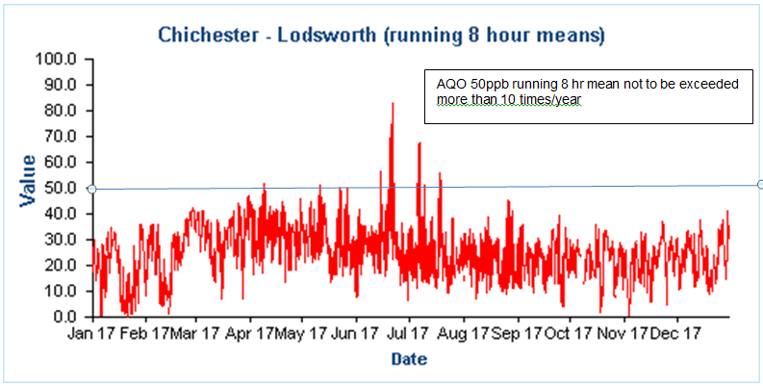

Comparison to the DEFRA banding below shows that in 2017 at Lodsworth there were 14 days when ‘moderate pollution’ occurred and one ‘high pollution’ day, see box for health messages of DEFRA pollution bands.

**Health messages of the DEFRA Pollution Bands**

|  |  |
| --- | --- |
| Pollution band and numerical index | Health messages for at-risk groups* |
| 1 – 3 (low) | Enjoy your usual outdoor activities. |
| 4 – 6 (moderate) | Adults and children with lung problems, and adults with heart problems, who experience symptoms, should consider reducing strenuous physical activity, particularly outdoors. |
| 7 – 9 (high) | Adults and children with lung problems, and adults with heart problems, should reduce strenuous physical exertion, particularly outdoors, and particularly if they experience symptoms. People with asthma may find they need to use their reliever inhaler more often. Older people should also reduce physical exertion. |
| 10 (very high) | Adults and children with lung problems, adults with heart problems, and older people, should avoid strenuous physical activity. People with asthma may find they need to use their reliever inhaler more often. |
| *\*Adults and children with heart or lung problems are at greater risk of symptoms.* | |

NB. Local authorities are no longer obliged to report annually on the following pollutants: 1,3 butadiene, benzene, carbon monoxide and lead, unless local circumstances indicate there is an issue. National monitoring results are available at https://uk-air.defra.gov.uk/data/

# Appendix A: Monitoring Results

Table A.1 – Details of Automatic Monitoring Sites

|  |  |  |  |  |  |  |  |  |  |  |
| --- | --- | --- | --- | --- | --- | --- | --- | --- | --- | --- |
| **Site ID** | **Site Name** | **Site Type** | **X OS Grid Ref** | **Y OS Grid Ref** | **Pollutants Monitored** | **In AQMA?** | **Monitoring Technique** | **Distance to Relevant Exposure (m) (1)** | **Distance to kerb of nearest road (m) (2)** | **Inlet Height (m)** |
| CI1 | Stockbridge | Suburban | 485881 | 103791 | NO2; PM10 | NO | chemilumin-escent/TEOM | 25 | 26 | 3 |
| CI4 | Orchard Street | Roadside | 485982 | 105221 | NO2 | YES | Chemiluminescent | 10 | 3.75 | 2 |
| AR1 | Lodsworth | Rural | 492396 | 123248 | O3 | NO | UV | n/a | n/a | 2.1 |

**Notes:**

(1) 0m if the monitoring site is at a location of exposure (e.g. installed on the façade of a residential property).

(2) N/A if not applicable.

Table A.2 – Details of Non-Automatic Monitoring Sites

|  |  |  |  |  |  |  |  |  |  |  |
| --- | --- | --- | --- | --- | --- | --- | --- | --- | --- | --- |
| **Site ID** | **Site Name** | **Site Type** | **X OS Grid Ref** | **Y OS Grid Ref** | **Pollutants Monitored** | **In AQMA?** | **Distance to Relevant Exposure (m) (1)** | **Distance to kerb of nearest road (m) (2)** | **Tube collocated with a Continuous Analyser?** | **Height (m)** |
| 1 | Kings Ave/Southbank Jct | Roadside | 485776 | 103961 | NO2 | N | 11 | 2.25 | N | 3 |
| 2 | Claremont Court | Roadside | 485772 | 103847 | NO2 | Y | 0 | 7.5 | N | 3 |
| 3 | Cabin | Suburban | 485880 | 103791 | NO2 | N | 25 | 26 | Y | 2.7 |
| 4 | Cabin | Suburban | 485880 | 103791 | NO2 | N | 25 | 26 | Y | 2.7 |
| 5 | Cabin | Suburban | 485880 | 103791 | NO2 | N | 25 | 26 | Y | 2.7 |
| 6 | Stockbridge Road South | Roadside | 485696 | 103731 | NO2 | N | 14 | 2 | N | 2.85 |
| 7 | Cleveland Rd | Urban Background | 486953 | 104414 | NO2 | N | 18 | 1.8 | N | 2.8 |
| 8 | Westhampnett Road | Roadside | 487341 | 105474 | NO2 | N | 3 | 1.65 | N | 2.85 |
| 9 | Hornet | Roadside | 486502 | 104795 | NO2 | N | 0 | 1.8 | N | 3.1 |
| 10 | St Pancras | Roadside | 486533 | 104860 | NO2 | Y | 0 | 2 | N | 3 |
| 11 | Arthur Purchase | Urban Background | 486082 | 105026 | NO2 | N | 0 | 6 | N | 2.7 |
| 12 | 174 Orchard St | Roadside | 485914 | 105185 | NO2 | Y | 0 | 2 | N | 2.65 |
| 14 | Rumbold’s Hill, Midhurst | Roadside | 488561 | 121479 | NO2 | N | 0.5 | 1.5 | N | 3.4 |

**Notes:**

(1) 0m if the monitoring site is at a location of exposure (e.g. installed on/adjacent to the façade of a residential property).

(2) N/A if not applicable.

Table A.3 – Annual Mean NO2 Monitoring Results

|  |  |  |  |  |  |  |  |  |  |
| --- | --- | --- | --- | --- | --- | --- | --- | --- | --- |
| **Site ID** | **Site Type** | **Monitoring Type** | **Valid Data Capture for Monitoring Period (%) (1)** | **Valid Data Capture 2017 (%) (2)** | **NO2 Annual Mean Concentration (µg/m3) (3)** | | | | |
| **2013** | **2014** | **2015** | **2016** | **2017** |
| CI1 | Suburban | Automatic |  | 99 | 32 | 33 | 34 | 34 | 33 |
| CI4 | Roadside | Automatic |  | 100 | 27 | 34 | x | 29 | 23 |
| 1 | Roadside | Diffusion Tube |  | 100 | 30 | 32 | 30 | 33 | 29 |
| 2 | Roadside | Diffusion Tube |  | 100 | **42** | **42** | **42** | **42** | 39 |
| 3 | Suburban | Diffusion Tube |  | 100 | 30 | 33 | 34 | 34 | 33 |
| 4 | Suburban | Diffusion Tube |  | 100 | 33 | 33 | 34 | 33 | 32 |
| 5 | Suburban | Diffusion Tube |  | 100 | 33 | 33 | 34 | 35 | 34 |
| 6 | Roadside | Diffusion Tube |  | 100 | **45** | **41** | **41** | **43** | 36 |
| 7 | Urban Background | Diffusion Tube |  | 100 | 20 | 16 | 17 | 18 | 16 |
| 8 | Roadside | Diffusion Tube |  | 100 | 36 | 31 | 30 | 31 | 30 |
| 9 | Roadside | Diffusion Tube |  | 100 | **42** | 38 | **40** | **41** | 38 |
| 10 | Roadside | Diffusion Tube |  | 100 | **53** | **52** | **46** | **51** | **44** |
| 11 | Urban Background | Diffusion Tube |  | 100 | 20 | 18 | 18 | 20 | 18 |
| 12 | Roadside | Diffusion Tube |  | 100 | 38 | 39 | 33 | 38 | 33 |
| 14 | Roadside | Diffusion Tube |  | 92 | x | x | **48** | **51** | **49** |

**Diffusion tube data has been bias corrected**

**Annualisation has been conducted where data capture is <75%**

**Notes:**

Exceedances of the NO2 annual mean objective of 40µg/m3 are shown in **bold**.

NO2 annual means exceeding 60µg/m3, indicating a potential exceedance of the NO2 1-hour mean objective are shown in **bold and underlined.**

(1) Data capture for the monitoring period, in cases where monitoring was only carried out for part of the year.

(2) Data capture for the full calendar year (e.g. if monitoring was carried out for 6 months, the maximum data capture for the full calendar year is 50%).

(3) Means for diffusion tubes have been corrected for bias. All means have been “annualised” as per Boxes 7.9 and 7.10 in LAQM.TG16 if valid data capture for the full calendar year is less than 75%. See Appendix C for details.

**Figure A.1 – Trends in Annual Mean NO2 Concentrations**

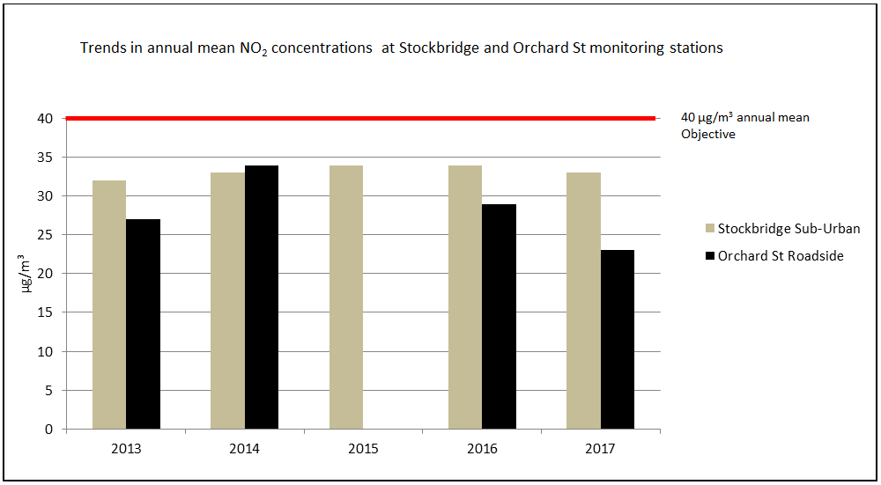

Table A.4 – 1-Hour Mean NO2 Monitoring Results

|  |  |  |  |  |  |  |  |  |  |
| --- | --- | --- | --- | --- | --- | --- | --- | --- | --- |
| **Site ID** | **Site Type** | **Monitoring Type** | **Valid Data Capture for Monitoring Period (%) (1)** | **Valid Data Capture 2017 (%) (2)** | **NO2 1-Hour Means > 200µg/m3 (3)** | | | | |
| **2013** | **2014** | **2015** | **2016** | **2017** |
| CI1 | Suburban | Automatic |  | 99 | 0 | 0 | 0 | 0 | 0 |
| CI4 | Roadside | Automatic |  | 100 | 0 | 0 | x | 0 | 0 |

**Notes:**

Exceedances of the NO2 1-hour mean objective (200µg/m3 not to be exceeded more than 18 times/year) are shown in **bold.**

(1) Data capture for the monitoring period, in cases where monitoring was only carried out for part of the year.

(2) Data capture for the full calendar year (e.g. if monitoring was carried out for 6 months, the maximum data capture for the full calendar year is 50%).

(3) If the period of valid data is less than 85%, the 99.8th percentile of 1-hour means is provided in brackets.

**Figure A.2 – Trends in Number of NO2 1-Hour Means > 200µg/m3 (100ppb)**

There have been no 1 hour mean concentrations that exceed the 200µg/m3 (100ppb)Objective in 2017 at either monitoring station

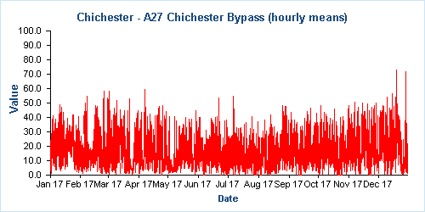

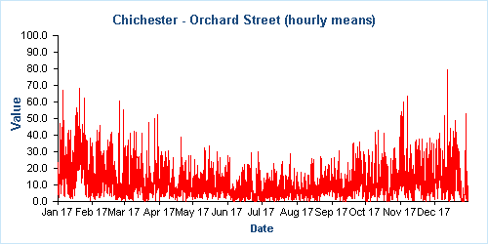

Values on the y axis are expressed as parts per billion (ppb)

Figure A.3 - Trends in NO2 diffusion tubes 2012 – 2017

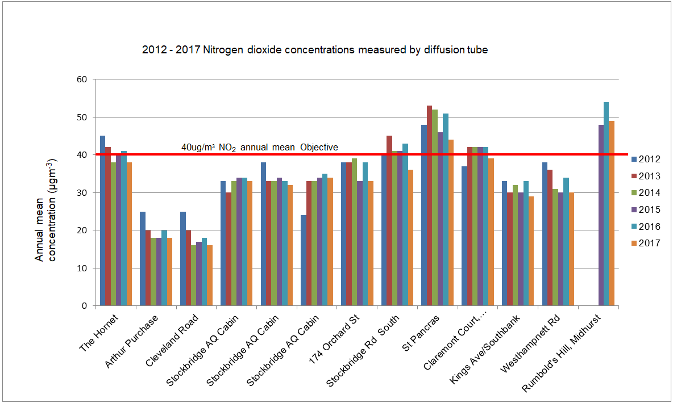

Table A.5 – Annual Mean PM10 Monitoring Results at Stockbridge monitoring station

|  |  |  |  |  |  |  |  |  |
| --- | --- | --- | --- | --- | --- | --- | --- | --- |
| **Site ID** | **Site Type** | **Valid Data Capture for Monitoring Period (%) (1)** | **Valid Data Capture 2017 (%) (2)** | **PM10 Annual Mean Concentration (µg/m3) (3)** | | | | |
| **2013** | **2014** | **2015** | **2016** | **2017** |
| CI1 | Suburban |  | 97 | 20 | 20 | 21 | 20 | 19 |

**Notes:**

Exceedances of the PM10 annual mean objective of 40µg/m3 are shown in **bold.**

(1) Data capture for the monitoring period, in cases where monitoring was only carried out for part of the year.

(2) Data capture for the full calendar year (e.g. if monitoring was carried out for 6 months, the maximum data capture for the full calendar year is 50%).

(3) All means have been “annualised” as per Boxes 7.9 and 7.10 in LAQM.TG16, valid data capture for the full calendar year is less than 75%. See Appendix C for details.

**Figure A.4 – Trends in Annual Mean PM10 Concentrations at Stockbridge monitoring station**

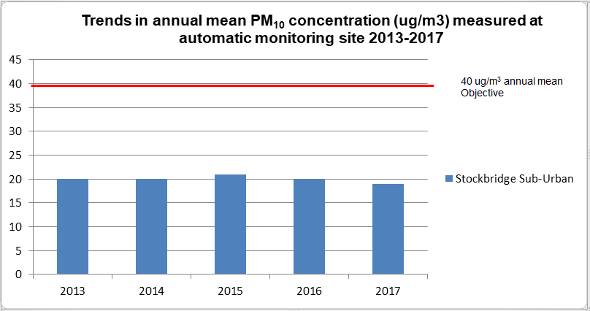

Table A.6 – 24-Hour Mean PM10 Monitoring Results at Stockbridge monitoring station

|  |  |  |  |  |  |  |  |  |
| --- | --- | --- | --- | --- | --- | --- | --- | --- |
| **Site ID** | **Site Type** | **Valid Data Capture for Monitoring Period (%) (1)** | **Valid Data Capture 2017 (%) (2)** | **PM10 24-Hour Means > 50µg/m3 (3)** | | | | |
| **2013** | **2014** | **2015** | **2016** | **2017** |
| CI1 | Suburban |  | 97 | 1 | 2 | 3 | 2 | 1 |

**Notes:**

Exceedances of the PM10 24-hour mean objective (50µg/m3 not to be exceeded more than 35 times/year) are shown in **bold.**

(1) Data capture for the monitoring period, in cases where monitoring was only carried out for part of the year.

(2) Data capture for the full calendar year (e.g. if monitoring was carried out for 6 months, the maximum data capture for the full calendar year is 50%).

(3) If the period of valid data is less than 85%, the 90.4th percentile of 24-hour means is provided in brackets.

**Figure A.5 – Trends in Number of 24-Hour Mean PM10 Results >50µg/m3**

24 hour means AQO not to be exceeded more than 35 times/year


Values on the y axis are expressed as microgrammes per cubic metre (µg/m3)

# Appendix B: Full Monthly Diffusion Tube Results for 2017

Table B.1 – NO2 Monthly Diffusion Tube Results - 2017

|  |  |  |  |  |  |  |  |  |  |  |  |  |  |  |  |
| --- | --- | --- | --- | --- | --- | --- | --- | --- | --- | --- | --- | --- | --- | --- | --- |
| **Site ID** | **NO2 Mean Concentrations (µg/m3)** | | | | | | | | | | | | | | |
| **Jan** | **Feb** | **Mar** | **Apr** | **May** | **Jun** | **Jul** | **Aug** | **Sep** | **Oct** | **Nov** | **Dec** | **Annual Mean** | | |
| **Raw Data** | **Bias Adjusted (0.933) and Annualised (1)** | **Distance Corrected to Nearest Exposure (2)** |
| 1 | 38.23 | 34.70 | 31.14 | 30.56 | 27.03 | 30.47 | 32.79 | 27.67 | 31.63 | 22.22 | 35.10 | 34.96 | 31.37 | 29.29 | 22.7 |
| 2 | 45.24 | 38.36 | 38.48 | 40.89 | 38.84 | 44.42 | 45.16 | 40.36 | 40.13 | 41.96 | 44.35 | 43.76 | 41.83 | 39.04 | 39.04 |
| 3 | 38.11 | 34.46 | 40.61 | 34.29 | 28.00 | 35.07 | 34.35 | 34.51 | 34.26 | 37.21 | 37.41 | 38.70 | 35.58 | 33.21 | n/a |
| 4 | 38.83 | 35.86 | 35.49 | 35.00 | 29.80 | 34.30 | 34.98 | 34.16 | 33.30 | 20.84 | 37.05 | 39.50 | 34.09 | 31.82 | n/a |
| 5 | 39.47 | 36.80 | 39.37 | 34.82 | 25.98 | 36.58 | 41.01 | 33.80 | 31.64 | 38.75 | 38.39 | 40.02 | 36.39 | 33.96 | n/a |
| 6 | 52.21 | 42.41 | 39.04 | 38.57 | 37.20 | 33.95 | 37.41 | 34.19 | 34.06 | 33.70 | 44.00 | 41.99 | 39.06 | 36.46 | 24.3 |
| 7 | 14.70 | 22.68 | 16.49 | 14.74 | 13.53 | 13.21 | 12.73 | 11.62 | 15.64 | 16.49 | 22.26 | 26.13 | 16.69 | 15.57 | n/a |
| 8 | 43.93 | 37.55 | 30.32 | 29.15 | 28.19 | 27.19 | 31.04 | 26.31 | 18.93 | 34.42 | 40.74 | 36.53 | 32.02 | 29.89 | 27.8 |
| 9 | 54.53 | 39.52 | 36.33 | 41.68 | 39.43 | 33.06 | 36.02 | 33.79 | 39.50 | 37.82 | 51.95 | 48.94 | 41.05 | 38.31 | 38.31 |
| 10 | 53.36 | 49.36 | 47.20 | 48.33 | 46.84 | 49.34 | 42.62 | 44.50 | 48.85 | 50.89 | 40.55 | 46.86 | 47.39 | **44.24** | **44.24** |
| 11 | 29.37 | 24.44 | 18.22 | 17.28 | 13.13 | 13.63 | 14.36 | 14.56 | 18.64 | 19.38 | 24.51 | 23.81 | 19.28 | 18.00 | n/a |
| 12 | 50.71 | 42.36 | 34.22 | 33.50 | 32.21 | 34.98 | 27.64 | 26.82 | 28.81 | 36.21 | 36.76 | 34.31 | 34.88 | 32.56 | 32.56 |
| 13 | 59.58 | 48.63 | 53.22 | 48.84 | 42.04 | A | 58.40 | 47.16 | 54.49 | 48.52 | 57.14 | 54.57 | 52.06 | **48.59** | **46.5** |

n/a – where bias adjusted mean does not exceed the annual mean objective of 40µg/m3 and the site is background or suburban, no distance correction has been calculated.

**Local bias adjustment factor used**

**Where applicable, data has been distance corrected for relevant exposure**

**Notes:**

Exceedances of the NO2 annual mean objective of 40µg/m3 are shown in **bold**.

(1) See Appendix C for details on bias adjustment and annualisation.

(2) Distance corrected to nearest relevant public exposure.

# Appendix C: Supporting Technical Information / Air Quality Monitoring Data QA/QC

**Significant changes to sources**No significant changes noted

**Monitoring campaigns in the District**

None undertaken

**Additional Evidence gathered**

None noted

**QA/QC of Automatic Monitoring**

All sites are visited by an officer for calibration and filter changes on a bi-monthly basis. CDC has a service agreement with a third party who provides site maintenance, auditing, regular inspections and 48-hour callout response if problems are encountered at the sites. Data is downloaded from all sites twice daily by the ERG[4] and is available to download online[5]. CDC has a contract with ERG to calibrate and ratify all real time data collected. ERG applies a VCM correction to the PM10 data and a screen shot of the correction is shown below. The graph shows the CDC TEOM data in blue and the VCM correction as a dotted red line.

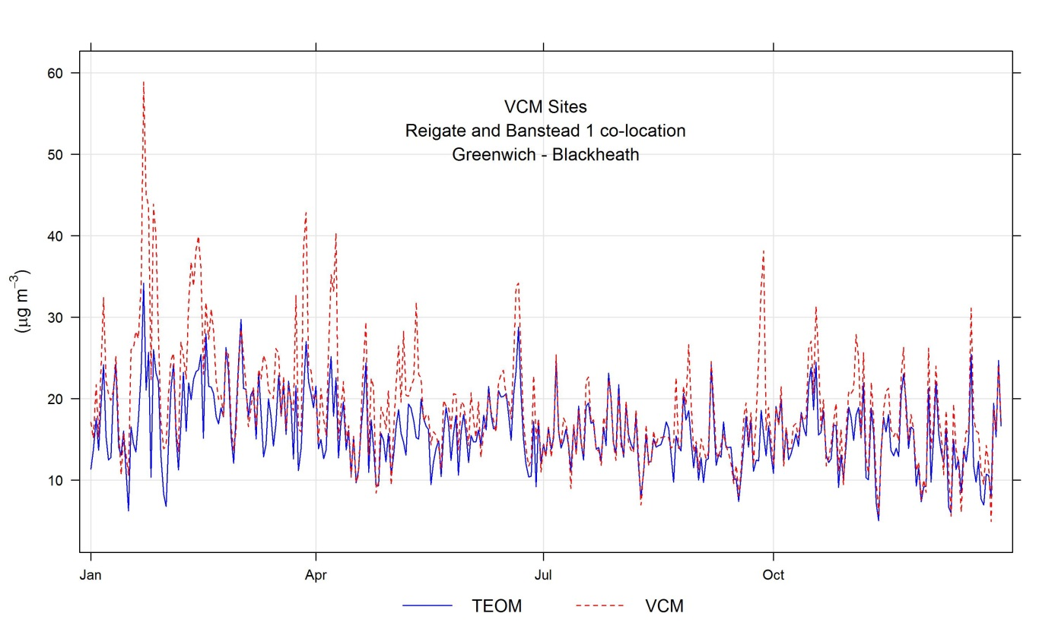

For more information please contact the ERG helpdesk[6].

**QA/QC Diffusion Tube Data**

Chichester District Council uses Gradko Environmental for supplying and analysing the diffusion tubes. The tube preparation method is 50% TEA/Acetone and ANA UKAS Method GLM 7 and GLM 9. CDC uses a local bias adjustment factor.

**Factor from Local Co-location Studies**

Three diffusion tubes are co-located with the Stockbridge monitoring station. These are used to calculate a bias-correction for the NO2 diffusion tubes. The automatic monitoring station’s data is quality assured by ERG. The annual average concentrations from the three co-located tubes are compared to the annual average real time data derived concentration for the same period. A factor can then be derived to correct all other diffusion tube data. The ‘bias correction’ calculation is as per the table below.

|  |  |
| --- | --- |
| Annual mean (automatic monitor) a,b,c | = 33 µg/m3 |
| Annual average mean (NO2 diffusion tubes) d | = 35.4 µg/m3 |
| Correction factor calculation | = 33/35.4  0.933 |

a 1st January 2017 – 31st December 2017

b Real-time data capture for 2017 = 99%

c All data ratified by Environmental Research Group

d Diffusion tube data capture for the period Jan - Dec = 100%

**QA/QC of Diffusion Tube Monitoring**

CDC has confirmed by checking the web site provided that Gradko Environmental uses the Workplace Scheme for Proficiency (WASP) indicator rating for quality control. The result for 2017 was Satisfactory (Z score +/- 2) for 100% of results submitted. For more information please contact Gradko Environmental[7].

**Distance calculations for roadside diffusion sites where monitoring is not carried out at a location of relevant exposure**

Using the NO2 fall off with distance calculator on the LAQM website, the following sites have had a distance calculation applied:

Stockbridge Road South

Stockbridge Road South

Westhampnett Road

Westhampnett Road

Rumbold’s Hill, Midhurst

Rumbolds Hill Midhurst

King’s Avenue/Southbank

Kings avenue southbank

# Appendix D: Map(s) of Monitoring Locations and AQMAs

Figure D.1 Stockbridge Roundabout AQMA and automatic and diffusion tube locations

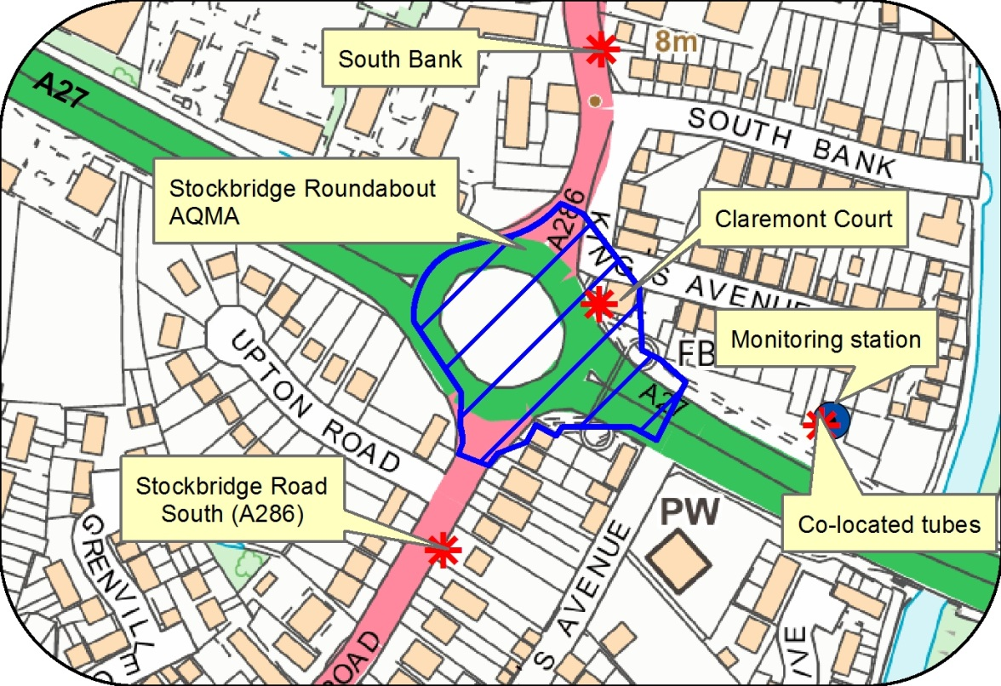

© Crown Copyright and database right 2017. Ordnance Survey 100018803

Figure D.2 Orchard Street AQMA and automatic and diffusion tube locations

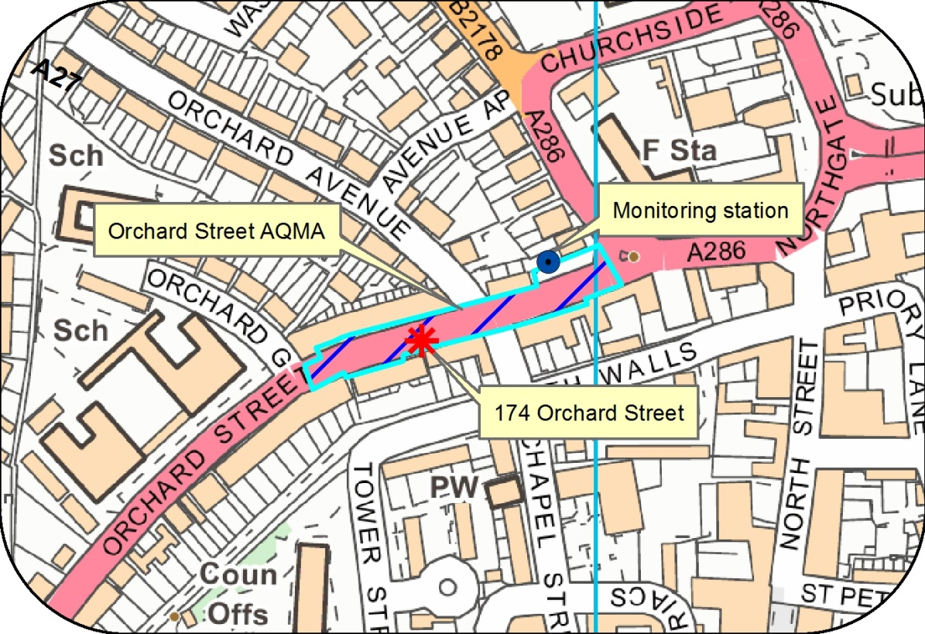

© Crown Copyright and database right 2017. Ordnance Survey 100018803

Figure D.3 St Pancras AQMA and diffusion tube locations

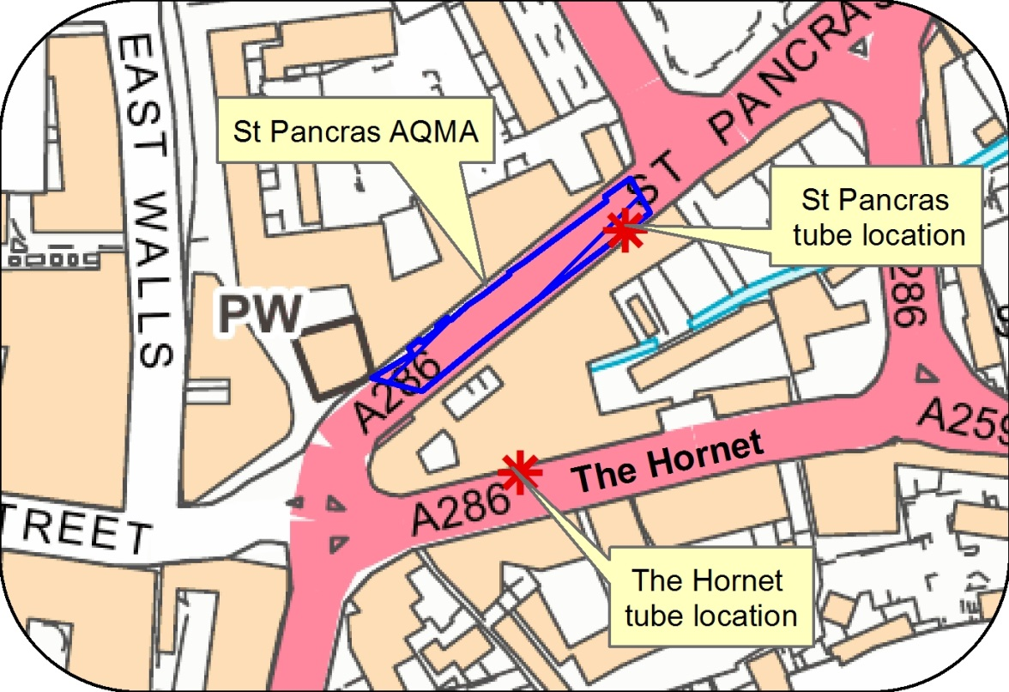

© Crown Copyright and database right 2017. Ordnance Survey 100018803

Figure D.4 Map of diffusion tube sites in Chichester

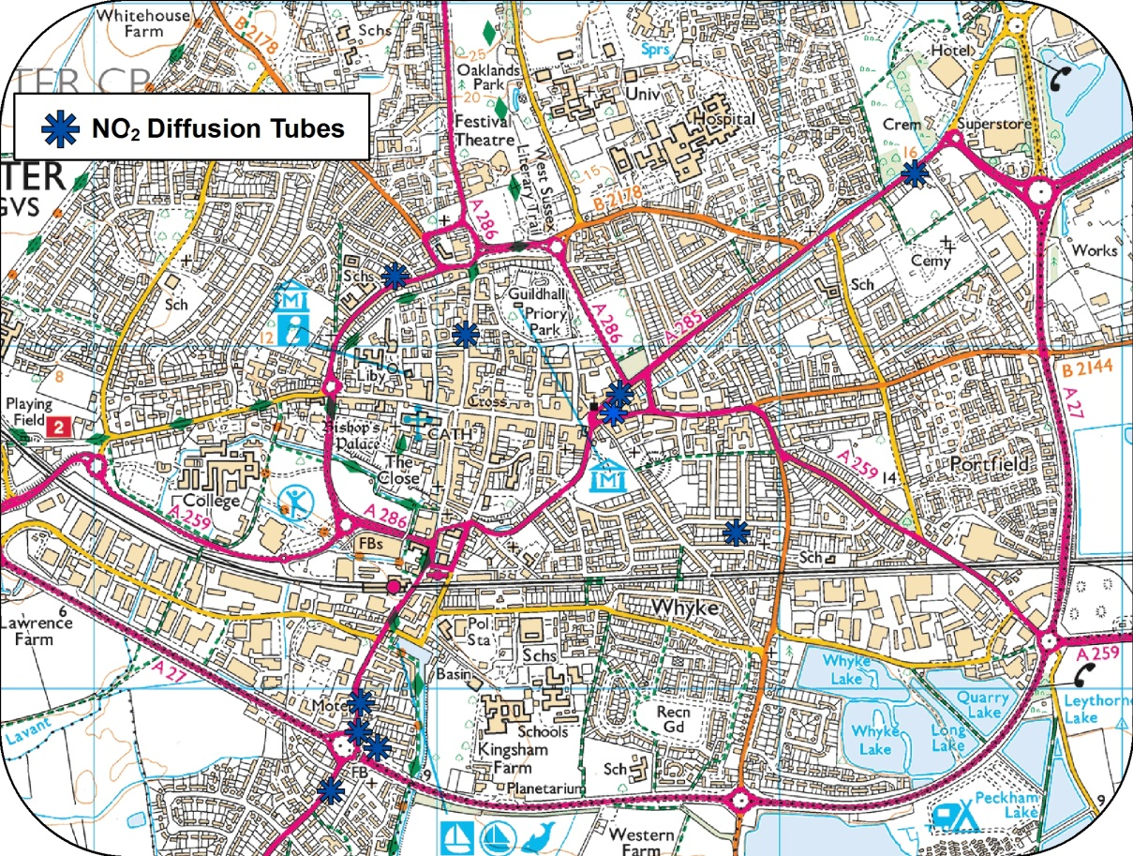

© Crown Copyright and database right 2017. Ordnance Survey 100018803

Figure D.5 Location of ozone monitoring station in Lodsworth

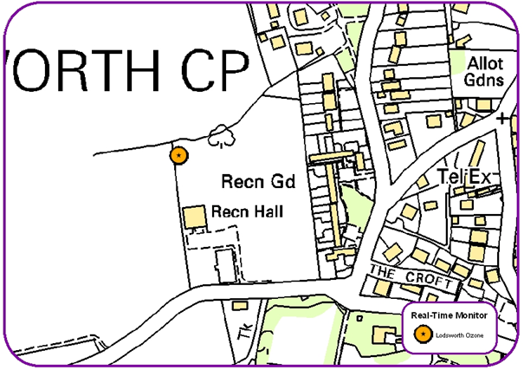

© Crown Copyright and database right 2017. Ordnance Survey 100018803

Figure D.6 Map of diffusion tube site at Rumbold’s Hill, Midhurst

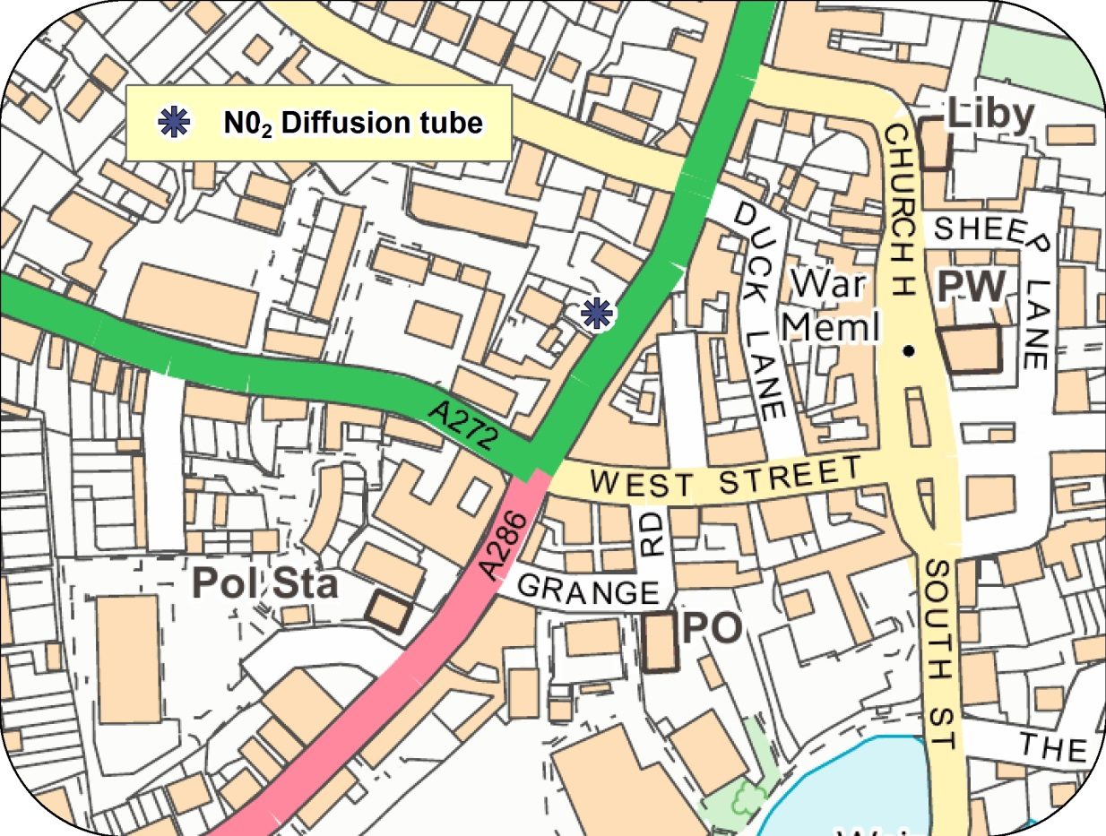

© Crown Copyright and database right 2017. Ordnance Survey 100018803

# Appendix E: Summary of Air Quality Objectives in England

Table E.1 – Air Quality Objectives in England

| **Pollutant** | **Air Quality Objective[8]** | |
| --- | --- | --- |
| **Concentration** | **Measured as** |
| Nitrogen Dioxide (NO2) | 200 µg/m3 not to be exceeded more than 18 times a year | 1-hour mean |
| 40 µg/m3 | Annual mean |
| Particulate Matter (PM10) | 50 µg/m3, not to be exceeded more than 35 times a year | 24-hour mean |
| 40 µg/m3 | Annual mean |
| Sulphur Dioxide (SO2) | 350 µg/m3, not to be exceeded more than 24 times a year | 1-hour mean |
| 125 µg/m3, not to be exceeded more than 3 times a year | 24-hour mean |
| 266 µg/m3, not to be exceeded more than 35 times a year | 15-minute mean |

# Glossary of Terms

|  |  |
| --- | --- |
| **Abbreviation** | **Description** |
| AQAP | Air Quality Action Plan - A detailed description of measures, outcomes, achievement dates and implementation methods, showing how the local authority intends to achieve air quality limit values’ |
| AQMA | Air Quality Management Area – An area where air pollutant concentrations exceed / are likely to exceed the relevant air quality objectives. AQMAs are declared for specific pollutants and objectives |
| ASR | Air quality Annual Status Report |
| CCTV | Closed circuit television |
| CDC | Chichester District Council |
| Defra | Department for Environment, Food and Rural Affairs |
| Dft | Department for Transport |
| DMRB | Design Manual for Roads and Bridges – Air quality screening tool produced by Highways England |
| EU | European Union |
| EV | Electric vehicle |
| FDMS | Filter Dynamics Measurement System |
| HE | Highways England |
| LAQM | Local Air Quality Management |
| LES | Low Emissions Strategy |
| LSTF | Local Sustainable Transport Fund |
| MOVA | Microprocessor Optimised Vehicle Actuation |
| NHS | National Health Service |
| NO2 | Nitrogen Dioxide |
| NOx | Nitrogen Oxides |
| OLEV | Office of Low Emission Vehicles |
| O3 | Ozone |
| PM10 | Airborne particulate matter with an aerodynamic diameter of 10µm (micrometres or microns) or less |
| PM2.5 | Airborne particulate matter with an aerodynamic diameter of 2.5µm or less |
| QA/QC | Quality Assurance and Quality Control |
| RTPI | Real Time Passenger Information |
| SAQP | Sussex Air Quality Partnership |
| SO2 | Sulphur Dioxide |
| UTC | Urban Transport Controls |
| VCM | Volatile correction measurement |
| VMS | Variable message signing |
| WSCC | West Sussex County Council |

# References

Towards Better Air Quality: An Air Quality Action Plan for Chichester District 2015-20

produced by Chichester District Council

West Sussex Walking and Cycling Strategy 2016 – 2026 produced by WSCC

1. Environmental equity, air quality, socioeconomic status and respiratory health, 2010
2. Air quality and social deprivation in the UK: an environmental inequalities analysis, 2006
3. Defra. Abatement cost guidance for valuing changes in air quality, May 2013
4. The Environmental Research Group (ERG), part of the School of Biomedical and Health Sciences at King’s College London, a leading provider of air quality information and research in the UK.
5. www.sussex-air.net
6. Contact ERG on 020 7848 4022
7. Contact Gradko on 01962 860331
8. The units are in microgrammes of pollutant per cubic metre of air (µg/m3).