| The names of the Local Authorites that have produced this document | Logo for Chichester District Council |
| --- | --- |

February 2021

Statement of Common Ground

Chichester District Council &

Havant Borough Council

Parties to the Agreement

The Agreement involves the following Local Planning Authorities

* Chichester District Council
* Havant Borough Council

Introduction

1. This Statement of Common Ground (SoCG) is jointly agreed between Chichester District Council and Havant Borough Council (‘the Councils’) in relation to the Havant Borough Local Plan (HBLP) and the Chichester Local Plan Review (excluding the South Downs National Park). It provides a written record of progress made on strategic cross-boundary matters during the preparation of the Councils’ respective Local Plans. It sets out where effective co-operation is happening on these matters in the context of the duty-to-cooperate.
2. The two Councils meet on a regular basis at an officer level, and with statutory bodies, to discuss:

* Timescales on respective Local Plans
* Evidence base studies
* Coordination of modelling inputs and assumptions which will inform our respective evidence base studies
* Emerging findings from respective evidence base studies

1. The SoCG will be updated to reflect these ongoing discussions and setting out progress to date. The Councils are at different stages of preparing Plans, but at the time of writing it is anticipated that Havant will be the first of the two authorities to submit a Plan for Examination. The Statement will be updated as appropriate as the two authorities progress towards examination and adoption. The progress of the two respective Plans is set out in detail below.

Current Position

1. The current position is as follows:

### Havant Borough Council

1. Havant Borough Council is preparing a Local Plan. The 2019 Pre-Submission Havant Borough Local Plan was consulted on between 1st February and 18 March 2019.
2. Due to a delay in the submission of the Plan in order to address the issue of nutrient neutrality, there has been a need to extend the plan period to 2037 in order to ensure a 15-year plan period from the date of adoption. The proposed changes to the 2020 Pre-Submission HBLP were subject to consultation between 3 November and 17 December 2020.

### Chichester District Council

1. Chichester District Council completed its Regulation 18 consultation in the early part of 2019, where comments were received on the Local Plan: Preferred Approach. The responses to the Local Plan: Preferred Approach were assessed during 2019 and further changes as a result of the comments received are being considered (Summer 2020). In addition, further work on the evidence base is being carried out to better inform the proposed spatial strategy. These further comments and the revised evidence base will feed into the Regulation 19 version of the plan, which will be consulted on during March – April 2022, before submission for independent examination (currently anticipated June 2022).

Location

1. Although adjoining administrative areas, Chichester District falls within West Sussex and Havant Borough falls within Hampshire. The administrative boundary between the two local authorities also marks the boundary between the two counties. The South Downs National Park lies to the north with Chichester Harbour AONB to the south. The main east-west strategic road, the A27 runs through both local authority areas. The location in relation to these key features is shown at Appendix 1.

Key Strategic Matters

1. The following key strategic planning matters which jointly affect Havant Borough Council and Chichester District Council are addressed by the statement:

* Housing Requirements and Distribution of Need
* Transport
* Nutrient Neutrality
* Wastewater Treatment
* Employment
* Other Cross Boundary Issues (Sites of International Importance and Wildlife Corridors)

Plan-Making Authorities

1. The two plan-making authorities are Havant Borough Council and Chichester District Council. A number of other bodies have an interest in the key strategic matters addressed by this statement. Of relevance to this SoCG are:

* Hampshire County Council and West Sussex County Council (Local Highway Authorities)
* Environment Agency (Wastewater and Nutrient Neutrality)
* Southern Water (Wastewater and Nutrient Neutrality)
* Natural England (Nutrient Neutrality, Designated Sites and Wildlife)
* West Sussex Growth Board (Sub-regional matters affecting CDC)
* Partnership for South Hampshire (PfSH) (Sub-regional matters affecting HBC)

1. In terms of the latter, a PfSH Statement of Common Ground which was approved at the PfSH Joint Committee on the 30th September 2020[1].

### Housing Requirements

1. The following table summarises the adopted housing requirements and the emerging local housing need figures for the two Councils’ at key stages in the preparation of their emerging plans.

| **Plan** | **Stage** | **Housing Need** |
| --- | --- | --- |
| **Chichester District[2]** | | |
| Chichester Local Plan Review 2016 - 2035 Preferred Approach (December 2018) | Consultation Draft | At least 12,350 |
| **Havant Borough** | | |
| Proposed Changes to the Pre-Submission Local Plan (2020) | Consultation Draft | 10,433 |

### Distribution of Need

### Housing

1. As set out above, there has been a need to extend the HBLP plan period to 2037 to provide a 15-year time horizon from adoption. The HBLP provides for Havant’s local housing need of 10,433 homes over the plan period, but with a reduced buffer of 340 homes. Whilst Havant Borough Council had envisaged that a buffer of 971 homes (identified in the 2019 Pre-Submission Plan) could contribute towards meeting any unmet need, the scale of the reduced buffer (included in the 2020 Pre-Submission Plan) means that it is unlikely that it could be considered to contribute towards unmet need.

1. Havant Borough Council is not looking towards Chichester District Council to provide any unmet need for housing.
2. Chichester District Council is not looking towards Havant Borough Council to provide for any unmet need for housing at this time (February 2021).

### Employment

1. Havant Borough Council has confirmed in its SoCG with PfSH that market conditions demonstrate that Havant Borough is a secondary office location by virtue of the lack of demand for higher grade office accommodation and the fact that residual land values do not support speculative development. The predicted office floor space requirement highlighted in the PfSH Economic and Employment Land Evidence Base Paper (March 2016) is therefore not achievable over the plan period. It should be noted that PfSH is currently updating its evidence base for employment needs to inform the production of the new Joint Strategy as set out in the PfSH.
2. Havant Borough Council has a SoCG with the PfSH Authorities which confirms that the Borough can meet its objectively assessed needs for employment over the plan period.
3. Havant Borough Council is not looking towards Chichester District Council to provide any unmet need for employment floorspace.
4. Chichester District Council updated its Housing and Economic Development Needs Assessment in 2020. This indicated a need for around 26.9 ha of employment land between 2019 and 2037, much of which can be met by existing commitments and allocations. Sufficient potential sites have been identified to accommodate the remaining requirement meaning Chichester is not looking towards Havant Borough Council to provide any unmet need for employment floorspace.

### Nutrient Neutrality

1. New development necessitates the provision of connections to the foul water drainage network and can increase surface water run-off. This can increase the amount of nutrients entering Solent European Sites. As a result, Natural England has advised that there is a likely significant effect on several of the Solent’s European Sites from development. Therefore, any new housing schemes and other proposals which include a net gain in overnight accommodation or development which has a high volume of water use will need to prevent any increase in nutrients into the harbour in order for them to be ‘nutrient neutral’.
2. Havant Borough Council has confirmed that development draining to two wastewater treatment works in Havant borough; Budds Farm and Thornham would likely lead to a significant effect on the integrity of Solent European Sites. In the Chichester Plan Area, this applies to Thornham, Bosham and Apuldram (Chichester) which drain into Chichester Harbour.
3. Havant Borough Council has published a Position Statement and Mitigation Plan for Nutrient Neutral Development which outlines the Council’s solution to addressing nutrients where it is not possible for development to achieve nutrient neutrality on site. The Review of the Warblington Farm Mitigation Option for Nutrient Neutral Development in the Havant Borough Report confirms the scientific link between the likely significant effect from the development and the mitigation at Warblington, as required by the Habitats Regulations. It also confirms that Havant Borough Council’s mitigation option is suitable for development draining to Budds Farm and Thornham Wastewater Treatment Works. Mitigation at Warblington has a finite capacity but provides Havant borough with a short-term solution. As such, it is unlikely to be able to provide mitigation for developments within the Chichester Plan Area.
4. HBC and CDC are both also continuing to work with PfSH through the Water Quality Working Group to coordinate a Solent wide solution in the medium to long term. This has included both Council’s support for the appointment of a Strategic Environmental Officer to take forward the creation of a pilot sub-regional mitigation scheme.
5. In advance of strategic Solent wide solutions, via PfSH or the parallel project being undertaken by MCHLG and DEFRA, Chichester has published information about nitrate mitigation on its website and is in the process of exploring solutions.

### Wastewater Treatment

1. Southern Water is the statutory wastewater undertaker for both Chichester District and Havant Borough. The Councils’ share a common Wastewater Treatment Works (WwTW) at Thornham which services the Emsworth area (Havant Borough), and parts of the Chichester Plan area. The WwTW operates in accordance with environmental permits issued and enforced by the Environment Agency. These permits set the maximum volume of treated wastewater the company is permitted to discharge into the environment, as well as defining the standards of treatment that must be met in order to protect water quality objectives.
2. CDC’s response to Havant Borough Council’s 2019 Pre-Submission Plan consultation expressed concern about some assumptions in the Habitats Regulation Assessment, namely an assumption that the Chichester Water Quality Study had taken full account of development in Havant that would be served by Thornham WwTW, and that the PfSH Integrated Water Management Study (IWMS) assumed all development in Havant would use Budds Farm which is the other WwTW serving Havant Borough.
3. The Chichester District Water Quality Assessment (August 2018) indicated that upgrades to Thornham would be needed by 2025. CDC has since been working with the Environment Agency and Southern Water to update information about remaining wastewater treatment capacity across the Chichester Plan Area. This work also shows that remaining capacity at Thornham WWTW is very limited. This differs from the conclusions of the PfSH IWMS Addendum (July 2020)[3]. The IWMS study uses a water efficiency rate of 110 L/P/D which is reflected in the Havant Borough Local Plan. In contrast, the CDC study uses an average of 500 litres water use per household per day on the advice of the Environment Agency and in line with Southern Water’s guidance on calculating Dry Weather Flow Headroom for Local Plans.
4. It should be acknowledged that it is not within either of the Councils’ control to provide a solution to providing additional wastewater capacity. Nevertheless, both signatories remain committed to working together in partnership with Southern Water to find and secure a solution for additional wastewater capacity.

### Transport Infrastructure

*March 2019*

1. CDC sought confirmation from HBC about the assumptions used in the baseline (reference case) for the transport modelling in relation to assumed levels and locations of growth from within Chichester District (and beyond). The safe and efficient operation of the highway network within Chichester District and the surrounding area remains a concern for Chichester District residents.
2. CDC wished to understand the potential implications that any increased highway congestion could have on air quality, particularly where it could affect areas already identified as having particularly poor air quality for human health or affecting protected habitats. Specific attention was drawn to the potential impact on the A27 Chichester Bypass and whether the impact of development in Havant Borough and the need for mitigation has been robustly assessed.
3. HBC has considered the traffic impact on designated sites, including Chichester & Langstone Harbours Ramsar & SPA and Pagham Harbour Ramsar & SPA which fall within the Chichester Plan Area through its Air Quality Habitat Regulations Assessment (HRA) (January 2019). The potential impact on human health was also considered as part of the PUSH Air Quality Impact Assessment (September 2018) though Havant does not have any declared Air Quality Management Areas, or any monitoring stations on the A27 corridor.

*December 2019*

1. Further transport work is being undertaken by Havant Borough Council to consider the implications on the transport network of the proposed strategic site at Southleigh, a strategic allocation for 2,100 homes (1,100 in the Plan period), which sits close to the border with Chichester District, just north of the A27 and A259.
2. In addition, CDC published the Chichester Transport Study Update (January 2020) which presents an updated 2035 Reference Case – Baseline Scenario. Table 3.1 identifies the committed and adopted Local Plan development assumed in the reference case, which includes 1,100 dwellings at Southleigh Strategic Site, to be completed by 2036. The two Councils continue to work together to feed into the quantum of development assumed by their respective Transport Assessments.

*Summer 2020*

1. Both Councils are aware of the emerging proposals by Highways England for the A259 Non-Motorised User link improvements between Chichester & Emsworth (the “Chem route”). The proposals have been subject to a feasibility study which considers a number of solutions for providing this provision. Funding has been allocated to develop the preferred solution further and it is anticipated that the next phase of work, up to the production of a preliminary design will commence during Autumn 2020. Both authorities support the principle of the Chem route and are ready to engage with Highways England as this project progresses.
2. Havant Borough Council has completed Part 1 of the Southleigh Transport Study. This forms an Addendum to the original Mainland Local Plan TA with a specific focus on the Southleigh Strategic site. Given the queries raised by CDC on how their potential development traffic had been factored into to original TA, this work included a review of the development assumptions in Chichester District. Additional development in Chichester was included in the detailed local model to reflect the latest published position on CDC’s local plan. The modelling as part of this study has confirmed that with the Strategic Site, the junctions on the local network would come under severe pressure, and that a direct link onto the A27 should be considered further, through Part 2 of the study.
3. Part 1 of the study was shared with CDC and West Sussex County Council, together with information to answer earlier queries on the function on the model underlying the TA.

*Autumn 2020*

1. Havant Borough Council has completed additional detailed transport modelling for Part 2 of the Southleigh Study. This modelled a direct access onto the A27 for Southleigh via the Warblington interchange and concluded that this measure would help to mitigate the impact of the Southleigh development as well as the impact of the wider Local Plan development traffic on the local network surrounding the site.
2. Notably, the proposed junction arrangement tested through the modelling also includes a jet lane from the A259 onto the Westbound A27, meaning that traffic from the A259 will not have to enter the roundabout to access to the A27 towards Havant, Portsmouth and beyond. This is likely to bring benefits to users of the A259 corridor in both districts. To date, CDC has not been requested to contribute towards the delivery of the jet lane.
3. Further information was provided to Chichester District Council and West Sussex County Council regarding the operation of the Sub-Regional Transport Model, which underpins Havant Borough Council’s Mainland Transport Assessment. This confirmed that the forecasted changes in flows on the modelled highway network in West Sussex, together with the transport mitigation strategy in Havant, are not likely to result in a severe residual impact as defined in national policy.

Additional Strategic Matters

### Sites of International Importance:

*March 2019*

1. CDC sought further clarification on the extent to which cumulative impacts on those sites within the Chichester Plan Area have been taken into account, the breadth of potential impacts and the potential scope of mitigation. In response, HBC confirmed that the Air Quality HRA for the Local Plan considers the potential for likely significant effect of international sites within 10km of Havant Borough. This is in line with best practice guidance for the area of coverage of a Plan. The Executive Summary details the 17 international sites considered.
2. Both authorities are partners in the Bird Aware project to mitigate the impact of additional development on the Solent SPAs. Further details are available on the Bird Ware website at https://solent.birdaware.org/home

### Wildlife Corridor:

*December 2019*

1. The River Ems forms the boundary between Havant Borough and Chichester District. Chichester District Council has proposed a new wildlife corridor on the eastern side of the River Ems. The western side of the River Ems is within Havant Borough and the Council considered how to respond to this proposal.

*December 2020*

1. The proposed changes to the Havant Borough Local Plan (2020) include the addition of paragraph 5.186 to the supporting text accompanying the Local Ecological Network Policy (E14) which recognises the importance of strategic wildlife corridors including the River Ems on the Havant – Chichester border.

Signatories

| **This statement has been prepared and agreed by the following organisations** | |
| --- | --- |
| **Havant Borough Council** | **Chichester District Council** |
| Signature  cid:image003.png@01D2A89A.FE39DA80 | Signature  Signed on behalf of Chichester District Council |
| Simon Jenkins | Councillor Susan Taylor |
| Director of Regeneration & Place | Deputy Leader of the Council and Cabinet Member for Planning |
| Date : 12th February 2021 | Date : 19th February 2021 |

Appendix 1 Map of the Plan Areas

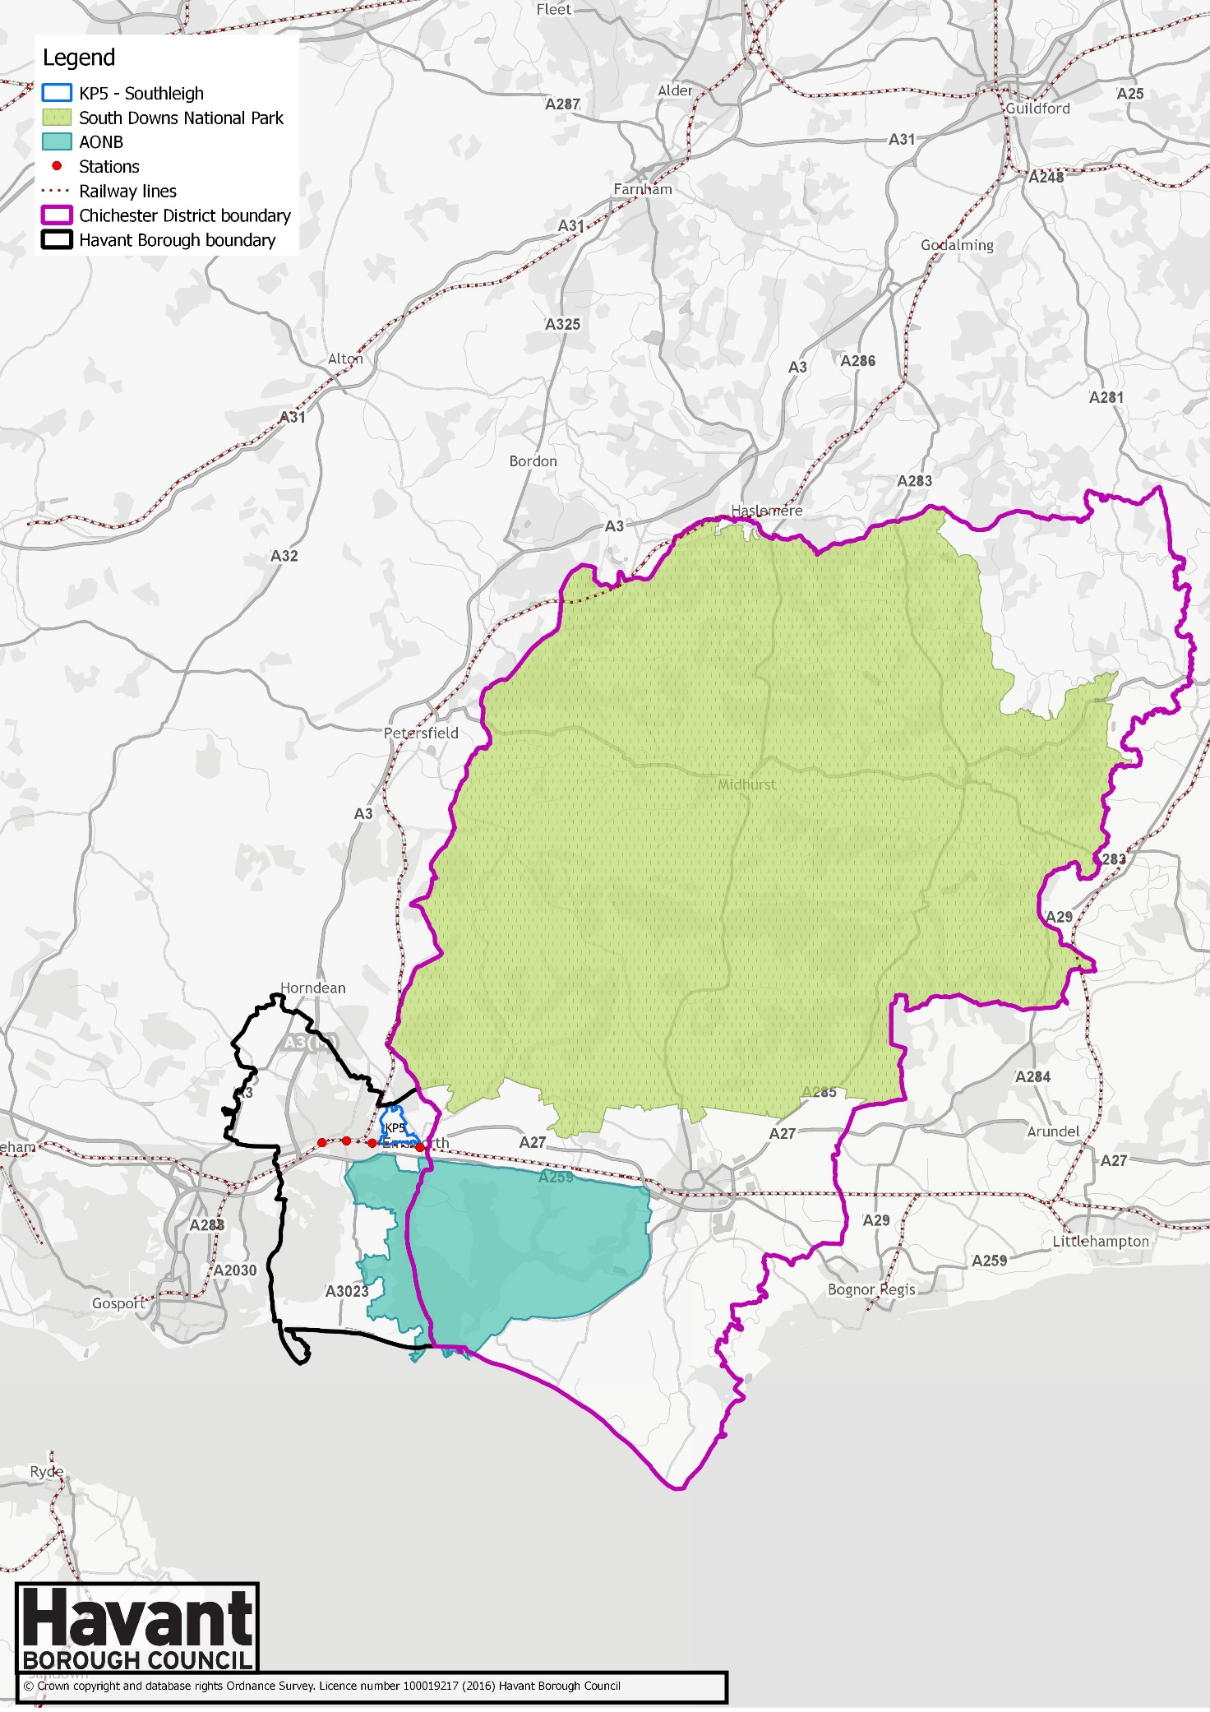

1. [Report to the Partnership for South Hampshire Joint Committee – 30th September 2020](https://www.push.gov.uk/work/our-meetings/joint-committee/)
2. Note that Chichester housing need figures relate to the Chichester Plan Area i.e. the part of Chichester District which falls outside the South Downs National Park
3. <https://www.push.gov.uk/wp-content/uploads/2020/10/Wood-Technical-Note-July-2020.pdf>