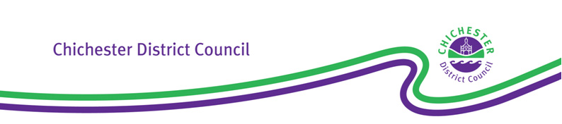

|  |  |  |  |
| --- | --- | --- | --- |
|  | If calling please ask for: | Customer Services  Tel: 01243 534601  E-mail  taxilicensing@chichester.  gov.uk | |
| Our ref: | TX16I(v13)(PH) |
| Your ref: |  | |
|  |  | |

Dear Sir or Madam

**Local Government (Miscellaneous Provisions) Act 1976**

**Renewal reminder - Private Hire Vehicle Licence**

The above Private Hire Vehicle Licence (the ‘licence’) will lapse at the end of the end date of the Licence.

Should you wish to renew the licence, please ensure that a complete and correct renewal application is submitted **no less than 5 clear working days** prior to the expiry date. This is essential in order that we have sufficient time to process, determine and issue any new licence prior to the existing licence lapsing.

Where a renewal application is submitted with less than 5 clear working days’ notice, then this Licensing Authority (the ‘Authority’) may not be in a position to process the application and re-issue the licence before the expiry of the existing licence. In such a situation you would not be able to use the vehicle as a Private Hire vehicle until the renewal application had been determined and a licence granted. **It is therefore strongly recommended that a renewal application is submitted at the earliest opportunity**.

Should you not wish to renew the licence, please ensure that the existing plate and the vehicle ID are returned to this Authority within 7 days of the date of expiry.

*…continued*

East Pallant House, 1 East Pallant, Chichester, West Sussex PO19 1TY

Telephone: (01243) 785166   Fax: (01243) 776766   [www.chichester.gov.uk](http://www.chichester.gov.uk)  DX30340 Chichester

For current opening hours of East Pallant House: <https://www.chichester.gov.uk/contactus>

Items which must be provided in order to renew are shown below and these must all be submitted at the same time and must be original documents.

1. **Application form** (**Form T10C) -** Apartially-completed form is enclosed based on information currently held: Please check, finalise, and ensure you both read and manually sign the declaration.
2. **Disclosure and Barring Service (DBS) Certificate**: As the result of the Department for Transport’s requirements, Applicants and existing Vehicle Proprietors not already providing the Enhanced DBS Criminal Record check Certificate in their separate standing as a Hackney Carriage/ Private Hire Vehicle Driver, must provide a Basic DBS Criminal Record check Certificate which is no more than 3 months old: Vehicle Proprietors which are Limited Companies or Partnerships must provide such Certification for every Director/ Partner of the Company/ Partnership. These are required upon initial Application and at subsequent Renewals.
3. **Certificate of Insurance -** This must show that the vehicle is currently insured for Private Hire or Reward.

**4. MOT Test Certificate** - The certificate must have been issued no more than 5 working days before the Fitness Test Report (see 5 below) and the vehicle must pass the test. The MOT Test may be undertaken at any DVSA approved testing station, however Chichester Contract Service (CCS) provides an independent service for the current fee of £54.85 (Class 4) and £58.60 (Class 7). **Combined MOT and Fitness Tests at CCS costs a reduced fee of £83.40.** Bookings must be made online <https://www.chichester.gov.uk/article/38871/Book-an-MOT-taxi-meter-or-fitness-test>. **Early booking is strongly recommended up to one calendar month before the due date.**

**5. Fitness** **Test Report** - The Fitness Test may only be undertaken by CCS: The current fee is £40.00. The report must be obtained within 5 working days of when the vehicle passed an MOT test and the vehicle must pass the test. **Early booking is strongly recommended up to one calendar month before the due date.** Bookings must be made online <https://www.chichester.gov.uk/article/38871/Book-an-MOT-taxi-meter-or-fitness-test>

**6. Meter Test** - Where a vehicle is fitted with a taximeter, the meter is to be tested and sealed and must pass the test: This must be undertaken by CCS where the current charge is £26.90. Bookings must be made online <https://www.chichester.gov.uk/article/38871/Book-an-MOT-taxi-meter-or-fitness-test>

**7. Application Fee** - The current Renewal Fee is £162.94: This is payable online <https://www.chichester.gov.uk/article/39542/Pay-for-a-new-or-renewal-of-a-Hackney-Carriage-Private-Hire-or-Dual-Driver-s-Licence-a-Hackney-Carriage-Vehicle-Licence-a-Private-Hire-Vehicle-Licence-or-New-Operator-s-Licence> Note: Until the fee is received, the Application is incomplete.

We look forward to receiving your application in due course.

Yours faithfully

**Licensing Team**

Chichester District Council